Title (Turkish) (Calibri (Body), 14 Font size, Initials Capital, Bold and Centred Alignment)
There should be an “enter” between two titles.
Title (English) (Calibri (Body), 14 Font size, Initials Capital, Bold and Centred Alignment)
After the title in English, there should be two space and then the author information should follow as indicated below.

Name, SURNAME, Title, Affiliation, City/ COUNTRY, e-mail, ORCİD ID (Calibri (Body), only author’s name and surname should be 11 font size, the others should be 9 font size, centred)

If there are more than one author, there should be one “enter” space. When writing the last author, space before should be 0 nk and after the space should be 10 nk and there should be one enter space.

Surname, N. (2017). Title. Batı Anadolu Eğitim Bilimleri Dergisi, x(x), x-x. If there are more than one author, authors should be seperated by “and”. If the authors are foreigners they should be seperated by “&”. Besides, they should be written as indicated above.
Submission date: Acceptance date: Publishing date:
Abstract. Abstract and key words must be written in Calibri (Body) and Key Words must be written in Calibri (Body) 10 font size. The Turkish abstract must be between 150-250 words. “Key Words” must be bold and italics and the initials must be capital letters and separated with “,”. At the end of key words there must be “.”. Header and footer shouldn’t be used. Margin should not be changed.

Key Words: “Key Words” must be bold and italics and the initials must be capital letters and separated with “,”. At the end of key words there must be “.”. Key words that will be seen in index scanning.

Abstract. Abstract and key words must be written in Calibri (Body) and Key Words must be written in Calibri (Body) 10 font size. The English abstract must be between 150-250 words. “Key Words” must be bold and italics and the initials must be capital letters and separated with “,”. At the end of key words there must be “.”. Header and footer shouldn’t be used. Margin should not be changed.

Key Words: “Key Words” must be in bold and italics and the initials must be capital letters and separated with “,”. At the end of key words there must be “.”. Key words that will be seen in index scanning.

Extended Abstract
(It should start on a new page. Title should be centred, Calibri (body), 12 font size and bold. After the title, there should be an “enter” space)

Introduction. Calibri (Body), 11 font size and paragraph should be justified. If there will be a second paragraph it should start after a “tab”.

Between the subheading there should be an “enter”.

Method. Calibri (Body), 11 font size and paragraph should be justified. If there will be a second paragraph it should start after a “tab”.

Results. Calibri (Body), 11 font size and paragraph should be justified. If there will be a second paragraph it should start after a “tab”.

Discussion and Conclusion. Calibri (Body), 11 font size and paragraph should be justified. If there will be a second paragraph it should start after a “tab”.

Introduction
(It should start on a new page. Centred, bold, 14 font size and Calibri (Body). After the title there should be an “enter” space.)

Subheading (left justified, Calibri (body) and 11 font size)
The introduction part of the article should be 11 font size and single line. While starting a paragraph there should be one “tab” indenting and between paragraphs there should be an “enter” space. Between lines before and after there should be one nk.

*On the right and left, at the top and bottom of the page there should be 2,5 cm.

**Main headings should be centred, bold, Calibri (body) and 14 fonts size. Sub heading should be left justified, bold Calibri (body) and 11 font size. The following subheading should be left justified, bold, italic, Calibri (body) and 11 font size.

***Before and after the tables and figures which are added within the text there should be an “enter” space.

>Tables should be designed according to (http://www.tk.org.tr/APA/apa_2.pdf). The text in the table must be 10 font size. Statistical term in the table such as t, p, F should be shown in italics. There shouldn’t be vertical lines, it should be composed of horizontal lines.

>> Table title should be above the table. Tables should be left justified. Before “Table X.” ‘there should be an “enter” space. After “Table X.” there should be a new line. After that, table name should be given like “Analysis of attitudes towards gender…”. The initial letter of the table title should be capital and the rest of the letters should be lower case, 11 font size and Calibri (body). If there is numeral data numeral data should be right justified. Example table is given in table 1.

Table 1.
Example table (the text in the table should be Calibri (body) and 10 font size. Besides, table format should be as it is shown in the example.)
 | New students (Bold) | Graduated students (Bold) | Difference (Bold)
 | Undergraduate students
İzmir | 110 | 103 | +7
 | 223 | 214 | +9
 | Graduate
İstanbul | 53 | 52 | +1
Total | 998 | 908 | 90

>>> Tables may contain numerical data besides text. In this kind of tables textual data are given left justified. Example table is given in Table 2.

Table 2.
Parts of the studies that will be accepted by BAED
Part | Content
English and Turkish title | 14 font size, centred and bold.
English and Turkish summary | Between 150-250 words
Main text | Main text 11 font size
References | 10 font size and single-line between the lines

+Figure resolution shouldn’t be distorted in figures. Distortions occur in the figures that change shape by pulling from the bottom, top or sides.

++Only the first word of figure names must begin with a capital letter. There must be an "enter" space before and after the figure.

+++The figure text should be placed under the figure and should be written as "Figure X. Group work example". An example figure addition is given in figure 1. An example of adding the wrong figure is given in figure 2.

Figure 1. Example figure adding (There should be an “enter” space before the figure. Then the figure should be placed and after the figure there should be an “enter” space. In other words, there will be an enter space before and after the figure name. Unlike the table, figure name should be below the figure. Figures must be left justified. The initial of the first word of the figure names should be capital. Title of the figure should be 11 font size, Calibri (Body) and not bold. Only the first word of the figure name should be capital and there should be an empty space for the following paragraphs.

Figure 2. Figure title

Figure 2 is an example of wrong figure writing because there is no space between figure name and figure.

Method
(Centred, Calibri (body) and 14 font size. Besides, there should be an enter space after the title.)

In the article, method part should be written in 11 font size and in single line. When starting the paragraph, a "tab" paragraph head must be made and an "enter" space must be left between the paragraphs. Before and after the lines there should be 1 nk.

Sub heading (left justified, calibri (body) and 11 font size, after the sub heading an “enter” space must be left.)

Sub heading (italics, bold, left justified, calibri (body) and 11 font size, after the sub heading an “enter” space must be left)

Findings
(Centred, calibri (body) and 14 font size. Besides, there should be an enter space after the title.)

In the article, method part should be written in 11 font size and in single line. When starting the paragraph, a "tab" paragraph head must be made and an "enter" space must be left between the paragraphs. Before and after the lines there should be 1 nk.

Sub heading (left justified, calibri (body) and 11 font size, after the sub heading an “enter” space must be left.)

Sub heading (italics, bold, left justified, calibri (body) and 11 font size, after the sub heading an “enter” space must be left)

Discussion, Results and Suggestions
In the article, method part should be written in 11 font size and in single line. When starting the paragraph, a "tab" paragraph head must be made and an "enter" space must be left between the paragraphs. Before and after the lines there should be 1 nk.

Sub heading (left justified, calibri (body) and 11 font size, after the sub heading an “enter” space must be left.)

Sub heading (italics, bold, left justified, calibri (body) and 11 font size, after the sub heading an “enter” space must be left)

Bibliography (Left-aligned, caliber (body), bold and 10 point. After the title, there should be an “enter”. References should be set as 1 pt before and after line spacing. References should start from a new page.)

Bibliography should be organized according to APA. http://www.tk.org.tr/APA/apa_2.pdf

With Google Academic you can organize your references according to APA. However, its accuracy should be checked according to the APA Writing guide addressed above.

1. After you have found your article in Google Academic tick the “ sign.
2. Copy the APA demonstration in the opening window.

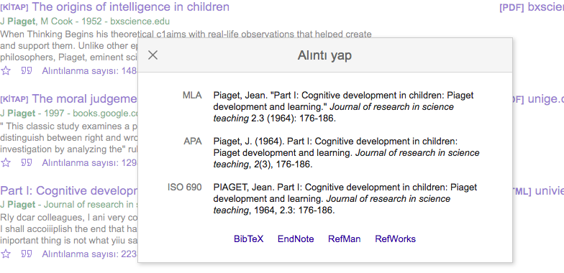
* References should be justified and formatted according to the alphabetical order. The typeface should be calibri (body) and 10 font.

