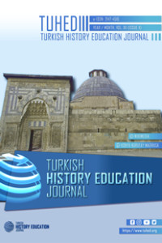 | Turkish History Education Journal  www.tuhed.org

Ethical Declaration and Copyright Transfer Form

Manuscript Title
As the Choose an item of this manuscript Choose an item declare that;

Ethics approval:
Choose an item.

Copyright:
Choose an item

Conflict of interest:
Choose an item.

Copyright Transfer:
If the article is accepted for publication, all financial rights, including processing, reproduction, representation, printing, publication and distribution rights, belong to the Turkish History Education Journal (TUHED). However, the author(s) reserve all proprietary rights other than copyright, such as patent rights, reprint as a book or book chapter rights, and non-commercial reproduction rights.
Author (s)
 | Name |  | Institution | Signature
1
2
3
4
Corresponding Author
Name
Institution
E-mail:
Phone:

Appendix:
Choose an item.

Choose an item.

