Bibliometric investigation of academic studies on
“tax compliance” published between 1983-2021
Ahmet Tekinª
Özlem Sökmen Gürçam^{b}
ª Associate Professor, Eskişehir Osmangazi University, Faculty of Economics and Administrative Sciences, Eskişehir, TÜRKİYE.
^{b} Associate Professor, Iğdır University, Faculty of Economics and Administrative Sciences, Iğdır, TÜRKİYE.

ABSTRACT
Tax Compliance refers to the timely and lawful fulfillment of tax obligations by taxpayers to ensure full tax payment. Understanding the factors influencing taxpayers' decisions to comply with tax laws is a central topic in the literature. This article presents a bibliometric analysis of academic research on Tax Compliance, covering studies published between 1983 and 2021 and indexed in the Web of Science (WoS) database. The analysis aims to provide insights and guidance for future research in this area. A total of 585 studies on Tax Compliance were identified in the WoS database, with the majority being articles primarily written in English. The United States, England, Australia, and Austria emerged as the most productive countries in terms of Tax Compliance publications. Furthermore, a notable trend is the growing number of multidisciplinary studies conducted by authors from diverse countries. To enhance future research endeavors, this study recommends exploring multiple databases and broadening search queries to include additional fields. By doing so, researchers can gain a more comprehensive understanding of Tax Compliance and its various influencing factors. This bibliometric mapping of academic studies on Tax Compliance provides a foundation for advancing knowledge and fostering informed investigations in the domain of taxation and compliance behavior.

ARTICLE HISTORY
Received: 21.06.2023
Revised: 21.07.2023
Accepted: 28.07.2023

KEYWORDS
tax compliance, bibliometric mapping,
bibliometric analysis,
Web of Science,
WoS database

Introduction
Taxation, as a fundamental mechanism for states to collect monetary contributions from individuals and entities, forms the backbone of public finance and government operations (Öner, 2019, p. 23). However, the efficacy of taxation depends greatly on the concept of "Tax Compliance," which refers to the timely and lawful fulfillment of tax obligations by taxpayers. This adherence to tax laws is essential for governments to generate the necessary income to fund public services and meet societal needs (Fauzan et al., 2022, p. 52).
In the realm of taxation, the behavior of taxpayers towards compliance is a complex interplay of voluntary and non-compliant actions. When tax rates increase, taxpayers may react in various ways, ranging from active responses like tax evasion or refusal to passive actions such as delayed tax payments and reduced consumption. Such reactions are closely tied to the relationship between tax policies and taxpayers' economic capabilities, as taxation can impact income, wealth, spending, and saving capacities (Kaynar Bilgin, 2011, p. 260). Consequently, this interplay can significantly influence the level of Tax Compliance among taxpayers.
The present study aims to delve into the international literature on "Tax Compliance" and contribute valuable insights to the national literature. Leveraging the extensive Web of Science (WoS) database, this research sets out to answer key questions through a comprehensive bibliometric analysis:
- What is the temporal distribution of "Tax Compliance" studies over the years?
- Who are the most cited authors in the field of "Tax Compliance," and what are the focal points of their studies?
- Which authors collaborate most frequently on the subject of "Tax Compliance"?
- How do different countries engage in cooperative research on "Tax Compliance"?
- What are the prevalent keywords associated with "Tax Compliance"?
To accomplish these objectives, the data gathered from the WoS database is processed using the VOSviewer software, an open resource developed by Van Eck and Waltman (2010, p. 35), which enables bibliometric mapping. By adhering to these methodological parameters, this study endeavors to serve as a guiding reference for future research in the domain of "tax compliance," enriching the understanding and discourse on this vital aspect of taxation behavior in the literature.

Conceptual framework: Tax compliance
Tax Compliance, defined as “the accurate and timely fulfillment of taxpayers' obligations under tax laws” is a crucial aspect of taxation (James & Allaey, 2004, pp. 29-30). Another perspective of Tax Compliance emphasizes that taxpayers should fully state their tax obligations in declarations, following applicable tax laws, regulations, and judicial decisions, and submit them to the relevant authorities on time (Tuncer, 2015, p. 109). It is also defined as such:
Tax compliance is the acting of taxpayers in accordance with the tax laws and proclamations of the country. It can be appropriate reporting of income or tax base, computing the tax liability in the correct manner, filing of returns and payment of the tax liability on time. Tax compliance can be described as the degree to which a taxpayer compels to tax rules and regulations. On the other hand, non-compliance can be defined as failure of individuals to act according to their tax obligation. (Tilahun, 2019, p. 1)
Managing and improving Tax Compliance has been a matter of concern for public administrations since the inception of taxation, with its modern foundations dating back to the Magna Carta, published in England in 1215 (Yoruldu, 2020, p. 57). The primary objective of Tax Compliance is to efficiently collect taxes (Didinmez, 2018, p. 11).
The basis of the Tax Compliance subject revolves around the fundamental question of "Why do people pay taxes?" This question connects Tax Compliance with the notions of "voluntary compliance" and "voluntary non-compliance."

Voluntary compliance
The study of voluntary tax compliance traces its origins back to the research by Allingham and Sandmo in 1972 (Allingham and Sandmo, 1972, p. 324). Voluntary tax compliance refers to taxpayers willingly adhering to tax laws and rules, and it can be elucidated by two prominent theories: the Theory of Rational Expectations and the Theory of Moral Sentiments (Ştefura, 2012, p. 192; Tekin and Sökmen Gürçam, 2019, p. 69).
- Classical Approach / Rational Expectations Theory: This theory, also known as the "Allingham-Sandmo Model," is considered the oldest theory in voluntary tax compliance. It posits that individuals make decisions and preferences to maximize benefits while minimizing internal costs, which may lead to choices involving minimal or no tax payment. However, the Rational Expectations Theory has faced criticism due to its limited ability to explain the relationship between tax evasion and human instinct, and its isolation of taxpayers from their social-psychological characteristics (Aktan, 2006, p. 126; Kitapci, 2014, p. 3). Additionally, it has been deemed insufficient in explaining the impact of tax penalties on voluntary tax compliance (Tekin et al., 2018, p. 230).
- Social Psychological Approach / Moral Sentiment Theory: Developed after the 1990s, this theory considers individuals as striving to maximize their interests and benefits, with morality playing a significant role in their attitudes and behaviors towards tax payment (Yayla et al., 2009, p. 56). Unlike previous voluntary compliance models, the Moral Sentiment Theory acknowledges the importance of ethical, moral, and social dynamics. For a comprehensive understanding of voluntary compliance, economic, psychological, and sociological approaches need to be integrated, embracing a multidisciplinary perspective (Kitapci, 2014, p. 43).

Voluntary non-compliance
Voluntary non-compliance occurs when taxpayers knowingly declare their incomes inaccurately, either understating or overstating them (Roth et al., 1989, p. 2). This behavior is a synthesis of attitudes and behaviors, such as disobeying the law and engaging in tax avoidance (Kirchler and Wahl, 2010). It encompasses both voluntary and involuntary non-compliance. Voluntary non-compliance involves taxpayers consciously avoiding paying taxes or not paying them at all, while involuntary non-compliance arises from situations where taxpayers unintentionally provide false information, misunderstand tax obligations, or avoid taxes unintentionally (Çetin Gerger, 2011, p. 57).
In cases of voluntary non-compliance, especially when tax rates increase, taxpayers may respond with "active" or "passive" reactions to the tax:
- Active Response: In response to higher tax rates, taxpayers may exhibit active reactions, such as acting against the law and disobeying authority (Taşkın, 2010, p. 77). Active reactions include tax evasion, tax refusal, and even collective rebellion against taxation (Gök, 2007, p. 15; Aktan et al., 2006, p. 164).
- Passive Response: An increase in tax rates may lead to reduced income levels for taxpayers, prompting passive responses. These may include choosing idleness, reducing consumption, paying taxes late, decreasing production, or abstaining from investment (Aktan et al., 2002; Taşkın, 2010, p. 77). Passive reactions enable taxpayers to reflect on the impact of taxes, vocalize their concerns, and engage in legal protests (Gök, 2007, p. 150).
Understanding the dynamics of voluntary non-compliance is vital for shaping effective tax policies and fostering a higher level of voluntary compliance among taxpayers. In this study, we aim to explore the international literature on Tax Compliance, conducting a comprehensive bibliometric analysis of academic research indexed in the Web of Science database from 1983 to 2021. By addressing the questions surrounding Tax Compliance and mapping the research landscape, we strive to provide valuable insights that enrich the understanding of taxpayer behavior and its implications for taxation systems globally.
Our research endeavors to contribute to the advancement of knowledge and facilitate informed investigations in the domain of taxation and compliance behavior, promoting the development of more effective and equitable tax systems to ensure the financial sustainability and welfare of nations and their citizens.

Methodology
The current study, focusing on “Tax Compliance,” aims to evaluate the publications in the Web of Science database between 1983 and 2021, considering author names, publication dates, citation numbers, author collaboration, and the most repeated words. In addition, this study is prominent in revealing the status of the latest “Tax Compliance” studies and guiding future studies. The study was approved by the Iğdır University Ethics Committee with decision number 2022/17 during its meeting on January 23, 2022.

Data collection
In the bibliometric analysis using the keyword “Tax Compliance,” results such as the most cited author, the most productive authors, and the distribution of the keywords were obtained. VOSviewer (version 1.6.16), widely used in recent bibliometric studies, was used to map the results. VOSviewer is a free software tool to create, visualize and explore maps based on network data. In the created visualization map, different colors represent different clusters. Item weights determine tag sizes and item circles. The distance between two items reflects the strength of the relationship between the items. Connection lines represent parameters such as collaboration and togetherness. The stronger the connection between the two elements, the thicker the line used to display the connection, which provides easily interpretable graphical representations (Wang et al., 2022, p. 2; Van Eck & Waltman, 2010, p. 524).

Data set
The data of this study consists of 585 studies covering the years 1983-2021 in the WoS database. WoS started to be used actively in 1997 with the development of internet usage. WoS is a bibliographic database that shows the impact power of scientific journals published in different disciplines, the number of citations of the articles in the database, and also lists the articles of the authors and the bibliography of the articles. WoS provides access to the most relevant and prestigious publications in all research fields by regularly scanning journals and conference proceedings on the sciences, social sciences, arts, and humanities. WoS links all related records using reference information and subject relations in the studies of expert researchers who produce publications in all research fields. With this aspect, WoS has the world's most reliable database for scientific research (Asan, 2017, p. 36; Wang et al., 2022, p. 2). The data of this study was obtained from the resources scanned in the WoS database between 1983-2021. A total of 585 resources were reached by typing "Tax Compliance" in the search section of the WoS database and selecting the "title" from the field tab. All these resources were included in the bibliometric mapping.

Research method
The current study adopted bibliometric mapping as a bibliometric method. In 1922, E. Wyndham Hulme was the first to use the word Bibliometrics as a term for the statistical bibliography. Bibliometrics thematically analyses studies made in different disciplines and then evaluates and interprets the obtained data (Pritchard, 1969, p. 348; Çomaklı Sökmen and Yılmaz, 2021, p. 942).
OECD (2002) defines bibliometrics as a general term for the data obtained from publications. While bibliometric studies aiming to create productivity indicators were first limited to collecting data on the number of scientific articles and other publications classified according to the author, institution, field of science, country, etc., they later developed further with the emergence of multidimensional techniques (OECD, 2002, pp. 203-204).
Bibliometric mapping is a visual representation of a bibliometric network. In this context, a bibliometric map visualizes a series of objects and the relationship between them (Van Eck, 2011, p. 10). The main limitation of this research is the acquisition of data via the Web of Science. Besides, studies on "Tax compliance" were searched only in the titles of the studies.

Findings
Studies between 1983-2021 in the Web of Science database were scanned by typing “Tax Compliance” in the title tab. Table 1 shows the analysis of studies conducted between 1980-2021 by years. The table shows that the first research on this subject in the WoS was in 1983, and 585 studies in total were conducted.
The WoS database contains more than 20 “Tax Compliance” studies in 2007, 2008, and 2009. Although there was a decrease in the number of studies in the following years, the increase in the studies on “Tax Compliance” in recent years is remarkable. This increase shows higher importance on “Tax Compliance” than in previous years.
Table 1. The distribution of studies on "tax compliance" in the WoS database over the years
Year | Number | Year | Number | Year | Number
1983 | 2 | 1997 | 3 | 2010 | 12
1984 | 1 | 1998 | 3 | 2011 | 17
1985 | 5 | 1999 | 3 | 2012 | 20
1986 | 1 | 2000 | 2 | 2013 | 21
1987 | 1 | 2001 | 4 | 2014 | 52
1989 | 2 | 2002 | 3 | 2015 | 29
1990 | 1 | 2003 | 8 | 2016 | 36
1991 | 4 | 2004 | 6 | 2017 | 44
1992 | 2 | 2005 | 12 | 2018 | 33
1993 | 6 | 2006 | 5 | 2019 | 65
1994 | 4 | 2007 | 21 | 2020 | 50
1995 | 5 | 2008 | 23 | 2021 | 55
1996 | 2 | 2009 | 22 | - | -
Source: WoS Database
Table 2 shows the list of authors who have done the most research on "Tax Compliance." Kirchler, E. is the most productive author on Tax compliance subject with 35 publications, followed by Torgler, B with 19.
Table 2. List of the most productive authors on “tax compliance”
Authors | Number of the Publications | Authors | Number of the Publications
Kirchler, E. | 35 | Erard, B. | 8
Torgler, B. | 19 | Bergman, M. | 8
Alm, J. | 11 | D'Attoma, J. | 7
Sigle, Maarten A. | 10 | Alm, Jongshick | 7
Kogler, C. | 8 | Saad, N. | 6
Muehlbacher, S. | 8 | Hofmann, E. | 6
Source: WoS Database

Table 3 shows the publication names, publishers, publication years, and citation numbers of the authors who have worked on "Tax Compliance." The most cited work (939 citations), “Tax Compliance” by Andreoni, J., Erard, B. and Feinstein, J., was published in the Journal of Economic Literature in 1998. The study titled "Tax Compliance" prepared by Andreoni, J., Erard, B. and Feinstein, J. is among the first studies on tax compliance and is an empirical study that also contributes to the literature. His citations prove this.
The second most cited study was “Enforced Versus Voluntary Tax Compliance: The 'Slippery Slope' Framework,” published in the Journal of Economic Psychology in 2008 by Kirchler, E., Hoelzl, E., and Wahl, I. (392 citations).
In this study, a tax compliance framework is proposed in which both the power of tax authorities and trust in tax authorities are relevant dimensions to understand mandatory and voluntary compliance.
In addition, the factors examined in previous research such as penalties, audit possibilities, tax rate, knowledge, attitudes, norms and justice are reviewed and discussed with reference to the dimensions of power and trust.
Table 3. Distribution of authors conducting research on “tax compliance” by citations
Publication Title | Authors | Source | Year | Citations
Tax compliance | Andreoni, J., Erard, B. and Feinstein, J. | Journal of Economic Literature | 1998 | 939
Enforced versus voluntary tax compliance: The "slippery slope" framework | Kirchler, E., Hoelzl, E., Wahl, I. | Journal of Economic Psychology | 2008 | 392
Tax Compliance and Tax Morale: A Theoretical and Empirical Analysis | Torgler, B. | Edward Elgar Publishing Ltd. | 2007 | 327
The behavioralist as tax collector: Using natural field experiments to enhance tax compliance | Hallsworth, M., List, J. A., Metcalfe, R. D., Vlaev, I. | Journal of Public Economics | 2017 | 230
Speaking To Theorists and Searching For Facts: Tax Morale And Tax Compliance In Experiments | Torgler, B | Journal of Economic Surveys | 2002 | 220
Source: WoS Database
Figure 1 shows the network map of the authors most collaborating on “Tax Compliance” The minimum number of documents and citations was assigned one in the VOSviewer software program, which resulted in 774 of 1002 authors meeting the threshold value. In the studies on “Tax Compliance,” the authors who collaborated the most formed 18 clusters. Each cluster is in different colors (red, brown, green, purple, blue, and yellow). The most collaborating author was Kirchler, E., in the brown cluster, and he collaborated with other authors on 18 documents in eight clusters. The second most collaborating author was Torgler, B., with 16 studies.
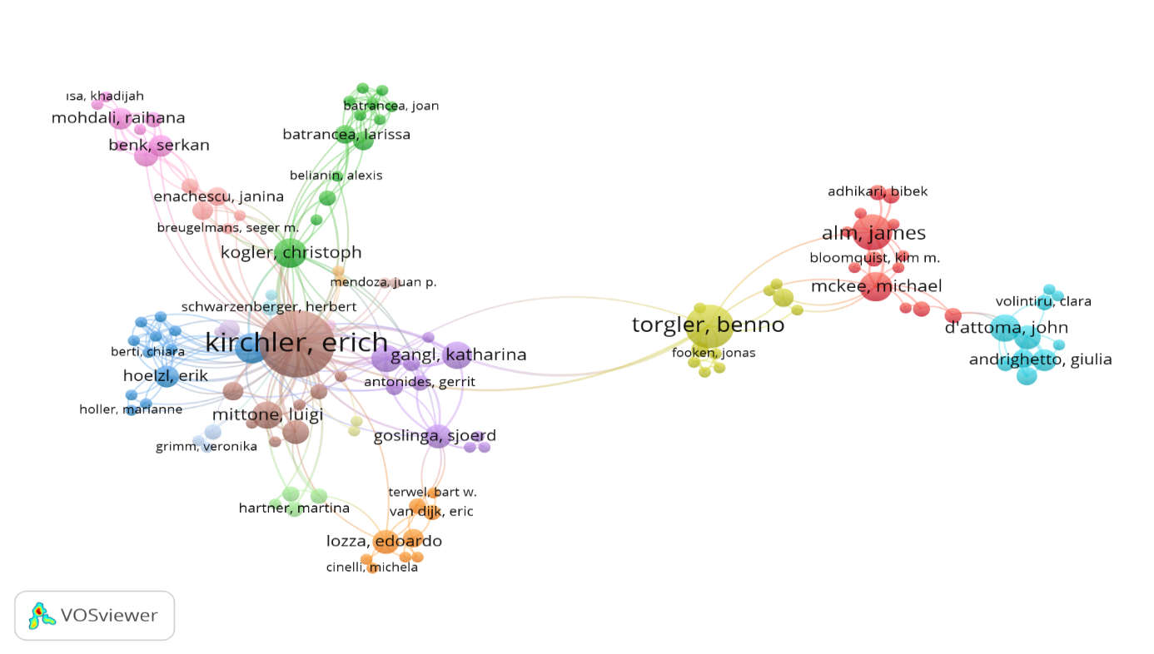Figure 1. Network map of the most collaborating authors in research on “tax compliance”

Figure 2 shows the most cooperative countries in "Tax compliance" studies. The figure shows the cooperating countries in 12 clusters with different colors. On the "Tax compliance" studies, the most cooperative country was the United States of America, with 138 documents. The second most collaborating country was England (53). Turkey has cooperated with Malaysia, Canada, and Austria (18).
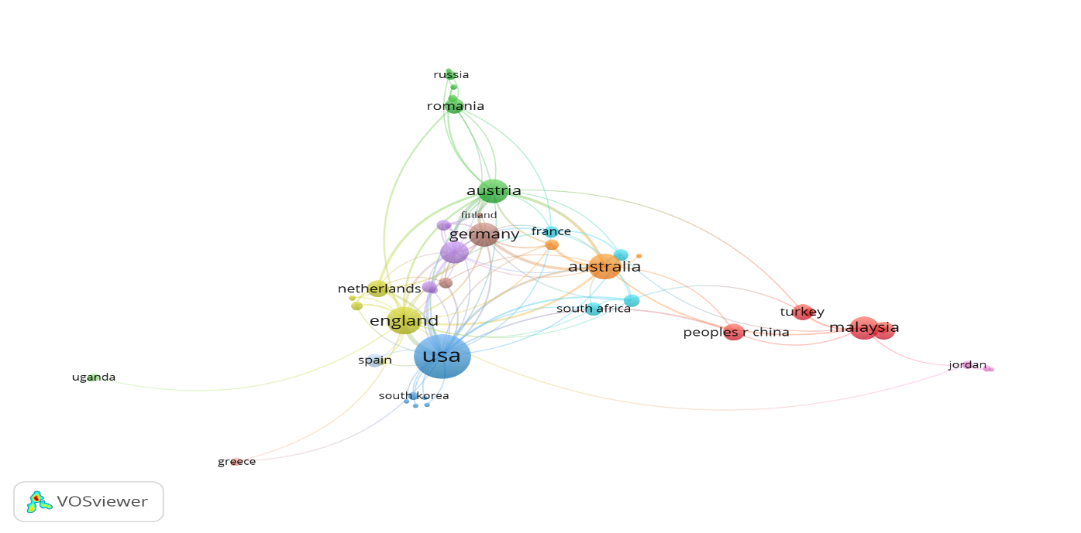

Figure 2. Network map of the most cooperative countries in research on “tax compliance”
The VOSviewer software program determined the most frequently used words in the studies on “Tax Compliance.” Figure 3 presents 11 clusters that contain keywords. The most used keyword in the WoS database was “Tax Compliance” (237) in the purple cluster followed by "Tax evasion" (78) in the green and "Tax morale" (35) in the blue.
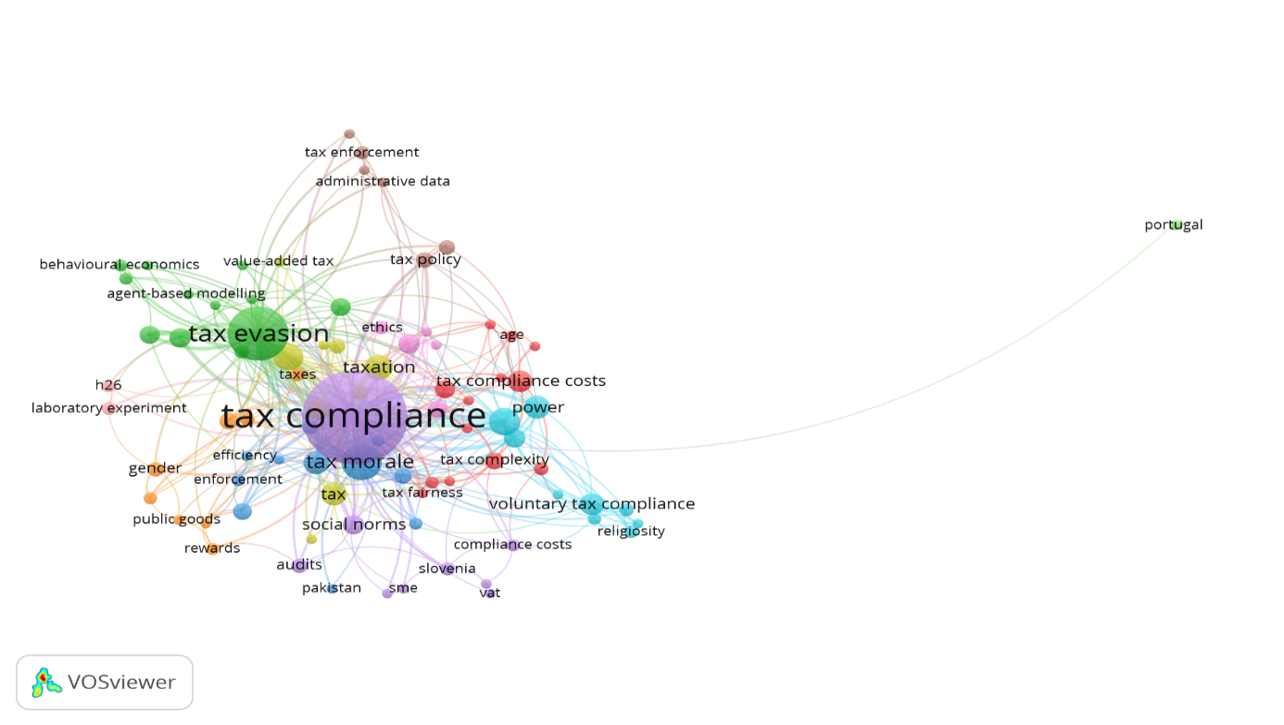

Figure 3. Network map of the keywords in the studies on “tax compliance”

Conclusion and evaluation
In conclusion, this study has made a significant contribution to the understanding of "Tax Compliance" by conducting an in-depth bibliometric analysis of academic research. Through a thorough review of the international literature, the research aimed to analyze earlier studies and provide valuable guidance for future investigations in this crucial area.
One notable finding was the identification of Fauzan et al. (2022)'s pioneering work titled "A Scholarly Examination of Tax Compliance: A Bibliometric Analysis (1960-2021)" as the first study to approach the subject of "Tax Compliance" bibliometrically. Unlike previous research, which focused on the SCOPUS database, this study expanded the scope by utilizing the extensive international WoS database, ensuring a more comprehensive analysis.
The utilization of the bibliometric analysis method, coupled with the VOSviewer software program, proved to be a robust and efficient approach for extracting valuable insights from the vast amount of data available in the WoS database. This enabled the researchers to map the landscape of "Tax Compliance" studies effectively and gain a better understanding of the research trends and patterns over time.
The findings revealed that a total of 585 studies on "Tax Compliance" were published between 1983 and 2021. Among these studies, the work titled "Tax Compliance" authored by Andreoni, J., Erard, B., and Feinstein, J. in 1998 stood out as the most cited, accumulating an impressive 939 citations. This indicates the significant impact of this study on subsequent research in the field.
The analysis also brought attention to key contributors in the field, with Professor Kirchler, E emerging as the most prolific author, having published 35 papers on "Tax Compliance." Moreover, Kirchler, E's collaboration with 18 co-authors emphasized the importance of interdisciplinary approaches in understanding the complex dynamics of tax compliance behavior.
Notably, the United States of America emerged as the most cooperative country in terms of research publications on "Tax Compliance," contributing a substantial number of 138 studies to the international literature.
Additionally, the prevalence of specific keywords, such as "Tax Compliance, Tax Evasion, and Tax Morale," highlighted the focus and key themes within the research landscape.
One crucial observation was the limited representation of Turkish authors and studies in the WoS database. The dearth of Turkish contributions to the international literature on "Tax Compliance" indicates a potential opportunity for further research and collaboration to enhance the global understanding of taxation compliance dynamics.
In conclusion, this comprehensive bibliometric analysis has enriched the existing body of knowledge on "Tax Compliance" and offers valuable directions for future research endeavors in the domain of taxation and compliance behavior. By embracing interdisciplinary collaboration and exploring various databases, researchers can build upon these insights and foster informed investigations that contribute to a more effective and fair tax system worldwide.

Bibliography
Aktan, C. C., Dileyici, D., & Saraç, Ö. (2002). Vergilere karşı tepkilerin anatomisi, vergi, zulüm ve isyan. Phoenix Yayınevi.
Aktan, C. C., Dileyici, D., & Saraç, Ö. (2006). Vergilere karşı tepkiler ve vergilerin ahlaki ve sosyo-psikolojik sınırları. In C. C. Aktan, D. Dileyici, & İ. Y. Vural (Eds.), Vergileme ekonomisi ve vergileme psikolojisi (pp. 159-171). Seçkin Yayıncılık.
Andreoni, J., Erard, B., & Feinstein, J. (1998). Tax compliance. Journal of Economic Literature, 36(2), 818-860.
Çetin Gerger, G. (2011). Mükellef hakları ve vergiye gönüllü uyum. Hukuk Kitapları Dizisi.
Çomaklı Sökmen, Ö., & Yılmaz, M. (2021). Yöneylem araştırması alanında yapılan çalışmaların bibliyometrik analizi. Avrupa Bilim ve Teknoloji Dergisi, Special Issue (28), 940-946.
DOI: 10.31590/ejosat.1012167.
Fauzan, F., Marhaiza, B. I., & Adi, S. J. (2022). A scholarly examination of tax compliance: a bibliometric analysis (1960- 2021). Journal of Indonesian Economy and Business, 37(1), 52-72.
Gök, A. K. (2007). Vergi direncinin gelişimi. Marmara Üniversitesi İİBF Dergisi, 22(1), 143-163.
Hallsworth, M., List, J. A., Metcalfe, R. D., & Vlaev, I. (2017). The behavioralist as tax collector: using natural field experiments to enhance tax compliance. Journal of public economics, 148, 14-31.
DOI: 10.1016/j.jpubeco.2017.02.003.
James, S., & Alley, C. (2004). Tax compliance, self-assessment and tax administration. Journal of Finance and Management in Public Services, 2(2), 27-42.
Kirchler, E., Hoelzl, E., & Wahl, I. (2008). Enforced versus voluntary tax compliance: the “slippery slope” framework. Journal of Economic Psychology, 29(2), 210-225.
DOI: 10.1016/j.joep.2007.05.004.
Kitapcı, İ. (2014). Vergi etiği ve vergi psikolojisi verginin sosyo-psikolojik teorisi. Seçkin Kitabevi.
Manchilot T. Determinants of tax compliance: a systematic review. Economics, 8(1), 1-7.
DOI: 10.11648/j.eco.20190801.11
OECD. (2002). Proposed standard practice for surveys on research and experimental development. OECD Library. https://www.oecd-ilibrary.org/science-and-technology/frascati-manual-2002_9789264199040-en
Öner, E. (2019). Maliye teorisi ve politikası. Nobel Yayıncılık.
Pritchard, A. (1969). Statistical bibliography or bibliometrics. Journal of Documentation, 25(4), 348-349.
Saruç, N. T. (2015). Vergi uyumu: teori ve uygulama. Seçkin Yayıncılık.
Sour, L. (2004). An Economic models of tax compliance with individual morality and conformity. Economia Mexicana, 13(1), 43-61.
Ştefura, G. (2012). A New perspective on individual tax compliance: the role of the income source, audit probability and the chance of being detected. The USV Annals of Economics and Public Administration, 12(16), 192-201.
Taşkın, Y. (2010). Vergi psikolojisi ve vergiye karşı mükellef tepkileri. İstanbul Üniversitesi İktisat Fakültesi Maliye Araştırma Merkezi Konferansları, 54. Seri.
Tekin, A., Tuncer, G., & Sağdıç, E. N. (2013). Vergi afları sonrasında vergi uyum süreci. Sakarya İktisat Dergisi, 2(2), 1-26.
Tekin, A., Doğan, E., & Çelikay, F. (2018). Vergi ahlakı kavramsallaştırılmasına yönelik bir değerlendirme: eskişehir-kütahya örneği. Maliye Dergisi, 175, 228-252.
Tekin, A., & Sökmen Gürçam, Ö. (2019). Davranışsal iktisat ve vergi uyumu arasındaki ilişki üzerine genel bir değerlendirme. Avrasya sosyal ve ekonomi araştırmaları dergisi (asead), 6(5), 65-76.
Torgler, B. (2002). Speaking to theorists and searching for facts: tax morale and tax compliance in experiments. Journal of Economic Surveys, 16(5), 657-683.
DOI: 10.1111/1467-6419.00185.
Torgler, B. (2007). Tax compliance and tax morale: a theoretical and empirical analysis. Edward Elgar Publishing.
Tunçer, M. (2002). Hükümet birey ve ilişkilerinin vergi uyumuna etkisi ve Türkiye. Ankara Üniversitesi SBF Dergisi, 57(3), 107-128.
Van Eck, N. J., & Waltman, L. (2010). Software survey: VOSviewer, a computer program for bibliometric mapping. Scientometrics, 84, 523-538.
DOI: 10.1007/s11192-009-0146-3.
Van Eck, N. J. (2011). Methodological advances in bibliometric mapping of science. Doctoral dissertation. Erasmus Research Institute of Management (ERIM).
Wang, Y., Shan, C., Tian, Y., Pu, C., & Zhu, Z. (2022). Bibliometric Analysis of Global Research on Perinatal Palliative Care. Frontiers in Pediatrics, 9, 1-9.
DOI: 10.3389/fped.2021.827507.
Yoruldu, M. (2020). Vergi uyumu ve vergiye uyum sağlayan mükelleflere tanınan vergi teşvikinin değerlendirilmesi. Al-farabi International Journal on Social Sciences, 5(3), 55-64. DOI: 10.46291/Al-Farabi.050306.

Acknowledgements
This article is an expanded version of the proceeding presented at the Fourteenth SCF International Conference on Economic, Social and Environmental Sustainability in the Post-Covid-19 World, held in Antalya between 13-16 October 2022.

Notes on contributors
Ahmet Tekin is an Associate Professor of Public Finance at Eskisehir Osmangazi University, Faculty of Economics and Administrative Sciences, where he also serves as the Head of the Department of Public Finance. He holds a Ph.D. in Tax Law from Istanbul University and specializes in Tax Law, Public Finance Theory, Tax Criminal Law, Tax Enforcement Law, and Tax Analysis. He has authored over 60 academic works, including 11 books and book chapters, and presented research papers in national and international congresses.
Özlem Sökmen Gürçam is an Associate Professor at Iğdır University, Faculty of Economics and Administrative Sciences, specializing in the Department of Economics. She holds a Ph.D. in Public Finance from Dumlupınar University, with expertise in Taxpayer's Rights, Tax Compliance, and Turkish Tax System. Her research also encompasses areas such as Public Finance, Microeconomics, and Tax Practices in Agriculture, Food Security, and Poverty.

ORCID
Ahmet Tekin https://orcid.org/0000-0003-0520-0434
Özlem Sökmen Gürçam https://orcid.org/0000-0002-2372-7355

Author contributions
The authors contributed equally to the article. The authors’ contributions are as follows: Ahmet Tekin examined and wrote down the literature part of the study. Özlem Sökmen Gürçam also did the bibliometric analysis of the research and the writing of the analyzes.

Disclosure statement
The authors have declared no potential conflicts of interest with respect to the research, authorship, and/or publication of this article. The authors have received no financial support for the research, authorship, and/or publication of this article.

Supplemental material
Supplemental material for this article is available online.

Ethics approval statement
The study was approved by the Iğdır University Ethics Committee with decision number 2022/17 during its meeting on January 23, 2022.

Through a comprehensive analysis of academic works, this research seeks to uncover patterns, trends, and gaps, thereby contributing to the enhancement of tax policies and fostering more effective “Tax Compliance” strategies in the broader context of public finance and governance.

