Title 16 font size Times New Roman left aligned and bold
Full Name^{*1} , Full Name² and Full Name³

¹University, Faculty, Department, City, Country
²University, Faculty, Department, City, Country
³University, Faculty, Department, City, Country
*Corresponding author: ijdshs@gmail.com

Abstract

A concise and concise summary is required (maximum 250 words). The summary should briefly indicate the purpose of the study, the material method, its main results and its major results. The summary is often presented separately from the article, so you need to be able to stand alone. For this reason references should not be used. Times New Roman; 10 pt. Shortly after the summary, provide up to 4-6 keywords avoiding general and plural terms and multiple concepts (eg "and" "). Protected with abbreviations: Strictly used abbreviations may be appropriate. A concise and concise summary is required (maximum 250 words). The summary should briefly indicate the purpose of the study, the material method, its main results and its major results. The summary is often presented separately from the article, so you need to be able to stand alone. For this reason references should not be used. Times New Roman; 10 pt. Shortly after the summary, provide up to 4-6 keywords avoiding general and plural terms and multiple concepts (eg "and" "). Protected with abbreviations: Strictly used abbreviations may be appropriate. A concise and concise summary is required (maximum250 words). The summary should briefly indicate the purpose of the study, the material method, its main results and its major results. The summary is often presented separately from the article, so you need to be able to stand alone. Times New Roman; 10 pt. Shortly after the summary, provide up to 4-6 keywords avoiding general and plural terms and multiple concepts (eg "and" ").

Keywords
Physical Activity, COVID-19, Exercise, Public Health, Active People

INTRODUCTION (TİMES NEW ROMAN 12 FONT SİZE)

Text content should be written in 2 columns with Times New Roman 12 font size. The first line of each paragraph should be written by 1 cm indentation.
Citation in text should be as;
The article should begin with an introduction section, which includes the ideas and the basic objectives and approaches of the article, combining scientific knowledge, evidence-based information and logical discussions in different disciplines. This section should be written considering all readers.

Technical terms, symbols Women are the basic unit of the society and they are pioneers of the nation.

They play significant roles in families as well as in society (Mojumder, 2020). Notwithstanding, the role of women in social, political, economic, religious, and cultural spheres is not recognized and their contribution is not counted as significant (Bayeh, 2016). In India, most of them are confined to family work and they seldom take care of their health and fitness with respect to their daily work (Bandyopadhyay & Das, 2022). In many cases, they have no ample scope to pay attention adequately to their physical fitness. But it is worth
noting that women live longer than men and are more likely than men to experience disabilities at a younger age (Baum et al., 2021). It has also been noticed from various studies that health status declines with aging and women experience a more rapid decline of health issues than men (Crimmins et al., 2019) consequently, they require assistance in their older age.

We only accept manuscripts written in English. Articles between 3,000 and 8,000 words are preferred.
This template explains how to design the manuscript. If the author (s) uses this template file, no settings change will be required since settings such as font and size, line spacing, spaces before paragraphs, indents, etc. are made in styles. If you want to avoid problems when copy and paste texts or with the text format, you can use “Applying styles to the article” section which is at the end of template.

MATERIALS AND METHODS (TİMES NEW ROMAN 12 FONT SİZE)

Text content should be written in 2 columns with Times New Roman 12 size. “Introduction” part should be followed by “Method”, “Results”, “Discussion” and “Conclusion” parts. The article should be saved in MS Office Word as either .doc or docx. Text should be written as A4 size. Text should be written with single line spacing. Page numbers should not be added.
Articles prepared in accordance with the principles of writing and approved by the review board are published.

The Second Level Headings (Times New Roman, First Character Capital, Bold 12 Font Size)
Text content should be written in 2 columns with Times New Roman 12 font size.
The second level headings should be written with left aligned, Times New Roman 12 font size, first character capital, bold and italic. Each paragraph should seperate with one line from former paragraph. You can delete this section and write the article text without disturbing the formatting.
No spaces should be left between paragraphs in the text.
The Second Level Headings (Times New Roman, First Character Capital, Bold 12 Font Size)
Text the second level headings should be written with left aligned, 12 Times New Roman font size, first character capital, bold. Each paragraph should seperate with one line from former paragraph. You can delete this section and write the article text without disturbing the formatting.
No spaces should be left between paragraphs in the text.

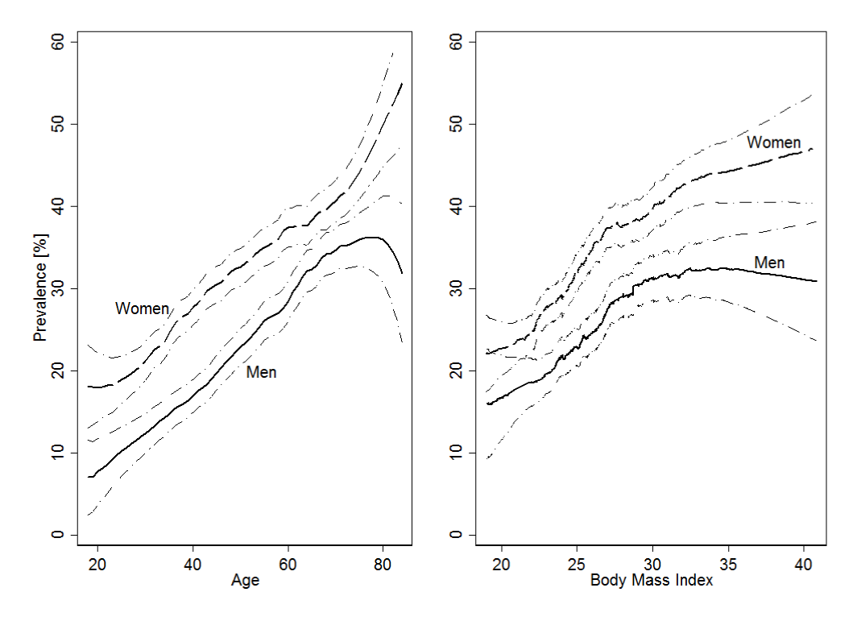
Figure 1. This is the example of figure formatting

Figures should be left and right aligned and numbered. Figure caption should be written 12 font size, Times New Roman, first letter of first word capital. It should not be written as bold or italic. A dot should be placed after the figure number.
Text in the figure should be 9 font size. A line should not be exist between figure and figure caption. A line should exist between text and figure. Figure caption should be located under the figure. Figures should be cited in the text as “Fig. 1”.

RESULTS (TİMES NEW ROMAN 12 FONT SİZE AND BOLD)

References, tables, figures to be used must be prepared in accordance with APA 7. Articles that do not comply with the rules of writing and APA are eliminated in the first stage by the editor. You should review your references and check their compliance with APA 7. Tables must be cited in the text together with the table number as “Table 1”.

Table 1. This is the example of table formatting

İtems | Activity type | Activity intensity
 |  | Light | Moderate | Vigorous
Exercise | Flexibility | 1 | 2 | 4
 | Strength | 2 | 4 | 8
 | Aerobic | 3 | 6 | 12
LTPA | Non-endurance | 1 | 2 | 4
 | Endurance | 2 | 4 | 8
LTPA (leisure time physical activity) 9 Times New Roman font size

Tables should be numbered and the title of the table should be written in 12 pt. Table title should not be bold or italic. The table number should be followed by a dot and the table nameshould be written. No dot should be placed after the table name is written. Please do not use vertical lines in Tables. In-table values / inscriptions should be 10 pt. No spaces should be left between the table title and the table. Tables should be specified in the text with the number of tables. Tables should be used in the text or on the following page. Related notes and references should be indicated at the bottom of the table after “Note:” or “Source:”. The space between the text and the table before and after the table must be 1 row.

DISCUSSION (TIMES NEW ROMAN AND BOLD 12 FONT SIZE)

Citation in text should be as;
Single author
...( Bandyopadhyay, 2020)
Two authors
...( Krantz & Ostergren, 2000)
Three or more authors
...(Demirci et al. 2019)
Two references
...(Toptaş et al. 2018; Demirci, 2021)

More than one references in the same parenthesis should be made with the alphabetical order. Bibliography should be prepared in accordance with the APA 7 Publication Manual publication guidelines. For more information; See https://apastyle.apa.org/style-grammar-guidelines/references/examples
References should be written in alphabetical order, with the title (12pt) and the references in 10-point font. Paragraph indentation should hang 1 cm from the right.
The second and subsequent lines of each bibliography should be indented 1 cm inward as shown in this text. There will be a gap between the sources. Thesis should be written as Master’s Thesis or Doctoral Thesis in the reference list.

ACKNOWLEDMENT

Acknowledgements of support for the project/paper/author are welcome.

REFERENCES

References should be written like this. All of the references should be written in alphabetical order. Please do not use any web-site [URL] as a citation. Do not put an empty line between references.

Journal names should be written in italics in articles.

Abate Daga, F., Panzolini, M., Allois, R., Baseggio, L., & Agostino, S. (2021). Age-Related Differences in Hamstring Flexibility in Prepubertal Soccer Players: An Exploratory Cross-Sectional Study. Frontiers in Psychology,2:12:741756. [PubMed]
Bandyopadhyay, N. (2020). Role of low-cost multi-component exercise programme on aging of Indian women. Theory and Methods of Physical Education and Sports, 04, 62–66. [CrossRef]
Krantz, G., & Ostergren, P. (2000). Common symptoms in middle aged women: Their relation to employment status, psychosocial work conditions and social support in a Swedish setting. Journal of Epidemiology and Community Health, 54(3), 192–199. [PubMed]

When referencing books, the title of the book or chapter should be written in italics.

Diken, H.İ. (2010). Students and Special Education with Special Needs Education, Pegem Yayınevi. ISBN: 1-57083-064-9

Conference

Toptaş, A., Demirci, N. and Bahar, M. (2020). Evaluation of Healthy Lifestyle Behaviors and Knowledge Level of Cardiovascular Risk Factors of Individuals with Chronic Disease 60 Years and Over, p. 566-567, 18th International Sport Sciences Congress, 07-09 November, 2020, Antalya.

Thesis

Eraslan, K. (2020). Investigation of Participation Motivation in Sports Activities of Children with Special Educational Needs. Master’s Thesis, Mersin University, Institute of Science, Mersin, 122p (in Turkish).

Journal writing rules are prepared according to APA 7, valid as of (02.01.2023).
APA 7: https://apastyle.apa.org/style-grammar-guidelines/references/examples

This work is distributed under https://creativecommons.org/licenses/by-sa/4.0/

