Analysis the Effects of Electric Vehicles on Distribution Networks with Simulations Based on Probabilistic Methods
Abstract
As the number of electric vehicles (EV) increases, technical concerns deal with additional load introduced by charging of EVs connected to power distribution networks, are being discussed in the literature. Smart mechanisms such as incentivizing charging of EV’s to periods at minimum loading hours are being considered to mitigate additional loading effect of EVs on power grids. In this study, such effects and smart solutions are investigated through quantitative analyses. For this purpose, impact on EVs are simulated for a set of pilot distribution grids in Turkey. First, reference network models of the pilot regions, which do not include any EV load, are developed for the target year 2030. Then, EV charging points in different technologies (slow and fast charging) are added to reference network models under two main scenarios; home charging support (HCS) and public charging support (PCS). Arrival times of EVs to the charging stations and state-of-charge (SOC) of EVs at arrival time are modelled with a stochastic approach. The effects of EVs on the pilot grids are quantified in terms of annual capacity factor (%) and overloading (%) of the branches (transformers and lines), and voltage drop (%) at the substations.
Keywords: Electric vehicles, distribution networks, stochastic approach, charging stations
- INTRODUCTION
Increasing energy demand and environmental effects have made it mandatory to use alternative energy sources in electricity generation and to prefer high energy efficient electrical devices in consumption. One of the most important sources of environmental problems is the use of fossil fuel vehicles, especially in the transportation sector, increasing greenhouse gases and noise pollution. Therefore, there is a tendency in the transport sector to switch to electric vehicles (EV) instead of vehicles using fossil fuels. These vehicles are basically divided into three in technological point of view; 1) Fully electric vehicles (FEV); 2) Hybrid vehicles (where HV, fossil fuel and electrical energy are used together and cannot be charged externally); and 3) Plug-in hybrid vehicles (PIHV, internal and external rechargeable hybrid vehicles).
The widespread use of both PIHV’s and FEV’s will contribute to the elimination of environmental impacts such as reducing greenhouse gas and noise pollution, as well as reducing dependence on fossil fuels. In addition, in the near future, the use of powerful batteries of new generation electric vehicles as a short-term power source for the grid is also considered an expected application [1-2]. On the other hand, since EV’s will bring additional load to the grid during charging, factors such as the adequacy of the generation resources in the grid and especially the capacity of the electricity distribution grids and power quality should be taken into consideration in parallel with the increase in the number of EV’s [3-4].
Various studies examining the effect of EV’s on the electricity grid are available in the literature. The changes that occurs in the grid equipments are examined as a result of integration of the EV load to the grid with load flow analysis. As a result of the analyzes made in different scenarios, it has been observed that the technical constraints are not exceeded in the equipment [5-6]. The effect of the EV load on the grid losses has also been examined and it has been observed that the EV's have a negative effect on the grid loss, especially in uncontrolled charging situations [7]. EV’s and charging stations contain power electronic equipment. Therefore, EV’s and charging stations have an effect on the power quality on the grid [8-10]. The effect of EV’s on the grid exists not only technically but also socially, economically and humanly [11-13].
There are several studies examining the effect of EV on Turkey's low voltage and medium voltage grid. As a result of the outcomes obtained from these studies, it has been determined that the EV load will cause a small number of constraint violations in grid equipment as a result of the grid integration with the existing grid expansion, and the importance of considering the EV load during grid planning in the coming years has been emphasized in terms of grid management [14-15].
In this study, in projection year 2030, a significant amount of the electricity distribution grid in Turkey to be integrated into the grid of the expected effects of EV were examined. For this purpose, the EV’s on a distribution network with metropolitan characteristics determined as a plot; i) Electrical equipment loading (such as line and transformer) and ii) Its effects in terms of voltage drop in the substations have been investigated by computer simulations.
The most important contribution of this study to the literature is the use of probabilistic techniques while determining the daily charge profile of EV’s and the performance of grid impact analysis in a real electricity distribution grid using these daily charge profiles. In addition, smart charging methods for minimizing the additional load of the EA's load to the network have been examined in two different main scenarios: i) Scenario where home charging is more intense (home charging support); ii) Scenario with more intense charging in public (public charging support).
In 2nd part of the study is about the technology of EV, the general information on Turkey's electricity grid will be given in Chapter 3 as well. In Chapter 4, the previous studies about the effect of EV’s on the grid and the analyzes and results made within the scope of this study are explained. Finally results obtained from the study is concluded in Chapter 5.
- OVERVIEW OF ELECTRIC VEHICLES
The first emergence of electric vehicles in history dates back to the 19th century. In the 19th century, EV was also manufactured and sold together with internal combustion engine vehicles. In the 20th century, the faster development of internal combustion engine technology and the cheaper fossil fuels led to a decrease the concern to EV [16]. In the 2000s, due to the decreasing trend of fossil fuels and increasing environmental pollution, environmentally friendly EV’s have come to the fore again. First, hybrid electric vehicles started to develop and produce [17]. With the development of battery technology, full electric vehicles have become popular and prominent in the market with plug-in hybrid electric vehicles.

  - ELECTRIC VEHICLES TECHOLOGIES
Electric vehicles used today are defined in 3 main types: hybrid electric vehicles (HEV), plug-in hybrid electric vehicles (PIEV) and full electric vehicles (FEV). The differences between the types are determined by the characteristics of the motors that provide motion in general, the batteries and the charging method. Engine structure and battery charging methods according to vehicle types are given in Table 1, and the hardware structure of the vehicles is given in Figure 1.
Table 1. Types of Electric vehicles
EV Technology | Battery Charging Method | Motor Type
FEV | External | Electric
HEV | Internal | Electric + Internal combustion
PIEV | Internal and External | Electric + Internal combustion
HEV's are vehicles that are widely used commercially today. In these vehicles, fossil fuel and electrical energy are used to obtain the desired power. While fossil fuel is used for internal combustion engine supply, the electric motor in the system is also powered by the battery in the vehicle. In these vehicles, the internal combustion engine is activated at high speeds and in situations where high power is required, while the electric motor is active at the moment of take-off and at low speeds, and both engines work as a hybrid. Since the electric machine has the feature of working both as a generator and as a motor, it provides braking on the one hand by gaining energy during braking, and on the other hand acts as a generator to charge the battery. In this way, the batteries are charged during braking. In such vehicles, the batteries cannot be charged externally. Although the electric motor increases the acceleration power of the vehicle, it is activated when the vehicle is in stop-and-go and provides up to 25% fuel savings [18].
PIEV and HEV’s are similar in structure. The difference of such vehicles from HEV's is that the battery in the vehicle can be charged externally. The battery can be charged both with regenerative braking technology while driving and from the electricity grid while parked. In terms of efficiency, PIEV’s are more efficient than HEV’s. Because the limited use of the internal combustion engine and the combined operation of the equipment increase efficiency [19].
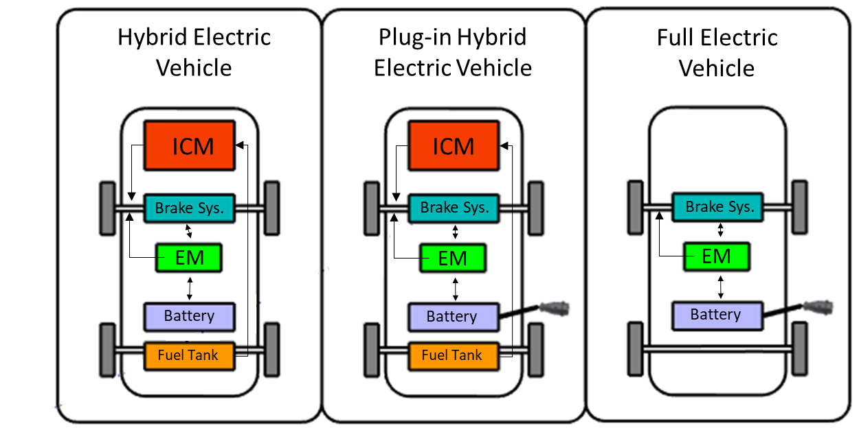
Figure 1. Structure of electric vehicle types
There are no internal combustion engines in FEV’s, the traction power of the vehicle is only provided by electric motors. For this reason, only batteries are used instead of fossil fuel as an energy source. The vehicle provides the power it needs from these batteries. The batteries should be charged at regular intervals, depending on the type of battery in the vehicle, the conditions of use and the range of the vehicle. While the charging process can be carried out with charging stations placed in areas such as homes, workplaces, shopping malls, charging stations for charging EV’s have also started to be developed. FEV’s are the type of electric vehicle with the lowest greenhouse gas emission compared to electric vehicles with internal combustion engines. In addition, it can produce more torque at low speeds than internal combustion engines, since it only has a battery and an electric motor [8]. Today, FEV types and numbers are increasing day by day in the automotive market. With the developing technology, mostly advanced lithium ion batteries are used in batteries today.
  - ELECTRIC VEHICLES CHARGING STATIONS
EV charging stations are structures that enable the charging of EV's that can be charged from external sources. Charging stations take the power from the electricity distribution grid in order to charge the EV's. EV's can receive electric current from charging stations in the form of alternating current (AC) or direct current (DC), depending on their structure.
EV’s that receive electric current as AC have AC-DC rectifier within their body. The electric current passes through the alternating current rectifier and turns into direct current and the battery is charged with direct current. These charging stations are called AC level charging stations. AC level charging stations come in 2 types, Level 1 (AC1) and Level 2 (AC2). The power of Level 1 charging stations is 2-3 kW, while the power of Level 2 charging stations is 20-30 kW. DC charging stations contain AC-DC rectifiers and charge the batteries by converting the alternating current received from the electricity grid into direct current. These stations have a power of 40-100 kW. DC charging stations are used for fast charging and can charge the battery in an average of 30 minutes. AC charging stations are generally used in homes and businesses because they charge more slowly than DC charging stations. DC charging stations are used in public places such as highways and shopping malls [20].
Since the number of EV’s charged from the electricity grid is low today, the effect of these loads on the grid remains limited. However, considering the increase in the number of EV’s in the near future, the effect of these loads on the grid should be taken into account. Grid structure and ports of EV are of great importance as well as the load profile they draw in the analysis of the impact of EV on the grid.
- ELECTRIC NETWORKS AND NETWORK STRUCTURE IN TURKEY
Electricity network is a system that includes production and consumption points with transmission and distribution systems. With this system, the electrical energy generated in generation plants is delivered to consumers. In the first electricity networks, generation facilities were being built in locations close to the consumption point. With the increasing use of electricity in the following time, the need to transmit electrical energy to further distances than production points arise. In addition, as the amount of electrical energy needed increased, the number of production facilities increased. With the increase in both production and consumption facilities, distribution and transmission systems have also expanded [21]. Due to the increase in the number of equipment included in the electricity network day by day, the network becomes more complex and its management is also difficult. For this reason, electricity networks are divided into production, transmission and distribution sections.
The generation system is the system that transfers the electrical energy generated from renewable and non-renewable energy sources to the transmission or distribution system in generation plants. The transmission system provides the transmission of high voltage level electrical energy from production facilities to consumption areas. The distribution network is the system that transmits the electrical energy coming from the transmission level to the end user at medium and low voltage levels.
Electric transmission level in Turkey is structured in 380 kV and 154 kV voltage levels. In the medium voltage level of the electricity distribution network in Turkey, 33 kV voltage are used mostly and 6.3 kV and 15.8 kV voltages are used rarely. Energy distribution for low voltage level customers is carried out at 0.4 kV voltage level. Therefore, electrical energy at medium voltage level is reduced to low voltage level by means of distribution transformers.
The main rule in distribution networks is that the end users are fed technically, economically and ergonomically. For this reason, branched and ring network systems are used in the Turkey’s electricity distribution network. Branched networks are networks where the supply is made from a single source and there is no alternative supply. Ring networks, on the other hand, are networks that have more than one source and therefore have alternative feeds. In branched networks, the installation cost is less and fault detection is easier than ring networks. However, ring networks are more advantageous than branched networks in terms of reliability. In the distribution network of Turkey, the network that feeds the city center and important port is operated as a ring network load. Networks that feed rural networks and points with low load are generally operated as branched networks.
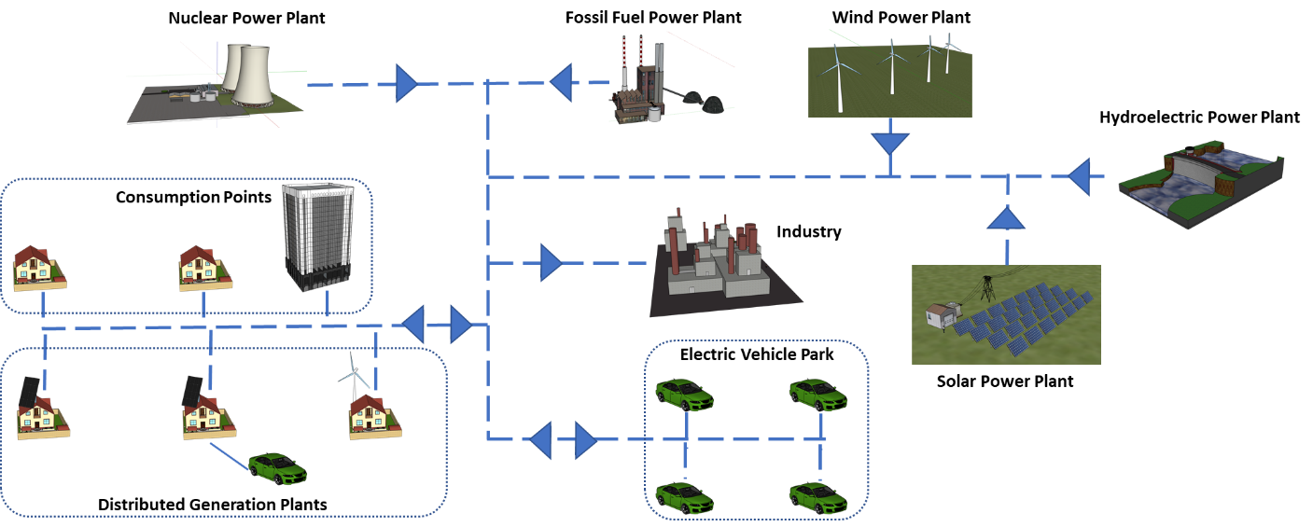
Figure 2. Example of bidirectional electric grid
Electric vehicle charging stations are connected to the distribution network from many different points, and as the number of charging stations increases, the number of different points connected will also increase. The electric vehicle load that can be integrated into the network can be estimated with the help of probabilistic functions according to the characteristics of the vehicles and their usage conditions. However, due to the ability of electric vehicles to use different charging stations, the point at which they will be integrated into the grid shows flexibility. This increases the need to examine the impact of electric vehicles, which can be manufacturers and consumers, on the Turkey electricity distribution network.
- EFFECTS OF ELECTRIC VEHICLES ON DISTRIBUTION NETWORK
As part of this study, the technical impact of electric vehicles on the distribution network in 2030 was examined in the region fed by the Akköprü substation in city center Ankara in Turkey. According to the projection, it is expected that by 2030, the population of Turkey will be 93 million and the number of personal vehicles will be 27.9 million [15]. Considering the policy of the government of the Republic of Turkey, the domestic electric vehicle is expected to go on sale in 2023. Therefore, the increase in the rate of electric vehicles in traffic will accelerate by 2023. Considering these developments, in this study, it has been assumed that the ratio of electric vehicles in all vehicles in 2030 will be 30% in the medium growth scenario and 65% in the high growth scenario.
The pilot region network model is modeled on DIgSILENT PowerFactory power system analysis software. In the network model, the power profiles taken from the field are processed on the feeders. Peak days were determined as a result of the analyzes made with the processed profiles and the analyzes were carried out on the determined day. The analyzed area is fed from two different HV/MV power transformers from the same transformer center. As of 2019, the number of MV/LV distribution transformers available in the pilot area is 599, the MV line length is 340 km and the LV line length is 1405 km. From 2019 to 2030, it has been assumed that the annual load increase will be an average of 5% [22]. Necessary network investments were added to the network model to prevent technical constraints in the network after load increase.
Criteria considered for technical constraints: i) overloading on network lines; ii) overvoltage drop at the consumer points and iii) N-1 reliability criteria in the primary distribution network in the plot regions. Parallel line and transformer investments are modeled on existing lines and transformers where these criteria cannot be met. In 2030, it is predicted that there will be 665 MV/LV distribution transformers, 352 km MV line and 1464 km LV line with the method explained in the plot network.
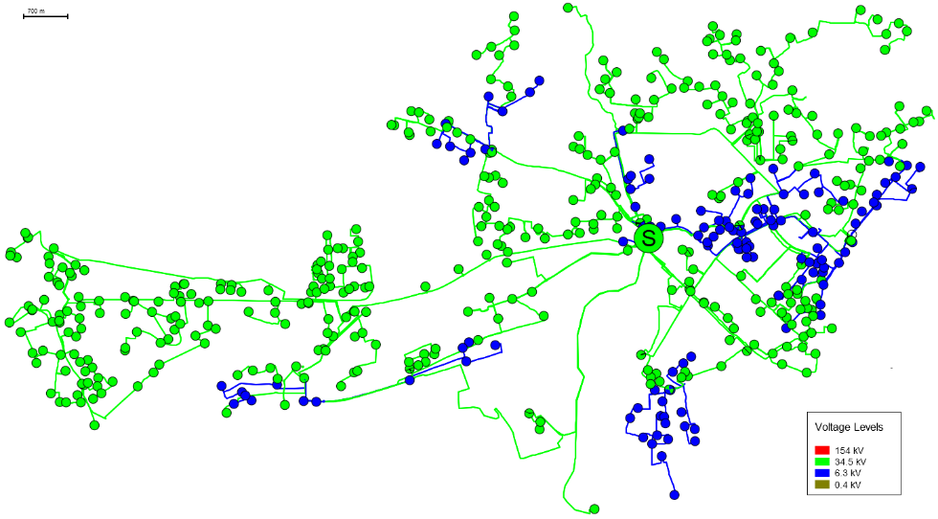
Figure 3. Single line diagram of pilot region
In the study, the margin of the total number of electric vehicles expected falling into the pilot region studied in traffic in Turkey calculated firstly. In this calculation, the following statistical data of the city of Ankara and the plot region are used: i) The ratio of the gross domestic product of the city of Ankara; ii) Growth coefficient; iii) Education level coefficient; iv) The pilot of a high-voltage transformer that feeds the center of Turkey's total installed capacity to a total installed capacity of high-voltage transformer ratio (1) [15]. With this approach, the total number of electric vehicles calculated for the pilot region in 2030, the total number of EV charging stations and different charging technologies are given in Table 2.
${EV}_{PR}={{EV}_{T}* TMK}_{PR}*{GDP}_{A}*{DC}_{A}*{EC}_{A}$ (1)
${EV}_{PR}:$ Pilot region number of electric vehicles
${EV}_{T}$: Total number of electric vehicles (2030)
${TMK}_{PR}$: Ratio of pilot regional substation installed capacity to total substation installed capacity in Turkey (2030)
${GDP}_{A}$: Ratio of the gross domestic product of the city in which the pilot region is located to the total gross domestic product of the country (2014) [23]
${DC}_{A}$: Development coefficient of the city where the pilot region is located [24]
${EC}_{A}$: Coefficient of education level of the city where the pilot region is located [25]
Table 2. Pilot region EV number of charging stations and charging technologies
Charging Status | Home Charging Support | Public Charging Support
AC1 – Home | 683 | 683
AC2 – Home | 1595 | 1595
AC2 – Workplace | 456 | 456
AC2 – Public place | 410 | 820
DC3 – Public place | 46 | 91
Total | 3190 | 3645
  - METHOD
The flow chart of the method followed in the study is given in Figure 4. Analyzes were carried out with DIgSILENT PowerFactory network analysis software. In this context, as can be seen in the flow chart, firstly the network geographic information system (GIS) data of the plot region was transferred to the network analysis software and the 2019 (current) reference network model was created. Then, the 2019 annual loading profiles of the transformers in the plot region were escalated, and the 2030 load profiles were obtained. For this purpose, an average annual demand increase of 5% is projected (excluding EV charging load). While determining the additional network investments needed after this increase in demand, the previous 5 and 10-year demand increase and network investment amounts and 2019 transformer occupancy rates (annual capacity factor) were taken as reference in the plot region. Thus, excessive low or high grid investment modeling is prevented in the 2030 reference grid model without EV charging load. Finally, the EV vehicle charge load was modeled on the 2030 reference grid model in different scenarios and the effects of EV’s on the network were analyzed.
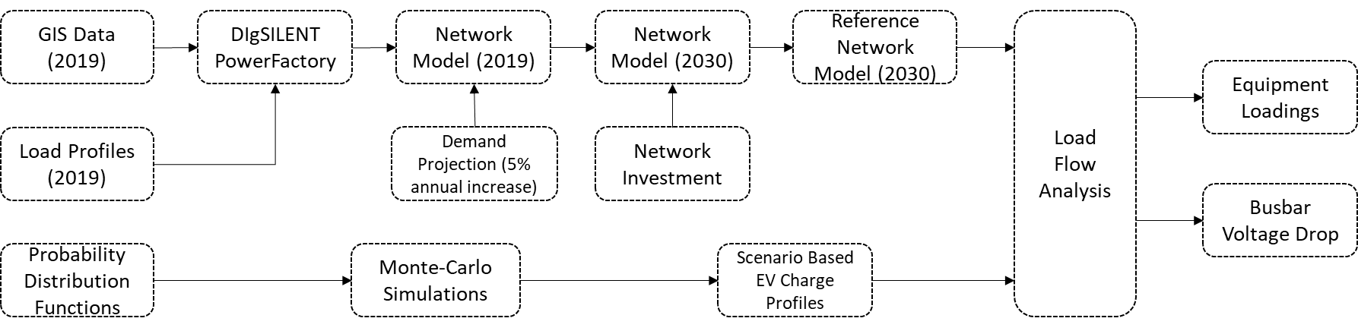
Figure 4. Flow chart of method
Monte-Carlo simulations were used to determine the daily charge profile of electric vehicles [26]. By using the charging times of electric vehicles during the day and their arrival times at charging stations as probabilistic inputs, a possible daily charge profile has been obtained. One million different charge profiles were created by Monte Carlo simulations. Among these, five representative charge profile probability distances have been determined using the scenario reduction approach [27]. One million scenarios are clustered in 5 categories according to their probability values. Later, the most representative electric vehicle charging model was selected in each category. Examples are given in Figure 5 for the probabilistic distribution functions (PDF) of the charge based on AC2 and DC technology and the current state of charge (SOC) modeling of the vehicles in the scenario where charging at home is intense. Charge in public place is modeled as uniform to daytime hours, while charging profile at home is modeled as evening and normal distribution.
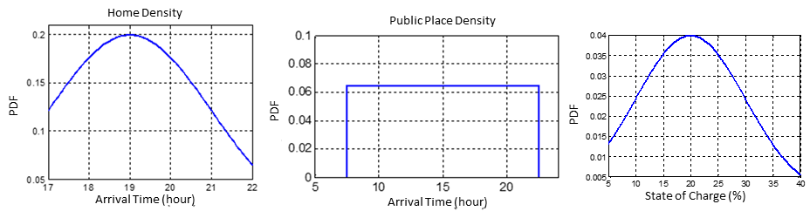
Figure 5. Possible daily EV load estimation method
Electric vehicle loads; connected to the LV networks of distribution transformers for home charging stations, to gas station and shopping center transformers for public place charging stations. The total daily profile projection of the total load, excluding the electric vehicle load for the peak day, in the plot region is given in Figure 6.
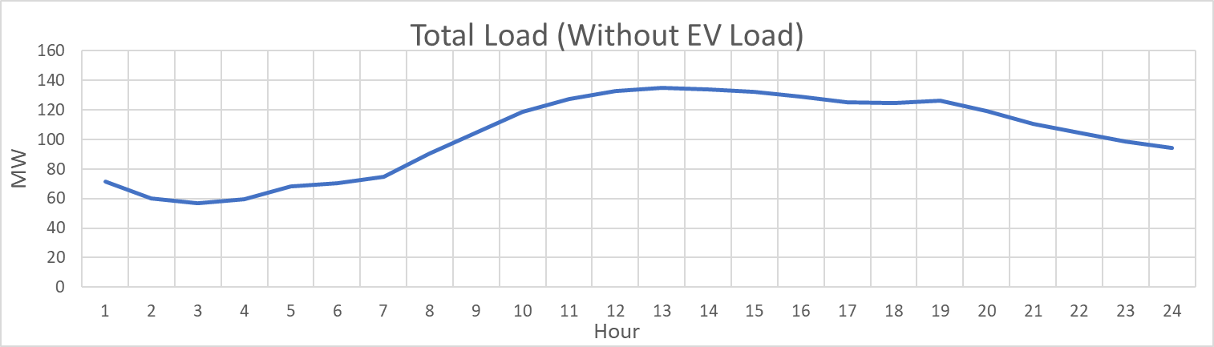
Figure 6. Pilot region total load profile projection excluding EV payload (2030) (MW)
The investigation of the effect of electric vehicle load on the distribution network was carried out in 2 different scenarios. In the scenario where home charging is supported, it is assumed that electric vehicles are mostly charged at homes. In the scenario where public charging is supported, it is assumed that electric vehicles are mostly charged in public places. It is assumed that when charging is supported in public areas, there will be more charging during the day, more fast charging points and regular charge load distribution at workplaces. In case of home charging is supported, it is assumed that there will be more charging at night, more slow charging points and regular charge distribution at workplaces. Along with these assumptions, the representative daily charge profiles of electric vehicles belonging to the scenarios obtained from Monte Carlo simulations using the probability functions in Figure 5 are given in Figure 7. In the simulations, it is assumed that all the electric vehicles given in Table 2 for the pilot area use charging stations during the day.
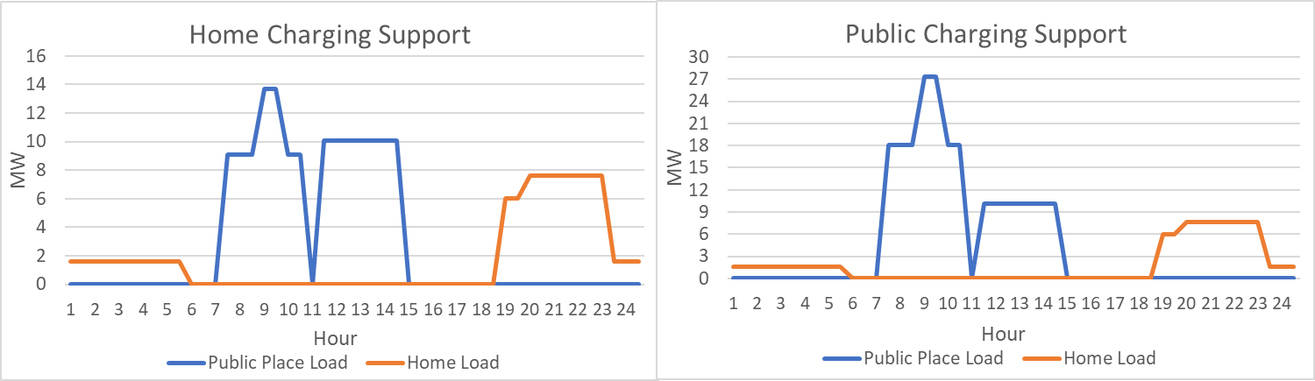
Figure 7. Electric vehicle daily charging profiles for scenarios
Figure 8 shows the ratio of electric vehicle load to other loads in the network. The electric vehicle load rate during the day is 13% in the home charge support scenario and 26% in the public place charge support scenario.
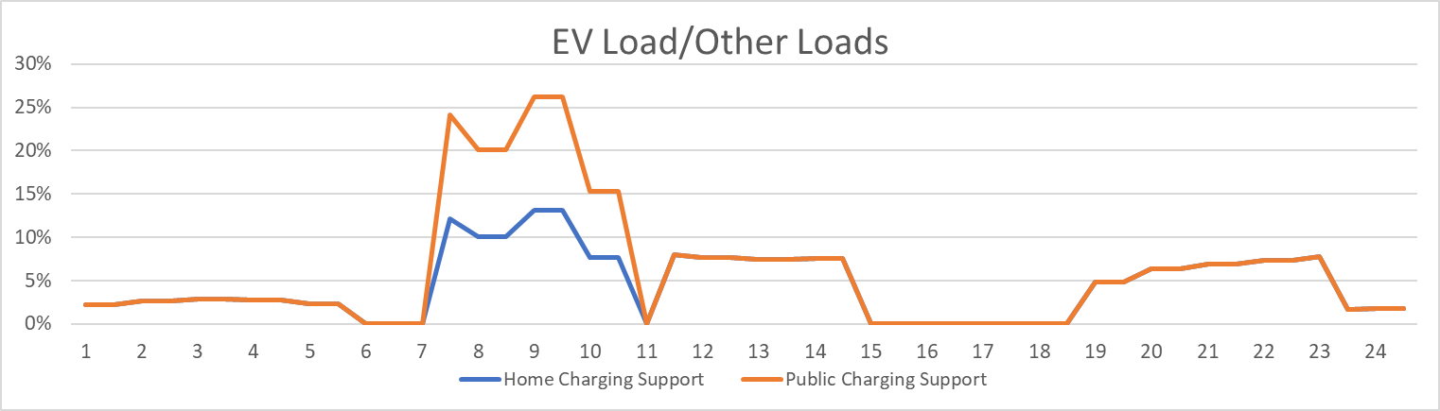
Figure 8. Ratio of EV load to other loads on the network
Load flow analyzes were carried out separately with and without the electric vehicle load on the network. As a result of the load flow analysis, the loading data of the line and transformer equipment and the voltage levels in the substations were examined.
The minimum voltage data of the busbar equipment obtained as a result of the analysis is given in Figure 9, the maximum loading data of the line equipment is given in Figure 10, and the maximum loading data of the transformer equipment is given in Figure 11.
The inclusion of the electric vehicle load in the network from more than one point causes the effect of the load increase to spread to many equipment in the network. In this case, rather than a high effect at a single point, a low effect occurs at many points. As seen in Figure 9, the minimum busbar voltage in the network decreases at most 1% when electric vehicles are included, and this corresponds to the times when the electric vehicle load ratio is the highest.
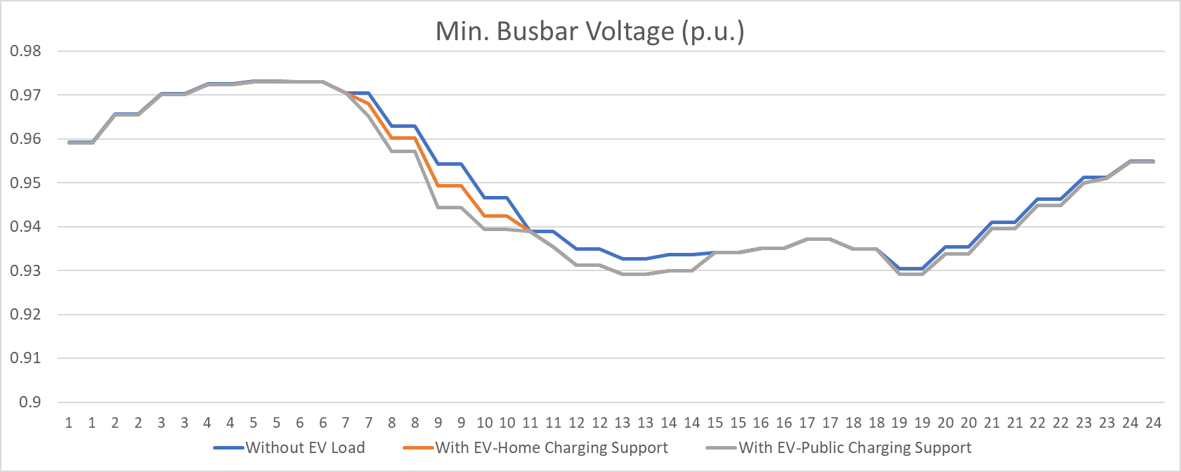
Figure 9. Minimum voltage for busbar equipment
If a load is connected to any point in the network, an increase occurs in the loading of all lines between the load and the source. With the connection of electric vehicle loads at more than one point, an increase occurs in the loading of many lines in the network. As can be seen in Figure 10, with the inclusion of the electric vehicle load into the network, the maximum change in line loads was 7%. Since the line cross section increases as the load point approaches the source, there has not been a high increase in the loading of the primary and secondary lines in the network. It is seen that electric vehicle charging stations are built close to the source of the distribution network to be an advantage for line loading and voltage drop. However, since the locations of home type charging stations are formed according to customer demands, it is not expected that every charging station will be close to the source.
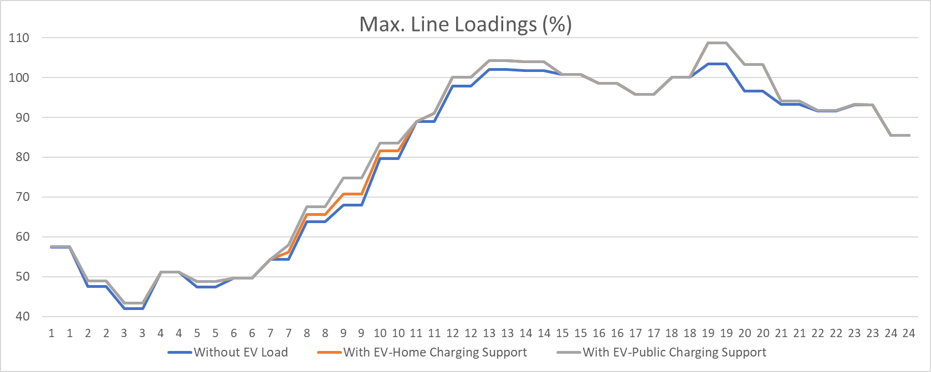
Figure 10. Maximum loading of line equipment
Home charging stations are modeled on the LV grid of distribution transformers. Because of this situation, the effect of electrical vehicle loads on distribution transformers has been more than effects on other equipment. As seen in Figure 11, the maximum change in transformer loads has been observed as 20%. This situation is 20% of the transformer capacity of the electric vehicle load fed from low-capacity distribution transformers. In Turkey, the occupancy rate of distribution transformers installed transformer to the low occupancy increase has brought to the level of 90% at sometimes but not overloaded.
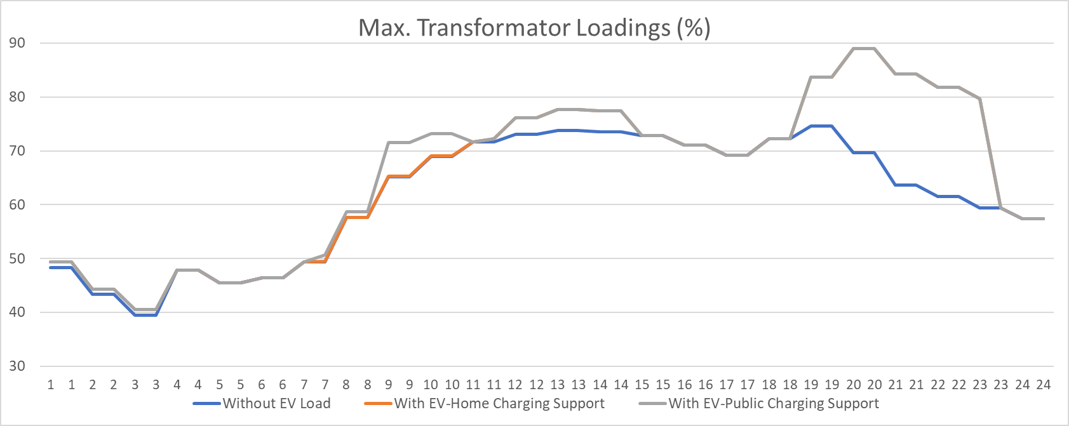
Figure 11. Maximum loading of transformer equipment
In previous similar studies, it was emphasized that electric vehicles will have negative effects on the distribution network because of their integration into the distribution network. It was emphasized that electric vehicles should also be taken into consideration in grid planning in the long term to solve these negative effects [14,28]. As another solution method, it has been suggested that electric vehicle charge-discharge methods should be properly structured and managed reasonably [29-30]. Compared with the results obtained in other studies, but obtained similar results in this study, distribution transformers annual occupancy rate in Turkey (capacity factor) due to the relatively low, Turkey was found to have a significant free capacity for EV charging load of the transformer in the mains. Therefore, it is anticipated that the power levels foreseen in the network capacity increase investments will not be kept at very high values, and network capacity increases at lower power will be made.
- CONCLUSION
In this study, in 2030, a significant number to reach the load charge the expected electric vehicle in Turkey, technical effects to a pilot metropolitan distribution network in Turkey was examined in two different scenarios (high charging at home, and high charge in the public place). The daily charging profiles of electric vehicles in both different scenarios were determined by probabilistic techniques. On the peak demand day, the effects of the electric vehicle charging load on the busbar voltages in the substations and loadings of line and transformer were observed with load flow analysis. As a result of the analysis, it was observed that the additional effect of the electric vehicle load on busbar voltages and line loads was at negligible levels. The most important reason for the electricity distribution network in Turkey distribution transformers annual capacity factor (occupancy rate) is quite low being (according to the difference between peak and minimum load of very high) and is to be filled with intelligent charging method of free capacity (at home charge is usually low load the amount of simultaneous demand is at a predictable level due to the fact that it occurs during night hours and the charging points are limited in the public place.). As a result, between 2018 and 2030, electricity demand increases by an average of 5% (excluding electric vehicles) annually, and if the grid investments required for this load increase are realized in accordance with the demand increase, as in previous years, a negligible level of technical problem is observed in the grid integration of electric vehicles. On the other hand, if the assumptions considered in this study are realized differently, different results may occur. Therefore, the most critical assumptions in this study; the annual demand increase, the network investments required for this demand increase and the occupancy rates of transformers should be followed by the distribution companies.
ACKNOWLEDGMENTS
This study was supported with the project number 9180003 under the program of "TÜBİTAK TEYDEB 1509 - International Industry R&D Projects".
REFERENCES
[1] Habib S., Kamran M., Rashid U., Impact analysis of vehicle-to-grid technology and charging strategies of electric vehicles on distribution networks - A review, Journal of Powers, 277 (2015) 205-214.
[2] Liu C., Chau K.T., Wu D., Gao S., Opportunities and Challenges of Vehicle-to-Home, Vehicle-to-Vehicle, and Vehicle-to-Grid Technologies, Proc. IEEE, 101 No. 11 (2013) 2409–2427.
[3] Salah F., Ilg J.P., Flath C.M., Basse H.,Dinther C.v., Impact of electric vehicles on distribution substations: A Swiss case study, Applied Energy, 137 (2015) 88-96.
[4] Fernandez L.P., Roman T.G.S., Cossent R., Domingo C.M., Frias P., Assessment of the Impact of Plug-in Electric Vehicles on Distribution Networks, IEEE Transactions on Power Systems, 26 No. 1 (2011) 206-213.
[5] Wu Q., Nielsen A.H., Impact Study of Electric Vehicle (EV) Integration on Medium Voltage (MV) Grids, 2011 2nd IEEE PES International Conference and Exhibition on Innovative Smart Grid Technologies, (2011) 1-7.
[6] Mauri G., Valsecchi A., Fast charging stations for electric vehicle: The impact on the MV distribution grids of the Milan metropolitan area, 2012 IEEE International Energy Conference and Exhibition (ENERGYCON),(2012) 1055-1059.
[7] Neagoe-Ştefana A.G., Neagoe A.C., Mandiş A.C., Impact of charging electric vehicles in residential grid on the power losses and voltage plan, 2014 International Symposium on Fundamentals of Electrical Engineering (ISFEE), (2014) 1-4.
[8] Al-Musawi L., Tran R., Dang M., Al-Mutawaly N., The impact of EV/PHEV chargers on residential loads-A case study, 2013 IEEE Transportation Electrification Conference and Expo (ITEC),(2013) 1-4.
[9] Vaisambhayana S., Tripathi A., Study of electric vehicles penetration in Singapore and its potential impact on distribution grid, 2016 Asian Conference on Energy, Power and Transportation Electrification (ACEPT), (2016) 1-5.
[10] Di Paolo M., Analysis of harmonic impact of electric vehicle charging on the electric power grid, based on smart grid regional demonstration project — Los angeles, 2017 IEEE Green Energy and Smart Systems Conference (IGESSC), (2017) 1-5.
[11] Yiyun T., Can L., Lin C., Lin L., Impacts of electric vehicles on power grid, IET Conference Publications, (2012) 1-5.
[12] Rizvi S.A.A., Xin A., Masood A., Iqbal S., Jan M.U., Rehman H., Electric Vehicles and Their Impacts on Integration into Power Grid: A Review, 2018 2nd IEEE Conference on Energy Internet and Energy System Integration (EI2), (2018) 1-6.
[13] Bora Y. (2017). Elektrikli Araç Sistemlerinin İncelenmesi, Yüksek Lisans Tezi, Yıldız Teknik Üniversitesi Fen Bilimleri Enstitüsü, İstanbul.
[14] Temiz A. (2015). Assessment of Impacts of Electric Vehicles on Low Voltage Distribution Networks in Turkey, Middle East Technical University Graduate School of Natural and Applied Sciences, Ankara.
[15] Türkiye Ulaştırma Sektörünün Dönüşümü: Elektrikli Araçların Türkiye Dağıtım Şebekesine Etkileri, SHURA Enerji Dönüşüm Merkezi,(2019).
[16] Elektrikli Araçlar, Dünya Enerji Konseyi Türkiye, Yeni Enerji Teknolojileri Çalışma Grubu,(2018).
[17] Situ L., Electric Vehicle Development: The Past, Present & Future, 3rd International Conference on Power Electronics Systems and Applications,(2009) 1-3.
[18] Polat Ö., Yumak K., Sezgin M.S., Yumurtacı G., Gül Ö., Elektrikli Araç ve Şarj İstasyonlarının Türkiye'deki Güncel Durumu, VI. Enerji Verimliliği, Kalitesi Sempozyumu ve Sergisi - EVK,(2015)
[19] Poullikkas A., Sustainable Options for Electric Vehicle Technologies, Renewable and Sustainable Energy Reviews, 41 (2015) 1277-1287.
[20] Morrow K., Karner D., Francfort J., Plug-in Hybrid Electric Vehicle Charging Infrastructure Review, Final Report Battelle Energy Alliance,(2008).
[21] Bayındır R., Yeşilbudak M., Çetinkaya Ü., Güç Sistemlerinde Gerilim Kararlılığını Etkileyen Faktörler, Gazi University Journal of Science, 3 (2015) 595-602.
[22] Türkiye’nin Enerji Sisteminde Yenilenebilir Kaynakların Artan Payı: İletimde Genişleme ve Esneklik Seçenekleri., SHURA Enerji Dönüşüm Merkezi,(2018).
[23] TÜİK, Türkiye İstatistik Kurumu, (2019), İl bazında gayrisafi yurt içi hasıla, iktisadi faaliyet kollarına göre, cari fiyatlarla, NACE Rev.2, 2004-2017
[24] Dinçer, B., Özaslan, M., 2004. İlçelerin Sosyo-Ekonomik Gelişmişlik Sıralaması Araştırması (2004). Devlet Planlama Teşkilatı, Ankara
[25] TÜİK, Türkiye İstatistik Kurumu, Eğitim İstatistikleri, http://tuik.gov.tr/PreTablo.do?alt_id=1018
[26] Fishman G. S., (1995). Monte Carlo: Concepts, Algorithms, and Applications. New York: Springer.
[27] Dvorkin Y., Wang Y., Pandzic H., Kirschen D., Comparison of Scenario Reduction Techniques for the Stochastic Unit Commitment. IEEE PES General Meeting| Conference & Exposition, (2014) 1-5.
[28] Tekdemir İ.G., Alboyacı B., Güneş D., Şengül M., A Probabilistic Approach for Evaluation of Electric Vehicles' Effects on Distribution Systems, 2017 4th International Conference on Electrical and Electronic Engineering (ICEEE), Ankara, (2017) 143-147
[29] Wang H., Song Q., Zhang L., Wen F., Huang J., Load Characteristics of Electric Vehicles in Charging and Discharging States and Impacts on Distribution Systems, International Conference on Sustainable Power Generation and Supply (SUPERGEN 2012), Hangzhou (2012) 1-7.
[30] Zhou X., Zou L., Ma Y., Gao Z., Research on Impacts of The Electric Vehicles Charging and Discharging on Power Grid, 2017 29th Chinese Control And Decision Conference (CCDC), Chongqing (2017) 1398-1402

