Dergi Anasayfası: ATA Dergisi
Avrasya Turizm Araştırmaları Dergisi
Journal of Eurasia Tourism Research
Journal Homepage: JETouR

Makale Başlığı (Turkish Article Title) (Times New Roman 12-point boldface, initially capitalised, flush left.)

Article Title (Times New Roman 12-point, italic, non-boldface type, initially capitalised, flush left)
Name SURNAME^{1,*}, Name SURNAME¹, Name SURNAME¹, Name SURNAME¹⁴
¹Academic position, Department, Faculty, University, City, Country
²Academic position, Department, Faculty, University, City, Country
³Academic position, Department, Faculty, University, City, Country
⁴Academic position, Department, Faculty, University, City, Country

MAKALE BİLGİSİ |  |  |  |  | ÖZ
Araştırma Makalesi |  |  |  |  | Öz bu bölümde olduğu gibi iki yana yaslı, yazı tipi Times New Roman, yazı tipi boyutu 9 punto ve satır aralığı tek olmalıdır. Özde bulunan kelime sayısı en az 150 en fazla 200 olmalıdır. Bu sınırlara uyulmadığı anlaşıldığı durumda sürece başlanmadan önce belirtilen sınırlara uyulacak hale getirilmesi için çalışma iade edilecektir. Makale Türkçe ya da İngilizce dilinde yazılabilir. Makale hangi dilde yazılırsa yazılsın hem Türkçe (Öz) hem de İngilizce (Abstract) öz bulunmalıdır. Makaledeki kelime sayısı: ilk gönderimde 4000 ile 7000 arasında ve revizyonlar sonrası son halinde ise 4000 ile 8000 arasında olmalıdır (tablolar, şekiller ve kaynaklar dahil).  Note: Those who do not know the Turkish language can request help to write Turkish abstract (ÖZ) for free.
Makale Süreci:
Gönderim |  | :
Düzeltme |  | :
Kabul |  | :
Yayımlanma |  | :
Anahtar Kelimeler:
Anahtar kelime 1
Anahtar kelime 2
Anahtar kelime 3
Anahtar kelime 4
Anahtar kelime 5

 |  |  |  |  | Avrasya Turizm Araştırmaları Dergisi yayıncı Bayram KANCA tarafından CC BY-NC-SA 4.0 ile lisanslanmıştır.
ARTICLE INFO |  |  |  |  | ABSTRACT
Research Article |  |  |  |  | The abstract is to be in fully-justified text as it is here. The abstract is to be Times New Roman font type in 9-point, single-spaced type. Abstract text length should not be longer than 200 words and should not be less than 150 words. This limit includes the body of the abstract only. If your abstract exceeds this limit, you will be prompted to shorten it before being allowed to continue. Manuscripts should be written in Turkish or English. The abstract should be written in both language whether manuscript is written in Turkish or English. Manuscript length: Between 4,000 and 7,000 words for initial submission and between 4,000 and 8,000 words for final paper including all revisions (including tables, figures and references).
Article history:
Received | :
Revised | :
Accepted | :
Available | :
Keywords:
Keyword 1
Keyword 2
Keyword 3
Keyword 4
Keyword 5

 |  |  |  |  | Journal of Eurasia Tourism Research by Bayram KANCA is licensed under CC BY-NC-SA 4.0 .

INTRODUCTION
These guidelines include complete descriptions of the fonts, spacing, and related information for producing your proceedings manuscripts.

FORMATTING YOUR PAPER
Margins are 1,5 cm on the left side, 1,5 cm on the right, 1,5 cm on the top, and 1,5 cm on the bottom.

Author name(s)
Author names are to be left- justified beneath the title and printed in Times New Roman 10-point, non-boldface type.
It should be specified in the "Title Page". The information will be included in the full text of the publication in the pre-print layout. AUTHORS MUST STRICTLY LEAVE THIS SECTION BLANK.

Affiliation(s)
Affiliations are to be left- justified beneath italicised the author names and printed in Times New Roman 9-point, non-boldface type.
It should be specified in the "Title Page". The information will be included in the full text of the publication in the pre-print layout. AUTHORS MUST STRICTLY LEAVE THIS SECTION BLANK.

Corresponding author
Corresponding author should have an asterisk sign (*), after the corresponding author’s name. The Corresponding author (e.g., *Corresponding Author) label should be appeared in the footnote section of the first page of the paper, Times New Roman in style and 8 in font size.
It should be specified in the "Title Page". The information will be included in the full text of the publication in the pre-print layout. AUTHORS MUST STRICTLY LEAVE THIS SECTION BLANK.

Orcid Id
It should be specified in the "Title Page". The information will be included in the full text of the publication in the pre-print layout. AUTHORS MUST STRICTLY LEAVE THIS SECTION BLANK.

Authors’ E-Mail
It should be specified in the "Title Page". The information will be included in the full text of the publication in the pre-print layout. AUTHORS MUST STRICTLY LEAVE THIS SECTION BLANK.

Keyword(s)
Immediately after the abstract, provide a maximum of 5 keywords, using Turkish and American or English spelling (not a mixture of both) and avoiding general and plural terms and multiple concepts (avoid, for example, "and", "of"). Be sparing with abbreviations: only abbreviations firmly established in the field may be eligible. These keywords will be used for indexing purposes.

Table(s)
A table is labelled Table and given a number (e.g., Table 1. Sample datasheet with attributes in linguistic term) it should be numbered consecutively. It should be uniformed fonts and font size, and use 10pt font size and Times New Roman style and aligned centre. The text in tables should be 9pt font size and Times New Roman style. Sources and notes appear below the table, aligned left.
For example:
Table 1. Table label
Taşıma Kapasitesi Türü | Taşıma Kapasitesi Hesaplama Formülü | Formül Açıklaması
Fiziksel Taşıma Kapasitesi (PCC) | S/sp*NV (Hv/tv). | S: Mevcut Alan, sp: Her bir turist tarafından kullanılan alan, NV: Alanın ziyaret edilme sayısı, Hv: Alanın açık olduğu toplam saat, tv: Her bir ziyaretin ortalama süresi.
Gerçek Taşıma Kapasitesi (RCC) | PCC (fiziksel taşıma kapasitesi) *Fcx (1)  Fcx= 1-Mlx/Mtx (2) | Fcx: Korelasyon Faktörleri (erişilebilen alanlar, geçici olarak ziyaretçiye kapalı alanlar, su seviyesi nedeniyle girilemeyen alanlar, aşınma alanları), Mlx: değişkenin sınırlayıcı büyüklüğü, Mtx: değişkenin toplam büyüklüğü
Source: (Dalar, 2018:12)

Figure(s)
Photos, graphs, charts, or diagram should be labelled Figure (do not abbreviate) and assigned a number consecutively. The label and title should be in line with the figure number (e.g., Figure 1. Location error rate of three schemes), it should be uniformed fonts and font size; use 10pt font size and Times New Roman style and aligned centre. The text (if any) in figures should be 9pt font size and Times New Roman style. Source (if any) appear underneath, flush left. Figures should be good enough quality.
For example:
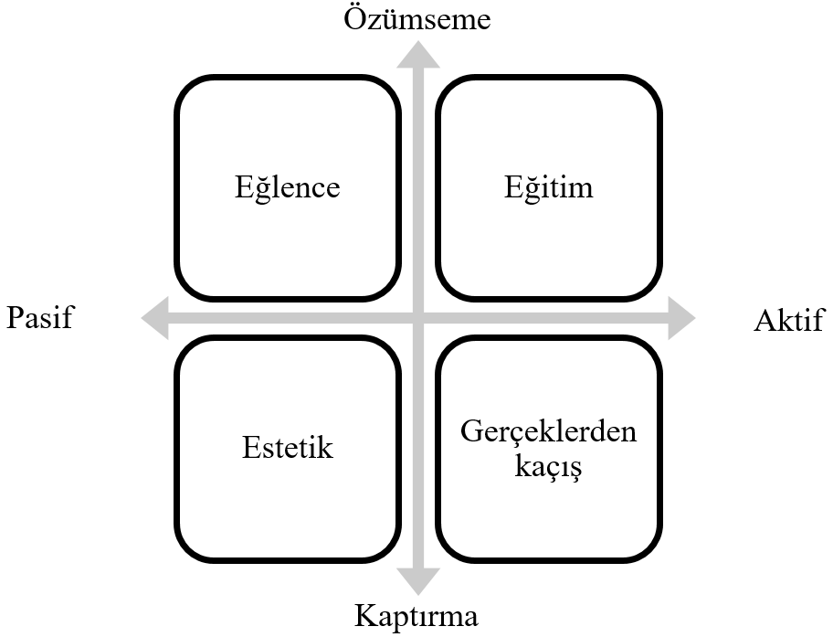
Figure 1. Deneyim Ekonomisinin 4E’si (Hwang & Lyu, 2015: 249)

Equation(s)
Including symbols and equations in the text, the variable name and style must be consistent with those in the equations. Equations should be indented at the left margin and numbered at the right margin, equation number is enclosed with open and close parenthesis () Time New Roman in style and 11pt font size. Deﬁne all symbols the ﬁrst time they are used. All equation symbols must be defined in a clear and understandable way.
For example:
(1)

FIRST-ORDER HEADINGS
For example, “1. INTRODUCTION”, should be Times New Roman 11-point boldface, full capitalised, flush left, with 6 nk blank before, and 6 nk blank after.

Second-order Headings (Sub-heading)
As in this heading, they should be Times New Roman 11-point boldface, initially capitalised, flush left, with 6 nk blank before, and 6 nk blank after.

Third-order headings
Third-order headings, as in this paragraph, are discouraged. However, if you must use them, use 11-point Times New Roman, boldface, initially capitalised, flush left, and proceeded by 6 nk blank line, followed by a colon and your text on the same line.

FOOTNOTES
Use footnotes sparingly (or not at all) and place them at the bottom of the column of the page on which they are referenced to. Use Times New Roman 8-point type, single-spaced.

ACKNOWLEDGEMENTS
It should be specified in the "Acknowledgements Form". The information will be included in the full text of the publication in the pre-print layout. IF AUTHORS HAVE ANY DECLARATION IN HERE, THEY MUST STRICTLY LEAVE THIS SECTION BLANK.
These should be brief and placed at the end of the text before the conflicts of interest as given below. List funding sources in this standard way to facilitate compliance to funder's requirements:
Funding: This work was supported by Turkish Science and Technological Researches Foundation with Award Number: XXXXXXXXX; Turkish Science and Technological Researches Foundation with Award Number: XXXXXXXXX; and Turkish Science and Technological Researches Foundation with Award Number: XXXXXXXXX.
If no funding has been provided for the research, please include the following sentence:
This research did not receive any specific grant from funding agencies in the public, commercial, or not-for-profit sectors.

CONFLICTS OF INTEREST
It should be specified in the "Conflicts of Interest Form". The information will be included in the full text of the publication in the pre-print layout. IF AUTHORS HAVE ANY DECLARATION IN HERE, THEY MUST STRICTLY LEAVE THIS SECTION BLANK.
These should be brief and placed at the end of the text before the authors’ contributions as given below.
The authors certify that they have NO affiliations with or involvement in any organization or entity with any financial interest (such as honoraria; educational grants; participation in speakers’ bureaus; membership, employment, consultancies, stock ownership, or other equity interest; and expert testimony or patent-licensing arrangements), or non-financial interest (such as personal or professional relationships, affiliations, knowledge or beliefs) in the subject matter or materials discussed in this manuscript.
The authors have actual, potential or perceived conflict of interest with Turkey Scientific and Technological Research Foundation relates to: ..........................

AUTHORS’ CONTRIBUTIONS
It should be specified in the "Authorship Contributions Form". The information will be included in the full text of the publication in the pre-print layout. IF AUTHORS HAVE ANY DECLARATION IN HERE, THEY MUST STRICTLY LEAVE THIS SECTION BLANK.
The roles of all authors should be listed and placed at the end of the text before the ethical statement using the authors’ contributions as given below.
F.L.: Conceptualization, Methodology, Data curation, Writing- Original draft preparation.; F.L.: Visualization, Investigation. F.L.: Supervision, Software, Validation.; F.L.: Writing- Reviewing and Editing.

ETHICAL STATEMENT
These should be brief and placed at the end of the text before the references as given below. IF AUTHORS HAVE ANY DECLARATION IN HERE, THEY MUST STRICTLY LEAVE THIS SECTION BLANK.
This work was approved as ethically by Social Sciences Ethical Committees of Giresun University with Number: XXXXXXXXX on 31 December 2020.
Ethics Committee approval is not required for this study in accordance with the Ethical Principles and Publication Policy of the Journal of Eurasia Tourism Research (JETouR).

REFERENCES
List all bibliographical references that have an important contribution on the paper in alphabetical order (from A to Z). 9-point Times New Roman, fully-justified, 6 nk spaced, 1cm lower left indent at the end of your paper.
Journal of Eurasia Tourism Research follows the referencing style of the American Psychological Association (APA). For full guidelines please consult the Publication Manual of the APA (Seventh Edition). Journal of Eurasia Tourism Research has its reference template available in one of the most popular reference management software products. This includes all products that support Citation Style Language styles, such as Mendeley. Using the word processor plug-ins from these products, authors only need to select the appropriate journal template when preparing their article, after which citations and bibliographies will be automatically formatted in the journal's style. If you can't find available template for this journal, please follow the format of the sample references and citations as shown in this Guide.
Users of Mendeley Desktop can easily install the reference style for this journal by going to “View” menu, then “Citation Styles” and “More Styles…”, then clicking the “Get More Styles” tab and pasting the following URL into the “Download Style” text box.
https://csl.mendeley.com/styles/459755961/JETouR
When preparing your manuscript, you will then be able to select this style using the Mendeley plug-ins for Microsoft Word or LibreOffice.

