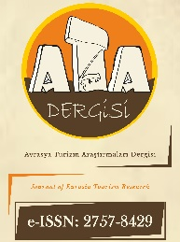

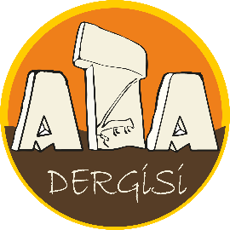
https://dergipark.org.tr/tr/pub/atadergi
Avrasya Turizm Araştırmaları Dergisi
Journal of Eurasia Tourism Research
https://dergipark.org.tr/en/pub/atadergi
CONFLICT OF INTEREST FORM

Article Title: Times New Roman 10-point, non-boldface type, initially capitalised, flush left
The authors whose names are listed immediately below certify that they have NO affiliations with or involvement in any
organization or entity with any financial interest (such as honoraria; educational grants; participation in speakers’ bureaus;
membership, employment, consultancies, stock ownership, or other equity interest; and expert testimony or patent-licensing
arrangements), or non-financial interest (such as personal or professional relationships, affiliations, knowledge or beliefs) in
the subject matter or materials discussed in this manuscript.

Author(s): Times New Roman 10-point, non-boldface type, initially capitalised, flush left

The authors whose names are listed immediately below report the following details of affiliation or involvement in an
organization or entity with a financial or non-financial interest in the subject matter or materials discussed in this manuscript.

Author(s): Times New Roman 10-point, non-boldface type, initially capitalised, flush left

Conflict of interest details:
…………………………………………………………………………………………………………...………………………… ……………………………………………………………………………………………..................................…….………….…………………………………………………………………………………………………………………………………………

Author(s)’ Name SURNAME: ORCID ID: Date: Signature:
Note: This document must be signed by all authors. However, if the authors are in different organizations, the forms can be signed separately provided that the author's name and article title are written. Delete this part before signing.

