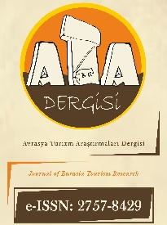

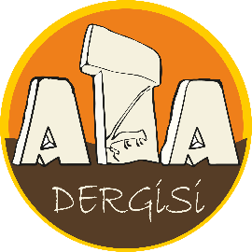
https://dergipark.org.tr/tr/pub/atadergi
Avrasya Turizm Araştırmaları Dergisi
Journal of Eurasia Tourism Research
https://dergipark.org.tr/en/pub/atadergi
COPYRIGHT FORM

As the author(s) of the article I/We have submitted;
- The submitted article is the original study of the author(s);
- All authors have seen the final version of the submitted article and approved the results;
- All authors have individually participated in this study and all responsibility for this study belongs to me/us;
- The information about all authors has been entered correctly in TÜBİTAK ULAKBİM DergiPark System;
- The article is not published elsewhere or presented for printing;
- That the text, figures, images and documents contained in the article do not violate the copyrights of other persons, institutions or organizations;
- I/We have waived all kinds of public transmission rights, including processing, reproduction, representation, printing, publication, distribution and transmission via the Internet, for unlimited use by the Journal of Eurasia Tourism Research;
- As Author(s), I/We undertake that “Journal of Eurasia Tourism Research and Journal Editors” have no responsibility for claims or lawsuits to be filed by third parties due to copyright infringement, and that all responsibility belongs to me/us as the author(s). In addition, I/We undertake that there are no criminal elements or statements against the law in the article, that I/We did not use any illegal methods while conducting the research, that I/We received all legal permissions regarding the study and that I/We followed the in accordance with ethical rules.
Nevertheless, intellectual property rights of the author(s) or if there the author(s)' employer what are reserved as;
- Patent rights;
- The authors' right to use the entire article in their future books or other studies free of charge;
- The right to reproduce the article for their own purposes, provided that they do not sell.
The use of any part of the article in another publication is permitted provided that Journal of Eurasia Tourism Research is specified as the publisher organization and that the journal is cited. While citing, author(s) 'Name, Surname, Article Name, Journal Name, Volume Number, Issue Number and Year information should be specified. However, Journal of Eurasia Tourism Research is licensed under Attribution-NonCommercial-ShareAlike 4.0 International (CC BY-NC-SA 4.0) . I/We accept and declare that specified in the relevant license terms; provide appropriate reference, link to the license and provide information if changes have been made; that the licensee does not show their approval of you and your use, even if these are properly implemented; that the publication cannot be used for commercial purposes; it can be distributed with the same license as the original license.

Article Title: Times New Roman 10-point, non-boldface type, initially capitalised, flush left

Name SURNAME: ORCID ID: Date: Signature:
Note: This document must be signed by all authors. However, if the authors are in different organizations, the forms can be signed separately provided that the author's name and article title are written. Delete this part before signing.

