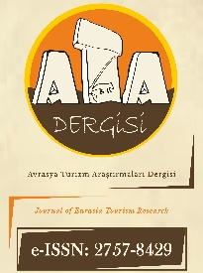

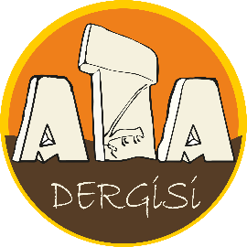
https://dergipark.org.tr/tr/pub/atadergi
Avrasya Turizm Araştırmaları Dergisi
Journal of Eurasia Tourism Research
https://dergipark.org.tr/en/pub/atadergi
ETHICS DECLARATION FORM

Article Title: Times New Roman 10-point, non-boldface type, initially capitalised, flush left

In accordance with the Ethical Principles and Publication Policy of the Journal of Eurasian Tourism Research (JETouR), "Ethics Committee Approval" is required for all kinds of research conducted with qualitative or quantitative approaches that require data collection from participants using questionnaire, interview, focus group study, observation, experiment, interview techniques; the use of humans and animals (including material / data) for experimental or other scientific purposes; clinical studies on humans; researches on animals; retrospective studies in accordance with the law on protection of personal data.
I/We accept and declare that the manuscript that above information is not included in this scope, that's why it does not require any “Ethics Committee Permission”; it is an original work; compliance with scientific ethical principles and rules is observed in all stages of preparation, data collection, analysis and presentation of information; all data and information not obtained within the scope of the study are cited and that these sources are included in the references; accepts that no changes have been made to the data used, that all ethical terms and conditions specified in RESPECT's EU Code of Ethics for Socio-Economic Research, Committee on Publication Ethics (COPE) and Higher Education Institutions Scientific Research and Publication Ethics Directive are accepted all ethical duties and responsibilities are complied.
At any time, in the event that a situation contrary to this statement regarding the study is detected, I/We accept and declare that I/We agree for all ethic and legal consequences that may arise.

Name SURNAME: ORCID ID: Date: Signature:
Note: This document must be signed by all authors. However, if the authors are in different organizations, the forms can be signed separately provided that the author's name and article title are written. Delete this part before signing.

