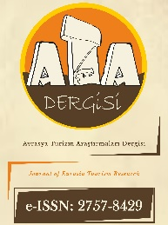

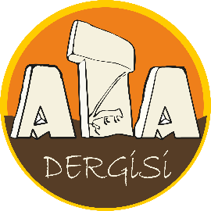
https://dergipark.org.tr/tr/pub/atadergi
Avrasya Turizm Araştırmaları Dergisi
Journal of Eurasia Tourism Research
https://dergipark.org.tr/en/pub/atadergi
MANUSCRIPT WITHDRAWAL LETTER

Article Title: Times New Roman 10-point, non-boldface type, initially capitalised, flush left
I/We would like to make a withdrawal request for my/our manuscript that titled above and is in the evaluation phase, with the following reason(s).

Conflict of interest details:
…………………………………………………………………………………………………………...………………………… ……………………………………………………………………………………………..................................…….………….…………………………………………………………………………………………………………………………………………

I/We accept and declare that I/We will not send my/our manuscript to another journal for evaluation, unless the request for withdrawal is approved by the Editorial Board of the Journal of Eurasia Tourism Research.

Author(s)’ Name SURNAME: ORCID ID: Date: Signature:
Note: This document must be signed by all authors. However, if the authors are in different organizations, the forms can be signed separately provided that the author's name and article title are written. Delete this part before signing.

