Article Type

**Title of article**

*Title of article in Turkish (if possible)*

First Authora,*, Second Authorb,**, Third Authorb,***

*a Affiliation, City, COUNTRY*

*b Affiliation, City, COUNTRY*

Received: 1 September 2021 * Accepted: 1 December 2021

**ABSTRACT**

This document serves as your template to create your paper. It should be written as justified text. The abstract should not exceed 175 words. The authors are strongly encouraged to give background, objective, methods and results briefly. No reference should be inserted in abstract. The abstract should be written in Arial 10 font.

**Keywords:** Word1, Word2, Word3, Word4, Word5

**Introduction**

This template has been prepared in such a way that the authors can create their articles by directly typing the text, charts and figures. Article length should not exceed 14 pages. Text area on Microsoft Word page should be set to A4 paper size (21.0 x 29.7 cm); top margin 2.5 cm, bottom margin 2.5 cm, left margin 2.5 cm, right margin 2.5 cm. Manuscripts should be written in Microsoft Word with Arial 10 font. Arial 12 fonts should be used only in the title and author names of manuscript. Bold texts should not be used except headings. The entire document should be single-spaced and 6 pt spacing will be left after paragraphs. The main text of the manuscript should be written as one column. The text should be fully justified. All pages, including the front page, must be numbered.

**1. Main heading**

All headings should be written in bold and lowercase, with the characters beginning with the leftmost of the text area. Headings of each section should be numbered according to the numerical system, such as 1., 2., etc.

1.1. Subheadings

Subheadings should be written in lowercase, beginning from the left most of the text area. They also should be numbered according to numerical system such as 1.1., 1.2., 3.1.1., 3.1.2., etc. You may insert up to 4 subheading levels into your manuscript.

1.2. Tables, Figures and Images

Tables and figures should be referred in the text just before they placed.

Tables should not be added as images. Only horizontal lines should be used on the tables. Individual tables or figures should not be longer than one page. All text and numbers in tables and figures must be in Arial 10 font.

1.3. Captions

Table captions should be in sentence case and numbered at the top of the table. Figure captions should be in sentence case, and also numbered just below of them. Captions should be of Arial Narrow 10 font and italic. Figure panels are referred to by bold capital letters in brackets: (A), (B), (C), (D), etc.

If a table or figure is quoted as it is from any reference, the cited reference should be indicated in parentheses at the end of the relevant captions.

Distribution of a mineral in liberation classes is given in Table 1.

*Table 1. Table caption*

|  |  |
| --- | --- |
| Liberation class | Amount of Mineral, % |
| 0.1-10 | 6.5 |
| 10-20 | 3.5 |
| 20-30 | 1.5 |
| 30-40 | 1.8 |
| 40-45 | 1.3 |
| 45-50 | 1.0 |
| 50-55 | 2.5 |
| 55-60 | 6.5 |
| 65-70 | 11.5 |
| 70-80 | 9.5 |
| 80-90 | 12.5 |
| 80-90 | 14.5 |
| 90-99.9 | 23.5 |
| 100 (free) | 41.5 |

1.4. Image Size and Resolution Requirements

Figures and images can be inserted in color, but resolution should be set to at least 300 dpi. The text in the figures should be legible and of high quality. The smallest visible text should be no less than 8 points in height when viewed at actual size. Solid lines should not be broken up. Any lines in the graphic should be no smaller than 2 points wide.

The development of coal supply is given in Figure 1.

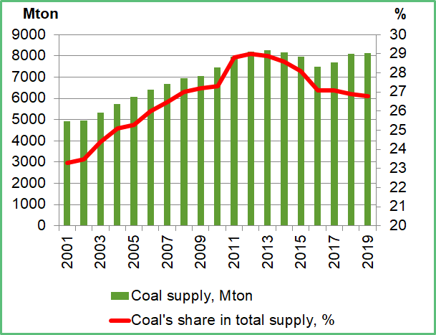

*Figure 1. Figure caption*

1.5. Equations

Equations should be inserted in editable format from the equation editor. The equations should start from the paragraph beginning line. Symbols used in equations should be explained together with their units. Each equation should be numbered and displayed on the rightmost edge of the writing area, and this number should be referred in the text (Equation 1).

$W=10×W_{i}×\left(\frac{1}{√P_{80}}-\frac{1}{√F_{80}}\right)$ (1)

The symbols in the equations should be shown in the form of "symbol: description, unit". Sample:

h: height, m

**2. Rules on references**

All references cited in the manuscript should be listed under the title "References" at the end of the text. Arial 9 fonts should be used. References should be written in alphabetical order by author surnames. The names of the first six authors followed by et al. and the DOI (when available) should be provided.

2.1. In-text Citations

All citations in the text, figures or tables must be in the reference list and vice-versa. Citations within the text should be linked to the relevant references.

Citation to any reference within the text should be made in author surname and year format.

Examples of citation to references in the text:

(Smith, 2015)

(Smith et al., 2016)

(Smith and John, 2017)

(Smith et al., 2018; World Bank, 2019)

(Smith, 2020a)

(Smith, 2020b)

“Smith et al. (2006) showed that in their study that…”

Any inclusion of verbatim text must be contained in quotation marks and clearly reference the original source.

**3. Conclusion**

In Conclusion section, the findings of the study should be summarized and suggestions should be presented, if any.

**References**

Smith, R. 2015. Principles of copper processing. Scientific Mining Journal. 59(1), 163-172.

Smith, R., John, Y., Sam, D.D. 2016. Principles of copper processing. Scientific Mining Journal. doi: 10.1000/fendo.2021.00001.

Smith, R., John, J.C. 2017. Copper processing. Robertson, S. L. (Ed.). Principles of Copper Processing, Academic Press. London, 375-405.

Smith, R., John, T.M., Sam, S.L. 2018. Principles of Copper Processing. New York: Oxford University Press.

Smith, R. 2020a. Principles of copper processing. [dissertation/master’s thesis]. [Ankara]: University of Ankara.

Smith, R. 2020b. Principles of copper processing. Preprint repository name [Preprint]. Available at: https://persistent-url (Accessed April 10, 2020).

World Bank. 2019. Total natural resources rents. <https://data.worldbank.org/indicator/NY.GDP.TOTL.RT.ZS> [Accessed April 20, 2021].