Research Article
Title
Received: date
Accepted: date

Abstract: English abstracts of the articles submitted to the International Journal of Pure and Applied Sciences should be written in this section. The abstract should be minimum 100 words and maximum 200 words. In the abstract, there should be general information about the article and the results obtained should be given briefly. The abstract should be an objective representation of the article and it must not contain results that are not presented and substantiated in the main text and should not exaggerate the main conclusions. References should not be given in the abstract.
Keywords: keyword 1; keyword 2; keyword 3 (Keywords should be at least 3 and at most 5.)

Makale Türü
Başlık
Özet: International Journal of Pure and Applied Sciences'a gönderilen makalelerin Türkçe özetleri bu bölüme yazılmalıdır. Özet en az 100, en fazla 200 kelime olmalıdır. Özette makale hakkında genel bilgiler yer almalı ve elde edilen sonuçlar kısaca verilmelidir. Özet, makalenin objektif bir sunumu olmalı ve ana metinde sunulmayan ve kanıtlanmayan sonuçları içermemeli ve ana sonuçları abartmamalıdır. Özette referans verilmemelidir.
Anahtar Kelimeler: anahtar kelime 1; anahtar kelime 2; anahtar kelime 3 (Anahtar kelimeler en az 3 en çok 5 tane olmalıdır.)

1. Introduction
The introduction section should be informative about the subject. Literature study should be done in this section. Information such as the historical development of the subject, the results of similar studies and the results obtained in the article should be presented systematically in this section. Square brackets should be used in writing the references. For example, an article can be cited as [3]. For multiple sequential articles, the notation [5-10] is used.
A new paragraph should start one "tab" inside. Paragraph entry must be compatible with the previous section entry.
2. Materials and Methods
The Materials and Methods section must be articulated with meticulous detail to ensure that other researchers can successfully replicate and further build upon the findings presented in the manuscript. It is crucial to acknowledge that by publishing your work, you commit to making all pertinent materials, data, computer code, and protocols openly available to the readership. Any restrictions on the accessibility of materials or information must be clearly disclosed during the submission stage. For novel methods and protocols, provide in-depth descriptions, while for well-established methods, a succinct yet informative portrayal, supported by appropriate citations, is warranted.
A new paragraph should start one "tab" inside. Paragraph entry must be compatible with the previous section entry.
2.1. Second Heading
If a subheading is necessary, additional numbers can be added to the section number.
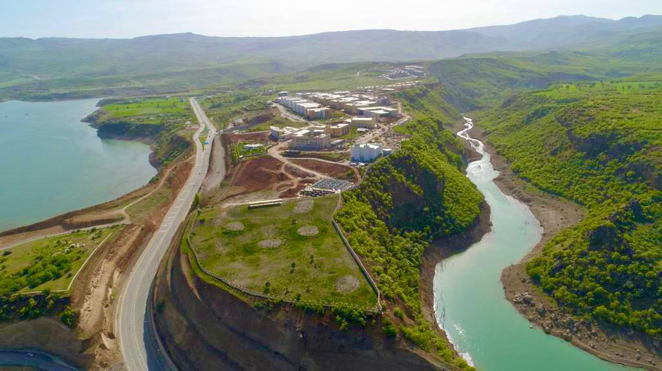
Figure 1. For captions, please use the figure description style.
When incorporating figures into your article, make sure to reference the corresponding image in the text, for example, as "Figure 1." When employing shapes, be mindful to utilize the "Shape Description" style.
When including equations, make sure that they are numbered sequentially. Enclose equation numbers in brackets and place them on the right-hand side of the page. Number equations according to the chapter number. Also, create equations using Word or other equation editors and do not use image formats.
$$\begin{aligned}f\left(x\right)=\frac{1}{xσ\sqrt{2π}}e^{\frac{-{\left(lnx-μ\right)}^{2}}{2σ^{2}}},x>0\#\left(5.1\right)\end{aligned}$$
Tables must be in editable form and each table column must be navigated with the Tab key. Table headings should be placed above the table. Each heading should be numbered and the table should be referenced within the main text. There should be a 5 nk space between the table and its heading. Besides, refer to the relevant table in the text, such as Table 1.
Table 1. Write a short description of the table
Heading 1 | Heading 2 | Heading 3
10.52 | 11.25 | 12.25
13.25 | 14.25 | 15.25
10.52 | 11.25 | 12.25
10.52 | 11.25 | 12.25
13.25 | 14.25 | 15.25

2.1.1. Third Heading
Similar numbering may continue for third level headings.
Fourth Heading
If a heading is required after the third level, do not use numbering.
3. Results and Discussion
This section should encompass the obtained results, substantiated by figures and tables as needed. Comparisons with relevant literature can be made, if necessary. The presentation of results should be both clear and concise. In the discussion section, emphasize the pivotal findings of the study, avoiding excessive citation and extensive literature discussion.
3.1. Second Heading
Subtitle(s) can be given if necessary.
4. Conclusion and Suggestions
The conclusion section should be self-contained, succinctly presenting the study's objectives and key findings. Additionally, provide concise and concrete suggestions and opinions pertaining to the study's results that are intended for the readers.
Acknowledgment
If necessary, the acknowledgement text should be written in this section.
Conflict of Interest
The Author report no conflict of interest relevant to this article
Research and Publication Ethics Statement
The author declares that this study complies with research and publication ethics.
References
While writing the references, make sure that they are written in APA format and that the bottom and top spaces are 0 pt, line spacing is single, right and left spaces are 0.00 and hanging 0.3 inch without using different formats.
[1] Badescu, V. (2002). First and second law analysis of a solar assisted heat pump based heating system. Energy conversion and Management, 43(18), 2539-2552.
[2] Naskar, A. K., Keum, J. K., and Boeman, R. G. (2016). Polymer matrix nanocomposites for automotive structural components. Nature nanotechnology, 11(12), 1026-1030.
[3] Linford, R. G. (Ed.). (1987). Electrochemical science and technology of polymers (Vol. 1). London: Elsevier Applied Science.
[4] Koulic, C., Yin, Z., Pagnoulle, C., Gilbert, B., and Jérôme, R. (2001). Premade versus in situ formed compatibilizer at the PS/PMMA interface: contribution of the Raman confocal microscopy to the fracture analysis. Polymer, 42(7), 2947-2957.

