Karaelmas İş Sağlığı ve Güvenliği Dergisi
Karaelmas Journal of Occupational Health and Safety
ÖZGÜN ARAŞTIRMA / ORIGINAL ARTICLE
DERLEME / REVIEW

Paper Template for the Karaelmas Journal of Occupational Health and Safety

İş Sağlığı ve Güvenliği Dergisi Makale Şablonu (Turkish title is not mandatory for articles written in English)

Author 1 Adı SOYADI, Author 2 Adı SOYADI

ABSTRACT
You need to place the abstract of your article in this section. The abstract should be written with "Cambria" font, 10 point size, justified and not exceeding 200 words (500-1000 characters). Turkish abstract is not mandatory for articles written in English. You can delete this part without changing the formatting and write your own abstract instead.
Keywords: Keywords should be written in lowercase letters. The number of keywords can be between 3 and 5 words. Keywords should be separated from each other with a comma (,) sign.

ÖZET
Turkish abstract is not mandatory for articles written in English. Bu kısma makalenizin Türkçe özetini yerleştirmeniz gerekmektedir. Özet, “Cambria” yazı karakteri ile 10 punto büyüklüğünde, iki yana yaslı ve 200 sözcüğü geçmeyecek (500-1000 karakter) şekilde yazılmalıdır. Makalenin dili Türkçe ise önce özet sonra abstract, İngilizce ise önce abstract sonra özet yazılmalıdır. İngilizce hazırlanan makalelerde Türkçe özet zorunlu değildir. Biçimlendirmeyi bozmadan bu kısmı silip yerine kendi özetinizi yazabilirsiniz.
Anahtar Kelimeler: Anahtar kelimeler küçük harflerle yazılmalıdır. Anahtar kelime sayısı 3 ila 5 sözcük arasında olabilir. Anahtar sözcükler virgül (,) işareti ile birbirinden ayrılmalıdır.

1st Author | authorr1email@mail.com
Bulent Ecevit University, Faculty of Arts and Sciences, Zonguldak, Turkey

2nd Author | authorr1email@mail.com
Bulent Ecevit University, Faculty of Arts and Sciences, Zonguldak, Turkey

For manuscripts derived from thesis study, an illustration should be made as follows.
* This study is derived from the master's / PhD thesis entitled "..............................." and with thesis number ..........., which is being written by ........... under the advision of ..........

I. INTRODUCTION
The article title should not exceed fifteen words. In the articles, the problem, purpose, conceptual framework, importance and contribution of the research should be clearly stated in the introduction section.
Section titles should be written in capital letters, using "Garamond" font, 11 pt, bold and centered.
As can be seen on the template, the subtitles should be shown in "Garamond" font, bold, vertical and with capital initials.
Subtitles should be shown in capital letters starting from the letter "A"; Subtitles in each section title must start from the letter "A".
Considering the research type; It is recommended to include the sections "Method", "Results", "Discussion and Conclusion" and "References", respectively, after the "Introduction" section.
Section titles should start with "I. Introduction"; the title of "References" should not be numbered.
Manuscripts should be written on A4 size paper, using 1.5 line spacing, with the font "Garamond" and 11 pt.
2 cm from the left and right, 3 cm from the bottom and 4 cm from the top should be left on the margins of the page.
Manuscripts should be written in Word format with a Garamond character, not exceeding 6000 words (Word count can be done with the related functions usually found in the "Tools" menu in word processing programs).
After the cover section; A two-column text format should be adopted with the introduction of the first section, "Introduction". The width of both columns should be 7.87 cm and the spacing between columns should be 1.25 cm.
The body text should be written in 11 font size with "Garamond" font and 1.5 line spacing; It should be justified. Paragraph indents should be 0.50 cm, 6 pt space should be left at the end of paragraphs, and page numbers should not be given.
II. METHOD
In research articles, the method section should be added and the recommendations below should be taken into account.
A. Tables and Figures
Tables and figures can be displayed in the text or at the end of the text. Tables and figures should be shown leaning on both sides of the relevant column. However; large tables can be shown to cover two columns.
As in the title of the table, the phrase "Table X:" in the table titles should be written with the first letter starting with a capital letter.
The heading of the table should be 10 points, the phrase "Table X:" should be shown in bold characters and single line spacing should be left.
There should be one line space before the table title, between the table title and the table, and between the table and the following text. Table text should be written in 8 font size and in Calibri font with single line spacing.
Table 1: Comparison of dose values and lifetime mortality risks of miners in the Zonguldak hard coal basin [6,9,10]
Mining Field | YED (mSv/y) | WLM (WLM/y) | Lifetime Mortality Risk
Kozlu | 4.72 | 0.83 | 2.49 X 10⁻⁴
Karadon | 5.08 | 0.90 | 2.70 X 10⁻⁴
Üzülmez | 4.84 | 0.85 | 2.55 X 10⁻⁴
Amasra | 0.85 | 0.15 | 0.45 X 10^{-4(a)}
Armutçuk | 1.44 | 0.25 | 0.75 X 10^{-4(a)}
(a) These values were calculated for the first time in this study.

The title of the figure and the phrase "Figure X:" should be written with the first letter of the sentence starting with a capital letter. The heading of the figure should be 10 points; the phrase "Figure X:" should be shown in bold characters.
Before the figure title, there should be one line space between the figure title and the figure and between the figure and the text that follows.
References should be cited (if necessary) for tables and figures at the end of the title using brackets. An example of this situation can be seen above.

Figure 1: Application of magnetization as a function

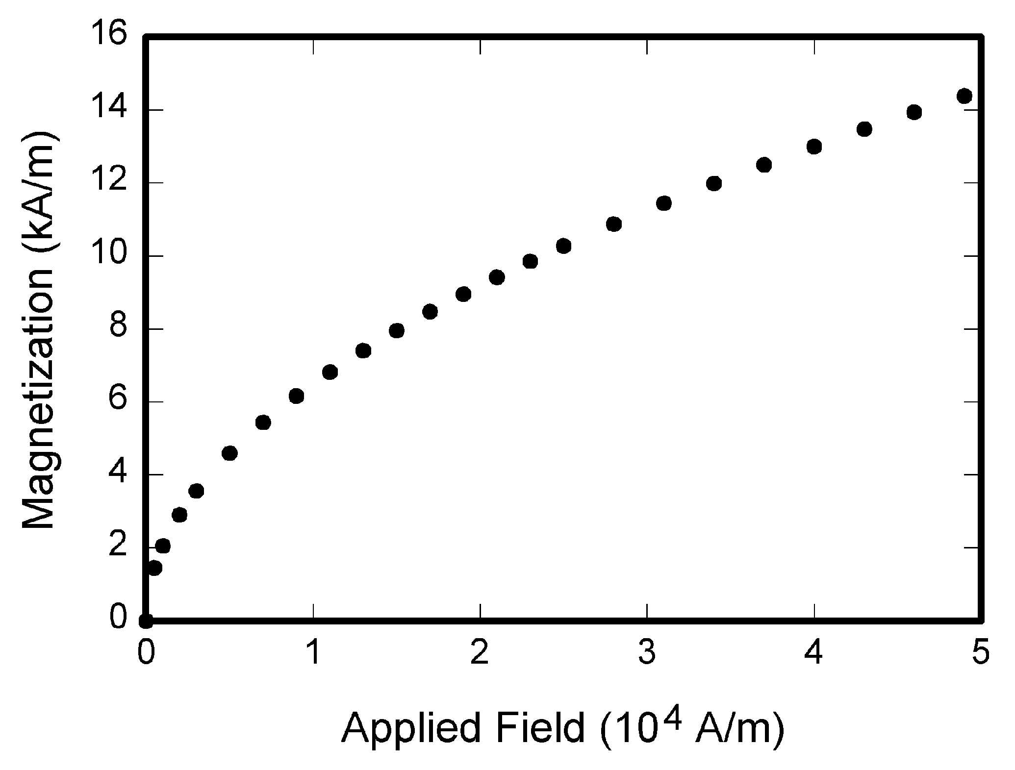

B. Figures, Graphics and Pictures
Figures, graphics and tables should be 600 dpi, photographs and grayscale images should be at least 300 dpi resolution.
The formatting explained above for table and figure titles are also valid for graphics and pictures.
III. REFERENCES
References should be numbered in square brackets according to their order in the text. When a reference is to be made to a previously numbered resource, the previously used number should be used. If you want to cite more than one source in square brackets, the order of importance of the references should be determinant.
References can be numbered in different ways in the text. For example;
• [5], reference number 5,
• References [6-8], 6 and 8 (6, 7 and 8),
• References [11, 9], 11 and 9,
• [15, 23-25], reference number 15 and references 23, 24 and 25,
The bibliography list should be written in "Garamond" typeface and 10 font size and justified; The "References" list should be shown as an unnumbered section title; References should be listed in numerical order.
IEEE style is used for reference notation. The detailed display guide can be accessed here. The references must include the following information:
- If reference is an article: J. K. Author, “Name of paper,” Abbrev. Title of Periodical, vol. x, no. x, pp. xxx-xxx, Abbrev. Month, year, doi: xxx.
- If reference is a book: J. K. Author, “Title of chapter in the book,” in Title of His Published Book, xth ed. City of Publisher, (only U.S. State), Country: Abbrev. of Publisher, year, ch. x, sec. x, pp. xxx–xxx.
- If reference is an paper: J. K. Author, “Title of paper,” in Abbreviated Name of Conf., (location of conference is optional), (Month and day(s) if provided) year, pp. xxx-xxx.
- If reference is a thesis: J. K. Author, “Title of thesis,” M.S. thesis, Abbrev. Dept., Abbrev. Univ., City of Univ., Abbrev. State, year.
- If reference is a report: J. K. Author, “Title of report,” Abbrev. Name of Co., City of Co., Abbrev. State, Country, Rep. xxx, year.
- If reference is a website: First Name Initial(s) Last Name. “Page Title.” Website Title. Web Address (retrieved Date Accessed).

Author Contrıbutıons: In this area, authors' contributions to the article / study should be given. For example; "Authors' contributions are equal." or “Research idea, design ABC, DE, FG; data collection ABC; analysis DE, FG; The comment and reporting of the article ABC, FG. " can be specified in the form.
Conflıct Of Interest: Conflict of interest, if any, should be specified in this field. Otherwise, it should be stated. Example: " The authors declare that they have no conflict of interest and adheres to research and publication ethics."
Fınancıal Support: The financial support and / or the funded project should be specified in this field. Example: "No financial support was received from any person, institution or organization in this study." or "Our study was supported financially by the Scientific Research Projects Unit of the ……………… University (Project number: …………… ..)"
Ethıcal Approval: “This study was approved by ..................... Ethics Board at the ................ Committee (Permission granted/Decision no: ......../......). " or "Since the research neither contains personal nor experimental data, ethical approval was not necessary. "

REFERENCES
[1] B. Klaus and P. Horn, Robot Vision. Cambridge, MA, USA: MIT Press, 1986.
[2] L. Stein, “Random patterns,” in Computers and You, J. S. Brake, Ed. New York, NY, USA: Wiley, 1994, pp. 55–70.
[3] R. L. Myer, “Parametric oscillators and nonlinear materials,” in Nonlinear Optics, vol. 4, P. G. Harper and B. S. Wherret, Eds. San Francisco, CA, USA: Academic, 1977, pp. 47–160.
[4] M. Abramowitz and I. A. Stegun, Eds., Handbook of Mathematical Functions (Applied Mathematics Series 55). Washington, DC, USA: NBS, 1964, pp. 32–33.
[5] E. F. Moore, “Gedanken-experiments on sequential machines,” in Automata Studies (Ann. of Math. Studies, no. 1), C. E. Shannon and J. McCarthy, Eds. Princeton, NJ, USA: Princeton Univ. Press, 1965, pp. 129–153.
[6] Westinghouse Electric Corporation (Staff of Technology and Science, Aerospace Div.), Integrated Electronic Systems. Englewood Cliffs, NJ, USA: Prentice-Hall, 1970.
[7] M. Gorkii, “Optimal design,” Dokl. Akad. Nauk SSSR, vol. 12, pp. 111-122, 1961 (Transl.: in L. Pontryagin, Ed., The Mathematical Theory of Optimal Processes. New York, NY, USA: Interscience, 1962, ch. 2, sec. 3, pp. 127–135).
[8] A. Histace, “Image restoration—Recent advances and applications,” in Super-Resolution Restoration and Image Reconstruction for Passive Millimeter Wave Imaging. Rijeka, Croatia: InTech, 2012, pp. 25–45.
[9] D. Caratelli, M. C. Viganó, G. Toso, and P. Angeletti, “Analytical placement technique for sparse arrays,” presented at the 32nd ESA Antenna Workshop, Noordwijk, The Netherlands, Oct. 5–8, 2010.
[10] J. G. Kreifeldt, “An analysis of surface-detected EMG as an amplitude-modulated noise,” presented at the 1989 Int. Conf. Medicine and Biological Engineering, Chicago, IL, USA, Nov. 9–12, 1989.
[11] G. W. Juette and L. E. Zeffanella, “Radio noise currents on short sections on bundle conductors,” presented at the IEEE Summer Power Meeting, Dallas, TX, USA, Jun. 22–27, 1990, Paper 90 SM 690-0 PWRS.
[12] J. Arrillaga and B. Giessner, “Limitation of short-circuit levels by means of HVDC links,” presented at the IEEE Summer Power Meeting, Los Angeles, CA, USA, Jul. 12–17, 1990, Paper 70 CP 637.
[13] RCA Receiving Tube Manual, Radio Corp. of America, Electronic Components and Devices, Harrison, NJ, Tech. Ser. RC-23, 1992.
[14] M. M. Chiampi and L. L. Zilberti, “Induction of electric field in human bodies moving near MRI: An efficient BEM computational procedure,” IEEE Trans. Biomed. Eng., vol. 58, pp. 2787–2793, Oct. 2011, doi: 10.1109/TBME.2011.2158315.
[15] M. Ito et al., “Application of amorphous oxide TFT to electrophoretic display,” J. Non-Cryst. Solids, vol. 354, no. 19, pp. 2777–2782, Feb. 2008.
[16] R. Fardel, M. Nagel, F. Nuesch, T. Lippert, and A. Wokaun, “Fabrication of organic light emitting diode pixels by laser-assisted forward transfer,” Appl. Phys. Lett., vol. 91, no. 6, Aug. 2007, Art. no. 061103.
[17] J. Zhang and N. Tansu, “Optical gain and laser characteristics of InGaN quantum wells on ternary InGaN substrates,” IEEE Photon. J., vol. 5, no. 2, Apr. 2013, Art no. 2600111.
[18] L. Kuang et al., “A numerical method for analyzing electromagnetic scattering properties of a moving conducting object,” Int. J. Antennas Propag., vol. 2014, 2014, Art. no. 386315, doi: 10.1155/2014/386315.
[19] M. M. Chiampi and L. L. Zilberti, “Induction of electric field in human bodies moving near MRI: An efficient BEM computational procedure,” IEEE Trans. Biomed. Eng., vol. 58, no. 10, pp. 2787–2793, Oct. 2011, doi: 10.1109/TBME.2011.2158315.
[20] E. E. Reber, R. L. Michell, and C. J. Carter, “Oxygen absorption in the earth’s atmosphere,” Aerospace Corp., Los Angeles, CA, USA,Tech. Rep. TR-0200 (4230-46)-3, Nov. 1988.
[21] J. H. Davis and J. R. Cogdell, “Calibration program for the 16-foot antenna,” Elect. Eng. Res. Lab., Univ. Texas, Austin, Tech. Memo. NGL-006-69-3, Nov. 15, 1987.
[22] R. E. Haskell and C. T. Case, “Transient signal propagation in lossless isotropic plasmas,” USAF Cambridge Res. Labs., Cambridge, MA, USA, Rep. ARCRL-66-234 (II), 1994, vol. 2.
[23] J. O. Williams, “Narrow-band analyzer,” Ph.D. dissertation, Dept. Elect. Eng., Harvard Univ., Cambridge, MA, USA, 1993.
[24] J. Smith and J. Doe. “Obama inaugurated as President.” CNN.com. http://www.cnn.com/POLITICS/01/21/obama_inaugurated/index.html (accessed Feb. 1, 2009).

