Write the Title of Your Study Here Without Changing the Formatting Here, and Not Exceeding Twelve Words

Author's Name and Surname 1

Author's Name and Surname 2

Author's Name and Surname 3

Abstract
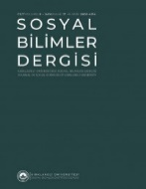
Article Type
Research Article
Application Date
2021-04-08
Acceptance Date
2021-04-16
DOI
10.47140/kusbder.XXXXXX
Write the summary of your work here in accordance with the rules specified in the writing rules. The abstract should be written in 9-point size, single line spacing, without entering, justified, and in 150-200 word range, (you can choose the abstract part from the Styles section). Write the summary of your work here in accordance with the rules specified in the writing rules. The abstract should be written in 9-point size, single line spacing, without entering, justified, and in 150-200 word range, (you can choose the abstract part from the Styles section). Write the summary of your work here in accordance with the rules specified in the writing rules. The abstract should be written in 9-point size, single line spacing, without entering, justified, and in 150-200 word range, (you can choose the abstract part from the Styles section). Write the summary of your work here in accordance with the rules specified in the writing rules. The abstract should be written in 9-point size, single line spacing, without entering, justified, and in 150-200 word range, (you can choose the abstract part from the Styles section). Write the summary of your work here in accordance with the rules specified in the writing rules. The abstract should be written in 9-point size, single line spacing, without entering, justified, and in 150-200 word range, (you can choose the abstract part from the Styles section).

Key Words: The number of keywords should be between 5 and 7 and should be written in lowercase letters.

Çalışmanızın Başlığını Buradaki Biçimlendirmeyi Bozmadan ve On İki Sözcüğü Geçmeyecek Şekilde Buraya Yazınız

Yazar Adı Soyadı 1

Yazar Adı Soyadı 2

Yazar Adı Soyadı 3

Öz
Makale Türü
Araştırma Makalesi
Başvuru Tarihi
08.04.2021
Kabul Tarihi
09.04.2021
DOI
10.47140/kusbder.XXXXXX
Çalışmanızın özetini yazım kılavuzunda belirtilen kurallara uygun olarak buraya yazınız. Öz, 9 punto büyüklüğünde, tek satır aralığında, girinti olmaksızın, iki yana yaslı ve 150-200 sözcük aralığında yazılmalıdır (Stiller kısmından Öz kısmını seçebilirsiniz). Çalışmanızın özetini yazım kılavuzunda belirtilen kurallara uygun olarak buraya yazınız. Öz, 9 punto büyüklüğünde, tek satır aralığında, girinti olmaksızın, iki yana yaslı ve 150-200 sözcük aralığında yazılmalıdır (Stiller kısmından Öz kısmını seçebilirsiniz). Çalışmanızın özetini yazım kılavuzunda belirtilen kurallara uygun olarak buraya yazınız. Öz, 9 punto büyüklüğünde, tek satır aralığında, girinti olmaksızın, iki yana yaslı ve 150-200 sözcük aralığında yazılmalıdır (Stiller kısmından Öz kısmını seçebilirsiniz). Çalışmanızın özetini yazım kılavuzunda belirtilen kurallara uygun olarak buraya yazınız. Öz, 9 punto büyüklüğünde, tek satır aralığında, girinti olmaksızın, iki yana yaslı ve 150-200 sözcük aralığında yazılmalıdır (Stiller kısmından Öz kısmını seçebilirsiniz). Çalışmanızın özetini yazım kılavuzunda belirtilen kurallara uygun olarak buraya yazınız. Öz, 9 punto büyüklüğünde, tek satır aralığında, girinti olmaksızın, iki yana yaslı ve 150-200 sözcük aralığında yazılmalıdır (Stiller kısmından Öz kısmını seçebilirsiniz). Çalışmanızın özetini yazım kılavuzunda belirtilen kurallara uygun olarak buraya yazınız.

Anahtar sözcükler: Anahtar sözcüklerin sayısı 5 ile 7 arasında olmalı ve küçük harflerle yazılmalıdır.

Introduction (Section Title)
Write the introduction part of your work within the framework of the rules specified in the writing rules, in "Calibri" font, 10 pt. Size, "single" line spacing, without first line indent and 6 nk space after paragraph (or simply use "Normal" style in the styles section).

Subheading (Use Level 1 Heading Style)

Subheadings in the study should be written in accordance with the title features specified in the spelling guide. To create a Level 1 Subheading, you can use the Level 1 Heading style in the "Styles" section of the article template.

Subheading (use level 2 heading style)

Subheadings in the study should be written in accordance with the title features specified in the spelling guide. To create a Level 2 Subheading, you can use the Level 2 Heading style in the "Styles" section of the article template.

Subheading (use level 3 heading style)
Subheadings in the study should be written in accordance with the title features specified in the spelling guide. To create a Level 3 Subheading, you can use the Level 3 Heading style in the "Styles" section of the article template. Be careful not to use a lower level header.

Method
Write the methodology of research type and pattern, research model, universe-sampling of the research depending on the research type, research data, data collection tool, data analysis, validity, and reliability of the data of your study under this section.

Findings
You can write the findings you obtained within the scope of your study in this section by considering the rules stated in the spelling guide.
Table 1. Sample Table Header
Aaaa Bbbb | Aaaa | Aaaa | Aaaaa | Aaaaa | Aaaa | Aaaa
Bbbb | 1 | 0,00 | 0,00 | 0,00 | 0,00 | 0,00
 | 2 | 0,00 | 0,00 | 0,00 | 0,00 | 0,00
Bbbbb | 1 | 0,00 | 0,00 | 0,00 | 0,00 | 0,00
 | 2 | 0,00 | 0,00 | 0,00 | 0,00 | 0,00
Bbbb | 1 | 0,00 | 0,00 | 0,00 | 0,00 | 0,00
**p< 0.01

Leave one blank space after the table. Table number and title should be 10 pt. In addition, centered as shown above, and information in the table should be 9 pt. The information in the first line of the table should be written in bold, the others should be normal. Vertical lines should not be used in the table; horizontal lines should be used as few as possible.
While writing the values obtained as a result of the analysis, two digits should be used in decimal numbers, but the decimal value of the significance level (p) should be given as three digits. A period, not a comma, should be used when writing decimals.
Turkish representation of percentage expressions: %10; The English representation should be 10%.

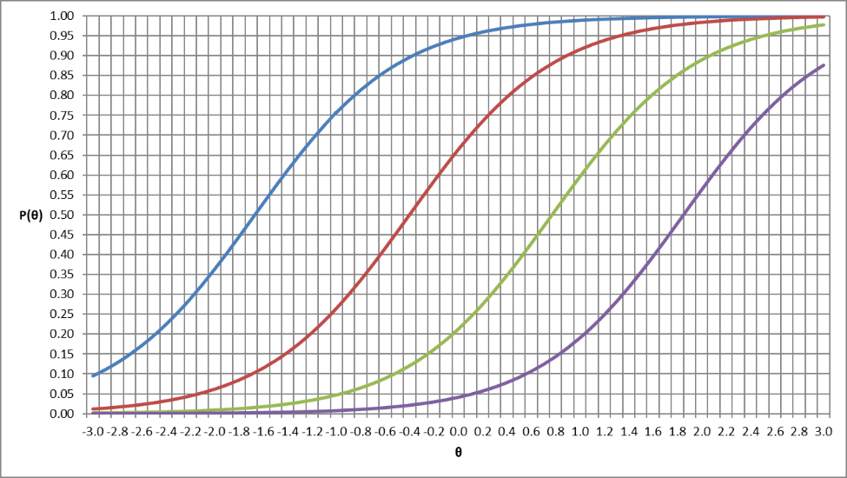
Figure 1. Write the title of the figure here.

Discussion and Conclusion
You need to explain and discuss the findings of your study in the context of your hypotheses (goals) and related literature. You are also expected to report the results of these discussions. In addition, based on the results, you are expected to make suggestions to practitioners and researchers. You can write all this information here.

Ethical Statement Information of the Article
Conflict of Interest Statement
Author Contributions
Ethics Committee Certificate Of Approval

References
You can create a list of the sources you use in your work here, consistent with the sources you use in the text. While creating this list, you can use the sample notations given in the spelling guide for resource types.

References Sample
Akay, B., Tokatlı, C., & Aksoy, M. (2017, Aralık). Kırklareli ve Edirne İllerine Yönelik Bir Turizm Potansiyeli Değerlendirme Çalışması. Kırklareli Üniversitesi Sosyal Bilimler Dergisi, 1(1), 89-102.
Arcayürek, C. (1966, Ocak 13). İşte Johnson Mektubu. Hürriyet Gazetesi, p. 1.
Ataş, M. (2021, Nisan 4). Anadolu Ajansı Türkiye'nin 100 Yıllık Serüvenini Kitaplaştırdı. Retrieved Nisan 15, 2021, from Anadolu Ajansı Resmî Web Sitesi: https://www.aa.com.tr/tr/kurumsal-haberler/anadolu-ajansi-turkiyenin-100-yillik-seruvenini-kitaplastirdi/2198558
Aydın, M., & Açıkmeşe, S. (2015). Türkiye'de Güvenlik Kavramsallaştırması. In M. Aydın, H. G. Brauch, M. Çelikpala, U. O. Spring, & N. Polat (Eds.), Uluslararası İlişkilerde Çatışmadan Güvenliğe (2. ed., pp. 491-508). İstanbul: istanbul Bilgi Üniversitesi Yayınları.
Baykal, N. (2020, Eylül). Aristo'nun En Seçkin Öğrencisi: Fârâbî. TÜBİTAK Bilim ve Teknik Dergisi(634), 66-70.
Bulgur, N. (2017). 20. Yüzyılda Göç Teorileri ve Türkiye'nin Uluslararası Göç Politikaları. I. Uluslararası İnsan ve Toplum Bilimler Kongresi. Priştina-Kosova.
Bulgur, N. (2017). 20. Yüzyılda Göç Teorileri ve Türkiye'nin Uluslararası Göç Politikaları. In G. B. Durgun, & T. Korkmaz (Ed.), I. Uluslararası İnsan ve Toplum Bilimler Kongresi (pp. 1-11). Priştina-Kosova: Gazi Üniversitesi Matbaası.
Dede Korkut Hikâyeleri. (2018). (A. Çakan, Trans.) İstanbul: Türkiye İş Bankası Kültür Yayınları.
Erhan, Ç. (2015). Türk-Amerikan İlişkilerinin Tarihsel Kökenleri (2. ed.). Ankara: İmge Kitabevi yayınları.
Foreign News: The Near East. (1923, March 24). Time Magazine.
Gedik, M. S., & Hakkoymaz, H. (2020, Kasım 12-15). 112 Acil Sağlık Hizmetleri Çalışanlarının Hizmet ve Sosyal Durumlarının Değerlendirilmesi. 16. Ulusal Acil Tıp Kongresi, 61. Ankara: Acil Tıp Uzmanları Derneği.
Gök, N. (1997). Beylikler Döneminden İtibaren Osmanlı Diplomatikasında Berat Formu. İstanbul: Marmara Üniversitesi Türkiyat Araştırmaları Enstitüsü Tarih Anabilim Dalı Ortaçağ Tarihi Bilim Dalı Yayınlanmamış Doktora Tezi.
Jensen, M. C., & Meckling, W. H. (1976). Theory of the Firm: Managerial Behavior, Agency Costs and Ownership Structure. Journal of Financial Economics, 3(4), 305-360.
Keohane, R. O., & Nye, J. S. (2012). Power and Interdependence (4. ed.). New York: Longman.
Lipson, L. (1978). Politika Biliminin Temel Sorunları (2 ed.). (T. Karamustafaoğlu, Trans.) Ankara: Ankara Üniversitesi Hukuk Fakültesi Yayınları.
Seyidoğlu, H. (2016). Bilimsel Araştırma ve Yazma El Kitabı (Genişletilmiş 10. ed.). İstanbul: Güzem Can Yayınları.
Şener, M. (2005). Mina. Türkiye Diyanet Vakfı İslâm Ansiklopedisi, 30, 96-97. Ankara: Turkiye Diyanet Vakfi Yayinlari.
Türkiye Cumhuriyeti Merkez Bankası. (2012). Sekseninci Hesap Yılı Hakkında Banka Meclisince Hazırlanan Faaliyet Raporu: Yıllık Rapor 2011. Ankara: Ömür Matbaacılık.
Yükseköğretim Kanunu. (1981, Kasım 4). (2547).

Corresponding Author: Title 1, Faculty, Department, E-mail: ……., Https://orcid.org/1234-1234-1234-1234
Title 2, Faculty, Department, E-mail: ……., Https://orcid.org/1234-1234-1234-1234
Title 3, Faculty, Department, E-mail: ……., Https://orcid.org/1234-1234-1234-1234
Sorumlu Yazar: Unvan 1, Fakülte, Bölüm, Anabilim Dalı, E-posta:……., https://orcid.org/1234-1234-1234-1234
Unvan 2, Fakülte, Bölüm, Anabilim Dalı, E-posta:……., https://orcid.org/1234-1234-1234-1234
Unvan 2, Fakülte, Bölüm, Anabilim Dalı, E-posta:……., https://orcid.org/1234-1234-1234-1234

