JOURNAL OF SOCIAL SCIENCES AND EDUCATION (JOSSE)

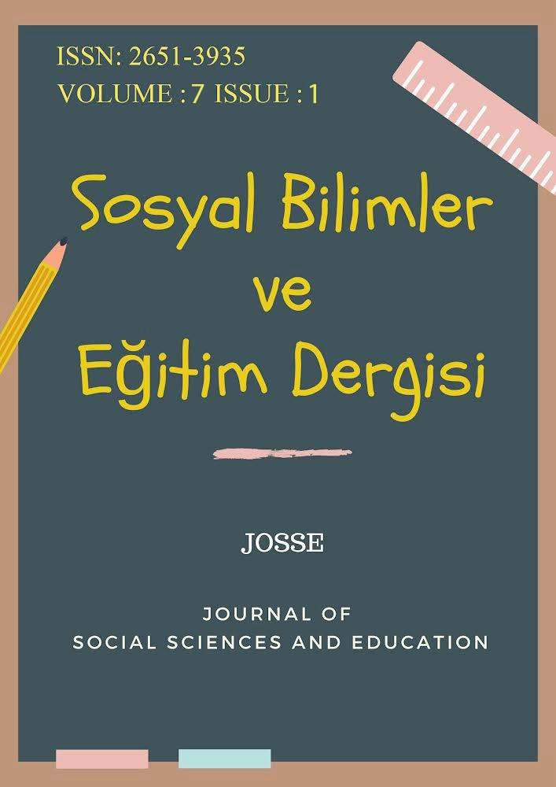

https://dergipark.org.tr/tr/pub/josse

The Article Title Will Be Written Here, with the First Letter of Each Word Capitalized

Name SURNAME¹  University, Faculty, Department  Tittle  example@gmail.com  Orcid ID: 0000-0000-0000-0000 | Name SURNAME²  University, Faculty, Department  Tittle  example@hotmail.com  Orcid ID: 0000-0000-0000-0000
*Bu bölüm dergi tarafından yayın aşamasında doldurulacaktır. | *This section will be filled in by the journal during the publication phase.
Article Type: Research Article  Received: 00.00.2024  Revision received: 00.00.2024  Accepted: 00.00.2024  Published online: 00.05.2024 | Citation: Surname, N., & Surname, N. (2024). Article title. Journal of Social Sciences and Education, X(X), xx-xx

The Article Title Will Be Written Here, with the First Letter of Each Word Capitalized

Name SURNAME
University, Faculty, Department
Name SURNAME²
University, Faculty, Department
Abstract | Research Article
The abstract is suggested to be 250 words maximum, written with 11 font size with Times New Roman. The abstract is suggested to be 250 words maximum, written with 11 font size with Times New Roman. The abstract is suggested to be 250 words maximum, written with 11 font size with Times New Roman. The abstract is suggested to be 250 words maximum, written with 11 font size with Times New Roman. The abstract is suggested to be 250 words maximum, written with 11 font size with Times New Roman. The abstract is suggested to be 250 words maximum, written with 11 font size with Times New Roman. The abstract is suggested to be 250 words maximum, written with 11 font size with Times New Roman. The abstract is suggested to be 250 words maximum, written with 11 font size with Times New Roman. The abstract is suggested to be 250 words maximum, written with 11 font size with Times New Roman. The abstract is suggested to be 250 words maximum, written with 11 font size with Times New Roman. The abstract is suggested to be 250 words maximum, written with 11 font size with Times New Roman. The abstract is suggested to be 250 words maximum, written with 11 font size with Times New Roman. | Received: dd.mm.yyyy  Revision received: dd.mm.yyyy  Accepted: dd.mm.yyyy  Published online: dd.mm.yyyy
Keywords: Five (5) keywords, keywords, keywords,

Introduction

The article should be written with 12 font and Times New Roman style. Text will be 1,5-spaced and justified for alignment. Margins should be 2.5 for up, down, right; and 2.75 for left for paragraphs. Main headings and sub-headings should be bold and aligned in the center. All words should be capitalized in main and sub headings. Headings shoud be 4 levels at most. Before and after each main heading one line should be left blank. Before sub-headings, one line should be left blank while after sub-headings no line should be left blank. The article should be written according to APA 7.
Topic of the article, aim of the article, problem statement, research questions, significance of the study and contribution to the field are presented in this part. Additionally, literature review and problem diagnose are expected to be written in introduction. The length of the introduction part is up to the author; however, it is expected to be satisfying. Topic of the article, aim of the article, problem statement, research questions, significance of the study and contribution to the field are presented in this part. Additionally, literature review and problem diagnose are expected to be written in introduction. The length of the introduction part is up to the author; however, it is expected to be satisfying. Topic of the article, aim of the article, problem statement, research questions, significance of the study and contribution to the field are presented in this part. Additionally, literature review and problem diagnose are expected to be written in introduction. The length of the introduction part is up to the author; however, it is expected to be satisfying. Topic of the article, aim of the article, problem statement, research questions, significance of the study and contribution to the field are presented in this part. Additionally, literature review and problem diagnose are expected to be written in introduction. The length of the introduction part is up to the author; however, it is expected to be satisfying. The article should be written according to APA 7.

Method

Model
Before sub-headings, one line should be left blank while after sub-headings no line should be left blank. No line should be left blank between paragraphs. .The article should be written according to APA 7.

Sample and Population
Before sub-headings, one line should be left blank while after sub-headings no line should be left blank. No line should be left blank between paragraphs. The article should be written according to APA 7.

Data Collection Tool
Before sub-headings, one line should be left blank while after sub-headings no line should be left blank. No line should be left blank between paragraphs. The article should be written according to APA 7.

Collection of Data and Analysis
Before sub-headings, one line should be left blank while after sub-headings no line should be left blank. No line should be left blank between paragraphs. The article should be written according to APA 7.

Ethical Committee Approval
Etik kurul izinleri her makale için talep edilmez. “Etik kurul izni gerektiren” makaleler için talep edilmektedir. Etik kurul izni gerektiren araştırmalar;
Anket, mülakat, odak grup çalışması, gözlem, deney, görüşme teknikleri kullanılarak katılımcılardan veri toplanmasını gerektiren nitel ya da nicel yaklaşımlarla yürütülen her türlü araştırmalar,
İnsan ve hayvanların (materyal/veriler dahil) deneysel ya da diğer bilimsel amaçlarla kullanılması, İnsanlar üzerinde yapılan klinik araştırmalar,
Hayvanlar üzerinde yapılan araştırmalar,
Kişisel verilerin korunması kanunu gereğince retrospektif çalışmalar.
Ayrıca;
Olgu sunumlarında (vaka analizi) “Aydınlatılmış Onam Formu” alındığının belirtilmesi, Başkalarına ait ölçek, anket, fotoğrafların kullanımı için sahiplerinden izin alınması ve belirtilmesi,
Kullanılan fikir ve sanat eserleri için telif hakları düzenlemelerine uyulduğunun belirtilmesi gerekmektedir.
Olgu sunumlarında, bilgilendirilmiş gönüllü olur/onam formunun imzalatıldığına dair bilgiye makalede yer verilmelidir. Araştırma yapılan kurumdan izin belgesinin alındığı belirtilmelidir (MEB, Bakanlıklar vb.).
Başkalarına ait ölçek, anket, fotoğrafların kullanımı için sahiplerinden izin alındığı belirtilmelidir. Kullanılan fikir ve sanat eserleri için telif hakları düzenlemelerine uyulduğu belirtilmelidir.

Findings

All tables, shapes, picture and graphics should be presented in appropriate places in the text, numbered successively and aligned as justified. Each table, shape, picture or graphic should be given with a heading. Table, shape, picture and graphics should be adjusted according to APA rules. Headings should be before the table, shape, picture or graphic; aligned left, each word uppercase and 12 font size. The article should be written according to APA 7.

Table 1
Did You Encounter Any Difficulty in Determining Your Advisor? If Yes, What Were They?
Yes/No | Difficulties encountered | f | Total
Yes | Too full quotas | 3 | 10
 | Not being assigned according to the advisor selection form | 10
 | Not being assigned to the desired advisor | 10
 | Not being assigned a suitable advisor for the topic of study | 8
 | Uncertainty of advisor assignment criteria | 6
No | - | 7 | 7

Table, shape, picture or graphic presented right after the related text should be pointed with the number of the table, shape, picture or graphics between brackets (Table 1). The article should be written according to APA 7.

Table 2
Did You Encounter Any Difficulties with the Advisor? If Yes, What Were They?
Yes/No | Difficulties encountered | f | Total
Yes | Advisor’s being busy/not allocating time | 11 | 12
 | Communication issues | 7
 | Thesis topic selection | 5
 | Lack of guidance (Conventionalism) | 7
 | Insufficient expertise in the thesis topic | 4
No | - | 5 | 5

All tables, shapes, picture and graphics should be presented in appropriate places in the text, numbered successively and aligned as justified. Each table, shape, picture or graphic should be given with a heading. Table, shape, picture and graphics should be adjusted according to APA rules. Headings should be before the table, shape, picture or graphic; aligned left, each word uppercase and 12 font size. The article should be written according to APA 7 https://apastyle.apa.org/style-grammar-guidelines/paper-format/professional-annotated.pdf

Discussion and Results

All tables, shapes, picture and graphics should be presented in appropriate places in the text, numbered successively and aligned as justified. Each table, shape, picture or graphic should be given with a heading. Table, shape, picture and graphics should be adjusted according to APA rules. Headings should be before the table, shape, picture or graphic; aligned left, each word uppercase and 12 font size. The article should be written according to APA 7 https://apastyle.apa.org/style-grammar-guidelines/paper-format/professional-annotated.pdf

Recommendations

Every source used in the article should be given in References part. The sources should be listed alphabetically regardless of their quality (thesis, article, rapport, etc.). Sources of the same author should be listed starting “from the newest” one to the oldest. Every source used in the article should be given in References part. The sources should be listed alphabetically regardless of their quality (thesis, article, rapport, etc.). Sources of the same author should be listed starting “from the newest” one to the oldest. Every source used in the article should be given in References part. The sources should be listed alphabetically regardless of their quality (thesis, article, rapport, etc.).

Ethical Committee Approval

Information regarding the permission regarding the ethics committee (committee name, date and issue number) should be included.

References

References should be written in this way / Her bir eser için kaynak gösterimi APA 7 stiline uygun olmalıdır: https://apastyle.apa.org/style-grammar-guidelines/paper-format/professional-annotated.pdf
References should be written in this way APA 7 https://apastyle.apa.org/style-grammar-guidelines/paper-format/professional-annotated.pdf

1 Corresponding author: Tittle example@gmail.com Orcid ID: 0000-0000-000-000 ²Tittle example@gmail.com Orcid ID: 0000-0000-000-000

