Title

Abstract: Water harvesting is crucially important for arid regions where the deficits in rainfall are irregular and a great amount of this water is rapidly lost due to surface runoff. In the arid areas, water harvesting is directly related to process of plant growth and conservation of soil and water. Water harvesting is based on the principle of preventing a part of the land, which is usually small and non-productive, from getting the share of rain and adding it to the share of another part….………………………………………..…………………………………………… ……………………………………………………………………………….The experiment was conducted in Soil and Water Research Station, Şanlıurfa, Turkey. The area had low rainfall (370 mm year⁻¹) and high evaporation (2048 mm year⁻¹). Conventional and runoff strip method were applied with tree replication on plot of 12x2.8 m under the same condition. ………………………………………………………………………………………………………………………………………………

Keywords: Lentil, runoff strip, water harvesting

1. Introduction
Dry lands are known for their water scarcity, land degradation and declined livelihood. They constitute about 40% of the global area, 60% of which covers developing countries, spreading over 110 nations and sheltering more than a population of 700 million and their contribution to food security is well-acknowledged (Anonymous, 1994) ……………………………….….. ……………………………………………………………………………………………………..
Macro catchment and floodwater-harvesting systems are characterized by having runoff water collected from a relatively large catchment……………………………………… …………………………………………………………………………………………………………………… Runoff strips, Contour-bench terraces and Inter-row systems are commonly used as micro-catchment water harvesting methods (Oweis et al., 2001)…………… ……………………………………………………………………………………………………..…………………………………………………………………………………
Vegetation can increase surface roughness and water infiltration rate, and decrease runoff volume that can reduce particles and sediment transport…………………………………. …………………………………………………………… from surface runoff by deposition, infiltration, adsorption, and absorption (Dillaha et al., 1989). It has been recommended as a best management practice in controlling non-point source pollution from agricultural lands (Anonymous, 1976).
In this study, lentil was chosen because of mentioned properties as vegetative strip and conducted afield experiment with runoff strips method. The results were evaluated based on yield of straw, seed and biomass that depends on water use efficiency of lentil.

2. Material and Methods
2.1. Description of the study area
The study was conducted in the Tektek Soil and Water Conservation Research Station, located in approximately 45 km eastern of Şanlıurfa (Figure 1). The average altitude is 530 m and located between 37º 07’ 30’’ North latitude and 39º 15’ 00’’ east meridian. The research station is located in Tektek Mountains.
Local red lentil sowed 4 to 5 cm deep, inter rill with rows as 14 cm and 90 kg ha⁻¹ seeds were used. ……………………………………………………………………………………………………………………………….. surface and land rolling was done before the plants reached the 5-7 node stage.
For the cultivation Lentil should be seeded as early as possible when the minimum average soil temperature reaches 5ºC……………………………………………………………………… …………………………………………………………………………………………….. The timetable for the cultivation was given in Table 1.

2.2. Soil characteristics of study area
The soil of the zone, Typical Torri fluvent had a clay silt soil texture, with 36% sand, 38% silt and 26% clay, 30% CaCO₃,……………………….. ………………………………………… ………………………………………………………………………….……………………..…is 29% and wilting point is 19% (Dinç et al., 1988).

2.3. Climate of the study area
Climate of the research area is affected by Mediterranean climate although it is located in the region of Southeastern Anatolia climate…………………………………………………………. ………………………………………………………………………………………………………………………………. The relative humidity is 48%, total evaporation is 2047 mm and daily sun shine duration is 8.73 hour.

2.4. Experimental setting and plant cover strips
The study area was divided into strips along the contour. An upstream strip was used as a catchment, while a downstream strip was used to grow crops. The experiment was designed with randomized complete block with three replications…………………………………………

3. Results and Discussion
The results of the straw, seed and biomass yield of lentil, and Independent Samples t test results were given Figure 3 and Table 2 for each yield.
The average straw yields were determined a 2663.7 and 4602 kg ha⁻¹ for control and Strip Plots application, respectively. The average seed yields were……………………………………. ……………………………………………………………………………………………………..and 5762.4 kg ha⁻¹ respectively. These results show that Strip plot application increased great amount of straw and seed yields……………………………………………………………….. …………………………………………………………………………………………….. That is why, it should be considered total area and its yield for the comparison.
When the yield of strip plots application was taken as half of yield is given in Table 1. There wasn’t seen superiority of this application for one year production. But………………… …………………………………………………………………………………………………………………………… soil tillage, cultivation, sowing, harvesting etc. According to experimental researches, total cost of lentil production is 1556.6 TL ha⁻¹ in Şanlıurfa (Monis et al., 2011). At this situation it can be say that strip plot applications have advantages as economical. Also, compact plots are useful in the arid region. Water in………………….. ……………………………………………………………………………………………can be collected with the compact areas in the strip plots and transferred to the near planted plots.
The fallow method is used for the conventional lentil production in study area due to water scarcity. But ……………………………………………………………………………………………………………………………………………………………… Widespread adoption of water harvesting techniques by the local population is the only way that significant areas of land can be treated at a reasonable cost on a sustainable basis. It is therefore important ………………………………………………………………………… to maintain.

4. Conclusions
The results show that the runoff strip method increased straw and grain yields significantly. In addition…………………………………………………………………………………………………………………………………. crop productivity. Furthermore, this kind of researches should be…………………………………………………………………………..………………. ……………………………………………………………………………………………………...…………. conditions for dry land areas.

Acknowledgements
I would like to thank to the ………………………………………….. for its financial assistance.

References
Anonymous, 1976. USDA, Natural Resources Conservation Service. Field Office Technical Guide, Section IV−Practice Standards and Specifications, 342-Critical Area Planting.
Boers, Th.M., Zondervan, K., Ben-Asher, J., 1986. Micro-Catchment-Water-Harvesting (MCWH) for arid zone development. Agricultural Water Management, 12(1-2): 21-39.
Dillaha, T.A., Reneau, R.B., Mostaghimi, S., Lee, D., 1989. Vegetative filter strips for agricultural nonpoint source pollution control. Transactions of the ASABE, 32(2):491-496.
Dinç, U., Şenol, S., Sayın, M., Kapur, S., Güzel, N., Derici, R., Yeşilsoy, M.Ş., Yeğingil, D., Sari, M., Kaya, Z., Aydın, M., Kettaş, F., Berkman, A., Çolak, A.K., Yılmaz, K., Tunç Göğüs, B., Çavuşgil, V., Özbek, H., Gülüt, K.Y., Karaman, C., Dinç, O., Öztürk, N., Kara, E.E., 1988. The Soils of Southeastern Anatolia Region (GAT) 1. Harran Plain. TUBİTAK Agriculture and Forestry Group Guided Research Project Final Result Report. Project Number: TOAG-534. (in Turkish)
Li, X.Y., Gong, J.D., Gao, Q.Z., Li, F.R., 2001. Incorporation of ridge and furrow method of rainfall harvesting with mulching for crop production under semiarid condition. Agric. Water Manag., 50(3):173–183.
Summerfield, R.J., 1981. Environmental adaptation. In WEBBC., HAWTING.C., eds., Lentils, pp. 91–110. Commonwealth Agricultural Bureau, Farnham Royal, England.

FIGURES
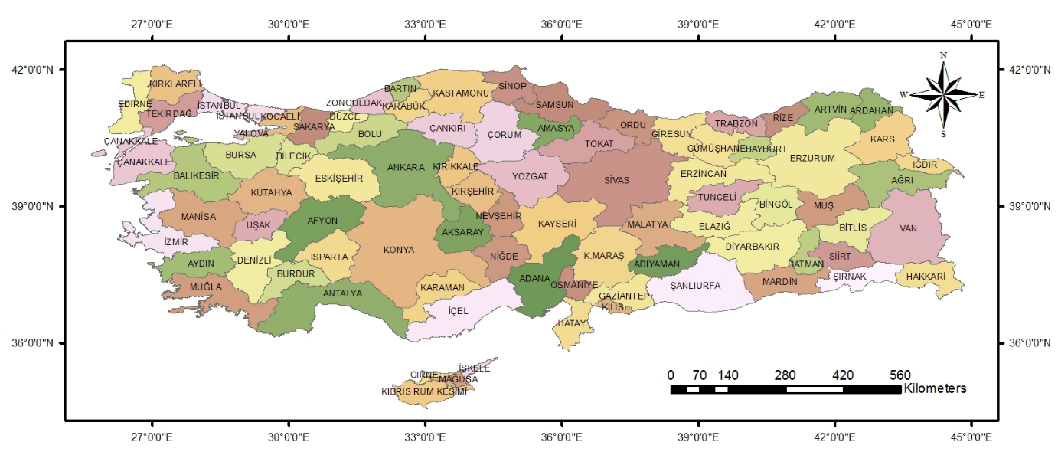
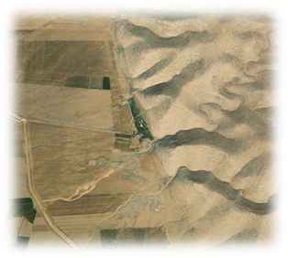
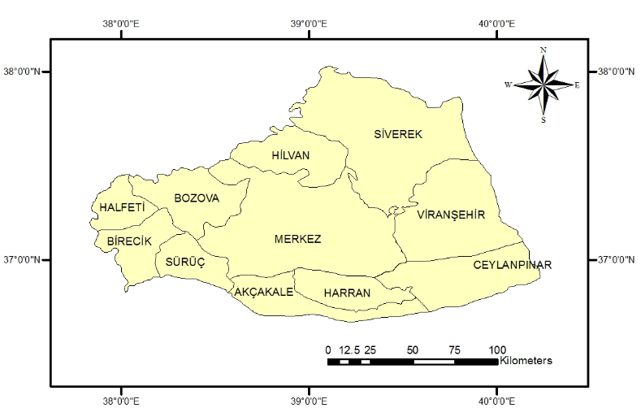

Figure 1. The map of study area

TABLES

Table 1. The timetable for the cultivation for lentil
Timetable
Time | Treatment
24.11.2006 | Making treatment plots
27.11.2006 | Planting lentil seeds
12.01.2007 | Compacting the treatment plot
15.02.2007 | Germination
15.04.2007 | Flowering
18.05.2007 | Harvesting

Table 2. Statistical data of treatments with yield of plants
Treatment | Replicates | Yields (kg ha⁻¹)
Treatment | Replicates | Straw | Seed | Biomass
Control | 1 | 2924.1 | 602.7 | 3526.8
Control | 2 | 2388.4 | 513.4 | 2901.8
Control | 3 | 2678.5 | 580.4 | 3258.9
Mean |  | 2663.7*** | 565.5*** | 3229.2***
STD |  | 268.2 | 46.5 | 313.6
Strip Plots | 1 | 4352.6 | 1093.8 | 5446.4
Strip Plots | 2 | 4732.2 | 1205.3 | 5937.5
Strip Plots | 3 | 4722.1 | 1181.1 | 5903.2
Mean |  | 4602.3*** | 1160.1*** | 5762.4***
STD |  | 216.3 | 58.6 | 274.2
*** Significantly different at P <0.001 probability level

