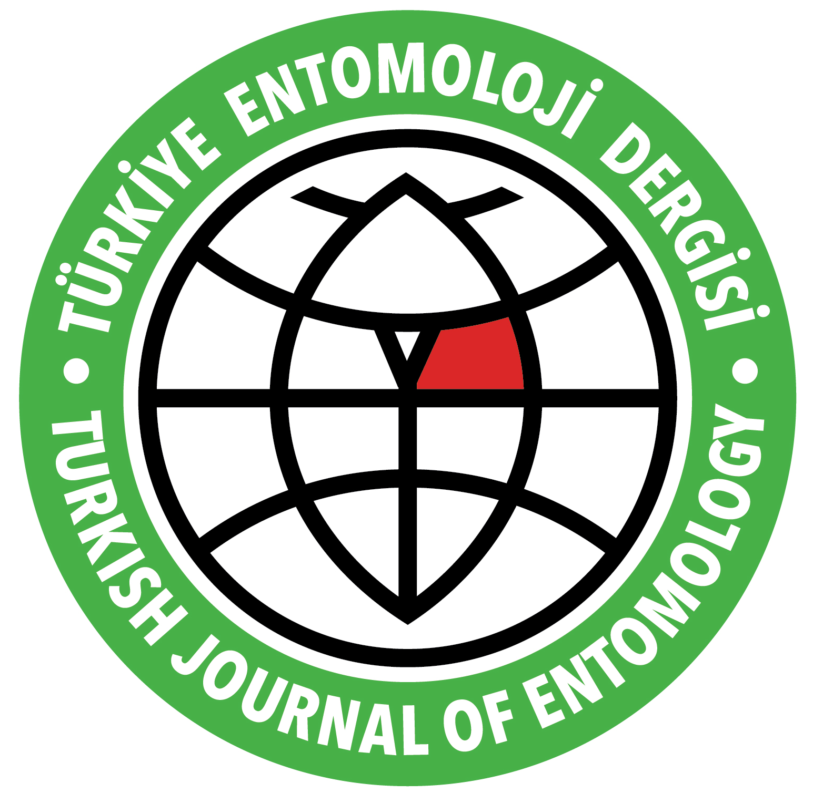 | COPYRIGHT RELEASE FORM

Article Title:__________________________________________________________________

The author(s) warrant(s) that:
i) The manuscript is author(s) own original work
ii) The manuscript has not been submitted/will not be submitted, any other journal or is not at the stage of any evaluation in another journal
iii) All authors participated in the work and have responsibility of the work,
iv) All authors have seen
v) All authors have seen and approved the manuscript;
vi) The manuscript is not copied wholly or substantially from any other work or material.
vii) Any material such as text, illustrations, and any others included in the manuscript are original and produced by the authors

Author(s) hereby grant Turkish Journal of Entomology the unlimited, worldwide, irrevocable royalty-free, right to publish, use, distribute, publish, license, transmit, display, exhibit, record, store, translate, digitize, broadcast, reproduce and archive, in any format or medium, whether now known or here after developed.

In consideration of my/our manuscript submitted Author(s) are agreed to transfer all financial rights to Entomological Society of Turkey.

This copyright form must be signed by all authors. Separate copies of the form (completed in full) may be submitted by authors located at different institutions; however, all signatures must be original.

Full name:_________________________ Signature:__________________ Date: ___________
Full name:_________________________ Signature:__________________ Date: ___________
Full name:_________________________ Signature:__________________ Date: ___________
Full name:_________________________ Signature:__________________ Date: ___________
Full name:_________________________ Signature:__________________ Date: ___________
Full name:_________________________ Signature:__________________ Date: ___________

