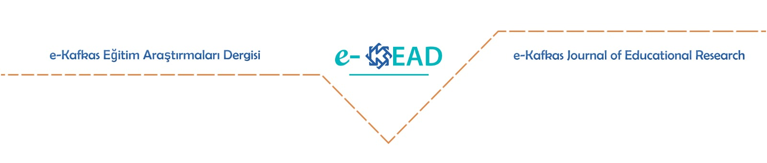

**Similarity Rate Statement**

The similarity rate of the article titled …………………………… is …..%. I declare that the article is not above this rate. I also declare that when one-to-one citations are over 40 words in the article, it is shown as a separate paragraph in accordance with the journal rules.

Correspondence author Name Surname

Signature