**[](https://dergipark.org.tr/jotcsb)** [](http://www.turchemsoc.org)

**Title of the Article (3 lines at most)**

**Author #11, Author #22, Author #33*, etc.**

1Affiliation line #1, two lines at most. University, Department, City, Zip, Country

2Affiliation line #2, two lines at most. University, Department, City, Zip, Country

3Affiliation line #3, two lines at most. University, Department, City, Zip, Country

**Abstract**: Maximum 250 words.

**Keywords:** Minimum 3, maximum 6.

*Corresponding author (E-mail is compulsory, providing telephone and fax numbers are optional)

# INTRODUCTION

(10 pt, Verdana, 1.5 paragraph spacing)

Lorem ipsum dolor sit amet, consectetur adipiscing elit. Maecenas pellentesque imperdiet lectus, pellentesque semper eros pretium in. Morbi finibus urna nec nisi facilisis tempor. Vestibulum a quam ut ipsum rutrum laoreet eget id purus. Donec in aliquet enim, id finibus diam. Aliquam interdum ac nibh non consectetur. Phasellus imperdiet sapien tortor, vel fringilla nunc placerat quis. Nulla scelerisque velit quis dignissim volutpat. Integer vulputate eu libero et pellentesque. Praesent quis scelerisque tellus. Ut eu scelerisque dui (Ackley et al., 1992; Erdoğan Alver, 2013; Nayak et al., 2017).

Aenean fermentum sem libero, nec tristique sapien pulvinar in. Phasellus non auctor enim. Curabitur sed ex lacinia, accumsan est nec, consequat eros. Cras finibus euismod lorem viverra rutrum. Nunc faucibus nec dui ut egestas. Integer ullamcorper, quam id aliquet condimentum, erat neque elementum metus, vel ornare risus mauris id erat (Ong et al., 2012) (4). Pellentesque auctor eros massa, sed malesuada purus lobortis sit amet. Fusce mi elit, imperdiet vitae urna et, aliquam pretium risus. Vestibulum sagittis, dui vitae interdum scelerisque, nibh lectus accumsan magna, nec euismod eros nulla a lorem. Aliquam pretium dui augue, sed tempus augue molestie non. Suspendisse blandit cursus vestibulum. Integer accumsan dui in risus aliquam, at fermentum urna hendrerit. Suspendisse pretium eu enim et pellentesque. Mauris tempor metus vitae iaculis feugiat. Cras in vulputate nunc. Nullam eleifend et arcu id finibus (Perrin et al., 2015; Pezoti et al., 2016; Rashid et al., 1972).

Vivamus at magna hendrerit, euismod ante eget, aliquam neque. In efficitur sit amet dolor accumsan consequat. Fusce enim justo, bibendum eu dolor et, ornare vulputate lacus. In hac habitasse platea dictumst. Phasellus quis ante et ligula ultricies mollis id ut sem. In hac habitasse platea dictumst. In ante lectus, facilisis eu enim dictum, mattis scelerisque purus. Pellentesque ultrices consequat nisl, eget rhoncus nibh molestie nec. Donec ante velit, iaculis id lacinia nec, finibus ut lacus. Donec congue turpis vitae viverra aliquet. In sed gravida odio. Donec efficitur scelerisque molestie. Vivamus pellentesque dapibus sapien, in elementum quam elementum eu (Perraki & Orfanoudaki, 2004; Roussel et al., 2010; Scholte et al., 1984).

# EXPERIMENTAL SECTION

## Second Degree Heading

Lorem ipsum dolor sit amet, consectetur adipiscing elit. Maecenas pellentesque imperdiet lectus, pellentesque semper eros pretium in. Morbi finibus urna nec nisi facilisis tempor. Vestibulum a quam ut ipsum rutrum laoreet eget id purus. Donec in aliquet enim, id finibus diam. Aliquam interdum ac nibh non consectetur. Phasellus imperdiet sapien tortor, vel fringilla nunc placerat quis. Nulla scelerisque velit quis dignissim volutpat. Integer vulputate eu libero et pellentesque. Praesent quis scelerisque tellus. Ut eu scelerisque dui (Tung, 1979; Vinu et al., 2006; Xia et al., 2013).

## Second Degree Heading

Lorem ipsum dolor sit amet, consectetur adipiscing elit. Maecenas pellentesque imperdiet lectus, pellentesque semper eros pretium in. Morbi finibus urna nec nisi facilisis tempor. Vestibulum a quam ut ipsum rutrum laoreet eget id purus. Donec in aliquet enim, id finibus diam. Aliquam interdum ac nibh non consectetur. Phasellus imperdiet sapien tortor, vel fringilla nunc placerat quis. Nulla scelerisque velit quis dignissim volutpat. Integer vulputate eu libero et pellentesque. Praesent quis scelerisque tellus. Ut eu scelerisque dui (Yu et al., 2019; Zimm & Kilb, 1959).

Aenean fermentum sem libero, nec tristique sapien pulvinar in. Phasellus non auctor enim. Curabitur sed ex lacinia, accumsan est nec, consequat eros. Cras finibus euismod lorem viverra rutrum. Nunc faucibus nec dui ut egestas. Integer ullamcorper, quam id aliquet condimentum, erat neque elementum metus, vel ornare risus mauris id erat. Pellentesque auctor eros massa, sed malesuada purus lobortis sit amet. Fusce mi elit, imperdiet vitae urna et, aliquam pretium risus. Vestibulum sagittis, dui vitae interdum scelerisque, nibh lectus accumsan magna, nec euismod eros nulla a lorem. Aliquam pretium dui augue, sed tempus augue molestie non. Suspendisse blandit cursus vestibulum. Integer accumsan dui in risus aliquam, at fermentum urna hendrerit. Suspendisse pretium eu enim et pellentesque. Mauris tempor metus vitae iaculis feugiat. Cras in vulputate nunc. Nullam eleifend et arcu id finibus (Molga et al., 2007).

## Second Degree Heading

Lorem ipsum dolor sit amet, consectetur adipiscing elit. Maecenas pellentesque imperdiet lectus, pellentesque semper eros pretium in. Morbi finibus urna nec nisi facilisis tempor. Vestibulum a quam ut ipsum rutrum laoreet eget id purus. Donec in aliquet enim, id finibus diam. Aliquam interdum ac nibh non consectetur. Phasellus imperdiet sapien tortor, vel fringilla nunc placerat quis. Nulla scelerisque velit quis dignissim volutpat. Integer vulputate eu libero et pellentesque. Praesent quis scelerisque tellus. Ut eu scelerisque dui (Mortazavi et al., 2021).

### Third degree heading

Lorem ipsum dolor sit amet, consectetur adipiscing elit. Maecenas pellentesque imperdiet lectus, pellentesque semper eros pretium in. Morbi finibus urna nec nisi facilisis tempor. Vestibulum a quam ut ipsum rutrum laoreet eget id purus. Donec in aliquet enim, id finibus diam. Aliquam interdum ac nibh non consectetur. Phasellus imperdiet sapien tortor, vel fringilla nunc placerat quis. Nulla scelerisque velit quis dignissim volutpat. Integer vulputate eu libero et pellentesque. Praesent quis scelerisque tellus. Ut eu scelerisque dui (McDonald et al., 2001).

### Third degree heading

Lorem ipsum dolor sit amet, consectetur adipiscing elit. Maecenas pellentesque imperdiet lectus, pellentesque semper eros pretium in. Morbi finibus urna nec nisi facilisis tempor. Vestibulum a quam ut ipsum rutrum laoreet eget id purus. Donec in aliquet enim, id finibus diam. Aliquam interdum ac nibh non consectetur. Phasellus imperdiet sapien tortor, vel fringilla nunc placerat quis. Nulla scelerisque velit quis dignissim volutpat. Integer vulputate eu libero et pellentesque. Praesent quis scelerisque tellus. Ut eu scelerisque dui (Lutz et al., 2002; Margot et al., 2013).

Aenean fermentum sem libero, nec tristique sapien pulvinar in. Phasellus non auctor enim. Curabitur sed ex lacinia, accumsan est nec, consequat eros. Cras finibus euismod lorem viverra rutrum. Nunc faucibus nec dui ut egestas. Integer ullamcorper, quam id aliquet condimentum, erat neque elementum metus, vel ornare risus mauris id erat. Pellentesque auctor eros massa, sed malesuada purus lobortis sit amet. Fusce mi elit, imperdiet vitae urna et, aliquam pretium risus. Vestibulum sagittis, dui vitae interdum scelerisque, nibh lectus accumsan magna, nec euismod eros nulla a lorem. Aliquam pretium dui augue, sed tempus augue molestie non. Suspendisse blandit cursus vestibulum. Integer accumsan dui in risus aliquam, at fermentum urna hendrerit. Suspendisse pretium eu enim et pellentesque. Mauris tempor metus vitae iaculis feugiat. Cras in vulputate nunc. Nullam eleifend et arcu id finibus (Levenspiel, 1999).

# RESULTS AND DISCUSSION[1]

Lorem ipsum dolor sit amet, consectetur adipiscing elit. Maecenas pellentesque imperdiet lectus, pellentesque semper eros pretium in. Morbi finibus urna nec nisi facilisis tempor. Vestibulum a quam ut ipsum rutrum laoreet eget id purus. Donec in aliquet enim, id finibus diam. Aliquam interdum ac nibh non consectetur. Phasellus imperdiet sapien tortor, vel fringilla nunc placerat quis. Nulla scelerisque velit quis dignissim volutpat. Integer vulputate eu libero et pellentesque. Praesent quis scelerisque tellus. Ut eu scelerisque dui (Katırcı et al., 2022).

Aenean fermentum sem libero, nec tristique sapien pulvinar in. Phasellus non auctor enim. Curabitur sed ex lacinia, accumsan est nec, consequat eros. Cras finibus euismod lorem viverra rutrum. Nunc faucibus nec dui ut egestas. Integer ullamcorper, quam id aliquet condimentum, erat neque elementum metus, vel ornare risus mauris id erat. Pellentesque auctor eros massa, sed malesuada purus lobortis sit amet. Fusce mi elit, imperdiet vitae urna et, aliquam pretium risus. Vestibulum sagittis, dui vitae interdum scelerisque, nibh lectus accumsan magna, nec euismod eros nulla a lorem. Aliquam pretium dui augue, sed tempus augue molestie non. Suspendisse blandit cursus vestibulum. Integer accumsan dui in risus aliquam, at fermentum urna hendrerit. Suspendisse pretium eu enim et pellentesque. Mauris tempor metus vitae iaculis feugiat. Cras in vulputate nunc. Nullam eleifend et arcu id finibus (Jodeh et al., 2016).

Vivamus at magna hendrerit, euismod ante eget, aliquam neque. In efficitur sit amet dolor accumsan consequat. Fusce enim justo, bibendum eu dolor et, ornare vulputate lacus. In hac habitasse platea dictumst. Phasellus quis ante et ligula ultricies mollis id ut sem. In hac habitasse platea dictumst. In ante lectus, facilisis eu enim dictum, mattis scelerisque purus. Pellentesque ultrices consequat nisl, eget rhoncus nibh molestie nec. Donec ante velit, iaculis id lacinia nec, finibus ut lacus. Donec congue turpis vitae viverra aliquet. In sed gravida odio. Donec efficitur scelerisque molestie. Vivamus pellentesque dapibus sapien, in elementum quam elementum eu (Fontecha-Cámara et al., 2007; Gu et al., 2019; Huerta-Fontela et al., 2011, p.) .

**Table 1:** Distribution of the elements in the milk sample.

|  |  |
| --- | --- |
| **Element** | **Concentration (mg/L)** |
| Calcium | 1500 |
| Magnesium | 700 |
| Potassium | 500 |
| Sodium | 350 |
| Lithium | 15 |

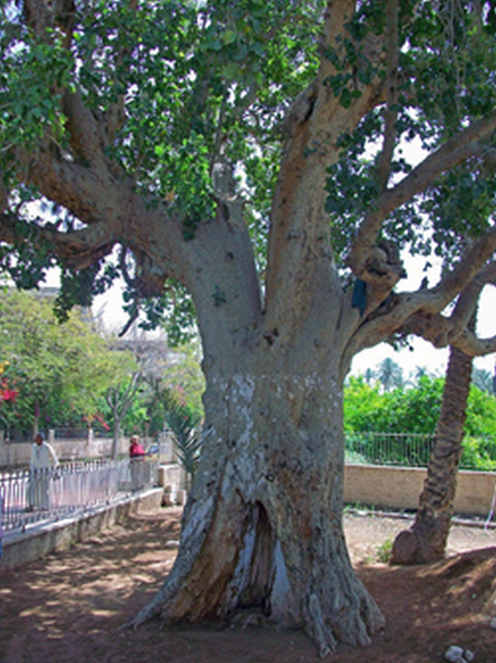

**Figure 1:** A tree (Minimum image resolution is 300 DPI; using irfanview at <https://www.irfanview.com> is recommended).

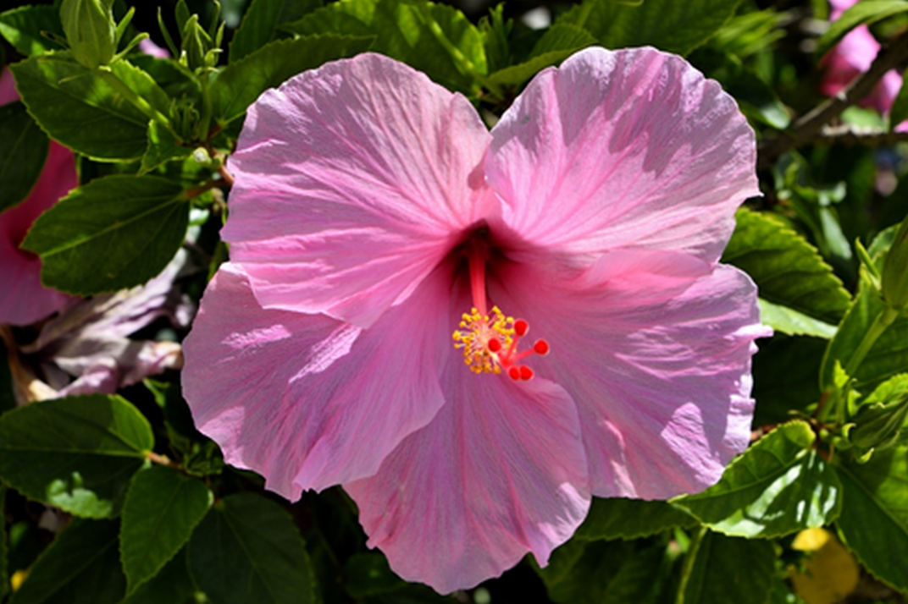

**Figure 2:** A flower (Minimum image resolution is 300 DPI; using irfanview at <https://www.irfanview.com> is recommended).

# CONCLUSION

Lorem ipsum dolor sit amet, consectetur adipiscing elit. Maecenas pellentesque imperdiet lectus, pellentesque semper eros pretium in. Morbi finibus urna nec nisi facilisis tempor. Vestibulum a quam ut ipsum rutrum laoreet eget id purus. Donec in aliquet enim, id finibus diam. Aliquam interdum ac nibh non consectetur. Phasellus imperdiet sapien tortor, vel fringilla nunc placerat quis. Nulla scelerisque velit quis dignissim volutpat. Integer vulputate eu libero et pellentesque. Praesent quis scelerisque tellus. Ut eu scelerisque dui (Flora et al., 2013).

Aenean fermentum sem libero, nec tristique sapien pulvinar in. Phasellus non auctor enim. Curabitur sed ex lacinia, accumsan est nec, consequat eros. Cras finibus euismod lorem viverra rutrum. Nunc faucibus nec dui ut egestas. Integer ullamcorper, quam id aliquet condimentum, erat neque elementum metus, vel ornare risus mauris id erat. Pellentesque auctor eros massa, sed malesuada purus lobortis sit amet. Fusce mi elit, imperdiet vitae urna et, aliquam pretium risus. Vestibulum sagittis, dui vitae interdum scelerisque, nibh lectus accumsan magna, nec euismod eros nulla a lorem. Aliquam pretium dui augue, sed tempus augue molestie non. Suspendisse blandit cursus vestibulum. Integer accumsan dui in risus aliquam, at fermentum urna hendrerit. Suspendisse pretium eu enim et pellentesque. Mauris tempor metus vitae iaculis feugiat. Cras in vulputate nunc. Nullam eleifend et arcu id finibus (Collins et al., 1973; de Souza et al., 2018; Desreux & Bischoff, 2010).

# CONFLICT OF INTEREST

Lorem ipsum dolor sit amet, consectetur adipiscing elit.

# ACKNOWLEDGMENTS

Lorem ipsum dolor sit amet, consectetur adipiscing elit. Maecenas pellentesque imperdiet lectus, pellentesque semper eros pretium in. Morbi finibus urna nec nisi facilisis tempor.

# REFERENCES

An example bibliography report, generated by Zotero, is like below:

Ackley, M. W., Giese, R. F., & Yang, R. T. (1992). Clinoptilolite: Untapped potential for kinetics gas separations. *Zeolites*, *12*(7), 780–788. https://doi.org/10.1016/0144-2449(92)90050-Y

Collins, E. A., Bareš, J., & Billmeyer, F. W. (1973). *Experiments in polymer science*. Wiley.

de Souza, V., Villarroel-Rocha, J., de Araújo, M., Sapag, K., & Pergher, S. (2018). Basic Treatment in Natural Clinoptilolite for Improvement of Physicochemical Properties. *Minerals*, *8*(12), 595. https://doi.org/10.3390/min8120595

Desreux, V., & Bischoff, J. (2010). Viscosimètres capillaires modifiés. *Bulletin Des Sociétés Chimiques Belges*, *59*(1–2), Article 1–2. https://doi.org/10.1002/bscb.19500590108

Erdoğan Alver, B. (2013). A comparative adsorption study of C2H4 and SO2 on clinoptilolite-rich tuff: Effect of acid treatment. *Journal of Hazardous Materials*, *262*, 627–633. https://doi.org/10.1016/j.jhazmat.2013.09.014

Flora, J. F. R., Lu, X., Li, L., Flora, J. R. V., & Berge, N. D. (2013). The effects of alkalinity and acidity of process water and hydrochar washing on the adsorption of atrazine on hydrothermally produced hydrochar. *Chemosphere*, *93*(9), 1989–1996. https://doi.org/10.1016/j.chemosphere.2013.07.018

Fontecha-Cámara, M. A., López-Ramón, M. V., Álvarez-Merino, M. A., & Moreno-Castilla, C. (2007). Effect of Surface Chemistry, Solution pH, and Ionic Strength on the Removal of Herbicides Diuron and Amitrole from Water by an Activated Carbon Fiber. *Langmuir*, *23*(3), 1242–1247. https://doi.org/10.1021/la062200f

Gu, R., Ding, J., Wang, Y., Yuan, Q., Wang, W., & Lu, J. (2019). Heat transfer and storage performance of steam methane reforming in tubular reactor with focused solar simulator. *Applied Energy*, *233–234*, 789–801. https://doi.org/10.1016/j.apenergy.2018.10.072

Huerta-Fontela, M., Galceran, M. T., & Ventura, F. (2011). Occurrence and removal of pharmaceuticals and hormones through drinking water treatment. *Water Research*, *45*(3), 1432–1442. https://doi.org/10.1016/j.watres.2010.10.036

Jodeh, S., Abdelwahab, F., Jaradat, N., Warad, I., & Jodeh, W. (2016). Adsorption of diclofenac from aqueous solution using *Cyclamen persicum* tubers based activated carbon (CTAC). *Journal of the Association of Arab Universities for Basic and Applied Sciences*, *20*(1), 32–38. https://doi.org/10.1016/j.jaubas.2014.11.002

Katırcı, R., Akgün, H. M., Tekin, B., Kömürkaya, O. G., Zontul, M., & Kaynar, O. (2022). Classification of Zinc-Coated Parts in Accordance with their Brightness Degree using Deep Learning Techniques. *Journal of t He Turkish Chemical Society, Section B: Chemical Engineering*, *5*(2), 145–156.

Levenspiel, O. (1999). Chemical Reaction Engineering. *Industrial & Engineering Chemistry Research*, *38*(11), 4140–4143. https://doi.org/10.1021/ie990488g

Lutz, W., Rüscher, C. H., & Heidemann, D. (2002). Determination of the framework and non-framework [SiO2] and [AlO2] species of steamed and leached faujasite type zeolites: Calibration of IR, NMR, and XRD data by chemical methods. *Microporous and Mesoporous Materials*, *55*(2), 193–202. https://doi.org/10.1016/S1387-1811(02)00403-1

Margot, J., Kienle, C., Magnet, A., Weil, M., Rossi, L., de Alencastro, L. F., Abegglen, C., Thonney, D., Chèvre, N., Schärer, M., & Barry, D. A. (2013). Treatment of micropollutants in municipal wastewater: Ozone or powdered activated carbon? *Science of The Total Environment*, *461–462*, 480–498. https://doi.org/10.1016/j.scitotenv.2013.05.034

McDonald, A. E., Grant, B. R., & Plaxton, W. C. (2001). Phosphite (phosphorous acid): Its relevance in the environment and agriculture and influence on plant phosphate starvation response. *Journal of Plant Nutrition*, *24*(10), 1505–1519. https://doi.org/10.1081/PLN-100106017

Molga, E. J., Lewak, M., & Roel Westerterp, K. (2007). Runaway prevention in liquid-phase homogeneous semibatch reactors. *Chemical Engineering Science*, *62*(18–20), 5074–5077. https://doi.org/10.1016/j.ces.2007.03.016

Mortazavi, N., Bahadori, M., Marandi, A., Tangestaninejad, S., Moghadam, M., Mirkhani, V., & Mohammadpoor-Baltork, I. (2021). Enhancement of CO2 adsorption on natural zeolite, modified clinoptilolite with cations, amines and ionic liquids. *Sustainable Chemistry and Pharmacy*, *22*, 100495. https://doi.org/10.1016/j.scp.2021.100495

Nayak, A., Bhushan, B., Gupta, V., & Sharma, P. (2017). Chemically activated carbon from lignocellulosic wastes for heavy metal wastewater remediation: Effect of activation conditions. *Journal of Colloid and Interface Science*, *493*, 228–240. https://doi.org/10.1016/j.jcis.2017.01.031

Ong, L. H., Dömök, M., Olindo, R., van Veen, A. C., & Lercher, J. A. (2012). Dealumination of HZSM-5 via steam-treatment. *Microporous and Mesoporous Materials*, *164*, 9–20. https://doi.org/10.1016/j.micromeso.2012.07.033

Perraki, Th., & Orfanoudaki, A. (2004). Mineralogical study of zeolites from Pentalofos area, Thrace, Greece. *Applied Clay Science*, *25*(1–2), 9–16. https://doi.org/10.1016/S0169-1317(03)00156-X

Perrin, F. X., Phan, T. A., & Nguyen, D. L. (2015). Synthesis and characterization of polyaniline nanoparticles in phosphonic acid amphiphile aqueous micellar solutions for waterborne corrosion protection coatings. *Journal of Polymer Science Part A: Polymer Chemistry*, *53*(13), 1606–1616. https://doi.org/10.1002/pola.27602

Pezoti, O., Cazetta, A. L., Bedin, K. C., Souza, L. S., Martins, A. C., Silva, T. L., Santos Júnior, O. O., Visentainer, J. V., & Almeida, V. C. (2016). NaOH-activated carbon of high surface area produced from guava seeds as a high-efficiency adsorbent for amoxicillin removal: Kinetic, isotherm and thermodynamic studies. *Chemical Engineering Journal*, *288*, 778–788. https://doi.org/10.1016/j.cej.2015.12.042

Rashid, M. A., Buckley, D. E., & Robertson, K. R. (1972). Interactions of a marine humic acid with clay minerals and a natural sediment. *Geoderma*, *8*(1), 11–27. https://doi.org/10.1016/0016-7061(72)90029-8

Roussel, N., Lemaître, A., Flatt, R. J., & Coussot, P. (2010). Steady state flow of cement suspensions: A micromechanical state of the art. *Cement and Concrete Research*, *40*(1), 77–84. https://doi.org/10.1016/j.cemconres.2009.08.026

Scholte, Th. G., Meijerink, N. L. J., Schoffeleers, H. M., & Brands, A. M. G. (1984). Mark–Houwink equation and GPC calibration for linear short-chain branched polyolefines, including polypropylene and ethylene–propylene copolymers. *Journal of Applied Polymer Science*, *29*(12), Article 12. https://doi.org/10.1002/app.1984.070291211

Tung, L. H. (1979). Block copolymer molecular weight by GPC. *Journal of Applied Polymer Science*, *24*(4), Article 4. https://doi.org/10.1002/app.1979.070240409

Vinu, A., Hossain, K. Z., Satish Kumar, G., & Ariga, K. (2006). Adsorption of l-histidine over mesoporous carbon molecular sieves. *Carbon*, *44*(3), 530–536. https://doi.org/10.1016/j.carbon.2005.08.004

Xia, F., Xu, H., Liu, C., Wang, J., Ding, J., & Ma, C. (2013). Microstructures of Ni–AlN composite coatings prepared by pulse electrodeposition technology. *Applied Surface Science*, *271*, 7–11. https://doi.org/10.1016/j.apsusc.2012.12.064

Yu, Y., Zhang, K., Yang, L., & Zhang, D. (2019). Fruit detection for strawberry harvesting robot in non-structural environment based on Mask-RCNN. *Computers and Electronics in Agriculture*, *163*, 104846. https://doi.org/10.1016/j.compag.2019.06.001

Zimm, B. H., & Kilb, R. W. (1959). Dynamics of branched polymer molecules in dilute solution. *Journal of Polymer Science*, *37*(131), Article 131. https://doi.org/10.1002/pol.1959.1203713102

1. # (or a similar first degree heading)

  