**RESEARCH / REVIEW Open Access**

**ARAŞTIRMA / DERLEME Açık Erişim**

**Article Title[1]\***

Makale Başlığı

**Author Name Surname, Author Name Surname**

|  |  |
| --- | --- |
| **ABSTRACT**  Turkish and English abstracts of no more than 150 words should be written in the manuscript. Do not make any changes to the header and footer. Do not change the page layout and margins. Do not mark tabs on the ruler. Do not change font and size. When copying your manuscript from another source and pasting it into this document, select Match Destination Formatting from the menu at the bottom right corner of the text. Complete all your editing on this document and do not use any other formatting. Save the document with the filename as the title of the article and send it via the "submit article" button on the Dergipark platform. Be careful not to overflow the Turkish and English abstract of the article on the next page. In the "Keywords" section of the Article information section, 3-5 keywords should be included. The first word of the keywords should start with a capital letter and be written one below the other. Something you want to point out in relation to the manuscript (e.g. Producing from a graduate thesis or a project, presenting as a paper), if any, please specify in the footnote. | **Author Information**  **Author Name Surname**  Title, Instution, City, Country [emailaddress@mail.com](mailto:emailaddress@mail.com)  **Author Name Surname**  Title, Instution, City, Country [emailaddress@mail.com](mailto:emailaddress@mail.com)  **Author Name Surname**  Title, Instution, City, Country [emailaddress@mail.com](mailto:emailaddress@mail.com) |
| **ÖZ**  Aday makalede 150 kelimeyi geçmeyecek şekilde Türkçe Öz ve İngilizce Abstract yazılmalıdır. Üst bilgi ve alt bilgi ile ilgili herhangi bir değişiklik yapmayınız. Sayfa yapısı ve kenar boşluklarını değiştirmeyiniz. Cetvel üzerinde sekme noktaları işaretlemeyiniz. Yazı tipi ve boyutunda değişiklik yapmayınız. Aday makalenizi başka bir kaynaktan kopyalayıp bu belgeye yapıştırıyorsanız, yapıştırma işleminden sonra metnin sağ alt köşesinde çıkan menüden Hedef Biçimlendirmesini Eşleştir seçeneğini seçiniz. Tüm düzenlemenizi bu belge üzerinde tamamlayınız ve farklı bir biçimlendirme kullanmayınız. Belgeyi, dosya adı makale başlığı olacak şekilde kaydedip Dergipark platformu üzerinden “makale gönder” butonu aracılığı ile gönderiniz. Makalenin Türkçe ve İngilizce özetinin sonraki sayfaya taşmamasına dikkat ediniz. Makale bilgileri kısmında yer alan “Anahtar Kelimeler” bölümünde 3-5 adet anahtar kelimeye yer verilmelidir. Anahtar kelimelerin ilk sözcüğü büyük harfle başlamalı ve alt alta yazılmalıdır. Makale geçmişi bilgileri dergi editörlüğü tarafından düzenlenecektir. Aday makale ile ilgili belirtmek istediğiniz bir durum (Ör: Lisansüstü bir tezden veya projeden üretilme, bildiri olarak sunulma) var ise dipnotta belirtiniz. | **Article Information**  **Keywords**  Keyword 1  Keyword 2  Keyword 3  **Anahtar Kelimeler**  Anahtar kelime 1  Anahtar kelime 2  Anahtar kelime 3  **Article History**  **Arrival**: xx/xx/xxxx  **Editing**: xx/xx/xxxx  **Acceptance**: xx/xx/xxxx |
| **For Attribution:** Surname, N., & Surname, N. (20XX). Title of the article*. JRES, X*(X), X-X. https://doi.org/10.51725/etad.xxxxxx | |
| **Ethical Statement:** In this section information about ethics committee approval will be given (Committee name, date, and issue numbers). | |

Introduction

Palatino Linotype font should be used in the entire document. First level headings such as introduction, method, findings, discussion and conclusion, and references should be written in 12 font size, centered, bold and the initials of each word should be written in capital letters except for conjunctions. First level headings should be written in 1.15 line spacing with 12 pt before the paragraph and 6 pt after the paragraph with automatic space.

The main text should be 10 point size and justified alignment. It should be written in 1,15 line spacing with 6 pt automatic spacing before the paragraph and 0 pt after the paragraph. This part of the article can be given as a whole or it can be given as sub-headings when necessary.

The Journal of Research in Education and Society includes experimental, review, quantitative and qualitative research in the field of education. The Journal of Research in Education and Society publishes theoretical and / or empirical articles online, that contributes to the field and guides academics and educators. Our journal includes articles on policy recommendations, educational practices and problems related to education.

Manuscripts submitted to the journal should not have been published elsewhere or submitted for publication. All publication rights of the articles accepted for publication belong to the Journal of Research in Education and Society. In the writing of the manuscript, the narrative should be as simple, understandable, short and concise as possible. Statements containing judgment or precise should be based on data/references. 3rd person singular narration should be used in article writing. During the writing process, the most recent Spelling Guide published by the Turkish Language Institution should be taken as a guide. Manuscripts can be written in Turkish or English.

The manuscript submitted to the Journal of Research in Education and Society is formally reviewed by the Editor and/or Assistant Editors in terms of publishing policy and rules. The manuscript that is found unsuitable is returned to its author(s) without evaluation or sent back to the author(s) for corrections.

Citation rules specified in the 6th edition of the American Psychological Association (APA 6th Edition) should be referenced when citing citations in the text and citing the references in the "REFERENCES" section. Do not make any changes to the header and footer. Do not change the page layout and margins. Do not mark tabs on the ruler. Do not change font and size. When copying your manuscript from another source and pasting it into this document, select Match Destination Formatting from the menu at the bottom right corner of the text. Complete all your editing on this document and do not use any other formatting. Save the document with the file name as the title of the article and send it on the Dergipark platform.

**Second Level Subheading**

The second level subheading should be written in 11 pt, left aligned, bold, and the first letter of each word should be written in capital letters except conjunctions. Second level subheadings should be written in 1.15 line space with 6 pt automatic space before and after the paragraph.

**Third Level Sub-Heading**

The third level subheading should be written in 11 points, indented 1.25 cm from the left margin, in bold, and the first letter of each word should be written in capital letters except conjunctions. Third level headings should be written in 1.15 line spacing with 6 pt automatic spacing before and after the paragraph.

***Fourth Level Sub-Heading***

The fourth level subheading should be written in 11 font size, 2.5 cm indented from the left margin, bold, italic and the first letter of each word should be capitalized except for the conjunctions. Fourth level headings should be written in 1.15 line spacing with 6 pt automatic spacing before and after the paragraph.

**Method**

The type of study, research group, data collection tools, validity and reliability, data collection process, data analysis, ethics committee approval should be explained in the method section. In case reports, information about signing the informed consent/consent form should also be included in the method section. There should be no direct transition between titles, explanatory statements should be included.

**Research Model**

The model/design of the research should be explained.

**Study Group / Population and Sample**

Information about the participants of the study should be given.

**Ethical Statement**

In cases where ethics committee approval is required, the name of the ethics committee, the date on which it was taken and the issue number should be included (Ex: This study was carried out in accordance with the approval of the Ethics Committee of ... University with the date and number ...). In articles that do not require an ethics committee decision, it should be stated in this section and in the "Ethical Statement" section on the first/last page of the article that the ethics committee decision is not required, along with its justification. (For example: This article does not require an ethics committee decision as it is a review type.)

**Data Collection Tools**

This section should include information on data collection tools. If the data collection tools are to be explained in the form of titles, they can be presented as follows.

**Attitude Scale Towards Reading**

Information on the scale should be explained.

**Data Collection**

Data collection process should be explained.

**Data Analysis**

Detailed information on the analysis of the data should be included in this section.

**Findings**

The findings obtained in the research should be explained with relevant tables, figures, graphics or pictures in a way that supports the purpose and problem of the study and maintains its integrity.

**Sub-Heading**

Do not make any changes to the header and footer. Do not change the page layout and margins. Do not mark tabs on the ruler. Do not change the font and size.

When copying your manuscript from another source and pasting it into this document, select Match Destination Formatting from the menu at the bottom right corner of the text. Complete all your editing on this document and do not use any other formatting. Save the document with the filename as the title of the article and send it via the Dergipark platform.

**Table 1.** Statistics Results Regarding the Distribution of Students by Gender

|  |  |  |  |  |  |
| --- | --- | --- | --- | --- | --- |
|  | **Girl** | **Boy** | **Total** | **Unanswered** | **General Total** |
| **Frequency** | 852 | 671 | 1523 | 2 | 1525 |
| **Percentage** | 55,9 | 44,0 | 99,9 | 0,1 | 100,0 |

The table title should be positioned above and centered on the table. The section where the table number is indicated should be written in bold and the table name should be written in thin font. In the table name, the first letter of each word should be capitalized, except conjunctions. Single line spacing should be used in tables.

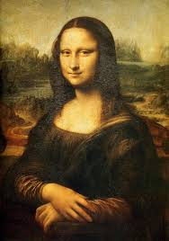

**Figure 1.** Leonardo Da Vinci, Monalisa. **Figure 2.** Johannes Vermeer, Girl with a Pearl Earring.

Figure information should be written below the figure, centered on the figure. The part where the figure number is indicated should be written in bold and the figure name should be written in thin font. Sentence case should be used in the figure name, the first letter of the first word should be written in capital letters and the other words should be written in lowercase, except for proper nouns. A period (.) should be placed at the end of the figure name. Depending on the request of the author(s), some figures can be given side by side as seen above.

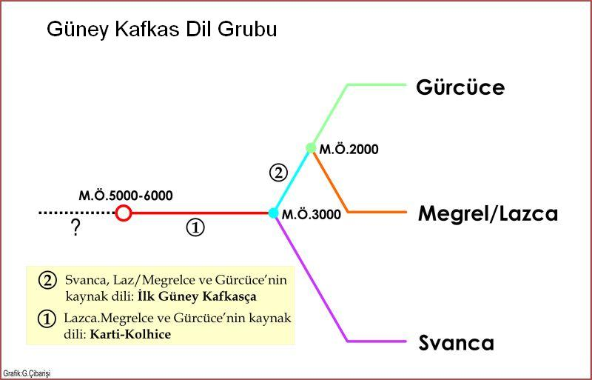

**Figure 3.** Languages in the South Caucasian language group (Çibarişi, 2015).

**Discussion, Conclusion, and Recommendations**

Conclusion, discussion and recommendations can optionally be presented under separate headings. In the discussion section, the findings obtained as a result of the research should be discussed with the comments of the literature and of the author. In the conclusion part, the main ideas emerging in the light of the discussions should be explained. Recommendations should be made in accordance with the discussion and conclusion of the study. In addition, recommendations for future studies and applications in the field that will contribute to the literature should also be included.

**References**

In this section, reference should be made to the citation guidelines specified in the 6th edition of the American Psychological Association (APA 6th Edition). References should be given in alphabetical order. The section should be placed on the same page with the text without moving to a new page. All the sources mentioned in the text should be included in the "References" list, and all the sources in the "References" list should be included in the text.

For detailed information, please see the “Writing Rules” tab of the journal web page.

Bard, I., Gaskell, G., Allansdottir, A., da Cunha, R. V., Eduard, P., Hampel, J., … Zwart, H. (2018). Bottom-up ethics-neuroenhancement in education and employment. *Neuroethics, 11*(3), 309–322.

Borg, S. (2015, April). *Evaluating an action research scheme for English language teachers.* Paper presented at the IATEFL, Manchaster.

Bourdieu, P., & Passeron, J. (1990). *Reproduction in education, society and culture.* UK: Sage.

Bruer, J. T. (2013). Afterword. D. Mareschal, B. Butterworth, & A. Tolmie (Eds.), In *Educational neuroscience* (pp. 349-363). UK: Wiley Blackwell.

DARPA (2016a). Boosting synaptic plasticity to accelerate learning. Retrieved from <https://www.darpa.mil/news-events/2016-03-16>

Goodfellow, R., & Lamy, M. (2009). *Learning cultures in online education.* London: Continuum. Retrieved from <http://site.ebrary.com/lib/gazi/docDetail.action?docID=10362025>

Larrivee, B. (2008). Meeting the challenge of preparing reflective practitioners. *The New Educator, 4*(2), 87-106. <https://doi.org/10.1080/15476880802014132>

Moran, C. (2005). *Teacher and principal perceptions of dispositional characteristics needed by middle school teachers to be most effective in the classroom.* (Doctoral dissertation). Retrieved from <https://www.proquest.com/openview/c5abcad4fd61d2898521f09a1c00f719/1?pqorigsite=gscholar&cbl=18750&diss=y>

Squire, L. R., Berg, D., Bloom, F. E., Du-Lac, S., Ghosh, A., & Spitzer, N. C. (2013). *Fundamental neuroscience* (4th ed.). Oxford, UK: Academic.

**Author Contribution Statement**

In this section, the contributions of the authors to the research process should be briefly explained.

**Acknowledgement**

In this section, if any, information about the institutions and organizations that support the article, or people who do not take place as authors but support researchers should be included.

**Conflict of Interest**

If the researchers have any conflicts of interest with other persons and institutions related to the research, please please specify that in this section. Otherwise, it should be stated that there is no conflict of interest.

**Ethical Statement**

In cases where ethics committee approval is required, the name of the ethics committee, the date of receipt and the issue number should be included (Ex: This study was carried out in accordance with the approval of the Ethics Committee of the University of ... with date and number ...).

In articles that do not require ethics committee approval, this should be stated along with its justification. (For example: This article does not require an ethics committee decision as it is a review type).

1. * Indicate if the study was produced from a graduate thesis, supported within the scope of the project or presented as a paper. If there is nothing to specify, delete the footnote symbol (*) in the upper right corner of the article title.