Türkçe Başlık (14pt)

Özet
Türkçe öz tükçe öz Türkçe öz tükçe öz Türkçe öz tükçe öz Türkçe öz tükçe öz Türkçe öz tükçe öz Türkçe öz tükçe öz Türkçe öz tükçe öz Türkçe öz tükçe öz Türkçe öz tükçe öz Türkçe öz tükçe öz Türkçe öz tükçe öz Türkçe öz tükçe öz Türkçe öz tükçe öz Türkçe öz tükçe öz Türkçe öz tükçe öz Türkçe öz tükçe öz Türkçe öz tükçe öz Türkçe öz tükçe öz Türkçe öz tükçe öz Türkçe öz tükçe öz Türkçe öz tükçe öz Türkçe öz tükçe öz Türkçe öz tükçe öz Türkçe öz tükçe öz Türkçe öz tükçe öz Türkçe öz tükçe öz Türkçe öz tükçe öz Türkçe öz tükçe öz Türkçe öz tükçe öz Türkçe öz tükçe öz
Anahtar kelimeler:Kelime, kelime, kelime, kelime, kelime
Jel Kodu: C01, C23, K12
English Title(12pt)
Abstract
Abstract abstract abstract abstract abstract abstract abstract abstract abstract abstract abstract abstract abstract abstract abstract abstract abstract abstract abstract abstract abstract abstract abstract abstract abstract abstract abstract abstract abstract abstract abstract abstract abstract abstract abstract abstract abstract abstract abstract abstract abstract abstract abstract abstract abstract abstract abstract abstract abstract abstract abstract abstract abstract abstract abstract abstract abstract abstract abstract abstract abstract abstract abstract abstract abstract abstract abstract abstract abstract abstract abstract abstract abstract abstract abstract abstract.
Keywords: Keyword, keyword, keyword, keyword, keyword
Jel Codes: C01, C23, K12

GİRİŞ
Lorem Ipsum is simply dummy text of the printing and typesetting industry. Lorem Ipsum has been the industry's standard dummy text ever since the 1500s, when an unknown printer took a galley of type and scrambled it to make a type specimen book. It has survived not only five centuries, but also the leap into electronic typesetting, remaining essentially unchanged. It was popularised in the 1960s with the release of Letraset sheets containing Lorem Ipsum passages, and more recently with desktop publishing software like Aldus PageMaker including versions of Lorem Ipsum.
Lorem Ipsum is simply dummy text of the printing and typesetting industry. Lorem Ipsum has been the industry's standard dummy text ever since the 1500s, when an unknown printer took a galley of type and scrambled it to make a type specimen book. It has survived not only five centuries, but also the leap into electronic typesetting, remaining essentially unchanged. It was popularised in the 1960s with the release of Letraset sheets containing Lorem Ipsum passages, and more recently with desktop publishing software like Aldus PageMaker including versions of Lorem Ipsum.

KAVRAMSAL ÇERÇEVE
Lorem Ipsum is simply dummy text of the printing and typesetting industry. Lorem Ipsum has been the industry's standard dummy text ever since the 1500s, when an unknown printer took a galley of type and scrambled it to make a type specimen book. It has survived not only five centuries, but also the leap into electronic typesetting, remaining essentially unchanged. It was popularised in the 1960s with the release of Letraset sheets containing Lorem Ipsum passages, and more recently with desktop publishing software like Aldus PageMaker including versions of Lorem Ipsum.
  - Motivasyon Kavramı
Lorem Ipsum is simply dummy text of the printing and typesetting industry. Lorem Ipsum has been the industry's standard dummy text ever since the 1500s, when an unknown printer took a galley of type and scrambled it to make a type specimen book. It has survived not only five centuries, but also the leap into electronic typesetting, remaining essentially unchanged. It was popularised in the 1960s with the release of Letraset sheets containing Lorem Ipsum passages, and more recently with desktop publishing software like Aldus PageMaker including versions of Lorem Ipsum(Ahmed, 2010).
  - Örgütsel Vatandaşlık Kavramı
Lorem Ipsum is simply dummy text of the printing and typesetting industry. Lorem Ipsum has been the industry's standard dummy text ever since the 1500s, when an unknown printer took a galley of type and scrambled it to make a type specimen book. It has survived not only five centuries, but also the leap into electronic typesetting, remaining essentially unchanged. It was popularised in the 1960s with the release of Letraset sheets containing Lorem Ipsum passages, and more recently with desktop publishing software like Aldus PageMaker including versions of Lorem Ipsum(Ahmed, 2010).

LİTERATÜR TARAMASI
Lorem Ipsum is simply dummy text of the printing and typesetting industry. Lorem Ipsum has been the industry's standard dummy text ever since the 1500s, when an unknown printer took a galley of type and scrambled it to make a type specimen book. It has survived not only five centuries, but also the leap into electronic typesetting, remaining essentially unchanged. It was popularised in the 1960s with the release of Letraset sheets containing Lorem Ipsum passages, and more recently with desktop publishing software like Aldus PageMaker including versions of Lorem Ipsum.

YÖNTEM
Lorem Ipsum is simply dummy text of the printing and typesetting industry. Lorem Ipsum has been the industry's standard dummy text ever since the 1500s, when an unknown printer took a galley of type and scrambled it to make a type specimen book. It has survived not only five centuries, but also the leap into electronic typesetting, remaining essentially unchanged. It was popularised in the 1960s with the release of Letraset sheets containing Lorem Ipsum passages, and more recently with desktop publishing software like Aldus PageMaker including versions of Lorem Ipsum.
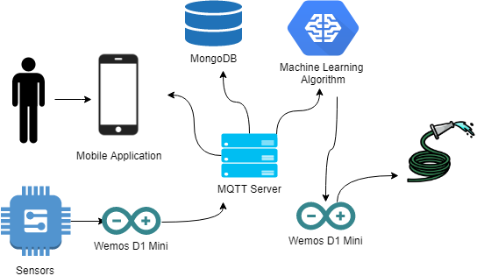
Şekil 1: Araştırmanın Modeli
Kaynak: Deep ve Mebrahtu, 2011
Lorem Ipsum is simply dummy text of the printing and typesetting industry. Lorem Ipsum has been the industry's standard dummy text ever since the 1500s, when an unknown printer took a galley of type and scrambled it to make a type specimen book. It has survived not only five centuries, but also the leap into electronic typesetting, remaining essentially unchanged. It was popularised in the 1960s with the release of Letraset sheets containing Lorem Ipsum passages, and more recently with desktop publishing software like Aldus PageMaker including versions of Lorem Ipsum. Lorem Ipsum is simply dummy text of the printing and typesetting industry. Lorem Ipsum has been the industry's standard dummy text ever since the 1500s, when an unknown printer took a galley of type and scrambled it to make a type specimen book. It has survived not only five centuries, but also the leap into electronic typesetting, remaining essentially unchanged. It was popularised in the 1960s with the release of Letraset sheets containing Lorem Ipsum passages, and more recently with desktop publishing software like Aldus PageMaker including versions of Lorem Ipsum (Çolak, 2010).

UYGULAMA
Lorem Ipsum is simply dummy text of the printing and typesetting industry. Lorem Ipsum has been the industry's standard dummy text ever since the 1500s, when an unknown printer took a galley of type and scrambled it to make a type specimen book. It has survived not only five centuries, but also the leap into electronic typesetting, remaining essentially unchanged. It was popularised in the 1960s with the release of Letraset sheets containing Lorem Ipsum passages, and more recently with desktop publishing software like Aldus PageMaker including versions of Lorem Ipsum.

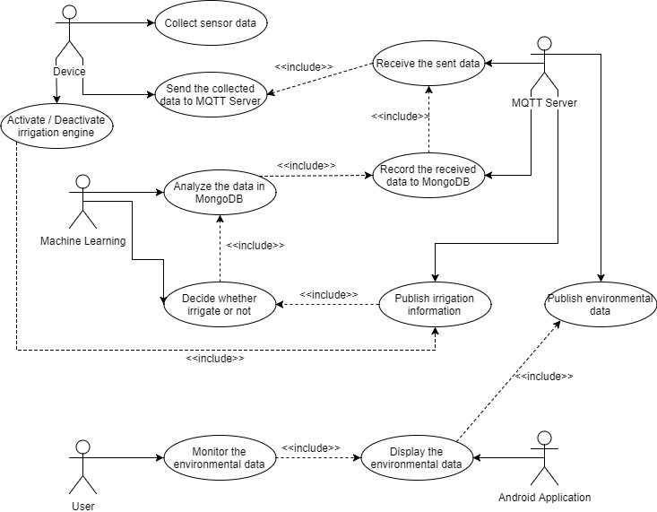
Şekil 2: Uygulama Diyagramı
Kaynak: Deep ve Mebrahtu, 2011

5.1. Aracılık Etkisinin Analizi
Lorem Ipsum is simply dummy text of the printing and typesetting industry. Lorem Ipsum has been the industry's standard dummy text ever since the 1500s, when an unknown printer took a galley of type and scrambled it to make a type specimen book. It has survived not only five centuries, but also the leap into electronic typesetting, remaining essentially unchanged. It was popularised in the 1960s with the release of Letraset sheets containing Lorem Ipsum passages, and more recently with desktop publishing software like Aldus PageMaker including versions of Lorem Ipsum.

5.2. Değişkenler Arası Korelasyonların İncelenmesi
Lorem Ipsum is simply dummy text of the printing and typesetting industry. Lorem Ipsum has been the industry's standard dummy text ever since the 1500s, when an unknown printer took a galley of type and scrambled it to make a type specimen book. It has survived not only five centuries, but also the leap into electronic typesetting, remaining essentially unchanged. As a result of 30 tests, 94% success was achieved as given in Table 1.
Tablo 1: Veri Tablosu
DATA | DATA | ACTUAL | RESULT
Kaynak: Deep ve Mebrahtu, 2011

Lorem Ipsum is simply dummy text of the printing and typesetting industry. Lorem Ipsum has been the industry's standard dummy text ever since the 1500s, when an unknown printer took a galley of type and scrambled it to make a type specimen book. It has survived not only five centuries, but also the leap into electronic typesetting, remaining essentially unchanged.

SONUÇ VE ÖNERİLER
Lorem Ipsum is simply dummy text of the printing and typesetting industry. Lorem Ipsum has been the industry's standard dummy text ever since the 1500s, when an unknown printer took a galley of type and scrambled it to make a type specimen book. It has survived not only five centuries, but also the leap into electronic typesetting, remaining essentially unchanged. It was popularised in the 1960s with the release of Letraset sheets containing Lorem Ipsum passages, and more recently with desktop publishing software like Aldus PageMaker including versions of Lorem Ipsum.

KAYNAKÇA

Ahmed, Z. H. (2010). Genetic algorithm for the traveling salesman problem using sequential constructive crossover operator. International Journal of Biometrics & Bioinformatics (IJBB), 3(6), 96.
Çolak, S. (2010). Genetik algoritmalar yardımı ile gezgin satıcı probleminin çözümü üzerine bir uygulama. Çukurova Üniversitesi Sosyal Bilimler Enstitüsü Dergisi, 19(3), 423-438.
Deep, K., & Mebrahtu, H. (2011). Combined mutation operators of genetic algorithm for the travelling salesman problem. International Journal of Combinatorial Optimization Problems and Informatics, 2(3), 1-23.

