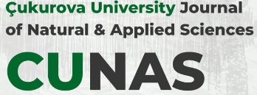
CUKUROVA UNIVERSITY JOURNAL OF NATURAL AND APPLIED SCIENCES

COPYRIGHT TRANSFER FORM

Title of the manuscript

Corresponding Author (on behalf of all authors)

The Author’s Responsibilities
Article(s) must be submitted on the understanding that they have not been published elsewhere and are not currently under consideration by another journal or any other publisher.

The submitting author is responsible for ensuring that the article’s publication has been approved by all the other co-authors.

The author(s) undertake(s) all scientific and ethical responsibility for the manuscript.

Signature
Corresponding Author

