Research/Review Article
Journal of Investigations on Engineering & Technology
Volume **, Issue *, **-**, 20**
DOI: xxxxxxxxxxxxxxxxx
ISSN: 2687-3052

The Title of the Article should be written with the first letter of the words in Capital (conjunctions in small) and in “Cambria” Font, 12 pt

AUTHOR NAMES WILL BE FILLED AFTER THE ARTICLE IS ACCEPTED. THIS SECTION WILL BE LEFT BLANK AT THE FIRST POSTING.

Name SURNAME, Name SURNAME, Name SURNAME

(Alınış / Received: **.**.20**, Kabul / Accepted: **.**.20**, Online Yayınlanma / Published Online: **.**.20**)
The first letter of the title must be written in 12 pt in Large (conjunctions small) and "Cambria" Font
Keywords  Please add at least three keywords  such as: Keywords 1  Keywords 2  Keywords 3 | Abstract: In this section, the summary of the study, method and results should be briefly written. The summary text should be typed in "Cambria" font size 10 and single line spacing. Please do not change the writing area limits in the right-left direction. In this section, the text to be added, the Turkish title and abstract, the English title and summary sections together must not exceed one (1) page. Do not change the layout in the section where the author and date information is located. There is no need to write Turkish title, abstract and key words in English articles. However, Turkish title and Abstract will be written in English. When your work is published, the volume, number, page number, date information will be edited by you. Do not make changes in these sections.

- Spelling Rules

The entire article should be written in a single column with 10 font size, "Cambria" font. Line spacing should be “single” and a “single line” space should be left before and after paragraphs. There should be 6 pt space between the titles and the text. Titles can be written as 1. Introduction, 2. Materials and Methods, 3. Results, 4. Discussion and Conclusion. Subtitles can be added if necessary.

Titles should be written in bold letters, the first letters of all words except conjunctions should be capitalized. Conjunctions should be written in lower case. In subtitles, only the first letter of the title should be capitalized. The font, size and spacing should be like the main section titles.

  - Reference notation

References should be shown in square brackets [1]. References should be given in order, and it should be checked that the references shown in the text are in the bibliography.

2. Display of Formulas
If it is necessary to show a formula in the article, it should be given from the beginning, in the order shown in the example. One line space should be left before and after the equation. The equation should be written in “Cambria Math” font, size 10 and single-spaced. The equation should be referenced in the text and the symbols in the equation should be explained.
$$F=m∙a$$ | (1)
$$q=0.00443\frac{V^{2}}{R}$$ | (2)

3. Display of Tables and Figures
Tables, graphics, pictures and figures used in the article should be numbered sequentially. No space should be left between the figure and table name and the figure or table. One line space should be left between the text and tables and figures. Graphics, pictures and figures should be named as “Figure”. A minimum resolution of 600dpi is required for images. The texts in the images should be easily readable. Tables and figures should be written in bold with their numbers. Example: Figure 1. XXXxxx. Figure and Table names should be in 10 points with only the first letters capitalized. Column headings and data in the table should be written in 9 font size, "Cambria" font. Tables or figures and their names should be centered in the layout.

You can use the following examples when you need to add tables and figures

Table 1. Example table [3].
Column Header | Column Header | Column Header | Column Header
Information line | Information input | Information line | Information input
Information line | Information input | Information line | Information input
Information line | Information input | Information line | Information input
Information line | Information input | Information line | Information input

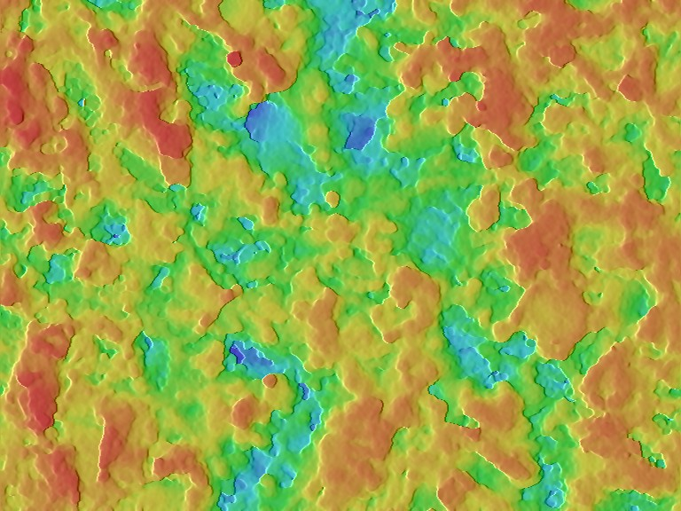
Figure 1. Topological view

Acknowledge
In this chapter; The people or institutions that contributed to the study should be thanked. Project support should be stated in the articles produced from the project.

Author Contribution

In this section, the contributions to the study should be clearly written next to the full name(s) of the author(s). For example, “Identification and management of the conceptual and design processes of First Name1 and Last Name1 work, First Name2 and Last Name2 data collection and data analysis, First Name3 and Last Name3 data analysis and interpretation”
Conflict of Interest

The author(s) confirm that there is no known conflict of interest or common interest with any institution/organization or person. (In case of no conflict of interest)
The author(s) confirm that the following conflicts of interest exist regarding the issues written and/or discussed in this study (Interests obtained should be written with the explicit name of the relevant author). (In case of any conflict of interest)
References
References to be given in the bibliography should be written in the order they are mentioned in the text, in "Cambria" font, 10 points. There should be 6 nk space between the references. References should be written according to the APA style.

- Hussein, A. A., Jaya, R. P., Hassan, N. A., Yaacob, H., Huseien, G. F., & Ibrahim, M. H. W. (2017). Performance of nanoceramic powder on the chemical and physical properties of bitumen. Construction and Building Materials, 156, 496-505. (Full lenght articles)
- Roberts, F. L., Kandhal, P. S., Brown, E. R., Lee, D. Y., & Kennedy, T. W. (1991). Hot mix asphalt materials, mixture design and construction. (Book sources)
- Hjelmstad, K. D., Kim, J., & Zuo, Q. H. (1997). Finite element procedures for three-dimensional pavement analysis. In Proceedings of the 1997 Airfield Pavement Conference. ASCE. (Conference papers)
- Rathburn, L., Heally, C.N., Tech, G. 2005. What is Nanotechnology? http://www.nnin.org/news-events/spotlights/what-nanotechnology (Erişim Tarihi: 13.11.2017). (Online sources)
- de Jong, F. B. P. (2007). Renovation techniques for fatigue cracked orthotropic steel bridge decks (Doctoral dissertation, TU Delft, Delft University of Technology). (Theses)

¹ Author 1 Contact Address (Only the full address of the Institution - Organization including the postal code will be given)
2 Author 2 Contact Address (Only the full address of the Institution - Organization including the postal code will be given)
Author 3 Contact Address (Only the full address of the Institution - Organization including the postal code will be given)

