Evaluation of Toxic Metal Accumulations in Meriç Delta Fish: Possible Human Health Risks
Abstract: Meriç Delta is in the Thrace region of Turkey, and it is one of the wetlands of worldwide importance. Sığırcı and Gala lakes are in the delta, and they are two of Turkey's most important wetland in terms of biodiversity………………………………It was determined that the percentage of inorganic As in the examined fish ranged from 0% to 9.5%. The findings of the present study revealed that the toxic element concentrations in the muscles of the fish in Sığırcı and Gala lakes do not pose a significant health risk for consumers.
Keywords: Gala and Sığırcı Lakes, fish, toxic metals, health risk assessment.

Meriç Delta Balıklarında Toksik Metal Birikimlerinin Değerlendirmesi: Muhtemel İnsan Sağlığı Riskleri
Özet: Meriç Deltası Türkiye’nin Trakya bölgesinde yer alan dünya çapında öneme sahip sulak alanlardan biridir. Delta içinde yer alan Gala ve Sığırcı gölleri, biyo-çeşitlilik bakımından Türkiye’nin önemli göllerindendir. İncelenen balıklarda inorganik As yüzdesinin %0 ila %9,5 arasında değiştiği belirlenmiştir…………………Çalışma bulguları, Sığırcı ve Gala göllerindeki balıkların kaslarındaki toksik element konsantrasyonlarının tüketiciler için önemli bir sağlık riski oluşturmadığını ortaya koymuştur.
Anahtar kelimeler: Gala ve Sığırcı Gölleri, balıklar, toksik metaller, sağlık riski değerlendirmesi.

1. INTRODUCTION
Meriç Delta is one of the wetlands of worldwide importance in the Thrace region of Turkey. Gala and Sığırcı lakes, located in the delta, are among the important lakes of Turkey in terms of biodiversity (Kar, 1990; Kar and Kar, 2020a; Kara and Kar, 2020b; Kar et al., 2021).

2. MATERIAL and METHODS
2.1. Working schedule
This study was conducted seasonally in 2016.

2.2. Work area
This study was carried out in the Meriç River Basin (Figure 1). The Meriç River Basin has a surface area of 14,850 km² (Kar, 2021).

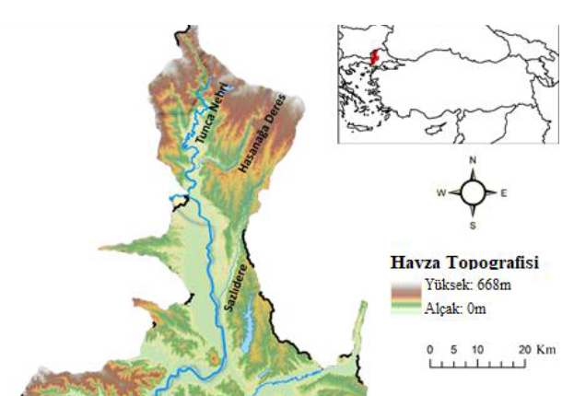
Figure 1. Meriç River Basin and lakes studied.

2.3. Taking fish samples
The fish were caught with gillnets, transported to the laboratory, and examined for parasites.

2.4. Chemical analyzes
The muscle tissues of the fish samples were removed, 0.50 g was taken from each sample and placed in the CEM Mars Xpress 5 microwave reactor (Kar, 1990; Kar and Kar 2020; Kar et al., 2021).

2.5. Statistical analyzes
The normal distribution of the data was determined by the Kolmogorov–Smirnov test, and the homogeneity of the variances was made using the Levene's test…………………………………………………….The significance level in the tests was accepted as α = 0.05. Data are given as mean ±standard error. Data were analyzed using IBM SPSS Statistics version 25.0 for Windows package software (IBM Corp., Armonk, NY, USA).

3. RESULTS
3.1. Chemical results
According to the findings, the Parameter1 values differed according to the working months (P < 0.05). The chemical values obtained in this study are presented in Table 1.

Table 1. Parameter values determined between the months examined.
Parameters | January | April | July | October
Parametre1 | 1.25 ± 2.14^{b} | 2.01 ± 5.83^{ab} | 3.24 ± 4.95^{ab} | 4.68 ± 5.47ª
Parametre2 | 5.98 ± 4.56^{c} | 6.78 ± 6.42^{bc} | 7.12 ± 8.00ª | 6.88 ± 6.19ª
Parametre3 | 8.99 ± 10.58^{b} | 6.10 ± 11.40^{ab} | 12.35 ± 13.77ª | 9.11 ± 8.12^{ab}
The difference between the averages shown with different letters in the same row is significant (P < 0.05).

3.2. Second subtitle
Content of the second subtitle.

3.3. Third subtitle
Content of the third subtitle.

4. DISCUSSION
Content of the discussion.

5. CONCLUSION
Content of the conclusion.

ACKNOWLEDGEMENT
The authors thank Ahmet Taş (Isparta University of Applied Sciences, Turkey) for his helps during the laboratory part of the study.

FUNDING
Example-1: This study was supported by the Scientific Research Projects Coordination Unit of Isparta University of Applied Sciences grant 3241-E2-14.
Example-2: No financial support was received for the present study.

CONFLICT OF INTEREST
Example: The authors declare that they have no known competing financial interests or personal relationships that could have appeared to influence the work reported in this paper.

AUTHOR CONTRIBUTIONS
Fiction: IT; Literature: KL, TN; Methodology: CT, FU; Performing the experiment: FM, CT, FU; Data analysis: FU, TA; Manuscript writing: CT, FU, Supervision: CT. All authors approved the final draft.

ETHICAL STATEMENTS
Example-1: Local Ethics Committee Approval was not obtained because experimental animals were not used in this study.
Example-2: This study was conducted with the approval of Animal Experiments Local Ethics Committee of Isparta University of Applied Sciences (Date: 01.07.2010, No: 21438139-147).

DATA AVAILABILITY STATEMENT
Example-1: The data that support the findings of this study are openly available in Figshare at https://doi.org/10.6084/m9.figshare.11815566.v1
Example-2: The data used in the present study are available upon request from the corresponding author. Data is not available to the public due to privacy or ethical restrictions.
Example-3: Data supporting the findings of the present study are available from the corresponding author upon reasonable request.
Example-4: Data sharing is not applicable for the present study as no new data was created or analyzed.
Example-5: Research data is not shared.
Example-6: Data supporting the findings of the present study are available in the supplementary material to this article.

REFERENCES
International Union for Conservation of Nature. (2010). Chondrostoma nasus. https://www.iucnredlist.org/species/4789/97800985
Le Couteur, D., Kendig, H., Naganathan, V., & McLachlan, A. (2010). The ethics of prescribing medications to older people. In S. Koch, F. M. Gloth, & R. Nay (Eds.), Medication management in older adults (pp. 29-42). Springer. https://doi.org/10.1007/978-1-60327-457-9_3
Ozdal, A. M. (2019). Effects on growth and coloration of red pepper supplementation as pigment sources to diets of jewel cichlid (Hemichromis guttatus). [Master's thesis, Isparta University of Applied Sciences].
Petrauskienė, L., Utevska, O., & Utevsky, S. (2009). Can different species of medicinal leeches (Hirudo spp.) interbreed? Invertebrate Biology, 128(4), 324-331. https://doi.org/10.1111/j.1744-7410.2009.00180.x
Sawyer, R. T. (1986). Leech biology and behavior. Oxford University Press.
Snoswell, C. (2016, October 31 - November 3). Models of care for store-and-forward teledermatology in Australia [Poster presentation]. 7th International Conference on Successes and Failures in Telehealth, Auckland, New Zealand.

