**(DO NOT FILL IN THE SECTIONS WRITTEN IN RED.)**

**Title (Bold, Centered, size 14, Initials Uppercase, Maximum 15 Words)**

Author’s Surname, Name[1]  https://orcid.org/0000-0001-1111-2222

Second Author’s Surname, Name [2]  https://orcid.org/0000-0001-1111-2222

Third Author’s Surname, Name[3]  <https://orcid.org/0000-0001-1111-2222>

**Running Head**

**ABSTRACT**

When submitting the manuscript, the author (s) must include a concise and informative abstract of between 150 and 200 words in English with the font Times New Roman, 10 pt., with one line spacing. The abstract must state briefly the purpose of the research, the methodology applied, the principal results and major conclusions.The manuscript must be **copy edited** and must be **free of grammatical, spelling, and/or punctuation errors.** When submitting the manuscript, the author (s) must include a concise and informative abstract of between 150 and 200 words in English with the font Times New Roman, 10 pt., with one line spacing. When submitting the manuscript, the author (s) must include a concise and informative abstract of between 150 and 200 words in English with the font Times New Roman, 10 pt., with one line spacing. When submitting the manuscript, the author (s) must include a concise and informative abstract of between 150 and 200 words in English with the font Times New Roman, 10 pt., with one line spacing. When submitting the manuscript, the author (s) must include a concise and informative abstract of between 150 and 200 words in English with the font Times New Roman, 10 pt., line spacing. When submitting the manuscript, the author (s) must include a concise and informative abstract of between 150 and 200 words in English with the font Times New Roman, 10 pt., with one line spacing.

***Received*** xx.xx.202x

***Accepted*** xx.xx.202x

***Key Words*** *Keywords (3 to 5) must be always submitted in English.*

# INTRODUCTION

The First level Headings such as introduction, method, findings, conclusion and discussion should be written in the center, aligned in 12 pt., **Bold** and all letters in capital. The paragraphs should be aligned justified and should be written by 12 font size of Times New Roman. Line spacing should be set to be 6 nk before and after the paragraph. In the introduction section, the importance of the subject, the history and the studies so far should be described and the hypothesis and the purpose of the study should be mentioned. Both the main and secondary objectives should be clearly stated. Only really relevant sources should be shown and no data or results of the study should be mentioned. At the end of the introduction, the purpose of the study, the research questions and hypotheses should be stated. ***APA 7 rules should be followed for in-text citations.***

Available at [https://apastyle.apa.org/style-grammar-guidelines/citations](https://translate.google.com/translate?hl=tr&prev=_t&sl=tr&tl=en&u=https://apastyle.apa.org/style-grammar-guidelines/citations) .

***Second Level Headings***

Second-level headings (for example, subheadings can be preferred to explain the theoretical framework or study groupunder the methodology section, etc.) should be written in 12 pt, bold and the first letters must be capitalized and aligned to the left. The paragraph formatting rules that stated before must be followed.

***The Third Level Headings***

The third level headings should be written in 12 pt. bold, italic font. The first letters should be capitalized and aligned to the left. The paragraph formatting rules that stated before must be followed.

***The Fourth Level Headings***

The fourth level headings should be written in 12 pt., italic and bold fond. Only the first letter of the title capitalized and aligned to the left. The paragraph formatting rules that stated before must be followed.

# METHODOLOGY

The methodology should include information about data collection technique and tools, participants, scales, interviews / evaluations and basic measurements, procedures and statistical methods. The methodology section should contain only the information that is clear when preparing the study plan. All information obtained during the study should be stated at finding section.

* The Population and The Sample
* Data Collection
* Data Collection Tool
* Analysis of Data

# FINDINGS

The findings should be presented completely, supported by statistical data and indicated visually with appropriate tables, graphics and figures. They should be presented in a rational order The findings in the texts, tables and figures can be stated starting from the most important to the least. All the data in the tables and figures should not be given in the article, only the important points should be emphasized. ***Tables and figures should be*** included in the text and in the findings. This section also  ***should be in APA 7 format.***Available at [https://apastyle.apa.org/style-grammar-guidelines/tables-figures](https://translate.google.com/translate?hl=tr&prev=_t&sl=tr&tl=en&u=https://apastyle.apa.org/style-grammar-guidelines/tables-figures) . Below is an example table and figure.

**Table 2**

*Means, Standard Deviations, and One-Way Analyses of Variance in Psychological and Social Resources and Cognitive Appraisals*

|  |  |  |  |  |  |  |
| --- | --- | --- | --- | --- | --- | --- |
| Measure | Urban | | Rural | | *F* (1, 294) | η2 |
| M | SD | M | SD |
| Self-esteem | 2.91 | 0.49 | 3.35 | 0.35 | 68.87*** | .19 |
| Social support | 4.22 | 1.50 | 5.56 | 1.20 | 62.60*** | .17 |
| Cognitive appraisals |  |  |  |  |  |  |
| Threat | 2.78 | 0.87 | 1.99 | 0.88 | 56.35*** | .20 |
| Challenge | 2.48 | 0.88 | 2.83 | 1.20 | 7.87*** | .03 |
| Self-efficacy | 2.65 | 0.79 | 3.53 | 0.92 | 56.35*** | .16 |

\*\*\**p* < .001.

**Figure 1**

*Path Analysis Model of Associations Between ASMC and Body-Related Constructs*

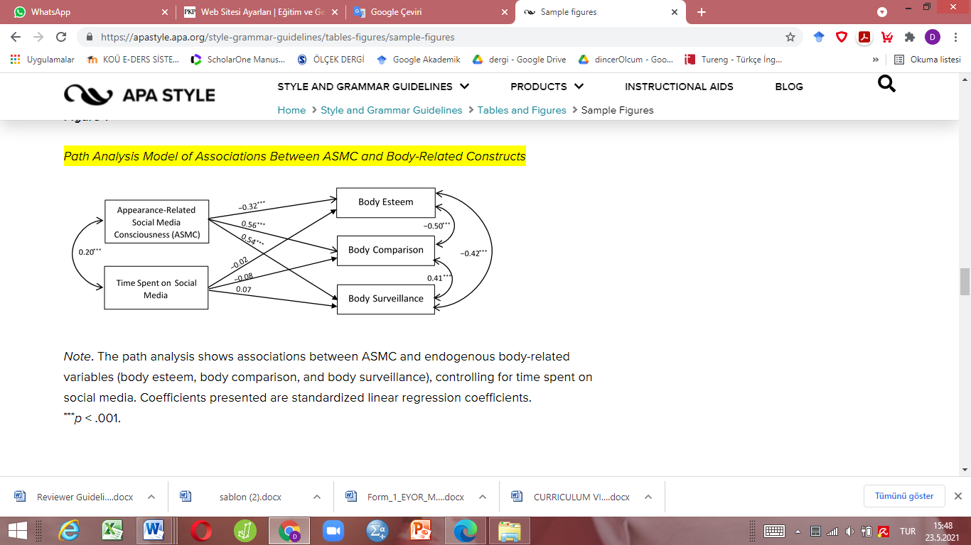

**Note:** APA7 rules state that tables can be single, one and a half and double line spacing. In articles to be submitted for EGAD, Times News Roman 12 pt., 6 pt before and after, single line spacing should be preferred for Table-Figure Number and title. Times News Roman 10 pt., 0 pt before and after, single line spacing should be preferred for table body layout. Figures should be arranged in readable size and embedded in the text.

# CONCLUSION and DISCUSSION

Results obtained from the study should be stated in conclusion section. Results should be linked to the objectives of the study. The unqualified statements and conclusions that are not sufficiently supported by the data must be avoided. New hypotheses should be stated when necessary and they should be defined clearly. In the presentation of results, findings should not be mentioned again. Only the results obtained from the findings should be presented.

In the Discussion section, the data obtained from that study and the results that support and do not support the hypothesis should be examined in line with the established hypothesis, and these results should be compared with similar studies in the literature, and if there are differences, they should be also explained. The new and important aspects of the study and their results should be emphasized. The information and data given in the introduction or conclusion part should be avoided.

## Support and Agreement

The author(s) should indicate at the end or before the bibliography if the manuscript has been presented at a conference, symposium, etc. If the manuscript is part of a larger research/project, this should also be indicated. For example, if the submitted manuscript is part of a dissertation, this must be indicated with the title of the dissertation. If it is an institution sponsored project (e.g. BAP, TUBITAK, ERASMUS +, HORIZON, UNND, FULBRIGHT etc.), the project name and end date of the project should be given (if it is an ongoing project, the project number should be given. The author(s) should note on the form, "As author(s), we have no support or appreciation for the process of conducting the research."

## Conflict Statement

At the end of the manuscript or before the bibliography, the author(s) should indicate whether the study has a conflict of interest. If there is no conflict of interest, it should read, "We declare that we, as authors of the study, have no interests/conflicts."

## Publication Ethical Statement

Authors should state the ethical statement at the end of the article, before the bibliography, as follows: All the rules stated in the framework of "Scientific Research in Universities and Publication Ethic Codes were followed throughout the process (planning, implementation, data collection and analysis). None of the actions stated under the title "Actions that violate scientific research and Publication Ethics " which is the second part of the codes that must be considered. During the writing process of the manuscript, the rules of scientific ethics and citation were followed, no falsifications were made to the collected data, and this study was not sent to any other academic publication environment for evaluation.

**REFERENCES**

The references stated in the manuscript should be arranged according to the APA 7 Rules. Avaible at [https://apastyle.apa.org/style-grammar-guidelines/references](https://translate.google.com/translate?hl=tr&prev=_t&sl=tr&tl=en&u=https://apastyle.apa.org/style-grammar-guidelines/references) ; or see examples at <https://apastyle.apa.org/style-grammar-guidelines/references/examples>

1. 1Corresponding Author’s name, Affiliation, Address, City, Country, email address

   2Author's Surname Name, Affiliation, Address, City, Country, email address

   3 ThirdAuthor’s Surname Name, Affiliation, Address, City, Country, email
2.
3.