 | International Journal of Contemporary Tourism Research  e-ISSN: 2587-1528 | 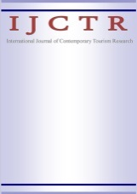
 | https://dergipark.org.tr/tr/pub/ijctr

REPLY TO REFEREES

Manuscript ID and Head: XXXX - xxxxxxxxxxxxxxxxxxxxxxxxxxxxxxxxxxxxxxxxxx

Note to the editor:

Referee 1
Referee Comment/Suggestion | Author(s) Disclosure
Note to referee:

Referee 2
Referee Comment/Suggestion | Author(s) Disclosure

Referee 3 (If any)
Referee Comment/Suggestion | Author(s) Disclosure

Note to referee:

