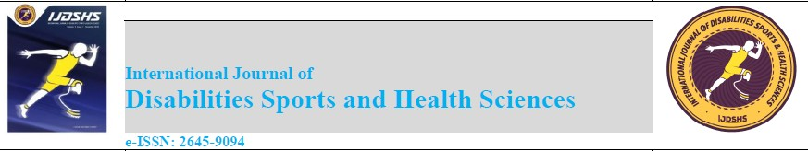
https://dergipark.org.tr/en/pub/ijdshs

Copyright Agreement

/ /202
Title:

Submission Date:

By submitting their work to the journal, the authors are deemed to have accepted the following conditions.
1. The copyright of the published article belongs to its author under CC BY-SA 4.0 license.
2. The authors authorize this Journal to publish the article and identify itself as the original publisher.
3. The authors grant the right to freely use the article to any third party as long as the original authors and citation details are identified.
4. Nothing in this license impairs or restricts an author's right to preserve the integrity and ownership of their work.
Best Regard.

Author(s) and signature(s) of all author(s) in order:

Author(s) Signature(s) Date
1. ………………………  2. ………………………  3. ………………………  4. ………………………  5. ………………………  6. ……………………… | …………………………….  ……………………………  ……………………………  ……………………………  ……………………………  …………………………… | …………………………….  ……………………………  ……………………………  ……………………………  ……………………………  ……………………………

