**Type or paste the title of the article here**

Author’s name and surname[1]

Author’s name and surname[2]

**Repeat the title of the article here**

**Abstract**

The abstract part of the article should consist of 200 words and should summarize the entire study. Do not use citations in the abstract. As indicated in the sample template, it should be arranged in 9-point, single-spaced, justified. The keywords of the study should be 9 points, minimum 3 and maximum 5 words as in the sample template. Semicolons should be placed between words, and should be written in lowercase letters, excluding proper nouns. The abstract section of the article should consist of 200 words and should summarize the entire study. Do not use citations in the abstract. As indicated in the sample template, it should be arranged in 9-point, single-spaced, justified. The keywords of the study should be 9 points, minimum 3 and maximum 5 words as in the sample template. Semicolons should be placed between words, and should be written in lowercase letters, excluding proper nouns.

**Keywords:** Word, Another word, Lowercase letters excluding names

**Makalenizin başlığını burada tekrarlayın**

**Özet**

Yazının özet bölümü 200 kelimeden oluşmalı ve tüm çalışmayı özetler nitelikte olmalıdır. Özet bölümünde atıf kullanmayınız. Örnek şablonda belirtildiği gibi 9 punto, tek satır aralıklı, iki yana yaslı şekilde düzenlenmelidir. Çalışmanın anahtar kelimeleri örnek şablonda olduğu gibi 9 punto, en az 3 en fazla 5 kelime olmalıdır. Kelimler arasında noktalı virgül konmalı, özel isimler hariç küçük harflerle yazılmalıdır. Yazının özet bölümü 200 kelimeden oluşmalı ve tüm çalışmayı özetler nitelikte olmalıdır. Özet bölümünde atıf kullanmayınız. Örnek şablonda belirtildiği gibi 9 punto, tek satır aralıklı, iki yana yaslı şekilde düzenlenmelidir. Çalışmanın anahtar kelimeleri örnek şablonda olduğu gibi 9 punto, en az 3 en fazla 5 kelime olmalıdır. Kelimler arasında noktalı virgül konmalı, özel isimler hariç küçük harflerle yazılmalıdır.

**Anahtar Kelimeler:** Kelime, Başka bir kelime, İsimler hariç küçük harf

**Introduction**

Theoretical foundations and literature review of the research should be clearly explained. The problem and the rationale should be explained in a clear and understandable language. In this section, scientific studies should be cited, and the importance of research should be stated with current sources. Theoretical foundations and literature review of the research should be clearly explained. The problem situation and the reason should be explained in a clear and understandable language. In this section, scientific studies should be cited, and the importance of research should be stated with current sources.

The theoretical foundations and literature review of the research should be clearly explained. The problem and the rationale should be explained in a clear and understandable language. In this section, scientific studies should be cited, and the importance of research should be stated with current sources. The theoretical foundations and literature review of the research should be clearly explained. The problem and the rationale should be explained in a clear and understandable language. In this section, scientific studies should be cited, and the importance of research should be stated with current sources.

**Method**

The design/model of the research, participant/sample/study group, data collection tools/measurements, analysis and collection of data should be explained in this section. The methodological design of the research should be explained clearly and understandably, and the process should be detailed.

*Research Model/Design*

The methodological model on which the research is based or the theoretical basis that constitutes the design should be explained.

*Participants/Sample/Study Group*

The characteristics of the sample/participant/study group included in the research should be explained in such a way that the protection of personal data does not violate the law and ethical principles.

*Measurement/Data Collection Instruments*

The measurement or data collection tools used in the research should be specified in detail. The characteristics of measurement tools or measurements and data collection tools should be explained in this section.

*Data Analysis*

The methods and techniques used in the analysis of the data should be explained in this section with their rationale and theoretical foundations.

**Results**

The findings of the research should be given in this section. Tables, figures, and graphics, if any, should be explained by giving examples.

**Table 1.** Table Sample

|  |  |  |  |
| --- | --- | --- | --- |
| Title 1 | Title k 2 | Title 3 | Title 4 |
| 1 | 2 | 3 | 4 |
| 5 | 6 | 7 | 8 |

Use the example above for the table.

**Figure 1.** Figure sample

Use the example above for the figure.

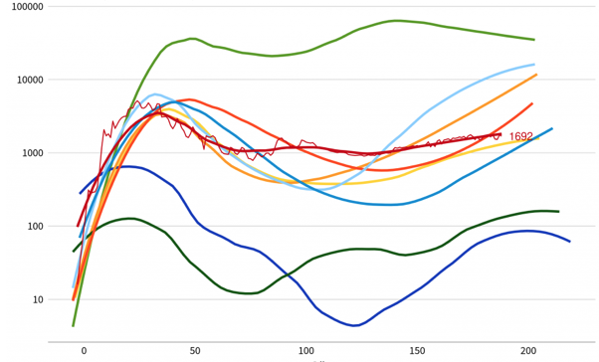

**Graphic 1.** Graphic sample

**Discussion**

In this section, it should be explained what the findings obtained as a result of the analyzes mean for the research problem and hypothesis. Please detail what gap these findings filled in the current literature, what similarities and differences were identified with the literature.

**Conclusion**

In this section, which will be written independently of the discussion and findings section, what inferences can be made for the target audience should be written. What conclusions the researchers reached as a result of the findings and discussion, and what kind of contribution these results will make should be explained in detail.

**Recommendations/Suggestions**

The researchers' recommendations for future studies will be included in this section.

**Author Contribution**

Each author's contribution should be noted. Author, A (Conceptual framework), Author, B (Data Analysis), Author, C (Data Collection)

**Conflict of Interest**

All authors must declare that there is no conflict of interest.

**Ethical Statement**

The ethics committee report of the research, the name of the committee and the number of decisions should be added here. For studies that do not require an ethics committee, the authors should state that an ethics committee is not required.

**Acknowledgment (Optional)**

Acknowledgments come at the end of an article after Conflicts of Interest and before Notes and references. It includes thanks to institutions, organizations or individuals who contributed scientifically during the research process.

**References**

APA 7 style should be followed in the list of references (see Author's Guide).

Author, A. A., Author, B. B., & Author, C. C. (Year). Title. Journal, Edition(Issue), page-by-page. DOI: http://dx.doi.org/xx.xxx/yyyyy

Author, A. A. (Year). Title. Location: Publisher.

Author, A. A., & Author, B. B. (Year). Section name. A. A. Editor & B. B. Editor (Ed), Book title (Chapter page range). Location: Publisher.

1. Department, Institution, City, Country, e-mail
2. Department, Institution, City, Country, e-mail

   **\*Corresponding Author Information:** Provide all correspondence details here, including the corresponding author's email