Article Type (Makale Türü):

Submitted: 02.02.2023
Accepted 31.03.2023

Cite as (Atıf): Soyad, A. & Soyad, A. (YIL)
Makale Başlığı. Akdeniz İletişim, (ISSUE), … DOI Link.

Akdeniz İletişim Title Akdeniz İletişim Title Akdeniz İletişim Title
Akdeniz İletişim Turkish Title
Name SURNAME
Name SURNAME
Name SURNAME

Abstract
Copy and paste the Abstract text you have prepared into this field. The Abstract should be a minimum of 150 and a maximum of 250 words. Abstract text font: Calibri (Body), 9 pt; Line spacing: Single; Bold Line spacing: Single; Spacing before: 0 pt; Spacing after: 6 pt (Must be positioned without paragraph indentation); justified. Articles should include both Turkish and English abstracts, consisting of maximum 250 words. The preparation of the articles to be submitted to JAUFC in line with this template will accelerate the editing, evaluation and publication stages. In abstracts, care should be taken to include information on the research problem, purpose, method, main findings and results in accordance with APA JARS standards. In-text citations and abbreviations should be avoided in abstracts. Underlined, bold or italic fonts should not be applied in abstracts. Abstracts should be followed by keywords (min. 3, max. 5 keywords) that will best express the article. Keywords should be formatted as follows: Keyword font type: Calibri (Body), 9 pt; Line spacing: Single; Spacing before: 0 pt; Spacing after: 6 pt. Copy and paste the Abstract text you have prepared into this field. The Abstract should be a minimum of 150 and a maximum of 250 words. Abstract text font: Calibri (Body), 9 pt; Line spacing: Single; Bold Line spacing: Single; Spacing before: 0 pt; Spacing after: 6 pt (Must be positioned without paragraph indentation); justified. Articles should include both Turkish and English abstracts, consisting of maximum 250 words.
Keywords: Keyword 1, Keyword 2, Keyword 3, Keyword 4, Keyword 5

Öz
Hazırlamış olduğunuz Öz metnini kopyalayıp bu alana yapıştırınız. Öz kısmı en az 150, en fazla 250 kelime olmalıdır. Öz ve Abstract metni Yazı tipi: Calibri (Body) 9 punto; Satır aralığı: Tek; Kalın satır aralığı: Tek; Aralık önce: 0 nk; Aralık sonra: 6 nk (Paragraf girintisi olmayacak şekilde konumlandırılmalı) iki yana yaslı olarak yazılmalıdır. Makalenin başında, en fazla 250 kelimeden oluşan metnin hazırlandığı Türkçe ve İngilizce özler yer almalıdır. JAUFC’a gönderilmek üzere hazırlanan makalelerin bu şablona bağlı olarak hazırlanması makalenin düzenlenme, değerlendirilme ve yayımlanma aşamalarını hızlandıracaktır. Özlerde; APA JARS standartlarına uygun olacak şekilde araştırma problemi, amacı, yöntemi, temel bulguları ve sonuçlarına ilişkin bilgilerin yer almasına özen gösterilmelidir. Öz metni içerisinde atıfta bulunulmamalı ve kısaltma kullanılmamalıdır. Öz metinlerinde altı çizili, kalın veya italik yazı tipinden kaçınılmalıdır. Öz metninin sonunda en az 3 en fazla 5 kelimeden oluşan, konuyu en iyi şekilde ifade edecek anahtar kelimeler (Keywords) yer almalıdır. Anahtar kelimeler için Yazı tipi: Calibri (Body), 9 punto; İtalik; Satır aralığı: Tek; Aralık Önce: 0 nk; Aralık Sonra: 6 nk olarak ayarlama yapılmalıdır. Hazırlamış olduğunuz Öz metnini kopyalayıp bu alana yapıştırınız. Öz kısmı en az 150, en fazla 250 kelime olmalıdır. Öz ve Abstract metni Yazı tipi: Calibri (Body) 9 punto; Satır aralığı: Tek; Kalın satır aralığı: Tek; Aralık önce: 0 nk; Aralık sonra: 6 nk (Paragraf girintisi olmayacak şekilde konumlandırılmalı) iki yana yaslı olarak yazılmalıdır. Makalenin başında, en fazla 250 kelimeden oluşan metnin hazırlandığı Türkçe ve İngilizce özler yer almalıdır. JAUFC’a gönderilmek üzere hazırlanan makalelerin bu şablona bağlı olarak hazırlanması makalenin düzenlenme, değerlendirilme ve yayımlanma aşamalarını hızlandıracaktır.
Anahtar Kelimeler: Anahtar Kelime 1, Anahtar Kelime 2, Anahtar Kelime 3, Anahtar Kelime 4, Anahtar Kelime 5

Introduction
(You can delete this entire area and paste the Introduction section you previously prepared here.).
Journal writing and publication rules are meticulously applied in order to comply with the rules of the indices to which Journal of Akdeniz İletişim is subject and to be accepted into higher level indices by publishing qualified studies. Studies that do not comply with these rules are rejected at the preliminary evaluation stage. In case of minor deficiencies within the scope of the Writing Rules, corrections are requested from the authors, but no concessions are made in these correction requests. For this reason, it is important for scientists and researchers who are considering submitting a study to Journal of Akdeniz İletişim to take into account the rules and recommendations in this section.
It is the authors' own responsibility to follow the processes. All responsibility for any delays caused by the author in the process belongs to the author.
All studies to be sent for evaluation to Journal should be prepared using this Manuscript Template. Works submitted without using this template and/or without checking its compliance with the spelling rules on this template will be rejected at the preliminary evaluation stage without being transferred to the reviewer evaluation process.
The manuscript text must be prepared using the Microsoft Word word processing program (.doc, .docx) and uploaded to the DergiPark system. Studies sent in different formats will be rejected at the preliminary evaluation stage without being taken into the reviewer evaluation process.
In studies, citation format should be used in the form of in-text reference instead of footnotes.
Paragraphs in the work should be without indentation. Paragraph spacing should first be 0 pt, then 6 pt. Page numbers should not be added to studies. All articles prepared in Turkish or English must be language checked.
The main and subheadings of the main text of the study (including the Introduction, Conclusion, References and Structured Extended Abstract headings) should be written in lowercase letters, with the first letters capitalized, in Calibri Light (Title) font, 14 points and bold. Except for the Introduction, Conclusion, References and Structured Extended Abstract headings, other first-level, second-level, etc. headings should be written in 12-point font, aligned to the left. All headings should be numbered except the main title, introduction, conclusion, references and Structured Extended Abstract sections. For headings, the paragraph settings should be adjusted so that the space before is 12 pt and the space after is 6 pt. RGB (R: 29; G: 54; B: 106) colors should be used in headings. Headings and subheadings should be short and specific. The main headings of the text in Turkish and English should not exceed 12 words.
Short quotes within the text should be given in double quotes, and if quotation marks are used within the quote, single quotes should be used. Quotations longer than 40 words should be written in italics, in blocks, without quotes, in line with the first line of the paragraphs (1.25 cm indented from the left), Calibri (Body) font, 10 pt, first 0 pt, then 6 pt, and single line spacing, as seen in the example below; and when quoting, words and sentences extracted from the original work should be indicated with three dots (…) in parentheses:
Short quotes within the text should be given in double quotes, and if quotation marks are used within the quote, single quotes should be used. Quotations longer than 40 words should be written in italics, in blocks, without quotes, in line with the first line of the paragraphs (1.25 cm indented from the left), Calibri (Body) font, 10 pt, first 0 pt, then 6 pt, and single line spacing, as seen in the example below; and when quoting, words and sentences extracted from the original work should be indicated with three dots (…) in parentheses.
All legal, academic and ethical responsibilities of the studies belong to the author(s). Studies submitted to our journal must be original studies that have not been published elsewhere and have not been sent for publication. The studies must not contain plagiarism, and the plagiarism report obtained from Turnitin or iThenticate programs must be uploaded to the system with the study. In order for the studies to be evaluated, the Turnitin or iThenticate plagiarism report must be 15% or less (excluding references, less than 5 words, including quotations). The rate of benefit from the same study should be at most 3%. Studies with similarity rates above these rates or without a Turnitin / iThenticate report will be rejected during the preliminary evaluation process.
Since it is taken into consideration in the index evaluation process, authors whose work has been published in our journal within a year cannot send a study to our journal with the request to be published in another issue in the same year. Additionally, each author is required to submit only one (1) work per issue for consideration. An author (regardless of whether it is the first, second, third, etc. author) must submit only one (1) paper to each issue. Otherwise, all works of an author will be rejected at the preliminary evaluation stage.
It would be appropriate to follow the following order in the studies: Title in Primary Language, Title in Secondary Language, Abstract, Keywords, Introduction, Method, Findings, Discussion, Conclusion, References, Extended Abstract in English (If the study is in Turkish, an extended summary is requested).
1. Methodology
It is Akdeniz İletişim’s priority criteria that;
- all manuscripts to be submitted are written in accordance with APA’s journal article reporting standards (available at https://apastyle.apa.org/jars)
- their references are arranged by using Mendeley (https://www.mendeley.com/) or Endnote (https://endnote.com/) reference managers.
- the number of words used in the titles is at most 12, the number of words used in the abstract is between 150-250, and the number of words in the manuscript is between 5000-8500 (including the abstract, tables and footnotes, excluding the References).
- the manuscripts are scanned for plagiarism on Turnitin or iThenticate, and their originality reports are uploaded to the Manuscript Submission System,
- the manuscripts are prepared on the Manuscript Template.
1.1. Tables, Figures, and Images
Tables, figures, or images should be appropriately numbered and titled. Titles of figures, graphics and pictures should be written in Calibri (Body) font and 10 point font, centered and below. Table headings should be numbered at the top and centered in Calibri (Body) font and 10 point font.
In accordance with the copyright law, tables, pictures, figures, etc. used in the study are copyrighted. The necessary permissions must be obtained from the authors and the permission letter must be uploaded to the system.
Table 1. Table Use within Manuscript
Column 1 | Column 2 | Column 3
Calibri (Body) 10 pt | Calibri (Body) 10 pt | Calibri (Body) 10 pt
Source: Information about the source
The texts used in the table must be in Calibri (Body) font, 10 points.
Titles of figures, graphics and pictures should be numbered at the bottom and centered in Calibri (Body) font and 10 point font.
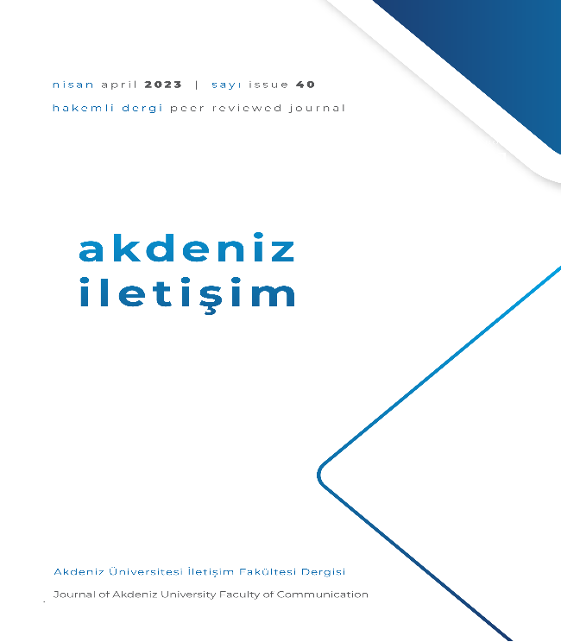
Figure 1. Example of Displaying Figures / Visuals / Pictures in the Text
If the study has appendices, they should be added after the references.
2. Findings
The following files must be uploaded separately from the article file:
- Originality Report
- Cover Letter (cover letter template)
- Copyright Transfer Form
- Approval Letter of Ethics Committee (If needed)
3. Discussion
Author information should not be included in the article files sent for evaluation.
If the studies have been previously presented at a meeting/symposium, the name, date and place of the meeting must be stated in the Declarations section.
Only studies produced from doctoral theses are accepted for evaluation, studies produced from master's theses are not evaluated.
If the study has previously been presented as a doctoral thesis, information such as the title of the doctoral thesis, institute / institution, and advisor must be reported. The editorial board has the right to remove from publication an article that it determines to have been produced from a doctoral thesis, even after it has been published, even though it was not notified by the author.
If the work produced from the doctoral thesis has been added to the system under a single name, the petition stating that the doctoral thesis advisor waives all rights (the physical signature of the doctoral thesis advisor must be present) must be uploaded to the system. Single-titled doctoral thesis summaries will be rejected at the preliminary evaluation stage unless they upload this petition to the system.
Conclusion
Only studies produced from doctoral theses are accepted for evaluation, studies produced from master's theses are not evaluated.
If the study has previously been presented as a doctoral thesis, information such as the title of the doctoral thesis, institute / institution, and advisor must be reported. The editorial board has the right to remove from publication an article that it determines to have been produced from a doctoral thesis, even after it has been published, even though it was not notified by the author.
If the work produced from the doctoral thesis has been added to the system under a single name, the petition stating that the doctoral thesis advisor waives all rights (the physical signature of the doctoral thesis advisor must be present) must be uploaded to the system. Single-titled doctoral thesis summaries will be rejected at the preliminary evaluation stage unless they upload this petition to the system.
Declarations
* Ethics Committee Approval: If human factors are involved in studies such as research articles, the Ethics Committee Document must also be added to the system. Studies that do not require Ethics Committee approval are required to upload a signed petition declaring this to the system. Studies that have received ethics committee approval should include information about the Ethics Committee Approval decision date and number in the relevant field both in the Declarations section and under the Method heading.
* Publication Ethics: This part should give information about the fact that this study has been prepared in accordance with the rules specified within the scope of the "Higher Education Institutions Scientific Research and Publication Ethics Directive", and that the article was scanned with plagiarism detection software (Turnitin / iThenticate) and no plagiarism was detected.
* Author Contribution Rate: In studies with more than one author, the authors' contribution to the study should be presented as a percentage (%). In studies with a single author, the phrase "Not applicable" should be added regarding the "Author Contribution Rate" information.
* Author Competing Interests: It may arise when the author(s) of the study or the institution or financial supporter of the author(s) has any direct or indirect financial, commercial, legal or professional relationship/interest with other institutions or employees of these other institutions that may affect the research. The corresponding author of the study must take into account all these issues and declare whether there is a conflict of interest in the study.
* Financial Support: If the study was supported by any academic financial support organization (TÜBİTAK, BAP, European Union, United Nations, etc.), information such as the information of the financial support provider organization and the project number must be reported.
* Acknowledgments: If the study was produced from a thesis, was presented at a congress/symposium/conference, or if an author statement is required on another similar subject, it should be presented clearly in this section.
References
References should be prepared by using reference managers such as Endnote, Mendeley, or Zotero. They should comply with the APA 7th Edition.

Author Contact Info
Author Contact Info
Author Contact Info

