metin içeren bir resim

Açıklama otomatik olarak oluşturuldu

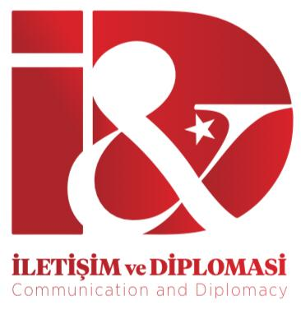

**Author Disclosure Form on Ethics Committee Approval, Financial Support, Conflict of Interest and Authorship Contribution**

**Manuscript Title:**….

**Ethics Committee Approval**

* If your paper is a research that requires ethics committee approval, has ethics committee approval been obtained? Is this indicated in the method section?.....

**Financial Support, Conflict of Interest and Authorship Contribution Level**

**1)** For single-authored papers, the following two items should be explained, and the document should be signed by the author and uploaded to the system:  
  
- Individuals/Institutions/Agencies/Companies or Non-Governmental Organizations that are providing Financial Support: ….   
  
- Conflict of Interest: *(Indicate whether there is a conflict of interest with any person or institution/agency/company/organization)*

**2)** For papers with two or more authors, the following three items should be explained, and the document should be signed by all authors or the corresponding author and uploaded to the system:

- Researcher Contribution: *(Specify the percentage of contribution and then write as shown in the example below:*

*Design of the Manuscript: O. Göksu, S. Ökten. Literature Review: O. Göksu. Data Acquisition and Analysis: S. Ökten. Conclusion: O. Göksu. Proofreading, Revision and Accountability: O. Göksu, S. Ökten.*)  
  
- Individuals/Institutions/Agencies/Companies or Non-Governmental Organizations that are providing Financial Support:…  
  
- Conflict of Interest: *(Indicate whether there is a conflict of interest with any person or institution/agency/company/organization)*

I hereby agree to submit this manuscript, as finalized and approved by the author(s), to the Journal of Communication and Diplomacy.

Name and Surname of the Corresponding Author /

Signature and Date /

Cell Phone Number /

E-Mail and Correspondence Address/