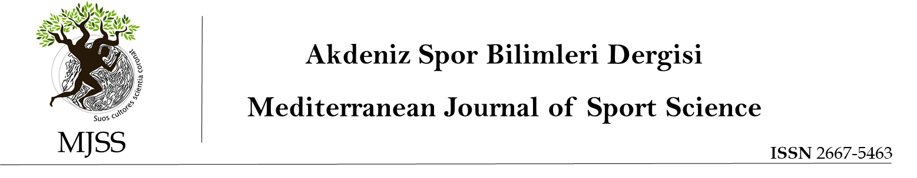

COPYRIGHT AGREEMENT FORM

Title of the paper:…...………………………………………………………………………………………
…………………………………………………………………………………………….
…………………………………………………………………………………………….
Author(s) : …...………………………………………………………………………………………
…………………………………………………………………………………………….
Corresponding author:.…………………………………………………………………………………….
…………………………………………………………………………………………….
By signing this agreement form, author(s) accept(s) that;
a) The submitted article is the original work of the author(s),
b) All authors have participated in this study individually and they take all kinds of responsibility for this study,
c) All authors have seen and approved the final version of the submitted article,
d) The article has not been published or submitted for publication elsewhere,
e) The text, figures and documents in the article do not violate the Copyrights of other persons,
f) They agree and undertake to transfer their financial rights on the submitted article, especially the rights of processing, reproduction, representation, printing, publication, distribution and transmission to the public, including transmission via internet, to Mediterranean Journal of Sport Science.

However, the author(s) has(have);
a) Patent rights,
b) The right to use the entire article in their future books or other works without paying any fee,
c) Intellectual property rights such as the right to reproduce the article for its own purposes, provided that it is not sold.

However, the author(s) has(have) the right to reproduce the article and distribute it by mail or electronically. The use of any part of the article in another publication is permitted provided that the Mediterranean Journal of Sport Science is stated as the publisher and the Journal is referenced. When citing, Journal Name, Article Name, Author(s) Name-Surname, Volume No, Issue No and Year should be stated.

I/We undertake that the "Mediterranean Journal of Sports Sciences and Journal Editors" have no responsibility in claims or lawsuits to be filed by third parties due to copyright infringement, and that all responsibility belongs to the author(s). In addition, I/We undertake that there are no criminal or illegal statements in the article, that no illegal materials and methods are used while conducting the research, and that ethical rules are followed accordingly.
Copyright Agreement Form must be signed by all authors. Authors working in different organizations can submit the Copyright Agreement Form by signing separately, provided that the Article Name and Author Names sections are filled accordingly. The form must be wet-ink signed.

Please state the contributions of authors to the publication in accordance with the stated items below.
- Working Design
- Collection of Data
- Statistical Analysis
- Interpretation of Data
- Full-text Preparation
- Literature Review

 | Author(s) | Contribution to Publication | Date | Signature
1
2
3
4
5
6

