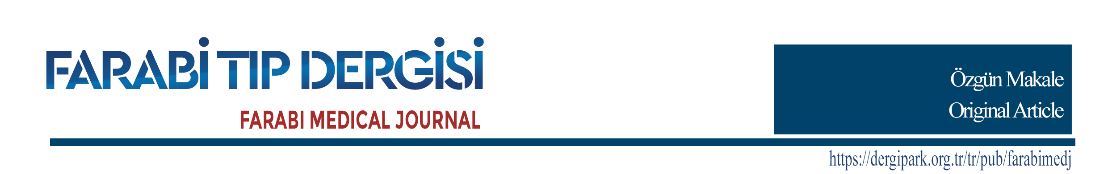

English Title

Türkçe Başlık

ABSTRACT

Original articles should include structured Turkish and English Abstracts. Abstract section; it should consist of Objective, Methods, Results and Conclusion sections. The abstract section should be limited to 250 words. References, tables, citations and unexplained abbreviations should not be used in the abstract. Times New Roman font size of 10 with single line spacing should be used.
Keywords: Replace this text with 3-5 keywords describing the topic of your manuscript. Each keyword, the first letter of which is capitalized, should be divided with a comma.

ÖZET

Özgün araştırmalar yapılandırılmış Türkçe Özet ve İngilizce Abstract içermelidir. Özet bölümü; Amaç, Yöntem, Bulgular ve Sonuç bölümlerinden oluşmalıdır. Özet bölümü 250 sözcük ile sınırlandırılmalıdır. Özet bölümünde kaynaklar, tablolar, atıflar ve açıklanmayan kısaltmalar kullanılmamalıdır. Tek satır aralığı ile 10 punto büyüklüğünde normal Times New Roman yazı tipi kullanılmalıdır.
Anahtar Kelimeler: Makalenizin konusunu açıklayan 3-5 anahtar kelime yazınız. İlk harfi büyük olan her anahtar kelime virgülle ayrılmalıdır.

Geliş Tarihi/Received Date: |  |  | Kabul Tarihi/Accepted Date:

INTRODUCTION
Giriş bölümünde, çalışmanın konusu, önemi ve gerekçesi önceden yapılmış çalışmalara atıf yapılarak verilmeli ve amacı açık ve net olarak ifade edilmelidir. Son paragrafta makaleye ilişkin hipotez verilmelidir. Makale metni. Makale metni. Makale metni. Makale metni. Makale metni. Makale metni. Makale metni. Makale metni. Makale metni.¹ [Times New Roman 11 punto, normal]
In the introduction, the subject, importance and justification of the study should be given with reference to previous studies and its purpose should be clearly stated. In the last paragraph, the hypothesis about the article should be given. Article text. Article text. Article text. Article text. Article text. Article text. Article text. Article text.² [Times New Roman 11 points, regular]
METHODS
Araştırmada kullanılan yöntemler aynı konuda çalışacak araştırmacılara yöntemi kullanabilme imkânı verecek nitelikte açık olmalıdır. Kullanılan istatistiksel yöntem açık ve net olarak verilmelidir. Klinik ve deneysel insan ve hayvanlar üzerinde yapılan çalışmalar için alınan etik kurul onayı kararlarına atıf yapılmalıdır.³ Makale metni. Makale metni. Makale metni. Makale metni. Makale metni. Makale metni. Makale metni. Makale metni. Makale metni. [Times New Roman 11 punto, normal]
The methods used in the research should be clear enough to allow researchers who will work on the same subject to use the method. The statistical method used should be given clearly and precisely. Ethics committee approval decisions should be made for clinical and experimental studies on humans and animals.⁴ Article text. Article text. Article text. Article text. Article text. Article text. Article text. Article text. [Times New Roman 11 point, regular]
RESULTS
Bulgular bölümünde, elde edilen bulgular açık, net ve anlaşılır şekilde verilmeli, gerek duyulursa şekil, grafik ve tablolarla desteklenerek ifade edilmelidir.⁵ Makale metni. Makale metni. Makale metni. Makale metni. Makale metni. Makale metni. Makale metni. Makale metni. Makale metni. [Times New Roman 11 punto, normal]
The findings should be given in a clear, clear and understandable way, and should be expressed by supporting figures, graphics and tables if necessary.⁶ Article text. Article text. Article text. Article text. Article text. Article text. Article text. Article text. [Times New Roman 11 point, regular]

Table 1. Xxxxxxxxxxxxxxxxxxxxxxxxxxxxxxxxxxxxxxxxxxxxxxxxxxxxxxxxxxxxxxxxxxxxxxxxx
Compound No | Compound Name | Retention Time (RT) (min)
1  2  3 | Chlorogenic acid  Caffeic acid  4,5-di-O-caffeoylquinic acid | 11.813  13.067  24.662

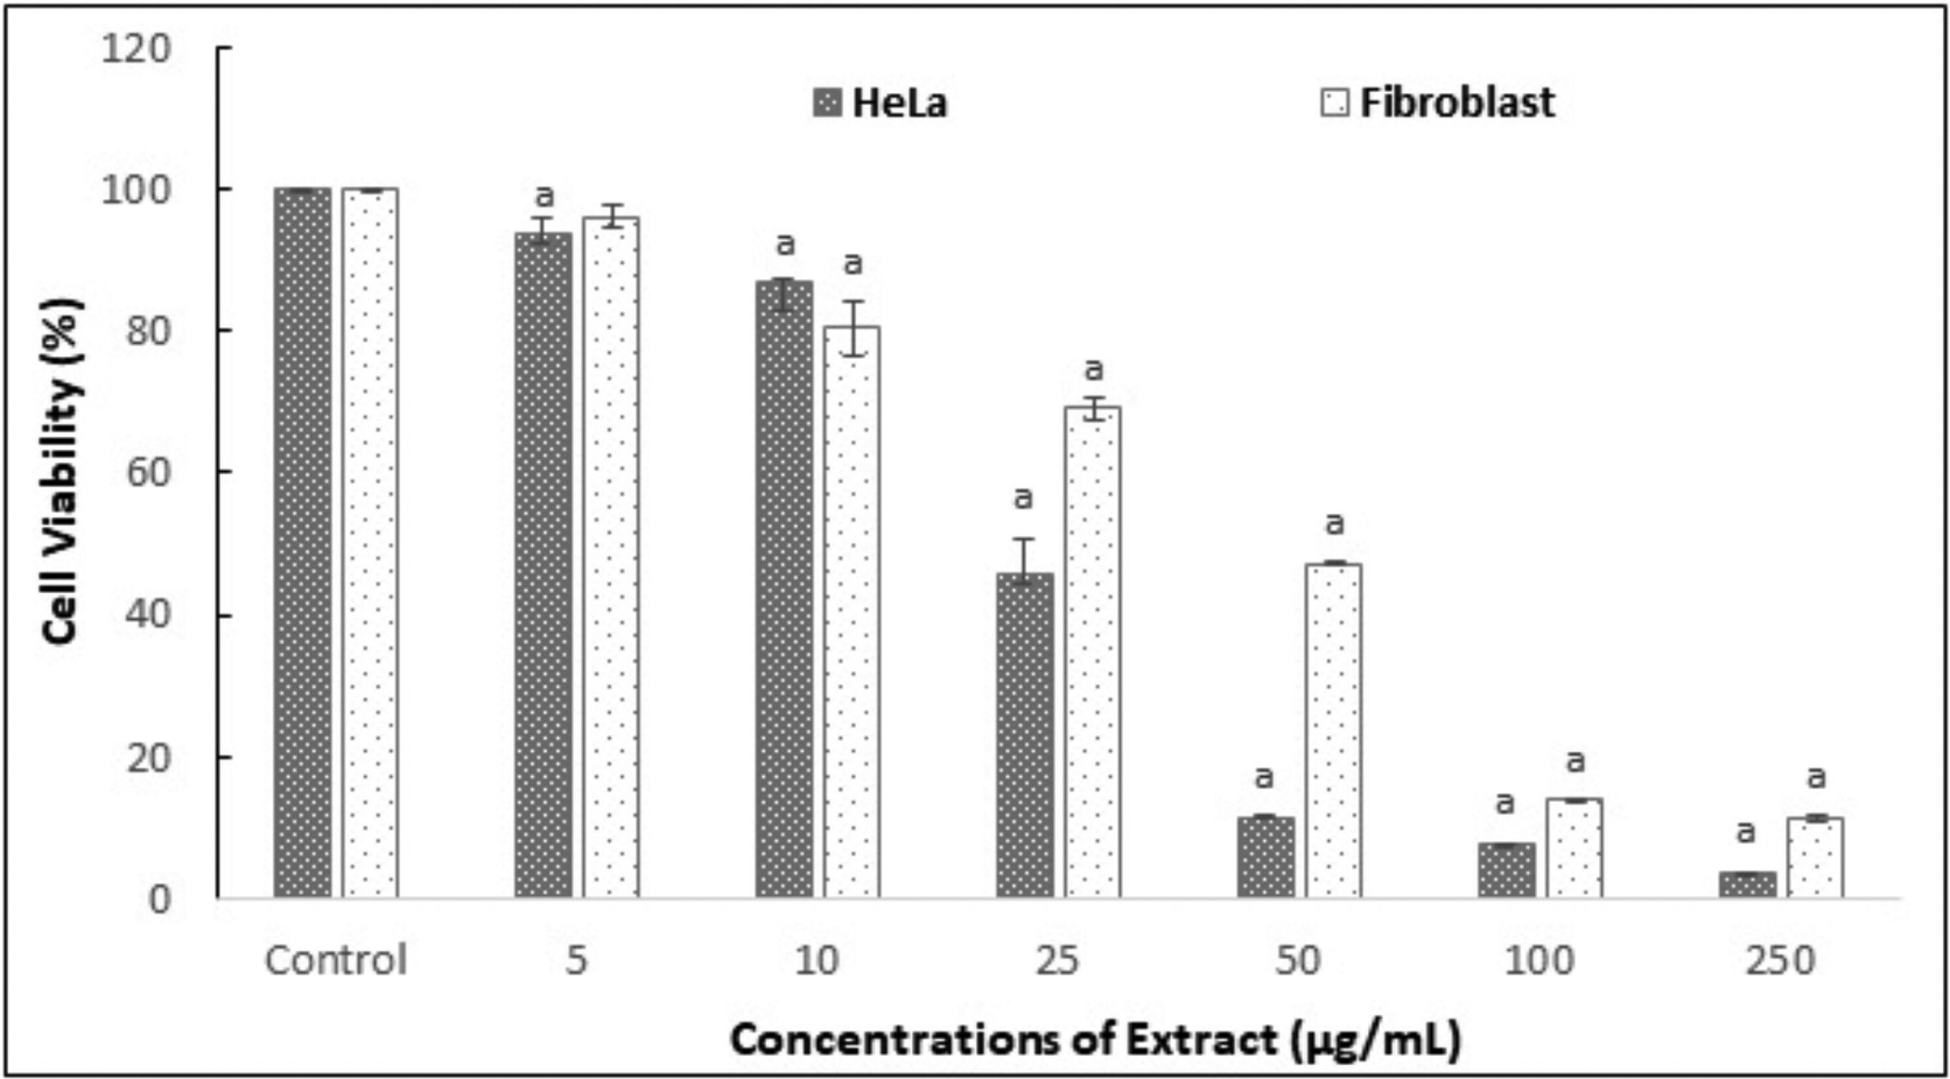
Figure 1. Xxxxxxxxxxxxxxxxxxxxxxxxxxxxxxxxxxxxxxxxxxxxxxxxxxxxxxxxxxxxxxxxxxxxxxxxxxxxxxxxxx
…..

DISCUSSION
Bu bölümde elde edilen bulgular literatüre benzerlik ve farklılıkları ortaya koyularak tartışılmalı, ancak gereksiz tekrarlardan kaçınılmalıdır.⁷ Makale metni. Makale metni. Makale metni. Makale metni. Makale metni. Makale metni. Makale metni. Makale metni. Makale metni. [Times New Roman 11 punto, normal]
The findings obtained in this section should be discussed by revealing their similarities and differences with the literature, but unnecessary repetitions should be avoided.⁸ Article text. Article text. Article text. Article text. Article text. Article text. Article text. Article text. Article text. [Times New Roman 11 point, regular]

CONCLUSION
Sonuç kısmında, elde edilen sonuçların bilime ve literatüre katkısı önerilerle birlikte ifade edilmelidir.⁹ Makale metni. Makale metni. Makale metni. Makale metni. Makale metni. Makale metni. Makale metni. Makale metni. Makale metni. [Times New Roman 11 punto, normal]
In the conclusion part, the contribution of the obtained results to science and literature should be expressed with suggestions.¹⁰ Article text. Article text. Article text. Article text. Article text. Article text. Article text. Article text. Article text. [Times New Roman 11 point, regular]

REFERENCES
- Lütfen referansları aşağıda verilen örnek formatta yazınız. / Please write the references in the sample format given below.
- Naren G, Guo J, Bai Q, Fan N, Nashun B. Reproductive and developmental toxicities of 5-fluorouracil in model organisms and humans. Expert Rev Mol Med. 2022; 24: e9. DOI: 10.1017/erm.2022.3.
- Zeng D, Wang Y, Chen Y, et al. Angelica polysaccharide antagonizes 5-FU-induced oxidative stress injury to reduce apoptosis in the liver through Nrf2 pathway. Front Oncol. 2021; 11: 720620. DOI: 10.3389/fonc.2021.720620.
- Al-Asmari AK, Khan AQ, Al-Masri N. Mitigation of 5-fluorouracil-induced liver damage in rats by vitamin C via targeting redox-sensitive transcription factors. Hum Exp Toxicol. 2016; 35(11): 1203-1213. DOI: 10.1177/0960327115626583.
- Alkis I, Ekin S, Yildirim S, Bakir A, Eser G, Firat M. Evaluation of the protective effect of chlorogenic acid and Rhabdosciadium anatolyi against cyclophosphamide-induced ovarian toxicity in the rat with histopathological and immunohistochemical findings. Kafkas Univ Vet Fak Derg. 2020; 26(6): 757-763. DOI: 10.9775/kvfd.2020.24305.
- Naveed M, Hejazi V, Abbas M, et al. Chlorogenic acid (CGA): A pharmacological review and call for further research. Biomed Pharmacother. 2018; 97: 67-74. DOI: 10.1016/j.biopha.2017.10.064.
- Lu H, Tian Z, Cui Y, Liu Z, Ma X. Chlorogenic acid: A comprehensive review of the dietary sources, processing effects, bioavailability, beneficial properties, mechanisms of action, and future directions. Compr Rev Food Sci Food Saf. 2020; 19(6): 3130-3158. DOI: 10.1111/1541-4337.12620.
- Vardi N, Parlakpinar H, Ates B, Otlu A. The preventive effects of chlorogenic acid against to testicular damage caused by methotrexate. Turkiye Klinikleri J Med Sci. 2010; 30(2): 507-513.
- Rashid S, Sultana S. Chlorogenic acid represses 5-fluorouracil induced renal oxidative stress, apoptosis and inflammation in murine model. Free Radic Biol Med. 2016; 100: S128-S129. DOI: 10.1016/j.freeradbiomed.2016.10.336.
- Mentese A, Alemdar NT, Livaoglu A, Demir EA, Aliyazicioglu Y, Demir S. Suppression of cisplatin-induced ovarian injury in rats by chrysin: An experimental study. J Obstet Gynaecol. 2022; DOI: 10.1080/01443615.2022.2130201, In Press.
- Domitrović R, Cvijanović O, Šušnić V, Katalinić N. Renoprotective mechanisms of chlorogenic acid in cisplatin-induced kidney injury. Toxicology. 2014; 324: 98-107. DOI: 10.1016/j.tox.2014.07.004.
- Park SH, Baek SI, Yun J, et al. IRAK4 as a molecular target in the amelioration of innate immunity-related endotoxic shock and acute liver injury by chlorogenic acid. J Immunol. 2015; 194(3): 1122-1130. DOI: 10.4049/jimmunol.1402101.
- Zhang S, Liu Y, Xiang D, et al. Assessment of dose-response relationship of 5-fluorouracil to murine intestinal injury. Biomed Pharmacother. 2018; 106: 910-916. DOI: 10.1016/j.biopha.2018.07.029.
- Narayana K, D'Souza UJ, Sanyal AK, Rao KP. 5-fluorouracil (5-FU) induces the formation of giant cells and sloughing of seminiferous epithelium in the rat testis. Indian J Physiol Pharmacol. 2000; 44(3): 317-322.
- Demir EA, Mentese A, Livaoglu A, Alemdar NT, Demir S. Ameliorative effect of gallic acid on cisplatin-induced ovarian toxicity in rats. Drug Chem Toxicol. 2021; DOI: 10.1080/01480545.2021.2011312, In Press.
- Mihara M, Uchiyama M. Determination of malonaldehyde precursor in tissues by thiobarbituric acid test. Anal Biochem 1978; 86(1): 271-278. DOI: 10.1016/0003-2697(78)90342-1.
- Demir S, Kazaz IO, Kerimoglu G, et al. Astaxanthin protects testicular tissue against torsion/detorsion-induced injury via suppressing endoplasmic reticulum stress in rats. J Invest Surg. 2022; 35(5): 1044-1049. DOI: 10.1080/08941939.2021.1995540.
- Lambouras M, Liew SH, Horvay K, Abud HE, Stringer JM, Hutt KJ. Examination of the ovotoxicity of 5-fluorouracil in mice. J Assist Reprod Genet. 2018; 35: 1053-1060. DOI: 10.1007/s10815-018-1169-6.
- Stringer JM, Swindells EOK, Zerafa N, Liew SH, Hutt KJ. Multidose 5-fluorouracil is highly toxic to growing ovarian follicles in mice. Toxicol Sci. 2018; 166(1): 97-107. DOI: 10.1093/toxsci/kfy189.
- Zhang QY, Wang FX, Jia KK, Kong LD. Natural product interventions for chemotherapy and radiotherapy-induced side effects. Front Pharmacol. 2018; 9: 1253. DOI: 10.3389/fphar.2018.01253.
- Rashid S, Ali N, Nafees S, Ahmad ST, Hasan SK, Sultana S. Abrogation of 5-flourouracil induced renal toxicity by bee propolis via targeting oxidative stress and inflammation in Wistar rats. J Pharm Res. 2013; 7(2): 189-194.
- Kazaz IO. Demir S, Kerimoglu G, et al. Chlorogenic acid ameliorates torsion/detorsion-induced testicular injury via decreasing endoplasmic reticulum stress. J Pediatr Urol. 2022; 18(3): 289.e1-289.e7. DOI: 10.1016/j.jpurol.2022.02.013.
- Kazaz IO, Demir S, Kerimoglu G, et al. Effect of chrysin on endoplasmic reticulum stress in a rat model of testicular torsion. J Invest Surg. 2022; 35(5): 1106-1111. DOI: 10.1080/08941939.2021.2015489.
- Al-Asmari AK, Khan AQ, Al-Qasim AM, Al-Yousef Y. Ascorbic acid attenuates antineoplastic drug 5-fluorouracil induced gastrointestinal toxicity in rats by modulating the expression of inflammatory mediators. Toxicol Rep. 2015; 2: 908-916. DOI: 10.1016/j.toxrep.2015.06.006.
- Gelen V, Şengül E, Yıldırım S, Senturk E, Tekin S, Kükürt A. The protective effects of hesperidin and curcumin on 5-fluorouracil-induced nephrotoxicity in mice. Environ Sci Pollut Res Int. 2021; 28(34): 47046-47055. DOI: 10.1007/s11356-021-13969-5.
- Ali N, Rashid S, Nafees S, et al. Protective effect of chlorogenic acid against methotrexate induced oxidative stress, inflammation and apoptosis in rat liver: An experimental approach. Chem Biol Interact. 2017; 272: 80-91. DOI: 10.1016/j.cbi.2017.05.002.
- Demir EA, Mentese A, Kucuk H, Alemdar NT, Demir S. p-Coumaric acid alleviates cisplatin-induced ovarian toxicity in rats. J Obstet Gynaecol Res. 2022; 48(2): 411-419. DOI: 10.1111/jog.15119.
- Arab HH, Salama SA, Maghrabi IA. Camel milk ameliorates 5-fluorouracil-induced renal injury in rats: Targeting MAPKs, NF-κB and PI3K/Akt/eNOS pathways. Cell Physiol Biochem. 2018; 46(4): 1628-1642. DOI: 10.1159/000489210.
- Liang N, Kitts DD. Role of chlorogenic acids in controlling oxidative and inflammatory stress conditions. Nutrients 2016; 8: 16. DOI: 10.3390/nu8010016.
- Rodrigues D, de Souza T, Coyle L, et al. New insights into the mechanisms underlying 5-fluorouracil-induced intestinal toxicity based on transcriptomic and metabolomic responses in human intestinal organoids. Arch Toxicol. 2021; 95: 2691-2718. DOI: 10.1007/s00204-021-03092-2.
- Xue Y, Huang F, Tang R, et al. Chlorogenic acid attenuates cadmium-induced intestinal injury in Sprague-Dawley rats. Food Chem Toxicol. 2019; 133: 110751. DOI: 10.1016/j.fct.2019.110751.
- Gao W, Wang C, Yu L, et al. Chlorogenic acid attenuates dextran sodium sulfate-induced ulcerative colitis in mice through MAPK/ERK/JNK pathway. Biomed Res Int. 2019; 2019: 6769789. DOI: 10.1155/2019/6769789.
- Shi H, Dong L, Jiang J, et al. Chlorogenic acid reduces liver inflammation and fibrosis through inhibition of toll-like receptor 4 signaling pathway. Toxicology. 2013; 303: 107-114. DOI: 10.1016/j.tox.2012.10.025.
- Guo Z, Li J. Chlorogenic acid prevents alcohol-induced brain damage in neonatal rat. Transl Neurosci. 2017; 8: 176-181. DOI: 10.1515/tnsci-2017-0024.

