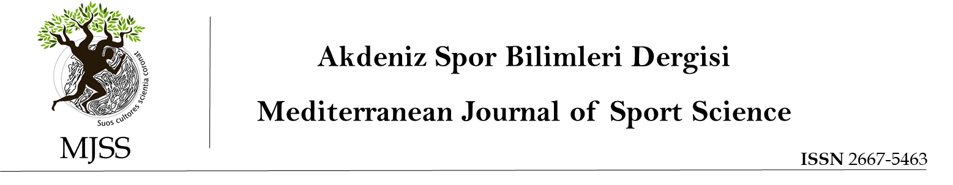
Title Article

ORIJINAL ARTICLE
Abstract

You can delete this part and replace it with your own abstract without violating the format. In this part, you need to place the English abstract of your article. The abstract should be justified, 200-250 words, single-spaced, Times New Roman 10 font size. The abstract should be justified, 200-250 words, single-spaced, Times New Roman 10 font size. The abstract should be justified, 200-250 words, single-spaced, Times New Roman 10 font size. The abstract should be justified, 200-250 words, single-spaced, Times New Roman 10 font size. The abstract should be justified, 200-250 words, single-spaced, Times New Roman 10 font size. The abstract should be justified, 200-250 words, single-spaced, Times New Roman 10 font size. The abstract should be justified, 200-250 words, single-spaced, Times New Roman 10 font size. The abstract should be justified, 200-250 words, single-spaced, Times New Roman 10 font size. The abstract should be justified, 200-250 words, single-spaced, Times New Roman 10 font size. The abstract should be justified, 200-250 words, single-spaced, Times New Roman 10 font size. The abstract should be justified, 200-250 words, single-spaced, Times New Roman 10 font size. The abstract should be justified, 200-250 words, single-spaced, Times New Roman 10 font size. The abstract should be justified, 200-250 words, single-spaced, Times New Roman 10 font size. The abstract should be justified, 200-250 words, single-spaced, Times New Roman 10 font size. The abstract should be justified, 200-250 words, single-spaced, Times New Roman 10 font size. The abstract should be justified, 200-250 words, single-spaced, Times New Roman 10 font size.
Keywords: 10 point, 3-5 words
Turkish Title
Öz

Biçimlendirmeyi bozmadan bu kısmı silip yerine kendi özetinizi yazabilirsiniz.
Bu kısma makalenizin Türkçe özetini yerleştirmeniz gerekmektedir.
Öz, iki yana yaslı ve 200-250 kelime olarak, tek satır aralığında, Times New Roman 10 punto olarak yazılmalıdır. İki yana yaslı ve 200-250 kelime olarak, tek satır aralığında, Times New Roman 10 punto olarak yazılmalıdır. İki yana yaslı ve 200-250 kelime olarak, tek satır aralığında, Times New Roman 10 punto olarak yazılmalıdır. İki yana yaslı ve 200-250 kelime olarak, tek satır aralığında, Times New Roman 10 punto olarak yazılmalıdır. İki yana yaslı ve 200-250 kelime olarak, tek satır aralığında, Times New Roman 10 punto olarak yazılmalıdır. İki yana yaslı ve 200-250 kelime olarak, tek satır aralığında, Times New Roman 10 punto olarak yazılmalıdır. İki yana yaslı ve 200-250 kelime olarak, tek satır aralığında, Times New Roman 10 punto olarak yazılmalıdır. İki yana yaslı ve 200-250 kelime olarak, tek satır aralığında, Times New Roman 10 punto olarak yazılmalıdır. İki yana yaslı ve 200-250 kelime olarak, tek satır aralığında, Times New Roman 10 punto olarak yazılmalıdır. İki yana yaslı ve 200-250 kelime olarak, tek satır aralığında, Times New Roman 10 punto olarak yazılmalıdır. İki yana yaslı ve 200-250 kelime olarak, tek satır aralığında, Times New Roman 10 punto olarak yazılmalıdır.
Anahtar kelimeler: 10 punto, Baş Harfler Büyük. (3-5 Kelime)

Introduction
You can delete this part and replace it with your own text without violating the format. In this section, please state the problem situation of your research. Explain the key concepts related to your research. Mention the literature on your research. Express how your research contributed to the literature. Explain how your research is important in other dimensions. Write the purpose and sub-objectives of your research.
Write the text double-sided, Times New Roman, 0 pt first, then 8 pt, 1.5 line spacing. Turn on the "Add Space After Paragraph" feature.
As the last paragraph of the introduction, write the research questions clearly and precisely. Write the text double-sided, Times New Roman, 0 pt first, then 8 pt, 1.5 line spacing. Turn on the "Add Space After Paragraph" feature. You can delete this part and replace it with your own text without violating the format.
Materials and Methods
You can delete this part and replace it with your own text without violating the format. In this section, explain the method of your research. Define the method using references if needed. Write down the step-by-step process you followed within the framework of the definition. Write the text double-sided, Times New Roman, 0 pt first, then 8 pt, 1.5 line spacing. Turn on the "Add Space After Paragraph" feature.
Model of the Research
You can delete this part and replace it with your own text without violating the format. In this section, explain the model of your research. Define the model using resources if needed. List the steps you followed according to the model. Write the text double-sided, Times New Roman, 0 pt first, then 8 pt, 1.5 line spacing. Turn on the "Add Space After Paragraph" feature.
Population and Sample / Study Group
You can delete this part and replace it with your own text without violating the format. In this section, please describe with whom or in what situations, depending on whether your research is quantitative, qualitative or mixed research. Tell about the people or situations you work with, within the framework of what criteria or techniques. Explain or describe the need for these criteria or techniques. List the steps you followed in this framework. Provide quantitative or qualitative information about the people or situations you have studied, depending on your research method. Write the text double-sided, Times New Roman, 0 pt first, then 8 pt, 1.5 line spacing. Turn on the "Add Space After Paragraph" feature.
Data Collection Tools
You can delete this part and replace it with your own text without violating the format. In this section, list the data collection tools you used in your research. State what parts each data collection tool consists of, what it aims to measure. In the case of measurement tools (i.e., questionaire), share the validity and reliability features of these tools. Write the text double-sided, Times New Roman, 0 pt first, then 8 pt, 1.5 line spacing. Turn on the "Add Space After Paragraph" feature.
Analysis of Data
You can delete this part and replace it with your own text without violating the formatt. In this section, explain how you analyzed the data you obtained. Mention your reasons for choosing analysis methods. Write whether you meet the assumptions required for the analysis. Write the text double-sided, Times New Roman, 0 pt first, then 8 pt, 1.5 line spacing. Turn on the "Add Space After Paragraph" feature.
Ethics of Research
You can delete this part and replace it with your own text without violating the format. Write down which ethical principles you paid attention to during the research (getting permission for the measurement tools, filling in the parent consent form, signing the informed consent form, etc.). Please write the information about the Ethics Committee Permission you have received. Write the text double-sided, Times New Roman, 0 pt first, then 8 pt, 1.5 line spacing. Turn on the "Add Space After Paragraph" feature.
Results
You can delete this part and replace it with your own text without violating the format. In this section, give the findings you have reached in line with the general purpose and sub-objectives of the research. Do not address any situation unrelated to the research objectives in this section. Write the text double-sided, Times New Roman, 0 pt first, then 8 pt, 1.5 line spacing. Turn on the "Add Space After Paragraph" feature.
Third Level Title

Tables
Tables, graphs and statistical reporting should be prepared according to APA 7 style. Table font should be written in 10 points, single spacing.
Example table;
Table 2
Title Should be Times New Roman 12 point. Table Number Should be Given Above.
 | Gender | n |  | Sd | t | p
Sub-Dimension | Female | 88 | 16,01 | 2,59 | 1,391 | ,000*
 | Male | 92 | 16,51 | 2,21
Sub-Dimension | Female | 88 | 22,57 | 4,09 | 1,177 | ,241
 | Male | 92 | 23,27 | 3,80
Sub-Dimension | Female | 88 | 16,75 | 2,56 | ,119 | ,906
 | Male | 92 | 16,79 | 2,36
Sub-Dimension | Female | 88 | 11,84 | 2,45 | ,136 | ,892
 | Male | 92 | 11,89 | 2,52
Sub-Dimension | Female | 88 | 12,06 | 2,27 | ,131 | ,896
 | Male | 92 | 12,10 | 1,87
p<0.05
Discussion and Conclusion, Suggestions (First Level Title, Bold)
You can delete this part and replace it with your own text without violating the format. In this section, express your conclusions based on your findings. Rather than include numerical values, explain what they mean. Discuss the results you have obtained within the scope of features such as similarities, differences, relationships, cause-effects, question-answers with each other and with other studies in the literature. State the limitations of your research. Within the framework of these limitations, interpret/discuss the findings of your research. State your suggestions for the next studies and to other researchers, practitioners, education stakeholders, those interested in program development etc. Make sure that these suggestions are only related to the problems you have identified within the scope of the study.

Tables
Tables, graphs and statistical reporting should be prepared according to APA 7 style. Table font should be written in 10 points, single spacing.
Example table display;
Table 2
Title Should be Times New Roman 12 point. Table Number Should be Given Above.
 | Variable | n |  | Sd | t | p
Sub-Dimension | Female | 88 | 16,01 | 2,59 | 1,391 | ,000*
 | Male | 92 | 16,51 | 2,21
Sub-Dimension | Female | 88 | 22,57 | 4,09 | 1,177 | ,241
 | Male | 92 | 23,27 | 3,80
Sub-Dimension | Female | 88 | 16,75 | 2,56 | ,119 | ,906
 | Male | 92 | 16,79 | 2,36
Sub-Dimension | Female | 88 | 11,84 | 2,45 | ,136 | ,892
 | Male | 92 | 11,89 | 2,52
Sub-Dimension | Female | 88 | 12,06 | 2,27 | ,131 | ,896
 | Male | 92 | 12,10 | 1,87

In-text citations
Author information can be given in/out parentheses.
• In the citation in parentheses, the author's surname and publication date are included in parentheses. The author surname and date are added at the end of the sentence in parentheses and a comma is used after the author surname.
(Gülşen, 2020)
• In citation outside of parentheses (narrative), the author's surname is included as part of the sentence and the year is in parentheses.
Gülşen (2020)
• If a work has two authors, always include the surnames of both authors whenever you refer to the source.
(Gülşen and Yıldız, 2022)
Gülşen and Yıldız (2020)
• If a study has three or more authors, give only the surname of the first author and then “et al.,”
Gülşen et al. (2022)
(Gülşen et al., 2022)
• When more than one source is in parentheses, they should be cited in alphabetical order and separated by semicolons.

A writer | (Gülşen, 2022) | Gülşen (2022)
**Two authors | (Gülşen and Yıldız, 2022) | Gülşen and Yıldız (2022)
With three or more authors | (Gülşen et al., 2022) | Gülşen et al. (2022)
Secondary sources | Gülşen, 2020, as cited in Yarayan, 2022 | According to Gülşen (as cited in Yarayan, 2022)
Group names as authors,  • In the first quote  • Subsequent quotes | (World Health Organisation [WHO], 2020)  (WHO, 2020) | World Health Organisation (WHO, 2020)  WHO (2020)

Bibliography
For a detailed review of the reference, please review the journal author guideline. Line spacing must be single. It should be in the 0 pt range first and then 8 pt. The second line of the bibliography should start with a 1 cm indent.
• References should be listed in alphabetical order according to the first author's surname and first letter.
• In studies with one or two authors, the conjunction "and" should be used between two authors.
• In studies with three or more authors, the conjunction "and" should be used before the last author.

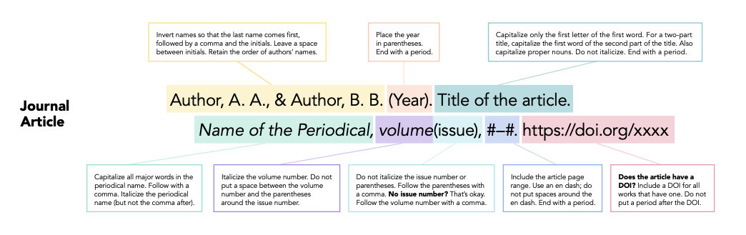*Retrieved from APA7

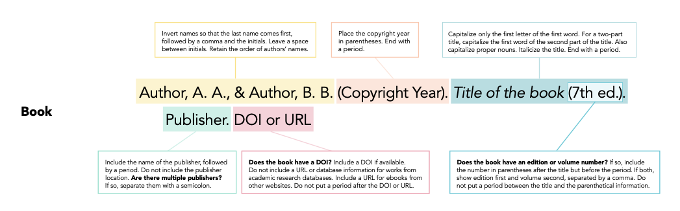 *Retrieved from APA7

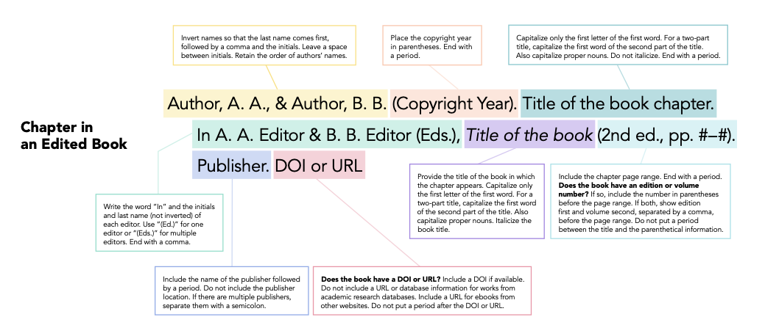
*Retrieved from APA7

Conference Papers
Author, A. A. (Year, Month 1-30). Title of the study. Congress Name, (pp. 13-23). City, Country.
Theses
Author, A. (2022). The title of the thesis is in italics. Unpublished PhD thesis, University, Institute, Department, City.
Webpage
Author Surname, Initial or Group name. (Date). Title of the study. The name of the website. The URL …. taken on.
World Health Organization (2020, 13 November). Coronavirus. World Health Organization. https://www.who.int/.
Official Publications and Press Releases
Turkish Statistical Institute. (2020). Sports with statistics (Publication no. 1313). https://tuik....

Note: All references should be arranged according to APA 7
https://apastyle.apa.org/style-grammar-guidelines/references/examples

This paper is licensed under a Creative Commons Attribution 4.0 International License.

