Title
ITU/JFST

Author1¹, Author2²
(ORCID link should be added with a hyperlink to the image next to the author)
¹Affiliation1.
²Affiliation2.

Abstract: A single paragraph of about 250-300 words. For research articles, abstracts should give a pertinent overview of the work. The first page should not exceed one page. If necessary, the font can be reduced to 8.5 points.

Keywords: First, second, third max. 5 words

Başlık 2. Satıra Geçen Başlıklar Arasında Boşluk Olmamalı

Özet: Özet 250-300 kelime arasında olmalı ve buraya yazılmalıdır. Yazı fontu 9 punto Arial olmalıdır. Metin yazılırken bu taslak indirilip üzerinden devam edilmelidir. İlk sayfa bir sayfayı aşmamalıdır. Gerekli olması halinde yazı fontu 8,5 puntoya kadar düşürülebilir.

Anahtar Kelimeler: Birinci, ikinci, üçüncü, maks 5 kelime.

Type of the Paper (Article, Review)

Corresponding Author: Author Name-Surname E-mail:

Reference: Author1 and Author2. (2024). Title of article, ITU Journal of Food Science and Technology, X(X), XX-XX.

Submission Date: 1 February 2024
Online Acceptance: 1 February 2024
Online Publishing: 1 February 2024

1.Introduction
The introduction should briefly place the study in a broad context and highlight why it is important. It should define the purpose of the work and its significance. The current state of the research field should be carefully reviewed and key publications cited (Trenberth et al., 2003).
Finally, briefly mention the main aim of the work and highlight the principal conclusions (Trenberth, 2003).
2. Materials and Methods
2.1 Materials
2.2 Methods

This section may be divided by subheadings.

Main headings should be informative, use 11 point Arial font and capitalize the first letter of the all words.

For Level 2 headings, use justified 11-point Arial font and capitalize the first letter.

3. Results and Discussion
This section may be divided by subheadings.
It should provide a concise and precise description of the experimental results, their interpretation, as well as the experimental conclusions that can be drawn.
Authors should discuss the results and how they can be interpreted from the perspective of previous studies and of the working hypotheses. The findings and their impli-cations should be discussed in the broadest context possible.
Equations (Cambia Math 12 punto)

$f=\frac{x^{2}}{y^{3}}$ (1)

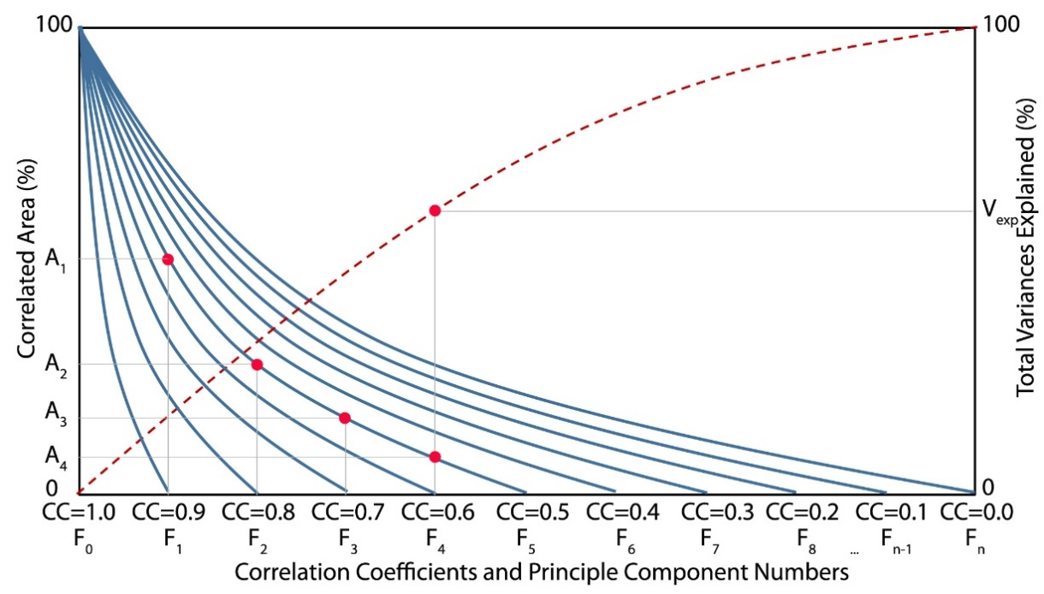
Figure 1. Figure captions should be written in 9 font size, centered and end with a dot.
Şekil 1. Şekil isminin Türkçesi de italik olarak yazılmalıdır.

Table 1. Table captions should be written in 9 font size, and end with a dot.
Tablo 1. Tablo isminin Türkçesi de italik olarak yazılmalıdır.
Probability (%) | SPI | Drought category
2.30 | SPI≥2.00 | extreme wet
4.40 | 2.00>SPI≥1.50 | very wet
9.20 | 1.50>SPI≥1.00 | moderate wet
68.20 | 1.00>SPI≥-1.00 | normal
9.20 | -1.00≥SPI>-1.50 | moderate drought
4.40 | -1.50≥SPI>-2.00 | severe drought
2.30 | -2.00≥SPI | extreme drought

Caption of the figures, drawings and graphs should be Arial font with 9 point and be placed below figure, drawing or graph. The Turkish version of captions should also be written in italics under English caption.
Heading and footnotes of the tables should be Arial font with 9 point. Headings should be placed above the table and footnotes should be placed below. Descriptor information should be placed in footnotes, should not be given in the heading. Explanations of abbreviations used in the table should be made in footnotes.

4. Conclusion

The conclusions section should come in this section at the end of the article, before the acknowledgements.

5. Acknowledgements

Acknowledgments of people, grants, funds, etc. may be placed in a separate section before the references section. The names of funding organisations should be written in full.

6. Conflicts of Interest

Conflicts of interest should be declared or “The authors declare no conflict of interest.” should be stated.

7. References

References should be arranged in accordance with the Publication Manual of the American Psychological Association (APA) guidelines.
Cholakov, R., Tumbarski, Y., Yanakieva, V., Dobrev, I., Salim, Y., & Denkova, Z. (2017). Antimicrobial Activity of Leuconostoc Lactis Strain Bt17, Isolated From A Spontaneously Fermented Cereal Beverage (Boza). Journal of Microbiology, Biotechnology and Food Sciences, 7(1), 47–49. https://doi.org/10.15414/jmbfs.2017.7.1.47-49
Duraçe, E., Dikmetaş, D. N., & Güler, F. K. (2024). Biyokontrol Yaklaşımı ile Küflerin Kontrolü. ITU Journal of Food Science and Technology, 2(1), 29-40.
Ozkan, G., Sakarya, F. B., Tas, D., Yurt, B., Ercisli, S., & Capanoglu, E. (2023). Effect of In Vitro Digestion on the Phenolic Content of Herbs Collected from Eastern Anatolia. ACS omega.

