

Geographical accessibility of health care network via GIS in Kastamonu

Cansel Çakıra, \* [ORCIDiD_icon16x16](https://orcid.org/0000-0001-5105-8630), Öznur Işınkaralarb [ORCIDiD_icon16x16](https://orcid.org/0000-0001-9774-5137), Sevgi Öztürkb [ORCIDiD_icon16x16](https://orcid.org/0000-0002-3383-7822)

a Department of Landscape Architecture, Institute of Science, Kastamonu University, Kastamonu, Türkiye

b Department of Landscape Architecture, Faculty of Engineering and Architecture, Kastamonu University, Kastamonu, Türkiye

\*Corresponding Author: canselakr@gmail.com

Received: April 07, 2022 ◆ Accepted: June 09, 2022 ◆ Published Online: June 27, 2022

**Abstract:** Accessibility is one factor that increases the quality of life in urban areas. Accessibility is an indicator that reflects the ease of reaching an intended point or location. In general, access to healthcare relates to the population in a given area combining the physical distance between home and the location of a healthcare facility.

**Keywords:** Accessibility, Health, GIS, Network Analysis, Kastamonu

**Öz:** Kentsel alanlarda yaşam kalitesini artıran unsurlardan biri de erişilebilirliktir. Erişilebilirlik, amaçlanan bir nokta veya bir konuma ulaşabilme kolaylığını yansıtan bir göstergedir.

**Anahtar Kelimeler:** Erişebilirlik, Sağlık, CBS, Ağ Analizi, Kastamonu

# 1. Introduction

Today, especially in the post-COVID-19 pandemic period, the importance of health care accessibility research has increased. There are many physical factors that affect the accessibility [1]. Easy access opportunities should be provided for transportation, road texture, parking lot and vehicle traffic, especially for pedestrians in urban areas [2-4]. Accessibility to health services [5] is an element that reflects the welfare level of the society and is related to the physical distance between the residence and the place of a health facility where the population living in an area can go when they leave the residential areas [6].

Although research on access to health services is increasing day by day, a common judgment has not emerged regarding the definition of the concept due to its multidimensional nature [11]. Dimensions such as accessibility of health services in rural areas [12], adequacy of services [13-15] service quality [16-18] is often explored. In addition, physical/geographic accessibility is also a topic of discussion in spatial planning [19-22].

# 2. Material and Method

The case area for the study was chosen as the central district of Kastamonu province (Figure 1). Kastamonu province is located in the Western Black Sea region between 41 degrees 21' north latitude and 33 degrees 46' east longitudes [28]. Its height above sea level is 775m. It has a surface area of 13,108.1 km² [29].

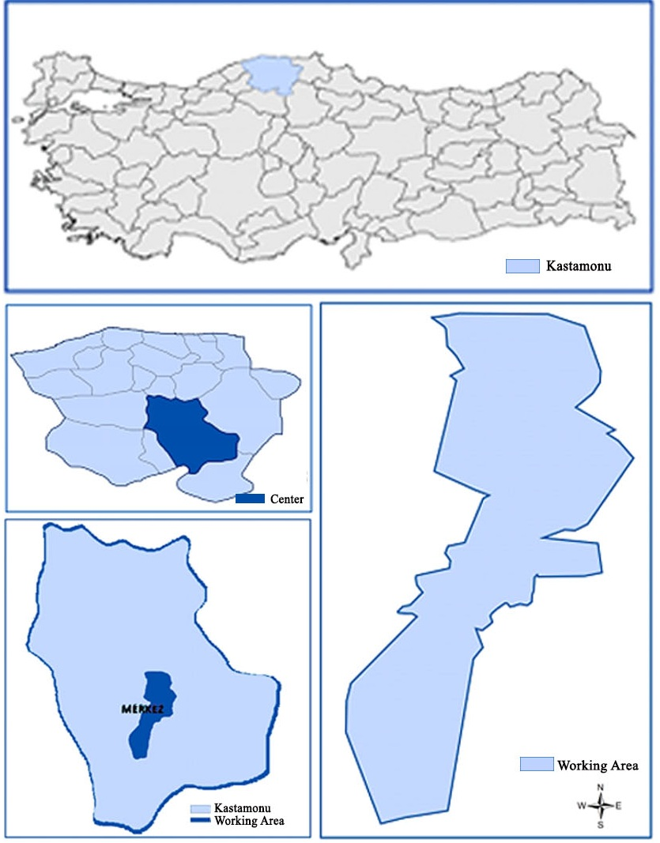

**Figure 1.** Location of case area

The research consists of four stages. First of all, the locations of FHCs in the city were determined, and neighborhoods with and without facilities were chosen. Then, the possible transportation network to the determined areas was mapped. As in some of the studies on the use of health services, GIS software was used in spatial accessibility analysis studies. Network analysis was performed using GIS software to determine accessible locations.

Digital transportation network to be used in the implementation of the analysis and the evaluation of the analysis result; Data of the locations of Health Service Centers; border and population data of the neighborhoods within the study area; The vector data of the houses in the study area were used. Digital road network data of the study area has been obtained, and corrections have been made.

# 3. Result

According to TUIK 2020 data, the population of Kastamonu is 376 377 and the population of the Central district is 151500. 49.83% of the center population is male and 50.17% is female [30]. The health facilities in the central district of Kastamonu, where the study was carried out, constitute the main material of the study. While there are no health facilities in 10 of the 19 neighborhoods in the district, there are health services facility areas in 9 neighborhoods. Neighborhoods with healthcare facilities can be listed as Aktekke, Beyçelebi, Esentepe, Hepkebirler, İnönü, İsmailbey, Kuzeykent, Mehmet Akif, Saraçlar (Figure 2).

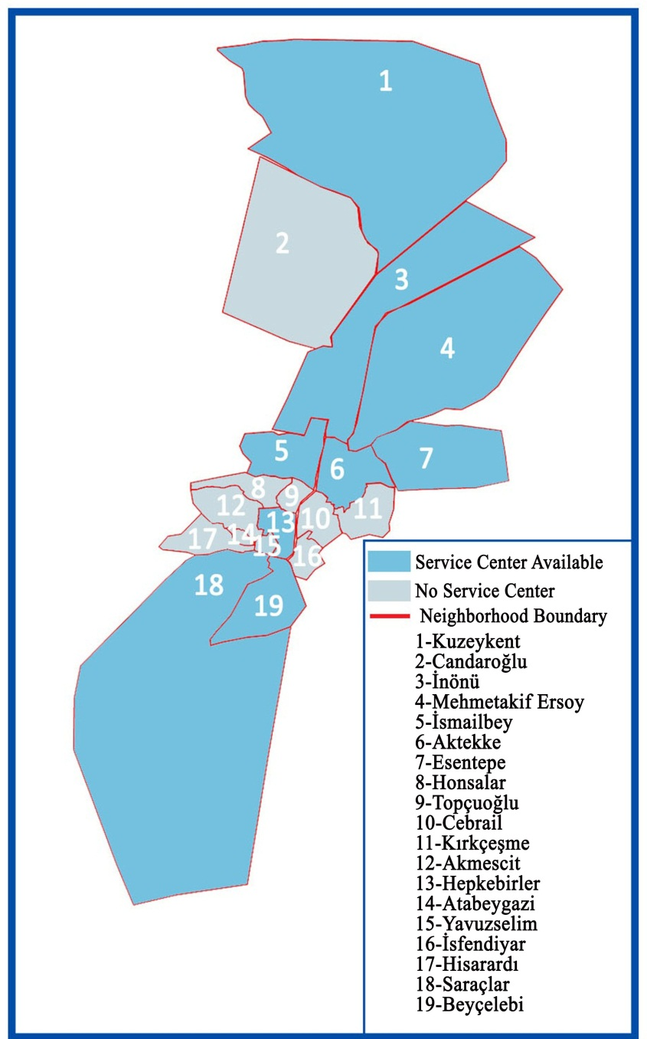

**Figure 2.** Neighborhoods with health service centers

In the study area, there are 12 health care facility areas, including 1 Training and Research hospital, 1 physical therapy and rehabilitation center, 1 private hospital and 9 family health centers, located at different points of the study area (Figure 3).

| Neighborhood Name | Population | Total Area  (m²) | Building | | | Accessible Rate (%) | |
| --- | --- | --- | --- | --- | --- | --- | --- |
| Total | 300m | 500m | 300m(%) | 500m(%) |
| Aktekke | 4505 | 481000 | 477 | 150 | 250 | 31.45 | 51.42 |
| Beyçelebi | 2899 | 685687 | 188 | 68 | 153 | 36.17 | 81.38 |
| Esentepe | 3528 | 1231016 | 540 | 0 | 90 | 0 | 16.67 |
| Hepkebirler | 1842 | 178000 | 257 | 246 | 257 | 95.72 | 100 |
| İnönü | 21874 | 2783000 | 790 | 185 | 319 | 23.42 | 40.38 |
| İsmailbey | 3687 | 303000 | 623 | 0 | 23 | 0 | 3.69 |
| Kuzeykent | 27814 | 5739000 | 1710 | 97 | 135 | 5.67 | 7.89 |
| MehmetAkif | 23814 | 4180000 | 940 | 16 | 45 | 1.7 | 4.79 |
| Saraçlar | 13618 | 8487782 | 1091 | 192 | 358 | 17.6 | 32.81 |
| Akmescid | 1256 | 383556 | 405 | 5 | 17 | 1.23 | 4.2 |
| Atabeygazi | 343 | 46216 | 156 | 0 | 110 | 0 | 70.51 |
| Candaroğlu | 9230 | 3112499 | 577 | 3 | 4 | 0.52 | 0.69 |
| Cebrail | 2304 | 269436 | 394 | 12 | 126 | 3.05 | 31.98 |
| Topçuoğlu | 1168 | 127063 | 256 | 47 | 72 | 18.36 | 28.13 |
| İsfendiyar | 1328 | 168016 | 204 | 31 | 104 | 15.2 | 50.98 |
| Kırkçeşme | 1519 | 364591 | 285 | 0 | 0 | 0 | 0 |
| Hisarardı | 890 | 311615 | 250 | 65 | 104 | 26 | 41.6 |
| Honsalar | 1297 | 259484 | 408 | 23 | 23 | 5.64 | 5.64 |
| YavuzSelim | 536 | 57559 | 86 | 32 | 84 | 37.21 | 97.67 |
| Toplam | 151500 | 29168520 | 9637 | 1172 | 2274 | 12 | 23.60 |

**Table 1.** Spatial accessibility status of health service centers

# 4. Discussion and Conclusion

Today, health services serve two main purposes, raising health standards and increasing knowledge about diseases [31, 32]. The health service centers that are the subject of our study are not separated as primary, secondary or tertiary health services, but are institutions that include private and public services ranging from institutions where users can receive services on follow-up and simple interventions to institutions containing intensive care services.

Hospitals are located very close to the city center in Kastamonu [33]. Network analysis applied to the city center aims to determine accessible areas for family health centers.

# Competing Interest / Conflict of Interest

The authors declare that they have no competing interests.

# Author Contribution

We declare that all Authors equally contribute.

# Acknowledgements

# 5. References

[1] Kalay, G., Bogenç, Ç., (2022). An Evaluation of Urban İmage and The Use of Urban Space in Karabük City Center. International Social Mentality and Researcher Thinkers Journal. 8(57): 645-655

[2] Bogenç, Ç., Sabaz, M., (2017). In the Process of Development of the Site Management Plan of the World Heritage Site Safranbolu; Identifying Themes, Goals, and Actions. Journal of Human and Social Sciences Research. 8(3):1526/1544