TITLE

¹Author, ²Author*

¹Address
²Address
¹email@author, ²email@author

Highlights

- Highligts 1
- Highligts 2
- Highligts 3

'Highlights' include 3 to 5 bullet points (maximum 85 characters, including spaces, per bullet point).

Graphical Abstract (Optional)

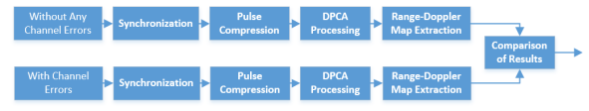
Figure Flowchart of the proposed method

