INTERNATIONAL JOURNAL OF ENERGY STUDIES

e-ISSN: 2717-7513 (ONLINE); homepage: https://dergipark.org.tr/en/pub/ijes

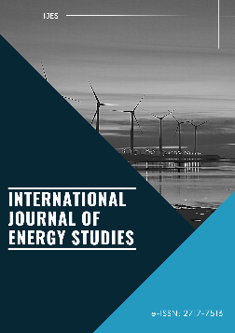

Received | : | XX May 2024
Revised | : | XX May 2024
Accepted | : | XX May 2024

Research Article / Review Article
Int J Energy Studies 2024; X(X): X-X
DOI:

Title of the paper

Highlights
- At least 3, max 5 highlights should be listed here

You can cite this article as: Attaining sustainable energy transition or facing costs of delayed action: A case of Turkey. Int J Energy Studies 2020; 5(2): 133-144.
ABSTRACT
Maximum word numbers should not be exceeded 300 words. The abstract should be prepared via Times New Roman and 10 pts, single spaced and align full.
Keywords: Sustainable policy, Energy transition, Energy efficiency, Environment
3 to 5 (Each one should be seperated by comma)

1. INTRODUCTION
Please use the template given during preperation of your paper you will submit to International Journal of Energy Studies.

Starting from the introduction, all paragraphs in the text should be prepared in Times New Roman format, 12 font size, 1.5 line spacing and fully aligned. There should be spaces between paragraphs.

2. SECOND SECTION’ TITLE
Second section should be written here as it is written. There is no any limitation how many headings and sub-headings are used. So, the heading number of Conclusion section depends on how many headings are used.

2.1. Figures and Tables
The first letter of the first word of the subtitle should be capitalized, and the others should be written in lower case. If there are figures and/or tables in your paper, they should be given in the paper as it is seen below.

2.1.1. Positioning of figures and tables
The title of the figure should be written in "Times New Roman" font, 12 pt, and without any spaces between it and the figure. The figure and figure title should be centered. No space should be left between the table title and the table. Tables and table headings should be left aligned.

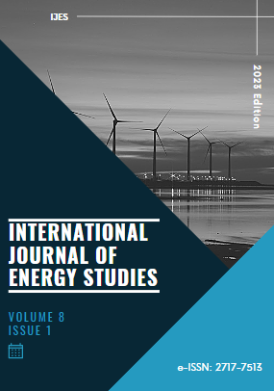
Figure 1. The figure’ caption

Table 1. The table’ caption
Any Item
1
2

If there are equations in the text, the equations should be left aligned and the equation numbers should be right aligned. Example equations are given below.

$$∇.\vec{V}=0$$ | (1)

$$\frac{∂\vec{V}}{∂t}+\vec{V}.∇\vec{V}=\frac{1}{ρ}\left(-∇P+µ{∇^{2}\vec{V}+ρβ\vec{g}(T-T}_{ref}))+ \vec{S}\right)$$ | (2)

3. CONCLUSION
Please conclude all the results you obtain in this section.

NOMENCLATURE
If there are abbreviations in the text, it should be given in this section.

ACKNOWLEDGMENT
If available, any institution, company, and etc. that supports to the paper submitted should be acknowledged here.

DECLARATION OF ETHICAL STANDARDS
The author/The authors of the paper submitted declare/declares that nothing which is necessary for achieving the paper requires ethical committee and/or legal-special permissions.

CONFLICT OF INTEREST
There is no conflict of interest in this study.

REFERENCES
[1] Karyeyen S, Ilbas M. Experimental and numerical analysis of turbulent premixed combustion of low calorific value coal gases in a generated premixed burner. Fuel 2018; 220: 586-598. (If a journal paper is cited)
[2] Tsuji H, Gupta AK, Hasegawa T, Katsuki M, Kishimoto K, Morita M. High temperature air combustion from energy conservation to pollution reduction. CRC Press LLC, Florida, US, 2003. (If a book is cited)
[3] Karyeyen S. Experimental and numerical investigations of combustion characteristics of coal gases in a developed combustor. PhD Thesis, Gazi University, 2016. (If a thesis published is cited)
[4] Karyeyen S, Feser JS, Gupta AK. Hydrogen enrichment effects in gaseous fuels on distributed combustion. The American Society of Mechanical Engineers (ASME)-Power Conference and Nuclear Forum Salt Lake City, Utah, US, 2019. (If a proceedings of a conference is cited)

