English title of the article
(Point Size 12, Times New Roman, must be wholly written in lower case except the first Word and proper nouns)
Turkish title of the article
(Point Size 12, Times New Roman, must be wholly written in lower case except the first Word and proper nouns)

WARNING: The text should include no information as to the author(s). Information about author(s) must be provided within the folder of “ARU Journal of FEAS Author Info” and must be uploaded to the Dergipark system as a folder during the application process.

Abstract (point size 8, 200 words maximum)
Text text text. Text text text. Text text text. Text text text. Text text text. Text text text. Text text text. Text text text. Text text text. Text text text. Text text text. Text text text. Text text text. Text text text. Text text text. Text text text. Text text text. Text text text. Text text text. Text text text. Text text text. Text text text. Text text text. Text text text. Text text text. Text text text. Text text text. Text text text. Text text text. Text text text. Text text text. Text text text. Text text text. Text text text. Text text text. Text text text. Text text text.
Keywords: Word, Word, Word (minumum 3, maximum 5 words)

BASIC RULES FOR WRITING
- Use APA Version 7 for in-text reference, and bibliography. Our journal suggests the usage of reference management softwares such as Mendeley, EndNote, Zotero, RefWorks. For the APA Version 6. Principles.
- The article to be submitted must be 25 pages maximum, including all the elements of the study (abstract, text, bibliography, appendixes).
- Below provided a guideline for the article design. It may vary according to the feature of the study.
- The studies that are not prepared in accordance with the rules for writing will be sent back to the author(s) for a revision, or they might be rejected.
- If the article is accepted, page design (page layout) will be performed by the Journal auhtorities, the author(s) will be deemed to have accepted the changes in the design in advance.

1. Introduction (1. Level title: point size 12, Times New Roman, First letters in upper case)
Text Text text text text text text text text text text text text text text text text text text text text text text text text text text text text text text text text text text text text text text text text text text text text text text text text text text text text text text text text text text text text text text text text text text text text text text text text text text text text text (Baker & Wallage, 2000; Bititci, Garengo, Dörfler, & Nudurupati, 2012).
Text text text text text text text text text text text text text text text text text text text text text text text text text text text text text text text text text text text text text text text text text text text text text text text text text text text text text text text text text text text text text text text text text text text (Wang, 2005).
2. Literature Review (1. Level title: point size 12, Times New Roman, First letters in upper case)
Text text text text text text text text text text text text text text text text text text text text text text text text text text text text text text text text text text text text text text text text text text text text text text text text text text text text text text text text text text text text text text text text text text text text text text text text text text text text text text text text text text text text text text (Armstrong, 2009).
3. Methodology (1. Level title: point size 12, Times New Roman, First letters in upper case)
Text text text text text text text text text text text text text text text text text text text text text text text text text text text text text text text text text text text text text text text text text text text text text text text text text text text text text text text text text text text text text text text text text text text text text text text.
3.1. Sampling and Data Collection (2. Level title: point size 12, Times New Roman, First letters in upper case)
Text text text text text text text text text text text text text text text text text text text text text text text text text text text text text text text text text text text text text text text text text text text text text text text text text text text text text text text text text text text text text text text text text text text text text text text.

Table 1: Stock Market List
(Table denomination: Above the table, point size 11, Times New Roman, The first letter in upper case only)
(In-table texts: point size 10, Times New Roman, line spacing: single, spacing value before and after:0 nk)
(Table format: A solid line is added only at the top, bottom and below the main categories in the table, as in the example below)
Country | Name of the Stock Market | Beginning | End | Number of Observation
Bahrain | Bahrain Stock Exchange | 02.01.2003 | 31.08.2015 | 3302
Egypt | Egyptian Exchange | 02.01.1995 | 31.08.2015 | 5390
Kuwait | Kuwait Stock Exchange | 03.01.2000 | 31.08.2015 | 4086
Lebanon | Beirut Stock Exchange | 01.02.1996 | 31.08.2015 | 5108
Tunisia | Tunis Stock Exchange | 02.01.1998 | 31.08.2015 | 4607
Türkiye | Borsa Istanbul | 02.01.1990 | 31.08.2015 | 6695
Reference/Source: Armstrong (2009). (Reference: point size 10, Times New Roman, Last Name (Year))
Text text text text text text text text text text text text text text text text text text text text text text text text text text text text text text text text text text text text text text text text text text text text text text text text text text text text text text text text text text text text text text text text text text text text text text text.
3.2. Research Hypothesis (2. Level title: point size 11, Times New Roman, First letters in upper case)
Text text text text text text text text text text text text text text text text text text text text text text text text text text text text text text text text text text text text text text text text text text.
H1a. Delayed dividends have an effect on the dividend decision.
H1b. Delayed dividends have no effect on the dividend decision.
Text text text text text text text text text text text text text text text text text text text text text text text text text text text text text text text text text text text text text text text text text text text text text text text text text text text text text text text text text text text text text text text text text text text text text text text.
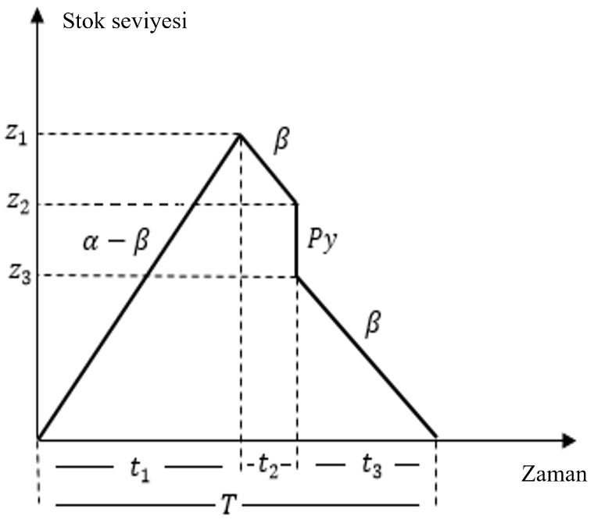
Figure 1: Number of inventory over time
Source/Reference: Bititci et al. (2012).
(Reference: point size 10, Times New Roman, Last Name (Year))
(Figure denomination: Below the figure, point size 11, Times New Roman, The first letter in upper case only)
(Figure format: Figure must be clear and understandable as much as possible)
4. Findings (1. Level title: point size 12, Times New Roman, First letter in upper case)
Text text text text text text text text text text text text text text text text text text text text text text text text text text text text text text text text text text text text text text text text text text text text text text text text text text text text text text text text text text text text text text text text text text text text text text text.
Table 2: Text text text
 | xxxxxx |  | xxxx |  | xxx
Constant | 0.2085 (58.50)*** |  | 0.0150 (63.21)*** |  | 0.0192 (64.41)***
$$\left|R_{m,t}\right|$$ | 0.0824 (2.27)** |  | 0.3353 (16.86)*** |  | 0.2013 (7.54)***
R²_{m,t} | 2.1967 (3.21)*** |  | 1.8767 (4.77)*** |  | 0.0133 (0.0377)
Adj. R² | 0.1507 |  | 0.2373 |  | 0.2166
Notice: Table 2 reports the estimated coefficients for the comparison model: CSAD_{i,t} = α + у₁$\left|R_{m,t}\right|$ + у₂R²_{m,t} + у₃D^{RussianCrisis}R²_{m,t} + ε_{+.} D^{RussianCrisis} It is a dummy variable that takes the value “1” for the period from August 1998 to December 1998, otherwise the value “0”. Data range is from 1.1.1997 to 31.7.2018. Missing information for holidays is carefully reviewed or interpreted. Numbers in parentheses are t-statistics based on Newey – West (1987) consistent standard errors. *, ** and **** represent statistical significance at the 10%, 5% and 1% levels, respectively.

5. Results (Discussion/Implication) (1. Level title: point size 12, Times New Roman, First letters in upper case)
Text text text text text text text text text text text text text text text text text text text text text text text text text text text text text text text text text text text text text text text text text text text text text text text text text text text text text. Text text text text text text text text text text text text text text text text text text text text text text text text text text text text text text text text text text text text text text text text text text text text text text text text text text text text.
References (APA 7 style will be used in alphabetical order)
Armstrong, M. (2009). Armstrong’s Handbook of Performance Management. Kogan Page Limited.
Baker, C. R., & Wallage, P. (2000). The Future of Financial Reporting in Europe: Its Role in Corporate Governance. The International Journal of Accounting, 35(2), 173–187.
Bititci, U., Garengo, P., Dörfler, V., & Nudurupati, S. (2012). Performance Measurement: Challenges for Tomorrow. International Journal of Management Reviews, 14(3), 305–327. https://doi.org/10.1111/j.1468-2370.2011.00318.x
Wang, Z. (2005). Organizational Effectiveness Through Technology Innovation and HRM Strategies. International Journal of Manpower, 26(6), 481–487. https://doi.org/10.1108/01437720510625403

