Author Guidelines
Kafkas University Journal of the Faculty of Economics and Administrative Sciences (KAUJEAS) aims to publish qualitative/quantitative research and review articles with in-depth analysis in the fields of Economics, Business Administration, Social Services, Management Information Systems, Political Science and Public Administration, Political Science and International Relations, International Trade and Logistics, and Electronic Commerce and Management twice a year (in June and December).
In this regard, authors who submit articles to KAUJEAS must pay attention to the journal writing rules outlined below:
- The text of the article should be prepared in MS Word format with 11 point Times New Roman font and a maximum of 25 pages or 7000 words.
- According to the page layout, the articles should be written in single line spacing and 3 cm margins should be left at the top, bottom and right, and 4 cm from the left.
- The title of the article should be written in capital letters, with 14 font size and not more than 12 words, in bold and centered.
- Author names, title, university, faculty and e-mail addresses, address line, ORCID ID should be listed just below the title.
- Abstracts in Turkish and English should be prepared in a single line spacing, with a length of at least 75 and maximum 150 words, including the purpose, scope, method, findings and conclusion of the article.
- After the abstract, 3 keywords that are directly related to the content of the article should be specified.
- 3 JEL codes should be specified under the keywords.
- Under the keywords, the field of research (For example: Business, Economics, Public Administration) and under it the type should be specified. (For example: Research, Compilation).
- Then, English title, author information, abstract, keywords, gel codes, scope and type should be specified.
- The bibliography content should be written in 10 points.
- The submitted work must not have been previously rejected in KAÜİİBFD, not peer-reviewed, not published anywhere, or not under review by another journal. Previously submitted papers can be sent by expanding and specifying this situation by giving footnotes to the article title.
- In order for the presented studies to be accepted as research articles, it is necessary to carry out in-depth analysis, to explain the method (qualitative or quantitative) in detail, or to contribute to the literature.
- The method (qualitative or quantitative) used in research articles should be explained in detail.
- Research articles should contain new or original views on the subject.
- Authors who submit a research article should pay attention to the content of the article, including findings, results, evaluations or discussions that will contribute to the literature on the subject of the study.
- The content of review articles should be objective and concrete.
- Articles derived from master's or doctoral thesis must be submitted in English. Footnotes should be given in the title of the article from which these studies are derived from the thesis.
- Authors must have prepared the articles submitted for publication in the journal in accordance with the rules of research and publication ethics. Ethics committee approval must be obtained separately for studies (survey studies, laboratory experiments, field experiments, interviews, reviews, etc.)
- Intellectual property and copyrights: For the use of scales, surveys, photographs belonging to others, permission from the owners must be obtained and this must be stated in the article.
- In manuscript submissions, the Commitment must be filled in, signed and uploaded to the system together with the article.
- Since our journal is a peer-reviewed journal, there is a Peer Review System.
- Articles submitted to our journal are first reviewed by the Editor. After compliance with the spelling rules, it is scanned in the iThenticate plagiarism program. If there are problematic “overly-quoted places” in the article, they are re-corrected by the authors and included in the referee process.
- The "anonymous author anonymous referee" rule is applied in the refereeing process. Articles are sent to at least 2 referees who are experts in their fields. If the opinions of the two referees differ, the opinion of the third referee is taken. The final decision is made by the editor.
- Manuscripts that are not sent in accordance with the spelling rules, whose ethics committee approval is not documented when necessary, and/or have a high similarity rate (with the exception of the bibliography, maximum 20%) can be rejected by the editor.
- APA 6th Edition rules should be applied for in-text citation notation and bibliography writing.
- The sample manuscript submission draft is shown in Appendix 1

APPENDIX 1: Sample Manuscript Submission Draft

TITLE OF THE ARTICLE (14 Point, BOLD, maximum 12 words)

AUTHOR1 NAME (11 point)
Title, (11 point)
University (11 point)
Faculty (11 point)
Address (City, Country) (11 point),
Email (11 point),
ORCID ID: (11 point)

AUTHOR2 NAME (11 point)
Title, (11 point)
University (11 point)
Faculty (11 point),
Address (City, Country) (11 point),
Email (11 point),
ORCID ID: (11 point)
ABSTRACT (10 point)

Should be justified, 10 point, between 75 to 150 words, single spaced. It should include the purpose, scope, method, findings, and conclusion.

…………………….…………………………………………………………………………………………………………
Keywords: 10 point, 3 pieces (For example: Organizational justice, burnout, job performance)

JEL codes: 10 point, 3 pieces (For example: D43, D47, D40)

Field: 10 point, (For example: Business)
Type: 10 point (For example: Research)

Manuscript Submission Date: dd.mm.yyyy (11 point)

Date of Acceptance for Publication: Remain blank
INTRODUCTION (11 Point, CAPITAL LETTERS)
The introduction should be numbered………………………………………………
2. THEORETICAL BACKGROUND (11 Point, CAPITAL LETTERS)
The theoretical framework of the research should be explained………
2.1. Subheading (11 Point, First Letters Capitalized)
2.2. Other Subheading (11 Point, First Letters Capitalized)
3. METHOD (11 Point, CAPITAL LETTERS)
The method section should be explained in detail………………………
3.1. Ethics permissions for the research
All rules specified within the "Scientific Research and Publication Ethics Directive for Higher Education Institutions" were adhered to in this study. None of the actions specified under the "Actions Contrary to Scientific Research and Publication Ethics" section of the directive were carried out.
Ethics committee approval information:
Name of committee that conducted ethics evaluation =
Date of ethics evaluation decision =
Approval document number =
If scales, surveys, or photographs belonging to others were used, permission was obtained from the owners and this was indicated in the article.

4. RESULTS (11 Point, CAPITAL LETTERS)

4.1. Subheading (11 Point, First Letters Capitalized)

4.1.1. Second subheading (11 Point, Only first letter capitalized)

4.1.2. Other second subheading (11 Point, Only first letter capitalized)

5. CONCLUSION (11 Point, CAPITAL LETTERS)

6. DECLARATION OF CONFLICT OF INTEREST
There is no conflict of interest among the authors.
7. FINANCIAL SUPPORT
E.g:
No funding or support was received for this study.
8. AUTHOR CONTRIBUTIONS (AUTHORS WILL USE THEIR NAME AND SURNAME ABBREVIATION INSTEAD OF "IN" OR "EK")
Example:
IN: Conceptualization;
IN, EK: Design;
EK: Supervision;
IN, EK: Data collection and/or processing;
IN, EK: Analysis and/or interpretation;
In: Literature review;
In, EK: Writing;
EK: Critical review
9. ETHICS COMMITTEE STATEMENT AND INTELLECTUAL PROPERTY COPYRIGHTS
The principles of the ethics committee were followed in the study and necessary permissions were obtained in accordance with the principles of intellectual property and copyright.
10. REFERENCES (11 Punto, CAPITAL LETTERS)

- The reference list should be arranged alphabetically by author's last name, regardless of whether it is a book or a journal article, and end with a period (10pt).
- Only the first letter of the title of an article or book should be capitalized, and the rest should be lowercase.
Brockner, J., Ackerman, G., & Greenberg, J. (2001). Culture and procedural justice: The influence of power distance on reactions to voice. Journal of Experimental Social Psychology, 37(4), 300-315. doi: 10.1037/1076-8998.13.1.10.

Tonta, Y., Bitirim, Y., & Sever, H. (2002). Türkçe arama motorlarında performans değerlendirme (5.b). Ankara: Total Bilişim.

Yıldız, S. (2011). Entelektüel sermaye. İstanbul: Türkmen Kitabevi.

Yıldız, S., & Baştürk, F. (2013). Kars ili marka varlıklarının tüketici temelli değer ölçümü araştırması. TODAİE Çağdaş Yerel Yönetimler, 22(4), 75-90.

APPENDIX 2: Citation and Reference Guidelines of KAUJEAS
Table 1: Citation Rules (Table heading)
 | In-Text Citation (reference) | Bibliography
Single Author Book | (Yıldız, 2011, p. 137) A page number is required for direct transmission.  (Yıldız, 2011) Indirect quotation or general reference does not require page numbers. | Yıldız, S. (2011). Entelektüel sermaye. İstanbul: Türkmen Kitabevi.
Book with Two Authors | At the end of the sentence:  …..(Gülmez & Karakaş, 2015, p. 90).  At the beginning of the sentence:  Gülmez and Karakaş (2015, p. 90)…… | Gülmez, A., & Karakaş, A. (2014). İktisada giriş. İstanbul: Değişim Yayınları.
Book with Three, Four or Five Authors | First citation (reference):  At the end of the sentence:  ……(Tonta, Bitirim & Sever, 2002)  At the beginning of the sentence:  Tonta, Birim and Sever (2002)…….  Second citation (reference):  (Tonta et al., 2002, p. 125) | Tonta, Y., Bitirim, Y., & Sever, H. (2002). Türkçe arama motorlarında performans değerlendirme (5.b). Ankara: Total Bilişim.
Book with Six and Seven Authors | (Jones et al., 2012. p. 40) | Jones, M., Jones, R., Woods, M., Whitehead, M., Dixon, D., & Hannah, M. (2014). An introduction to political geography: space, place and politics. London: Routledge.
Chapter in an Edited Book | (Kejanlıoğlu, 2005, p. 690) | Kejanlıoğlu, B. (2005). Medya çalışmalarında kamusal alan kavramı. M. Özbek (Ed.) In Kamusal alan (pp.689-713). İstanbul: Hill.
Single Authored Article | (Yıldız, 2010, p. 185) | Yıldız, S. (2010). İşletme performansının ölçümü üzerine bankacılık sektöründe bir araştırma. Erciyes Üniversitesi İktisadi ve İdari Bilimler Fakültesi Dergisi, 36, 179-193.
Article with Two Authors | …..(Yıldız & Baştürk, 2013, pp. 77-78).  Yıldız and Baştürk (2013)……… | Yıldız, S., & Baştürk, F. (2013). Kars ili marka varlıklarının tüketici temelli değer ölçümü araştırması. TODAİE Çağdaş Yerel Yönetimler, 22(4), 75-90.
Article with Three, Four or Five Authors | First citation (reference):  (Brockner, Ackerman, & Greenberg, 2001, s. 300)  Second citation (reference):  (Brockner et al., 2001, s. 310) | Brockner, J., Ackerman, G., & Greenberg, J. (2001). Culture and procedural justice: The influence of power distance on reactions to voice. Journal of Experimental Social Psychology, 37(4), 300-315. doi: 10.1037/1076-8998.13.1.10
Article with Six and Seven Authors | (Restouine et al., 2009) | Restouin, A., Aresta, S., Prébet, T., Borg, J., Badache, A., & Collette, Y. (2009). A simplified, 96-well–adapted, ATP luminescence–based motility assay. BioTechniques, 47, 871–875. doi: 10.2144/000113250
Article with Eight or more Authors | (Steel et al., 2010) | Steel, J., Youssef, M., Pfeifer, R., Ramirez, J. M., Probst, C., Sellei, R., ... Pape, H. C. (2010). Health-related quality of life in patients with multiple injuries and traumatic brain injury 10+ years postinjury. Journal of Trauma: Injury, Infection, and Critical Care, 69(3), 523-531. doi: 10.1097/TA.0b013e3181e90c24
Presentation | (Akkoyunlu, 2007, p. 62) | Akkoyunlu, B. (2007). Öğrenme stilleri. Y. Tonta (Ed.) In Bilgi Yönetimi Ulusal Sempozyumu bildiriler kitabı (pp.51-71). Ankara: Hacettepe Üniversitesi.
Dissertation | (Köprülü, 1994) | Köprülü, D. (1994). Üniversite kütüphanelerinde kitap koleksiyonunun kullanımı üzerine bir araştırma. Unpublished doctoral thesis , Hacettepe University, Ankara.
Webpage | (Tillman, 2003) | Tillman, H. N. (2003). Evaluating quality on the net. Retrieved January 15, 2008, from www.hopetillman/findq.html.
Citation | According to Moore……….. ( Cited by Maxwell , 1999, p. 25) | Maxwell should be cited

Example figure presentation:
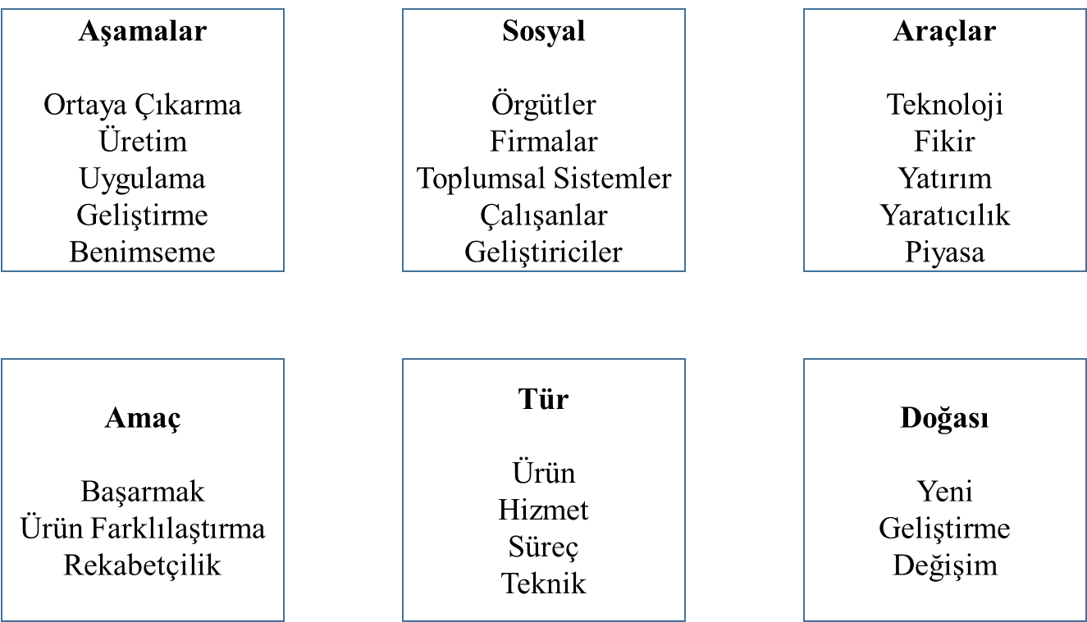
Figure 1 : Figure title display
Source: (Baregheh, Rowley & Sambrook, 2009, pp. 1323-1339)

Compliance with ethical principles regarding the relevant study has been declared.

