 | Van Yuzuncu Yil University  Journal of Engineering Faculty https://dergipark.org.tr/tr/pub/vyyumfd | 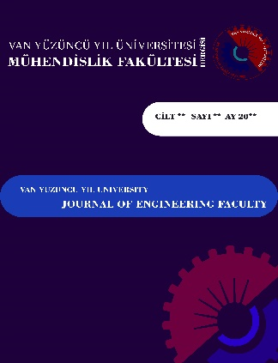

COPYRIGHT TRANSFER AGREEMENT

Article Title: | ………………………………………………………………………………………………………………………………………………………………………………………………………………………………………………………

The undersigned authors, whose full names, surnames, and signatures are provided below, hereby declare their notification and approval of this agreement concerning the publication of their work.

1. All authors hereby transfer all copyrights pertaining to this work to Van Yuzuncu Yil University Journal of Engineering Faculty.
2. This policy ensures that the work submitted is entirely original and has not been previously evaluated or published elsewhere, except for abstracts presented at scientific conferences.
3. The data, text, figures, tables, and other materials of the work are entirely original and do not violate any copyright or other rights of any person or entity.
4. It is explicitly stated that the study materials have not been previously published in any language or format.
5. The authors have given their approval for the final version of the study that was submitted.

For the contract to be considered valid, the study must be published in the Journal of Engineering Faculty at Van Yuzuncu Yil University.

Author name/surname | E-mail Address | Date | Signature
1.
2.
3.
4.
5.
6.
7.

Corresponding Author:
Name Surname: | Phone:
E-mail: | Address:

