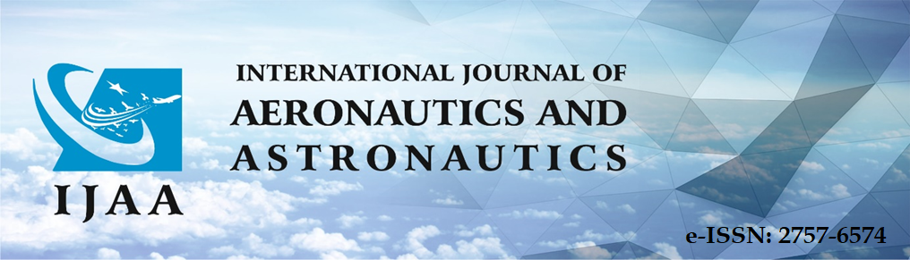
COPYRIGHT FORM
Title of Article/Paper/Manuscript: ......................................................................................
Author(s) – Names, emails and addresses of all authors (specifying of corresponding author):
Author Name: ...........................................
Address: ...............................................
e-mail: ...................................................
Contact number: .......................................
Yazar Sırası
Number | Name-Surname | E-Mail | Signature | Date
1
2
3

The author(s) agrees that:
The manuscript submitted is an original work of the author(s), has not been published in another peer-reviewed journal, has not been evaluated for publication by another journal, and has not been plagiarized from any prior work,

The article does not use any material or method that may be unlawful or infringe any proprietary or personal rights of others (including, without limitation, any copyright or privacy right),

All authors have seen and approved the manuscript as submitted,

They accept and undertake that all authors have participated in the work and take all kinds of responsibilities for the work.

The International Journal of Aeronautics and Astronautic will publish the content under Creative Commons Attribution-NonCommercial 4.0 International (CC BY-NC 4.0) license.

The Author(s) retain(s) all commercial rights in addition to copyright, and patent rights.

The article is not in violation of any existing copyright or any third party rights, and that the International Journal of Aeronautics and Astronautics publisher, editors, its staff or members of the editorial board are responsible for the products, negligence or We accept and undertake that we are not responsible for any other way or for any injury and/or damage to persons or property resulting from any use or operation, and all responsibility belongs to the authors.

This Copyright Agreement Form must be signed/ratified by all authors. Separate copies of the form (completed in full) may be submitted by authors located at different institutions; however, all signatures must be original and authenticated.

Responsible/Corresponding Author | Original Signature (in ink) | Date

