Title Should Be Centred Written in 14 Font, First Letters Should Be Capitalized (Do not Capitalize “of, not, a, the, and, or”)
First Author^{1*}, Second Author², Third Author³

¹Department of Chemistry, Faculty of Arts and Sciences, Kırklareli University, Kırklareli, Turkiye
²Department of Civil Engineering, Faculty of Engineering, Kırklareli University, Kırklareli, Turkiye
³Department of Physics, Faculty of Literature and Science, Fırat University, Elazığ, Turkiye
Received: 00.00.0000, Accepted: 00.00.0000, Published: 00.00.0000

ABSTRACT
Provide an abstract of 150 to 250 words. The abstract should not contain any undefined abbreviations. It should be written in 11-point font in Times New Roman. Single line spacing should be used. Abstract should be justified; text is aligned with both margins. Do not use paragraph indentation in the abstract and all sentences should be presented in a single paragraph. Between 3 and 5 keywords should be used. Capitalize the first letters of the keywords and use semicolon between keywords.
Keywords: Keyword 1; Keyword 2; …

Başlık 14 Punto ile Yazılmalı ve Kelimelerin İlk Harfleri Büyük Yazılmalı (“ve, ile, vs.” gibi Kelimeler Küçük Harfle Yazılmalı)
ÖZ
Özün 150 ile 250 kelime arasında olmasını sağlayınız. Öz tanımlanmamış kısaltmaları içermemelidir. Öz, Times New Roman karakteri ile 11 punto büyüklüğünde yazılmalıdır. Tek satır aralığı kullanılmalıdır. Öz iki yana yaslı seçeneği kullanılarak yazılmalı ve sayfa kenarındaki boşluklar arasına hizalanmalıdır. Özde paragraf girintisi kullanılmadan tek paragraf halinde sunulmalıdır. 3 ile 5 arasında anahtar kelime kullanılmalıdır. Anahtar kelimelerin ilk harfleri büyük yazılmalı ve anahtar kelimeler arasında noktalı virgül kullanılmalıdır.
Anahtar Kelimeler: Anahtar kelime 1; Anahtar kelime 2…

1. INTRODUCTION
Introduction presents the background to the study, introduces the topic, and aims, and gives an overview of the manuscript. It is advised to make a comprehensive literature search and it should be presented in the introduction and background information should be given. Please use UK English (not necessary but advised).
Manuscripts can be submitted in English or Turkish. The section (first level) titles should be written in 12-point font in Times New Roman-Bold with all capital letters. Each section should be numbered consecutively. Additional sections can be added if needed. Also, the section titles can be renamed as needed. After the title of all sections, there should be at least two lines. If not, the content and title should be moved to the next page.
Through the whole manuscript, the main text should be written in 11-point font in Times New Roman with 1.5-line spacing. The main text paragraph should be justified; text is aligned with both margins. No paragraph indentation should be given in the main text. Leave a blank line before a new section.

2. TITLE OF SECTION
Sections could be added depending on the content of the manuscript. For the all-subsection titling, only first letters of each subsection should be capitalized. Use the decimal system of title with no more than three levels. Leave a blank line before a new section.

2.1. Second level subsection title
The second level subsection title should be written in 12-point font in Times New Roman-Italic and Bold. In second level subsection, use two-digit numbering where full stop should be placed between digits. Each second level subsection should be numbered consecutively, such as 2.1., 2.2., etc.

2.1.1. Third level subsection title
If necessary, third level subsection title can be used. In third level subsection title should be written in 12-point font in Times New Roman-Italic. In third level subsection, use three-digit numbering where full stop should be placed between digits. Each third level subsection should be numbered consecutively, such as 2.1.1., 2.1.2., etc.

3. TITLE OF RESULTS SECTION
In this section, findings and results should be presented in precise and concise way. Explanations should be clear. Also, the section titles can be renamed as needed.
3.1. Second level subsection title
Equations should be written in 11-point font in Cambria Math as follows:
𝜗 = 𝑑𝐶/𝑑𝑡 = −𝑘 ∗ 𝐶^{𝑛} (1)
n = 1 assuming;
$\int_{C0}^{Ct}{dC/C}=-k\int_{0}^{t}{dt}$ (2)
$ln({\frac{Ct}{C0})=\ln\left(\frac{At}{A0}\right)= -k*t}$ (3)
Each parameter of the equations should be described. Each equation should be numbered consecutively, such as (1), (2), (3) etc. Equations should be left aligned, and equation numbers should be right aligned. An equation referencing in text should be “… Eq.(1) … ”.
Figures used in the text should be centred. Figures should be an appropriate size and should not include unnecessary empty space. Each figure should be captioned and numbered. The main text must include a reference to each figure. Figure numbers should start with 1 and should continue consecutively. Figures numbers should be written in 10-point font in Times New Roman-Bold and a colon should be used after figure numbers like “Figure 1:”. Figures captions should be written in 10-point font in Times New Roman with centred and must be ended with a full stop like “Figure 1: EDX spectra of an unknown sample.” For multiple figures, each figure should be tagged (like (a), (b), (c), etc). The tag may be placed in the figure or tags could be placed under the figure (See Figure 2). For multi-line figure captions, it is important that all the lines of the caption are justified and aligned (See Figure 2). For multi-line figure captions, there should be single line spacing with an after spacing of 6 pt.

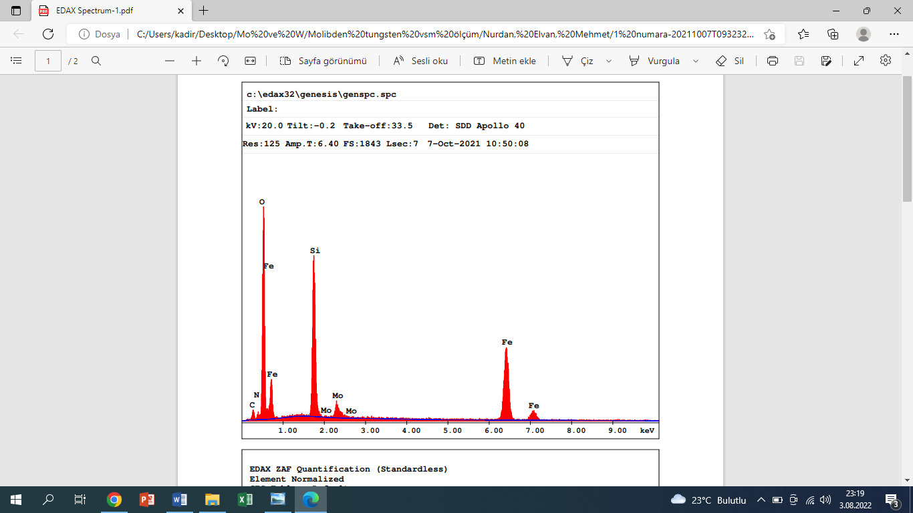
Figure 1: EDX spectra of an unknown sample.

(a) (b)
Figure 2: For multi-line figure captions, it is important that all the lines of the caption are justified and aligned. For multi-line figure captions, it is important that all the lines of the caption are justified and aligned.

3.2. Second level subsection title
Provide a brief descriptive caption for each table. Table captions should be placed above the table. Table captions used in the text should be centred. Table numbers should start with 1 and should continue consecutively. Table numbers should be written in 10-point font in Times New Roman-Bold and a colon should be used after table numbers like “Table 1:”. Tables captions and contents should be written in 10-point font in Times New Roman with centred and must be ended with a full stop like “Table 1: Comparison of the results of this work with other reported methods in the reduction of 4-NP to 4-AP.”. In necessary circumstances, the font size of the table content can be reduced to a minimum of 8-point font in Times New Roman. For multi-line table captions, it is important that all the lines of the caption are justified and aligned (See Table 2). For multi-line table captions, there should be single line spacing with an after spacing of 6 pt. The main text must include a reference to each table. Tables should be written with single row and centred in the text. The content of a colon in a table can be aligned either left side (see Table 1) or centre (see Table 2). Do not use both left side option and centred option together for different colon in the same table.

Table 1: Comparison of the results of this work with other reported methods in the reduction of 4-NP to 4-AP.
Parameter | Column 2 | Column 3 | Column 4
 |  |  | Sub-column | Sub-column
Row 1 | 37.173214 | 0.00 | 12 | 0
Row 2 | 35.182356 | 0.50 | 0 | 12
Row 3 | 32.173357 | 0.50 | 0 | 0
Row 4 | 31.173357 | 0.00 | 0 | 0
Row 5 | 30.173357 | 0.00 | 0 | 12
Row 6 | 29.173357 | 0.50 | 0 | 0

Table 2: For multi-line table captions, it is important that all the lines of the caption are justified and aligned. For multi-line table captions, it is important that all the lines of the caption are justified and aligned.
Parameter | Column 2 | Column 3 | Column 4
 |  |  | Sub-column | Sub-column
Row 1 | 37.173214 | 0.00 | 12 | 0
Row 2 | 35.182356 | 0.50 | 0 | 12
Row 3 | 32.173357 | 0.50 | 0 | 0
Row 4 | 31.173357 | 0.00 | 0 | 0
Row 5 | 30.173357 | 0.00 | 0 | 12
Row 6 | 29.173357 | 0.50 | 0 | 0

4. CONCLUSION
Conclusion should clarify the intent and importance of the paper. This section restates the main outcomes of the manuscript. Future works can be discussed.

CONFLICT OF INTEREST STATEMENT
There is no conflict of interest among the authors.
ACKNOWLEDGEMENT
Supporting organisations, if there any, people and institutions could be mentioned in this section. If the project was funded by an institution or an organisation, funders should be mentioned with fund or project number.
Note: The consequences/responsibilities of unwritten/unmentioned fundings/supports belong entirely to the authors. The Kırklareli University Journal of Engineering and Science does not accept any responsibility in this issue (regard).

CONTRIBUTIONS OF AUTHORS
The authors contributions (such as, conceptualization, formal analysis, investigation, validation, writing—original draft, writing—review & editing etc.) should be clearly stated. The following abbreviations should be used: F.A. for First Author, S.A. for Second Author, and T.A. for Third Author etc.
For an example:
F.A.: Conceptualization, methodology, software, validation, formal analysis, investigation, resources, writing—original draft preparation.
S.A.: Methodology, software, validation, investigation, resources, writing—review and editing.
T.A.: Software, validation, writing—original draft preparation.

REFERENCES
The APA 6th edition guidelines should be used for the citations in the manuscript. Different reference management software like Mendeley, Zotero, Endnote, etc. can be preferred. In this case, choose APA 6th edition as style editor. For more details about the APA 6th edition guidelines, check the https://www.apa.org/.
The references section should be in 10-point font in Times New Roman with single line spacing. The references section should be justified and aligned.

