Original Research / Review
The Title of The Paper
Abstract
Lorem ipsum dolor sit amet, consectetur adipiscing elit, sed do eiusmod tempor incididunt ut labore et dolore magna aliqua. Ut enim ad minim veniam, quis nostrud exercitation ullamco laboris nisi ut aliquip ex ea commodo consequat. Duis aute irure dolor in reprehenderit in voluptate velit esse cillum dolore eu fugiat nulla pariatur. Excepteur sint occaecat cupidatat non proident, sunt in culpa qui officia deserunt mollit anim id est laborum.
Keywords: Lorem, Ipsum, Dolor, Sit, Amet.

The Turkish Title of The Paper
Öz
Lorem ipsum dolor sit amet, consectetur adipiscing elit, sed do eiusmod tempor incididunt ut labore et dolore magna aliqua. Ut enim ad minim veniam, quis nostrud exercitation ullamco laboris nisi ut aliquip ex ea commodo consequat. Duis aute irure dolor in reprehenderit in voluptate velit esse cillum dolore eu fugiat nulla pariatur. Excepteur sint occaecat cupidatat non proident, sunt in culpa qui officia deserunt mollit anim id est laborum.
Anahtar Kelimeler: Lorem, Ipsum, Dolor, Sit, Amet.

Lorem ipsum dolor sit amet, consectetur adipiscing elit, sed do eiusmod tempor incididunt ut labore et dolore magna aliqua. Ut enim ad minim veniam, quis nostrud exercitation ullamco laboris nisi ut aliquip ex ea commodo consequat. Duis aute irure dolor in reprehenderit in voluptate velit esse cillum dolore eu fugiat nulla pariatur. Excepteur sint occaecat cupidatat non proident, sunt in culpa qui officia deserunt mollit anim id est laborum.
There are multiple options for citing references within the text. You can borrow a quote from an external source, so you need to provide the location of the quote in the document (in this case, the page number) in the parenthetical. According to X (2017), “Lorem ipsum dolor sit amet, consectetur adipiscing elit, sed do eiusmod tempor incididunt ut labore et dolore magna aliqua” (p. 91). Or you can merely paraphrase an idea from the external source. Thus, no location or page number is required. You can cite a page range if it will help your reader find the section of source material you are referring to, but you don’t need to, and sometimes it isn’t practical (too large of a page range, for instance). Lorem ipsum dolor sit amet, consectetur adipiscing elit, sed do eiusmod tempor incididunt ut labore et dolore magna aliqua (X, 1996) enim ad minim veniam, quis nostrud exercitation ullamco laboris.
If you want to present quotations from different locations in the original source each quotation should be followed by the corresponding page number. Lorem ipsum dolor sit amet (p. 365), consectetur adipiscing elit (p. 384), sed do eiusmod tempor incididunt ut labore et dolore magna aliqua (X et al., 2020, p. 450). If consecutive multiple pages are summarized and referenced, they should be indicated as a page range. Lorem ipsum dolor sit amet, consectetur adipiscing elit, sed do eiusmod tempor incididunt ut labore et dolore magna aliqua (X, 1960, pp. 4-12).
Spell out abbreviations the first time you use them, except in cases where the abbreviations are very well- known (e.g., "AI"). Lorem ipsum dolor sit amet, Consectetur Adipiscing Elit (CAE), sed do eiusmod tempor incididunt ut labore et dolore magna aliqua.
For sources with two authors, use an ampersand (&) between the authors' names rather than the word "and." Lorem ipsum dolor sit amet, consectetur adipiscing elit, sed do eiusmod tempor incididunt ut labore et dolore magna aliqua (X & Y, 2021). When listing multiple citations in the same parenthetical, list them alphabetically and separate them with semicolons. Lorem ipsum dolor sit amet, consectetur adipiscing elit, sed do eiusmod tempor incididunt ut labore et dolore magna aliqua (X, 2018; Y, 2021, Z, 2020). When citing multiple sources from the same author(s), simply list the author(s), then list the years of the sources separated by commas. Lorem ipsum dolor sit amet, consectetur adipiscing elit, sed do eiusmod tempor incididunt ut labore et dolore magna aliqua (X, 2018; X, 2021)
If you want to make an indirect or secondary citation a source that you found cited in a different source use the phrase "as cited in" in the parenthetical to indicate that the first-listed source was referenced in the second-listed one. X (1993, as cited in Y, 2007) finds that lorem ipsum dolor sit amet, consectetur adipiscing elit, sed do eiusmod tempor incididunt ut labore et dolore magna. Include an entry in the reference list only for the secondary source (Y, in this case).
Sources with three authors or more are cited via the first-listed author's name followed by the Latin phrase "et al." Note that the period comes after "al," rather than "et." Lorem ipsum dolor sit amet, consectetur adipiscing elit, sed do eiusmod tempor incididunt ut labore et dolore magna aliqua (X et al., 2020; Y et al., 2018).
To list a few sources as examples of a larger body of work, you can use the word "see" in the parenthetical. Lorem ipsum dolor sit amet, consectetur adipiscing elit, sed do eiusmod tempor incididunt ut labore et dolore magna aliqua (see, e.g., X et al., 2020; Y, 1960).
Quotations longer than 40 words should be formatted as block quotations. Indent the entire passage half an inch or 1.25 cm and present the passage without quotation marks. Any relevant page numbers should follow the concluding punctuation mark. If the author and/or date are not referenced in the text, as they are here, place them in the parenthetical that follows the quotation along with the page numbers. Since the entire paragraph is a direct quotation, place the period before the parentheses, not after. X et al. (2011) note the following, for instance:
Lorem ipsum dolor sit amet, consectetur adipiscing elit, sed do eiusmod tempor incididunt ut labore et dolore magna aliqua. Ut enim ad minim veniam, quis nostrud exercitation ullamco laboris nisi ut aliquip ex ea commodo consequat. Duis aute irure dolor in reprehenderit in voluptate velit esse cillum dolore eu fugiat nulla pariatur. (pp. 8–9)
Literature Review
Lorem ipsum dolor sit amet, consectetur adipiscing elit, sed do eiusmod tempor incididunt ut labore et dolore magna aliqua. Ut enim ad minim veniam, quis nostrud exercitation ullamco laboris nisi ut aliquip ex ea commodo consequat. Duis aute irure dolor in reprehenderit in voluptate velit esse cillum dolore eu fugiat nulla pariatur.
Lorem Ipsum Dolor
Lorem ipsum dolor sit amet, consectetur adipiscing elit, sed do eiusmod tempor incididunt ut labore et dolore magna aliqua. Ut enim ad minim veniam, quis nostrud exercitation ullamco laboris nisi ut aliquip ex ea commodo consequat. Duis aute irure dolor in reprehenderit in voluptate velit esse cillum dolore eu fugiat nulla pariatur. Excepteur sint occaecat cupidatat non proident, sunt in culpa qui officia deserunt mollit anim id est laborum.
Lorem Ipsum Dolor
Lorem ipsum dolor sit amet, consectetur adipiscing elit, sed do eiusmod tempor incididunt ut labore et dolore magna aliqua. Ut enim ad minim veniam, quis nostrud exercitation ullamco laboris nisi ut aliquip ex ea commodo consequat. Duis aute irure dolor in reprehenderit in voluptate velit esse cillum dolore eu fugiat nulla pariatur. Excepteur sint occaecat cupidatat non proident, sunt in culpa qui officia deserunt mollit anim id est laborum.
Lorem Ipsum Dolor. Lorem ipsum dolor sit amet, consectetur adipiscing elit, sed do eiusmod tempor incididunt ut labore et dolore magna aliqua. Ut enim ad minim veniam, quis nostrud exercitation ullamco laboris nisi ut aliquip ex ea commodo consequat. Duis aute irure dolor in reprehenderit in voluptate velit esse cillum dolore eu fugiat nulla pariatur. Excepteur sint occaecat cupidatat non proident, sunt in culpa qui officia deserunt mollit anim id est laborum.
Lorem Ipsum Dolor. Lorem ipsum dolor sit amet, consectetur adipiscing elit, sed do eiusmod tempor incididunt ut labore et dolore magna aliqua. Ut enim ad minim veniam, quis nostrud exercitation ullamco laboris nisi ut aliquip ex ea commodo consequat. Duis aute irure dolor in reprehenderit in voluptate velit esse cillum dolore eu fugiat nulla pariatur. Excepteur sint occaecat cupidatat non proident, sunt in culpa qui officia deserunt mollit anim id est laborum.
Method
Lorem ipsum dolor sit amet, consectetur adipiscing elit, sed do eiusmod tempor incididunt ut labore et dolore magna aliqua (of between 0.34-0.42 standart deviations). Ut enim ad minim veniam, quis nostrud exercitation ullamco laboris nisi ut aliquip ex ea commodo consequat. Duis aute irure dolor in reprehenderit in voluptate velit esse cillum dolore eu fugiat nulla pariatur. Excepteur sint occaecat cupidatat non proident, sunt in culpa qui officia deserunt mollit anim id est laborum.
Figure 1
Lorem Ipsum Dolor sit Amet
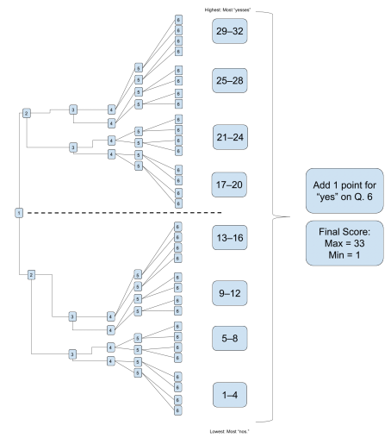
Note. Lorem ipsum dolor sit amet, consectetur adipiscing elit, sed do eiusmod tempor incididunt ut labore et dolore magna aliqua.
Lorem Ipsum Dolor
Lorem ipsum dolor sit amet, consectetur adipiscing elit, sed do eiusmod tempor incididunt ut labore et dolore magna aliqua. Ut enim ad minim veniam, quis nostrud exercitation ullamco laboris nisi ut aliquip ex ea commodo consequat. Duis aute irure dolor in reprehenderit in voluptate velit esse cillum dolore eu fugiat nulla pariatur. Excepteur sint occaecat cupidatat non proident, sunt in culpa qui officia deserunt mollit anim id est laborum.
Lorem ipsum dolor sit amet, consectetur adipiscing elit, sed do eiusmod tempor incididunt ut labore et dolore magna aliqua. Ut enim ad minim veniam, quis nostrud exercitation ullamco laboris nisi ut aliquip ex ea commodo consequat. Duis aute irure dolor in reprehenderit in voluptate velit esse cillum dolore eu fugiat nulla pariatur. Excepteur sint occaecat cupidatat non proident, sunt in culpa qui officia deserunt mollit anim id est laborum.
Table 1
Lorem Ipsum Dolor sit Amet
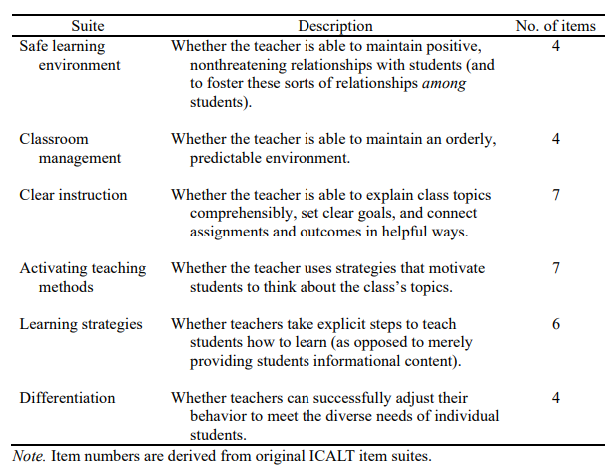
Lorem ipsum dolor sit amet, consectetur adipiscing. See Appendix for additional sample items.
Lorem Ipsum Dolor
Lorem ipsum dolor sit amet, consectetur adipiscing elit, sed do eiusmod tempor incididunt ut labore et dolore magna aliqua. Ut enim ad minim veniam, quis nostrud exercitation ullamco laboris nisi ut aliquip ex ea commodo consequat. Duis aute irure dolor in reprehenderit in voluptate velit esse cillum dolore eu fugiat nulla pariatur. Excepteur sint occaecat cupidatat non proident, sunt in culpa qui officia deserunt mollit anim id est laborum.
Results
Lorem ipsum dolor sit amet, consectetur adipiscing elit, sed do eiusmod tempor incididunt ut labore et dolore magna aliqua. Ut enim ad minim veniam, quis nostrud exercitation ullamco laboris nisi ut aliquip ex ea commodo consequat. Duis aute irure dolor in reprehenderit in voluptate velit esse cillum dolore eu fugiat nulla pariatur. Excepteur sint occaecat cupidatat non proident, sunt in culpa qui officia deserunt mollit anim id est laborum.
Discussion
Lorem ipsum dolor sit amet, consectetur adipiscing elit, sed do eiusmod tempor incididunt ut labore et dolore magna aliqua. Ut enim ad minim veniam, quis nostrud exercitation ullamco laboris nisi ut aliquip ex ea commodo consequat.
References
Ambady, N., & Rosenthal, R. (1993). Half a minute: Predicting teacher evaluations from thin slices of nonverbal behavior and physical attractiveness. Journal of Personality and Social Psychology, 64(3), 431–441. http://dx.doi.org/10.1037/0022-3514.64.3.431
American Association of University Professors. (n.d.). Background facts on contingent faculty positions. https://www.aaup.org/issues/contingency/background-facts
American Association of University Professors. (2018, October 11). Data snapshot: Contingent faculty in US higher ed. AAUP Updates. https://www.aaup.org/news/data-snapshotcontingent-faculty-us-higher-ed#.Xfpdmy2ZNR4
Anderson, K., & Miller, E. D. (1997). Gender and student evaluations of teaching. PS: Political Science and Politics, 30(2), 216–219. https://doi.org/10.2307/420499
Armstrong, J. S. (1998). Are student ratings of instruction useful? American Psychologist, 53(11), 1223–1224. http://dx.doi.org/10.1037/0003-066X.53.11.1223
Attiyeh, R., & Lumsden, K. G. (1972). Some modern myths in teaching economics: The U.K. experience. American Economic Review, 62(1), 429–443. https://www.jstor.org/stable/1821578
Bachen, C. M., McLoughlin, M. M., & Garcia, S. S. (1999). Assessing the role of gender in college students' evaluations of faculty. Communication Education, 48(3), 193–210. http://doi.org/cqcgsr
Basow, S. A. (1995). Student evaluations of college professors: When gender matters. Journal of Educational Psychology, 87(4), 656–665. http://dx.doi.org/10.1037/0022-0663.87.4.656
Becker, W. (2000). Teaching economics in the 21st century. Journal of Economic Perspectives, 14(1), 109–120. http://dx.doi.org/10.1257/jep.14.1.109
Benton, S., & Young, S. (2018). Best practices in the evaluation of teaching. Idea paper, 69.
Berk, R. A. (2005). Survey of 12 strategies to measure teaching effectiveness. International Journal of Teaching and Learning in Higher Education, 17(1), 48–62.
Bloom, B. S., Englehart, M. D., Furst, E. J., Hill, W. H., & Krathwohl, D. R. (1956). Taxonomy of educational objectives: The classification of educational goals. Addison-Wesley Longman Ltd.
Carrell, S., & West, J. (2010). Does professor quality matter? Evidence from random assignment of students to professors. Journal of Political Economy, 118(3), 409–432. https://doi.org/10.1086/653808
Cashin, W. E. (1990). Students do rate different academic fields differently. In M. Theall & J. L. Franklin (Eds.), Student ratings of instruction: Issues for improving practice (pp. 113– 121).
Centra, J., & Gaubatz, N. (2000). Is there gender bias in student evaluations of teaching? The Journal of Higher Education, 71(1), 17–33. https://doi.org/10.1080/00221546.2000.11780814
Davis, B. G. (2009). Tools for teaching (2nd ed.). Jossey-Bass.
Denton, D. (2013). Responding to edTPA: Transforming practice or applying shortcuts? AILACTE Journal, 10(1), 19–36.
Evans, A. C., Jr., Garbarino, J., Bocanegra, E., Kinscherff, R. T., & Márquez-Greene, N. (2019, August 8–11). Gun violence: An event on the power of community [Conference presentation]. APA 2019 Convention, Chicago, IL, United States. https://convention.apa.org/2019-video
Ew, S. (2019, April 25–28). Evolutionary theory of social connections: Past, present, and future [Conference presentation abstract]. Ninety-ninth annual convention of the Western Psychological Association, Pasadena, CA, United States. https://westernpsych.org/wp-content/uploads/2019/04/WPA-Program-2019-Final-2.pdf
Frou, A. L., Quirk, A., Gallop, R., Hoyle, R. H., Kelly, D. R., & Matthews, M. D. (2019). Cognitive and noncognitive predictors of success. Proceedings of the National Academy of Sciences, USA, 116(47), 23499–23504. https://doi.org/10.1073/pnas.1910510116
Fushilevitz, E., & Malkin, T. (Eds.). (2016). Lecture notes in computer science: Vol. 9562. Theory of cryptography. Springer. https://doi.org/10.1007/978-3-662-49096-9
Halmenda, C. (2019). Exploring the lived experiences of foster youth who obtained graduate level degrees: Self-efficacy, resilience, and the impact on identity development (Publication No. 27542827) [Doctoral dissertation, Pepperdine University]. PQDT Open. https://pqdtopen.proquest.com/doc/2309521814.html?FMT=AI
Herris, L. (2014). Instructional leadership perceptions and practices of elementary school leaders [Unpublished doctoral dissertation]. University of Virginia.
International Organization for Standardization. (2018). Occupational health and safety management systems—Requirements with guidance for use (ISO Standard No. 45001:2018). https://www.iso.org/standard/63787.html
Merriam-Webster. (n.d.). Semantics. In Merriam-Webster.com dictionary. Retrieved January 4, 2020, from https://www.merriam-webster.com/dictionary/semantics
Merriam-Webster. (2003). Litmus test. In Merriam-Webster’s collegiate dictionary (11th ed., p. 727).
National Cancer Institute. (2019). Taking time: Support for people with cancer (NIH Publication No. 18-2059). U.S. Department of Health and Human Services, National Institutes of Health. https://www.cancer.gov/publications/patient-education/takingtime.pdf
Oil painting. (2019, December 8). In Wikipedia. https://en.wikipedia.org/w/index.php?title=Oil_painting&oldid=929802398

Appendix
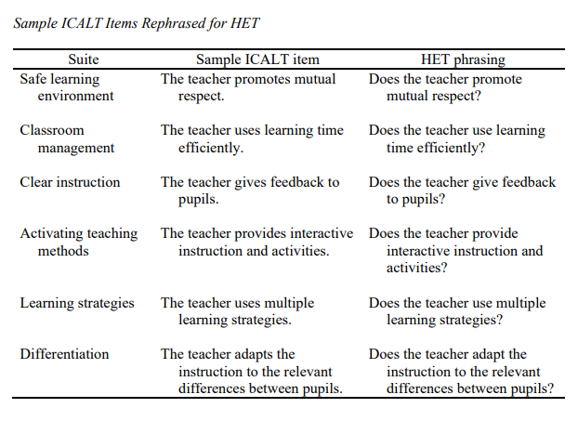

Notes

^{i} Lorem ipsum dolor sit amet, consectetur adipiscing elit, sed do eiusmod tempor incididunt ut labore et dolore magna
Lorem ipsum dolor sit amet, consectetur adipiscing elit, sed do eiusmod tempor incididunt ut labore et dolore magna This template has been prepared using APA 7 Style Guidelines and Student Sample Paper. For information not found in this guide, please visit https://apastyle.apa.org/ .

