English Title (Up to 12 words)
Türkçe Başlık (En fazla 12 sözcük)
Author Name, Department, Institution, orcid number
2th. Author Name, Department, Institution, orcid number

Abstract
The abstract summarize relevant knowledge in main disciplines/fields without directly referring to the specific project. Clearly and concisely state the main aim of the study. Research problem, theoretical approaches, method, original contribution and result should be statesdasdad. Every point made in every part of the abstract must be elaborated in the main text - even if the main text is organized quite differently from the abstract. Abstract should be 150-300 words long and the main text should begin at the top of the next page. Any kind of citation or reference should be avoided in the abstract.
Keywords: List 3-9 words seperated by commas, which are used in the main text as the most important concpets and words. Do not use capital letters except for the first word and proper nouns.
Academical disciplines/fields: List the disciplines/fields which your article is based on, seperated by commas. By "discipline/field" we mean an area of research with an independent international infrastructure that includes societies, conference series, journals, and/or university degree programs.
Özet
Öncelikle makalenin ait olduğu disiplin(ler)/alan(lar)ın konuyla ilgili bilgi birikimini özetleyiniz. Bu anlamda özet makalenin hangi disiplin(ler)/alan(lar)a ait olduğunu açıkça ifade etmelidir. Makalenin temel problemi veya araştırma sorusu, amacı, kuramsal yaklaşımı, yöntemi, özgün katkısı ve sonucu özette mutlaka belirtilmelidir. Özette yazılan her noktanın makalede geliştirilmiş olması beklenmektedir. Özet, anahtar sözcükler ve akademik disiplinler dahil 150-300 kelime arasında olmalıdır ve kesinlikle bir sonraki sayfaya taşmamalıdır. Özet içinde, yararlanılan kaynaklara, görsel ve çizelge numaralarına atıf yapılmamalı ve dipnot kullanılmamalıdır.
Anahtar Sözcükler: Makalede kullandığınız en önemli kelime ve kavramları 3-9 kelime arasında virgülle ayırarak yazınız. İlk kelime ve özel isimler dışında büyük harf kullanmayınız.
Akademik disipin(ler)/alan(lar): Makalenin ait olduğu disiplin(ler)/alan(lar)ı önem sırasına göre virgülle ayırarak yazınız. Disiplin/alan olarak dernekler, konferans dizileri, dergiler ve/veya üniversite diploma programlarına sahip bağımsız ve uluslararası tanınırlığı olan bir araştırma/çalışma alanı kastedilmektedir.

- Corresponding Author: Name of the corresponding author, Department, Institution.
- Adress: full address information
- E-mail: e-mail address of the corresponding author
- Published Online: Date of Arrival: / Date of Admission:
- doi:

1. Primary Title

Please copy the main text of your article and paste it into the magazine template without changing the style as 7_Body_Text. Line and paragraph spacing are automatically adjusted in the defined style. Therefore, the author should not make any changes.

Articles must be between 3,500 - 7,000 words, excluding abstract and bibliography. For parts of the text that need to be emphasized, bold font or double quotes (") should not be used, instead italic letters should be used. For this, 7_Emphasis_Text style should be selected. Period/Comma inside double quotes; It must be placed outside other punctuation marks (colon, semicolon, etc.). Double emphases such as quotation marks and italic letters should not be included in the text.

1.1. Secondary and subsequent titles
Secondary and other headings are written as "1.1." without using capital letters except the first word and proper names. , 1.2. , 1.1.1., 1.1.2. etc." It should be written in the format numbering system. Except for primary headings, 7_secondary_vd_headings style should be used. The main text will continue in its style as 7_Body_Text throughout the article. Exceptions to this can only be found in block quotes and sequential text.
The author must cite all direct or indirect quotations. When quoting directly, if the quoted section exceeds 40 words, it should be written as a block quote. Double quotes should not be used in the block quote and a period should be added before the closing parenthesis. For block quotes, 7_Block_Quote style should be selected. Since all indentation, line/paragraph breaks and font-related arrangements are included in the style, the author does not need to make any other changes.
APA 7 style should be applied for in-text citations. Accordingly, in articles with a single author, the notation is (Author's Surname, Year, p. 7-9), and in articles with two authors (Surname of the first author and Surname of the second author, Year, p. 7-9), in articles with three or more authors it should be like (first author Surname et al., Year, p. 7-9).
  - Display of tables and figures
Tables must have numbers and titles. Pictures, photographs, graphics, shapes, notes, etc. For visuals, only the expression Visual (Figure) should be used. All tables and visual aids must be numbered sequentially (Table 1, Table 2, etc.). The style “7_Figure&Table_Title should be applied to the entire line for these captions. Subsequently, the title of each table, excluding the word “Table” and its number, should be converted to regular font using the style “7_Figure&Table_Text” from the style gallery.
Figures should not be embedded within the text but should be placed with their number and description at the intended location. A maximum of 12 figures should be used in the article. Figures must be numbered sequentially (Figure 1., Figure 2., etc.). Following the procedure outlined in the preceding paragraph, use styles “7_Figure&Table_Title” and 7_Figure&Table_Text' for these captions. Figure captions should be positioned below the figure as shown in the example below. Table titles, however, should appear above the table.
Table 1. Table Title: Subdisciplines of the discipline of musicology. (Parncutt, 2007, p. 15)
Musicology
history | etnology | analysis | theory | sociology | psychology |  | acoustic
 |  |  |  |  | physiology
 |  |  |  | media
Aesthetic and cultural studies |  |  |  |  |  | calculation
philosophy
If there are pictures, photographs, notes or special drawings in the article, these documents should be scanned at 300 PPI (300 pixels per inch) quality with a short edge of 10 cm, saved in JPEG format and all visual materials should be uploaded to the Degi Park system in JPEG format in addition to the article. The author is responsible for the copyright, quality, and whether or not the images to be used as a source are published.
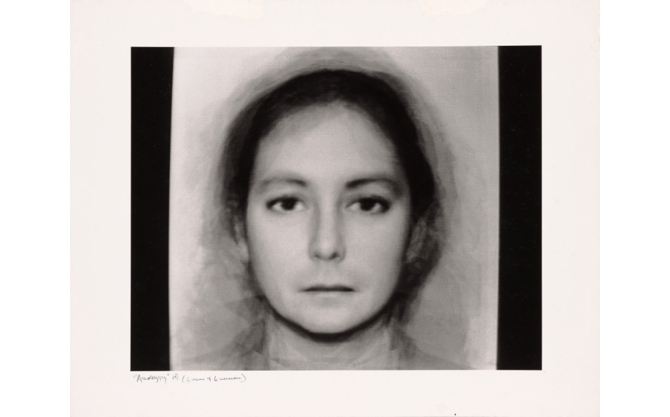
Figure 1. Figure Title: Androgyny, N. Burson, 1982.

References
Author Surname, Initial of Name. (Year). Title of the book. Publisher.
References will be cited according to APA 7 style. 7_References_Text style should be preferred when writing references.
For references, please review the 7 magazine article writing guide..

