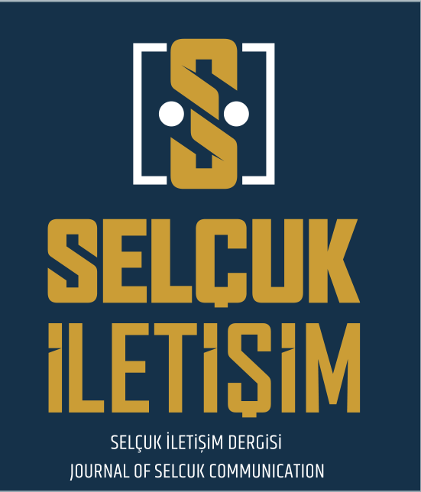
SELÇUK İLETİŞİM DERGİSİ

JOURNAL OF SELCUK COMMUNICATION

STATEMENT OF RESEARCHERS' CONTRIBUTION RATE AND CONFLICT OF INTEREST

RESPONSIBLE/CORRESPONDING AUTHOR
TITLE OF MANUSCRIPT

DATE

MANUSCRIPT TYPE (RESEARCH ARTICLE, REVIEW etc.)

LIST OF AUTHORS
(All authors must sign. If it is not possible for authors to sign together, they can fill out this form and upload it separately).

Sıra  No | NAME- SURNAME | AUTHOR CONTRIBUTIONS* | CONFLICT OF INTEREST** | SIGNATURE | DATE
1
2
3
4
5

* In the event that there are activities related to your study with third parties, such as affiliation/association/activity/support etc., the authors are expected to clearly indicate the person and activity in question in detail. Even if you are in doubt as to whether the possible situations with third parties constitute a conflict of interest, you are expected to indicate this. Please select the appropriate option for your study from the options below and upload the printout of the form to the DergiPark system with wet signature, by scanning or photographing the paper. If the contribution rate of all authors is equal, the statement "contributed equally to the article" can be written.
** Please indicate if the conditions listed below or similar ones are relevant to your study:
a. Support for the current manuscript (e.g. funding, provision of materials, processing fees, etc.)
b. Grants or binding contracts from any organization
c. Copyrights and licenses
d. Consultancy or expert witness fees
e. Support to attend meetings and/or travel
f. Participation in a paid or unpaid board, ensemble, committee or jury group
g. Any financial or non-financial interest (other)

RESPONSIBLE/CORRESPONDING AUTHOR:
NAME- SURNAME
UNIVERSITY/COMPANY/INSTITUTION
ADDRESS
E-MAIL
PHONE

RESPONSIBLE/CORRESPONDING AUTHOR | SIGNATURE | DATE
 |  | ……../……../……………

