**HİTİT THEOLOGY JOURNAL ARTICLE TEMPLATE**

**General Rules**

**1.** The sequence of article elements should be as follows:

**1.1.** English Title

**1.2.** Abstract

**1.3.** Keywords

**1.4.** Turkish Title

**1.5.** Turkish Abstract

**1.6.** Turkish Keywords

**1.7.** Body Text

**1.8.** Conclusion

**1.9.** Bibliography

**2.** All headings in the article must have initial capital letters and 11 point font.

**3.** The article page must be in A4 format.

**4.** Margins should be 3 cm on all sides.

**5.** If an explanation will be made for the article title at the end of the page, the * sign should be used.

**6.** Footer and Header Information should not be entered.

**7.** Page numbers should not be added.

**8.** Arabic words and texts in the article should be written in Times New Roman font, 10 point size. Other spelling rules for Arabic words are the same as the rules below.

**9. You can see other points to consider when working with templates via the link https://dergipark.org.tr/tr/pub/hid/writing-rules.**

Title

Abstract

Abstract text should be written here. Abstract text should be written here. Abstract text should be written here. Abstract text should be written here. Abstract text should be written here. Abstract text should be written here. Abstract text should be written here. Abstract text should be written here. Abstract text should be written here. Abstract text should be written here. Abstract text should be written here. Abstract text should be written here. Abstract text should be written here. Abstract text should be written here. Abstract text should be written here. Abstract text should be written here. Abstract text should be written here. Abstract text should be written here. Abstract text should be written here. Abstract text should be written here. Abstract text should be written here. Abstract text should be written here. Abstract text should be written here. Abstract text should be written here. Abstract text should be written here. Abstract text should be written here. Abstract text should be written here. Abstract text should be written here. Abstract text should be written here. Abstract text should be written here.

**Keywords:** Keywords 1, Keywords 2, Keywords 3, Keywords 4, Keywords 5.

Öz

Özet metni buraya yazılmalıdır. Özet metni buraya yazılmalıdır. Özet metni buraya yazılmalıdır. Özet metni buraya yazılmalıdır. Özet metni buraya yazılmalıdır. Özet metni buraya yazılmalıdır. Özet metni buraya yazılmalıdır. Özet metni buraya yazılmalıdır. Özet metni buraya yazılmalıdır. Özet metni buraya yazılmalıdır. Özet metni buraya yazılmalıdır. Özet metni buraya yazılmalıdır. Özet metni buraya yazılmalıdır. Özet metni buraya yazılmalıdır. Özet metni buraya yazılmalıdır. Özet metni buraya yazılmalıdır. Özet metni buraya yazılmalıdır. Özet metni buraya yazılmalıdır. Özet metni buraya yazılmalıdır. Özet metni buraya yazılmalıdır. Özet metni buraya yazılmalıdır. Özet metni buraya yazılmalıdır. Özet metni buraya yazılmalıdır. Özet metni buraya yazılmalıdır. Özet metni buraya yazılmalıdır. Özet metni buraya yazılmalıdır. Özet metni buraya yazılmalıdır. Özet metni buraya yazılmalıdır. Özet metni buraya yazılmalıdır. Özet metni buraya yazılmalıdır. Özet metni buraya yazılmalıdır. Özet metni buraya yazılmalıdır. Özet metni buraya yazılmalıdır. Özet metni buraya yazılmalıdır. Özet metni buraya yazılmalıdır. Özet metni buraya yazılmalıdır. Özet metni buraya yazılmalıdır. Özet metni buraya yazılmalıdır. Özet metni buraya yazılmalıdır. Özet metni buraya yazılmalıdır. Özet metni buraya yazılmalıdır. Özet metni buraya yazılmalıdır. Özet metni buraya yazılmalıdır. Özet metni buraya yazılmalıdır. Özet metni buraya yazılmalıdır. Özet metni buraya yazılmalıdır. Özet metni buraya yazılmalıdır. Özet metni buraya yazılmalıdır. Özet metni buraya yazılmalıdır.

**Anahtar Kelimeler:** Kelime 1, Kelime 2, Kelime 3, Kelime 4, Kelime 5.

Introduction

Body of introduction should be written here. Body of introduction should be written here. Body of introduction should be written here. Body of introduction should be written here. Body of introduction should be written here. Body of introduction should be written here. Body of introduction should be written here. Body of introduction should be written here. Body of introduction should be written here. Body of introduction should be written here. Body of introduction should be written here. Body of introduction should be written here. Body of introduction should be written here. Body of introduction should be written here. Body of introduction should be written here. Body of introduction should be written here. Body of introduction should be written here. Body of introduction should be written here. Body of introduction should be written here. Body of introduction should be written here.

1. Heading

The body text of headings should be written this way. The body text of heading should be written this way. The body text of headings should be written this way. The body text of heading should be written this way. The body text of heading should be written this way. The body text of heading should be written this way. The body text of heading should be written this way. The body text of heading should be written this way. The body text of heading should be written this way.

If a direct quote is to be made and this quote is in paragraph size, it should be written this way. If a direct quote is to be made and this quote is in paragraph size, it should be written this way. If a direct quote is to be made and this quote is in paragraph size, it should be written this way. If a direct quote is to be made and this quote is in paragraph size, it should be written this way. If a direct quote is to be made and this quote is in paragraph size, it should be written this way. If a direct quote is to be made and this quote is in paragraph size, it should be written this way.

If Arabic expressions are to be used as short words in the text, “الكتاب” should be written like this: “الكتاب”.

If Arabic expressions are to be given in a long text, they should be as follows.

يجب كتابة النصوص العربية بهذه الطريقة يجب كتابة النصوص العربية بهذه الطريقة يجب كتابة النصوص العربية بهذه الطريقة يجب كتابة النصوص العربية بهذه الطريقة يجب كتابة النصوص العربية بهذه الطريقة يجب كتابة النصوص العربية بهذه الطريقة يجب كتابة النصوص العربية بهذه الطريقة يجب كتابة النصوص العربية بهذه الطريقة يجب كتابة النصوص العربية بهذه الطريقة يجب كتابة النصوص العربية بهذه الطريقة يجب كتابة النصوص العربية بهذه الطريقة.

1.1. Subheadings

The body text of the subheading should be written like this. The body text of the subheading should be written like this. The body text of the subheading should be written like this. The body text of the subheading should be written like this. The body text of the subheading should be written like this. The body text of the subheading should be written like this. The body text of the subheading should be written like this. The body text of the subheading should be written like this. The body text of the subheading should be written like this. The body text of the subheading should be written like this. The body text of the subheading should be written like this.[1]

**Tables should be created like this:**

**Table 1.** Table Title Should Be Written Here.

|  |  |  |  |
| --- | --- | --- | --- |
| Table Template | | | |
| Table Content | Table Content | Table Content | Table Content |
| Table Content | Table Content | Table Content | Table Content |

**Source:** Source of the Table Should Be Written Here.

**Figures should be created like this:**

**Figure 1.** Title of the Figure Should Be Written Here.

**Source:** Source of the Figure Should Be Written Here.

**Pictures should be created like this:**

**Picture 1.** Title of the Picture Should be Written Like This.

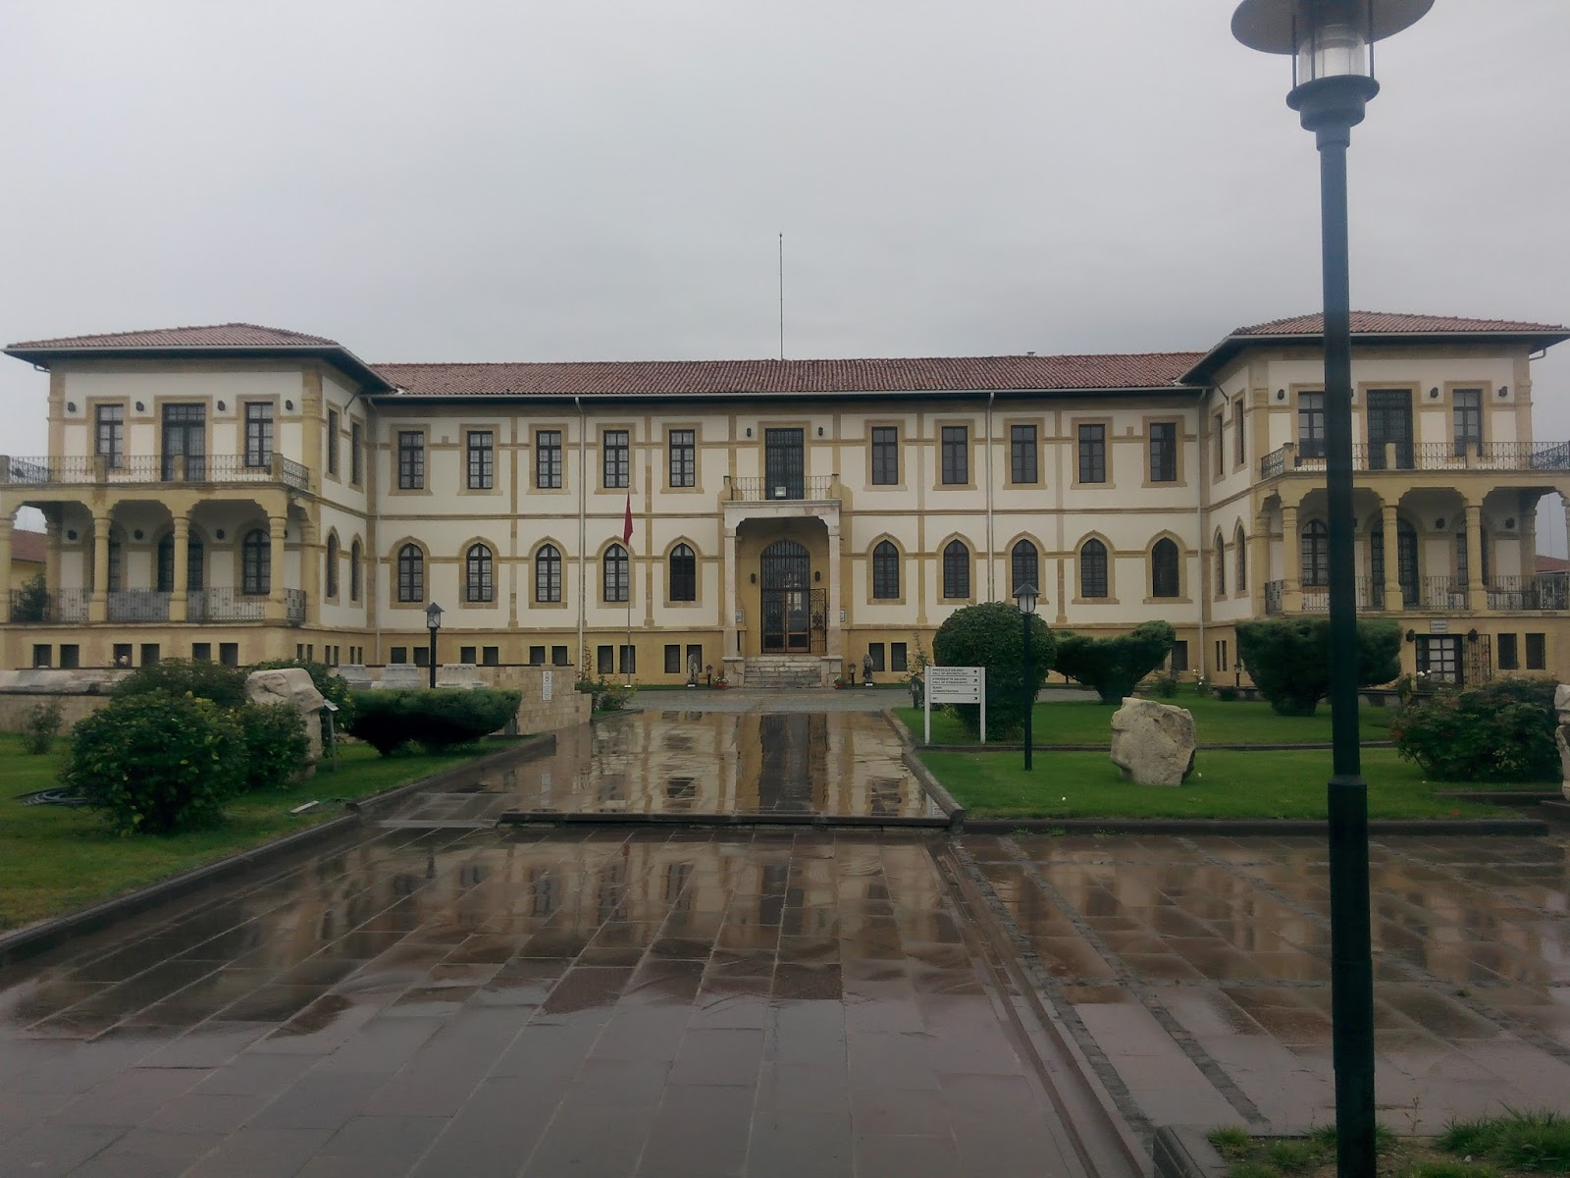

**Source:** Source of the Picture Written Here.

Conclusion

The body of the conclusion should be written here and like this. The body of the conclusion should be written here and like this. The body of the conclusion should be written here and like this. The body of the conclusion should be written here and like this. The body of the conclusion should be written here and like this. The body of the conclusion should be written here and like this. The body of the conclusion should be written here and like this. The body of the conclusion should be written here and like this. The body of the conclusion should be written here and like this.

Bibliography

References should be written like this. References should be written like this. References should be written like this.

References should be written like this. References should be written like this. References should be written like this.

References should be written like this. References should be written like this. References should be written like this.

References should be written like this. References should be written like this. References should be written like this.

References should be written like this. References should be written like this. References should be written like this.

References should be written like this. References should be written like this. References should be written like this.

References should be written like this. References should be written like this. References should be written like this.

1. Footnotes should be written like this.