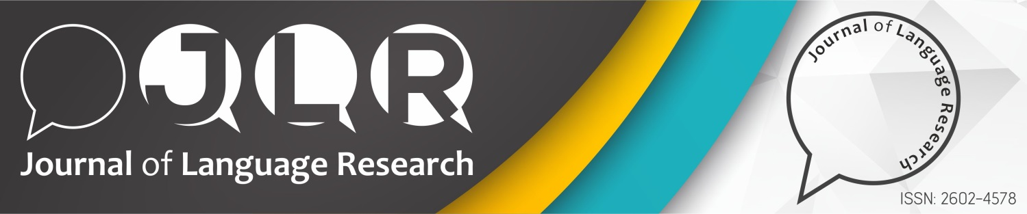

COPYRIGHT RELEASE FORM
Manuscript Title:
Full names and
Institutions of authors

On behalf of all authors, as the corresponding author of the manuscript, I warrant that;
a) The manuscript submitted is my/our own original work;
b) All authors participated in the work in a substantive way and are prepared to take public responsibility for the work;
c) I was authorized by all authors to transfer all royalties related with the manuscript and to enter into a binding contract with Journal of Language Research as detailed in this Copyright Release Form, and I will be responsible in the event of all disputes that have occurred and that may occur,
d) All authors have seen and approved the manuscript as submitted;
e) E-mail and addresses of all authors have been entered into the Journal of Language Research Manuscript Submission and Evaluation System correctly,
f) The manuscript has not been published and is not being submitted or considered for publication elsewhere;
g) The text, illustrations, and any other materials included in the manuscript do not infringe upon any existing copyright or other rights of anyone.
h) I transfer all financial rights, especially processing, reproduction, representation, printing, distribution, and online transmittal, to Journal of Language Research with no limitation whatsoever,
Notwithstanding the above, the Contributor(s) or, if applicable the Contributor’s Employer, retain(s) all proprietary rights other than copyright, such as;
a) Patent rights;
b) To use, free of charge, all parts of this article for the author’s future works in books, lectures, classroom teaching, or oral presentations;
c) The right to reproduce the article for their own purposes provided the copies are not offered for sale. However, reproduction, posting, transmission or other distribution or use of the article or any material contained therein, in any medium as permitted hereunder, requires a citation to the Journal and appropriate credit to Journal of Language Research as publisher, suitable in form and content as follows: Title of article, author(s), journal title and volume/issue, Copyright© year.
As the corresponding author, I also warrant that “Journal of Language Research and the Journal Editors” will not be held liable against all copyright claims of any third party or in lawsuits that may be filed in the future, and that I will be the only person who will be liable in such cases. I also warrant that the article contains no libelous or unlawful statements, I/we did not use any unlawful method or material during the research, I/we obtained all legal permissions pertaining to the research, and I/we adhered to ethical principles during the research.

Full Name:
Institution & Address:
Phone: | Date:
E-mail: | Signature:

