English Title (Times New Roman, 12 Point, centered, 2.0-line spacing)

Turkish Title (Times New Roman, 12 Point, centered, 2.0-line spacing)

TABLES
The tables used in the research are included in the publication, Table 1 etc. must be stated as such. Directional expressions such as above and below should not be used.
Table 1: Lorem İpsum Dolor Sit Amet
Paste here | Paste here | Paste here | Paste here
Paste here | Paste here | Paste here | Paste here
Paste here | Paste here | Paste here | Paste here
Paste here | Paste here | Paste here | Paste here
Paste here | Paste here | Paste here | Paste here
Source: Nam libero tempore (9 point, Times New Roman, italics, justified, 1.15-line spacing)
Tables should be prepared in 10 font size and in accordance with APA7 rules (as in Table 1). While explaining the tables, the explanation should be continued by giving the name of the table continuously, even though the place of the tables changes in the typesetting. Otherwise, readers will not be able to establish a relationship between the announced results and the table.

FIGURES
The figure used in the research are included in the publication, Figure 1 etc. must be stated as such. Directional expressions such as above and below should not be used.
Beklentiler
Algılanan Performans
Onaylamama
Tatmin/
Tatminsizlik
+
+
+
+
-
+

Figure 1: Expectation-Performance Disconfirmation Model
Source: Nam libero tempore (9 point, Times New Roman, italics, justified, 1.15-line spacing)
Figures should be prepared in 10 font size and in accordance with APA7 rules (as in Figure 1). While explaining the shapes, the explanation should be continued by giving the name of the shape continuously, even though the place of the shapes changes in the typesetting. Otherwise, readers cannot establish a relationship between the results explained and the figure.

IMAGES (Map, Photo, Picture, Graphic etc.)
The image used in the research are included in the publication, Image 1 etc. must be stated as such. Directional expressions such as above and below should not be used.
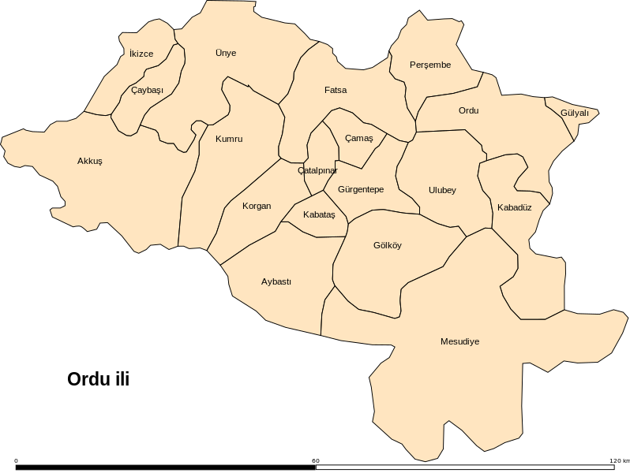
Image 2: Ordu Province Map
Source: Nam libero tempore (9 point, Times New Roman, italics, justified, 1.15-line spacing)
Images must be prepared in 10 font size and in accordance with APA7 rules (as in Image 1). While explaining the images, the explanation should be continued by giving the visual name even if the place of the images changes in the typesetting. Otherwise, readers will not be able to establish a relationship between the announced results and the images.

