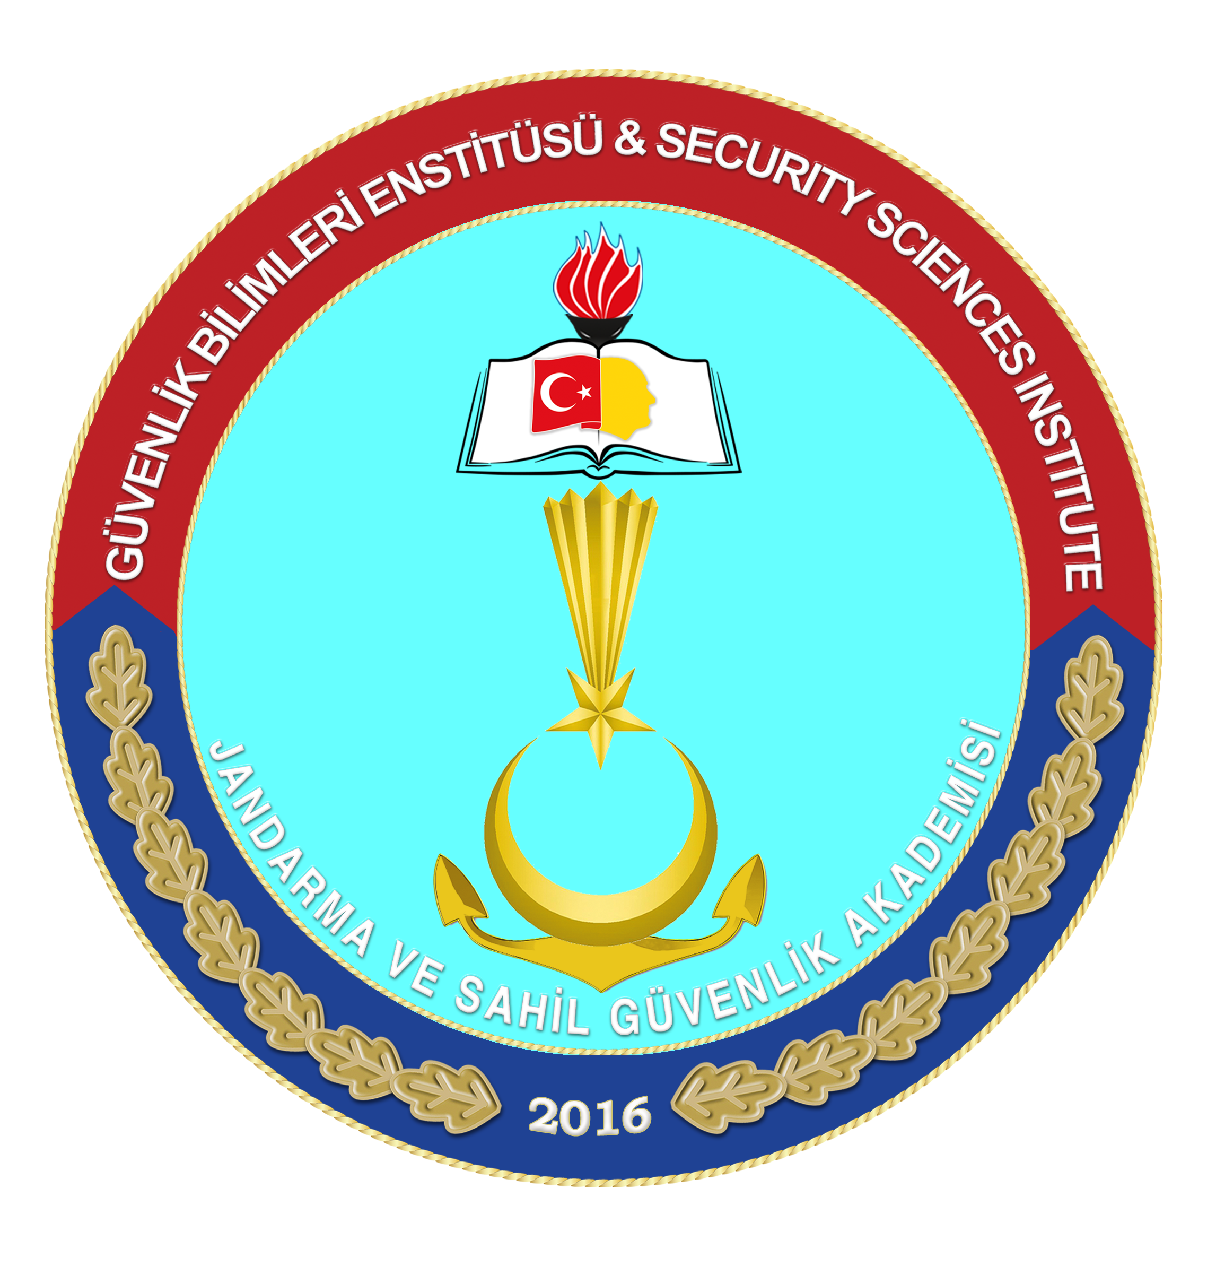
Gendarmerie and Coast Guard Academy
Security Sciences Institute
Journal of Security Sciences
Declaration Form for Exemption from Ethical Committee Approval

Title of the Study
Language of the Study
Department Relevant to the Study
Abstract of the Study
Keywords of the Study
I hereby declare that the study detailed above, which does not require ethical committee approval, involves research conducted through qualitative or quantitative approaches that require data collection from participants using surveys, interviews, focus groups, observation, experiments, interview techniques, and includes studies on humans and animals (including materials/data) for experimental or other scientific purposes, as well as retrospective studies in accordance with the Personal Data Protection Law.
Authors of the Study
Serial Number | Institution/University | Name Surname | Signature
1
2
3
4
Corresponding Author
Affiliated Institution
Mailing Address
e-mail
Phone Number; Mobile

