The effects of step over, feed rate and finish depth on the surface roughness of fiberboard processed with CNC machine

Bekir Cihad Bal1\*[C:\Users\User\Desktop\ORCIDiD_icon128x128.png](https://orcid.org/0000-0001-7097-4132) , Elif Akça2[](https://orcid.org/0000-0002-1638-3064)

**ABSTRACT:** Fiberboard is used extensively in furniture production in all over the world. One of the most important reasons for the preference of fiberboard is the easy shaping of its surfaces. In the past, the surfaces of the fiberboard were processed using conventional machines. Nowadays, Computer Numerical Control (CNC) machines are used in the processing of the fiberboard. CNC machines is operated using some computer control commands which provide the action of the machine. The code file consisting of these commands contains some adjustments such as step over, spindle speed, feed rate, finish depth, machining strategy, step down, plunge rate etc. These adjustments change the surface roughness of the processed section of fiberboard. In this study, the influence of finish depth (2 and 6 mm), step over (40%, 60% and 80%) and feed rate (3, 5 and 7 m/min) settings on the surface roughness of fiberboard were investigated. *Ra* roughness value of processed section of fiberboard test samples was determined using contact stylus method. According to the obtained data, it was concluded that the surface roughness increased as finish depth, feed rate and step over are increased.

Keywords**:** CNC machines, surface roughness, step over, feed rate, finish depth

CNC makineleri ile işlenen lif levhaların yüzey pürüzlülüğü üzerine bıçak adımı, besleme hızı ve kesme derinliğinin etkileri

**ÖZ:** Lif levha tüm dünyada mobilya üretiminde büyük miktarlarda kullanılmaktadır. Lif levhanın tercih edilmesinin en önemli nedenlerinden biri yüzeyinin kolay şekillendirilmesidir. Geçmişte, Lif levhaların yüzeyleri konvansiyonel makinelerle işlenmiştir. Günümüzde, Bilgisayar Sayısal Kontrol (CNC) makineleri lif levhaların işlenmesinde kullanılmaktadır. CNC makineleri, makinenin hareketini sağlayan bilgisayar kontrol komutları kullanılarak çalıştırılmaktadır. Bu komutlardan oluşan kod dosyaları, bıçak adımı, bıçak motoru hızı, besleme hızı, kesme derinliği, işleme taktiği, bıçak dalma derinliği, dalma hızı gibi birçok ayarlamaları içermektedir. Bu ayarlamalar, lif levhanın işlenen kısmının yüzey pürüzlülüğünü değiştirmektedir. Bu çalışmada, kesme derinliği, (2 mm ve 6 mm) bıçak adımı (%40, %60 ve %80) ve besleme hızı (3, 5 ve 7 m/min) ayarlarının lif levhanın yüzey pürüzlülüğü üzerine etkileri araştırılmıştır. Lif levha test örneklerinin işlenen kısımlarının *Ra* pürüzlülük değeri iğne taramaları temas yöntemi kullanılarak belirlenmiştir. Elde edilen verilere göre; kesme derinliği, besleme hızı ve bıçak adımı arttıkça yüzey pürüzlüğünün arttığı belirlenmiştir.

**Anahtar kelimeler:** CNC makineleri, yüzey pürüzlülüğü, bıçak adımı, besleme hızı

There is a section break here!...................................................................................

# Introduction

CNC machines have emerged primarily to meet the needs of aircraft and helicopter factories. It has been developed and widespread during the application in the automotive industry. With the introduction of CNC machines, the design and use of new machines have been completely changed, and new possibilities for engineers, workshops and factory owners have begun to emerge (Erer, 2000).

CNC machines are used in many different areas to process materials in all over the world. Today, there are many different types and special CNC machines developed for different types of production and for different purposes.

Many different parameters have to be adjusted on the CNC machines for the processing of material using code file. These are spindle speed, feed rate, cutter step over, cutter plunge speed, tool strategy etc. According to these adjustments, the surface of the material has different surface roughness. These adjustments effect the quality of processed surface.

CNC machines are used to cut, drill, shape, and other process of the wooden materials such as particleboard, fiberboard and solid wood. Particularly, the surfaces of the fiberboards are processed in workshops and factories to manufacture furniture parts and decoration objects.

Many researchers have been studied the effect of the settings made in the code files of the CNC machines on the material surface quality in the past. For example, review studies conducted by Benardos and Vosniakos (2003) and Karagöz (2011) revealed general criteria on this issue. In these studies, parameters effecting roughness are the parameters related to the cutting tool, to cutting, to machining, and to the material being machined.

In another study conducted by Sütçü and Karagöz (2012), the effects of parameters such as feed rate, spindle speed, finish depth and step over on the surface roughness of the fiberboards were investigated. According to the results of this study; as the spindle speed increased and as the feed rate, step over and cutting depth decreased, the surface roughness decreased. Similar results were obtained by Deus at al., (2015) and Lou et al., (1998). In the study conducted by Sofuoğlu (2015), it was determined that the surface roughness increased as the feed speed increased, and the offset strategy gave better results than the raster strategy.

The processing time is extremely important for work pieces machined on CNC machines. Increasing or decreasing the total number of work pieces per day depends on the CNC machine adjustments. Very slow feed rate or step over reduces the number of work pieces. On the other hand, very high feeding speed and blade step increase the number of work pieces per day, but the surface roughness is badly affected. In a study on this subject, it has been investigated how CNC machine adjustment change the process time and surface roughness of the work pieces. Bal (2018) studied the effects of step over and feed rate on the surface roughness and processing time of the fiberboard. According to obtained data; it was reported that surface roughness decreases as the step over and feed rate increases, but processing time decreases.

In previous studies, the effects of some CNC machines adjustments using different spindle speed on the surface roughness of the fiberboards were investigated. The aim of this study is to determine the effects of step over, feed rate and finish depth on the surface roughness of fiberboard using the same spindle speed.

# Material and Method

## Material

Fiberboards were supplied by means of purchase from the market. The obtained fiberboards are single-sided lamination fiberboards. These type fiberboards are used to produce kitchen cabinet doors. The dimensions of the supplied fiberboards are 18x2100x2800 mm (thickness x width x length).

The codes necessary for the test samples to be processed in the CNC machine were created in the ArtCAM program. The code file was transferred to the CNC control program (Mach3), and the machine was controlled by Mach3 program. The cutting speed of the CNC machine's spindle motor is set to 4000 rpm, the feed rate is 3, 5 and 7 m/min, and the step over is set to 40%, 60% and 80% processing raster strategy. Finish depth was set to 2 and 6 mm.

In the processing of the test specimens, two flute cutters produced from high speed steel (HSS) were used. A total of 6 cutters were used. The cutter showed in Fig. 1.

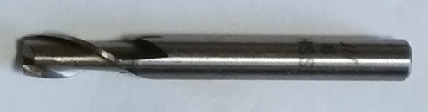

**Fig. 1.** Cutter used in the tests

CNC machine used to perform the tests is a 3-axis CNC machine (CNC router). The CNC machine is a specially manufactured machine by US Mekatronik Company (Fig. 2).

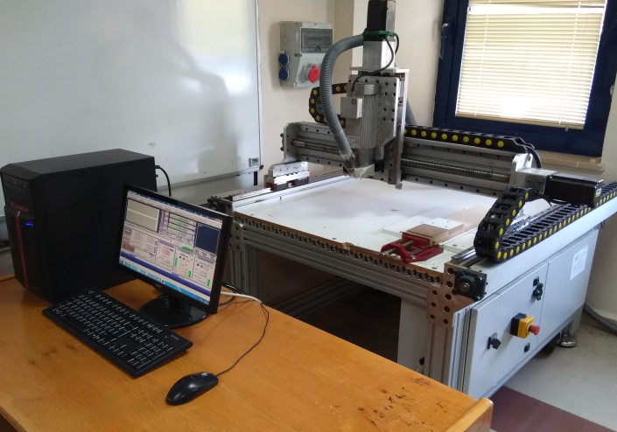

**Fig. 2.** CNC machine

## Method

In the experiments, fiberboard test specimens were prepared as 18x120x120 mm (thickness x width x length) and 10 test specimens were prepared for each group. In the middle of the test specimens, 100x100 mm squares were processed using the CNC machine. Roughness measurements were made in this section.

The surface roughness of the test specimens was measured using Mitutoyo surftest SJ-210 (Fig 3). Surface roughness meter settings and features; cutting length λc: 2.5 mm, stylus angle: 60°, drive unit speed: 0.75 mm/sn, x-axis measurement range: 12.5 mm, z-axis: 360 μm. The roughness value (*Ra*) was determined using TS 971 standard.

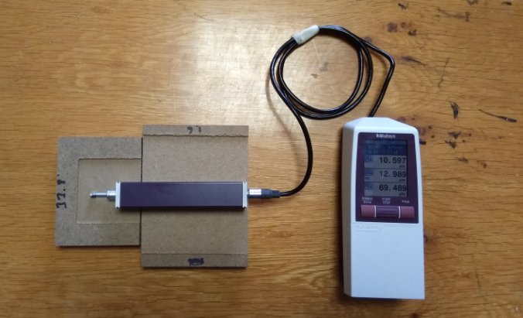

**Fig. 3.** Surface roughness tester

# Results and Discussion

The results of surface roughness obtained from tests were given in Fig. 3 and Fig. 4. When the data given in Fig 3 and 4, it can be seen easily that the *Ra* values of test samples processed 6 mm depth is higher than that of test samples processed 2 mm depth. In addition, the highest *Ra* value (14.9 µm) was measured from group processed using 7 m/min feed rate and 80% step over. The lowest *Ra* value (9.9 µm) was measured from group processed using 3 m/min feed rate and 40% step over in 2 mm finish depth.



**Fig. 3.** Surface roughness (finish depth: 2 mm)

When the data given in Fig. 4 analyzed, it can be said that the differences of *Ra* values among groups is very evident. But, the *Ra* values given in Fig. 3 aren’t very evident. It is thought that the reason of this difference is that the density of the fiberboard is variable on outer layers than that of on inner layers. As the density of the fibres board increases, the surface roughness values of fiberboard processed with CNC machines decreases. Similar results were reported by Lou et al., (1998), Sütçü and Karagöz (2012) and Deus et al., (2015).



**Fig 4**. Surface roughness (finish depth: 6 mm)

Three-Way ANOVA test results were given in Table 1. The table shows the effects of finish depth, step over, feed rate and their interactions. The effects of main factors were statistically significant. In other words, finish depth, step over and feed rate affect the surface roughness of fiberboard. Three-Way ANOVA test results are statistically significant.

**Table 1.** Three-Way ANOVA test results

|  |  |  |  |  |  |
| --- | --- | --- | --- | --- | --- |
| **Source** | **Sum of Squares** | **df** | **Mean Square** | **F** | **Sig.** |
| Finish depth (FD) | 656.373 | 1 | 656.373 | 1148.484 | 0.000 |
| Step over (SO) | 59.063 | 3 | 19.688 | 34.448 | 0.000 |
| Feed rate (FR) | 37.517 | 2 | 18.758 | 32.822 | 0.000 |
| FD \* SO | 22.313 | 3 | 7.438 | 13.014 | 0.000 |
| FD \* FR | 2.741 | 2 | 1.371 | 2.398 | 0.093 |
| SO \* FR | 3.525 | 6 | .587 | 1.028 | 0.408 |
| FD \* SO \* FR | 10.310 | 6 | 1.718 | 3.007 | 0.008 |

Table 2 shows Duncan test results about the effects of step over on the *Ra* values. When the Table 2 analyzed, it can be seen that step over of 20% and 40% was differ from step over percentages of 60% and 80%. According to mean values of groups; the lowest *Ra* values was 11.53 µm, and the highest value was 12.62 µm. Similar results were reported about the effects of step over on the surface roughness by other researchers (Lou et al. 1998; Sütçü and Karagöz 2012; Bal 2018).

**4. Conclusion**

In this study, the effects of the step over, feed rate and finish depth on the surface roughness of fiberboards were investigated. According to data obtained, following results can be said;

* Surface roughness value increases, as the feed rate increases. Especially, roughness of the test samples processed using 7 m/min feed rate are higher than that of other feed rate. The difference is statistically significant.
* Surface roughness value increases, as the step over increases. Roughness of the test samples processed using 20%, 40% step over are lower than that of step over of 60% and 80%. The differences between these two groups are significant.
* Roughness value increases, as the finish dept increases. It can be said that the reason of difference is the density of fiberboard. The outer layers of the fiberboard have higher density than that of inner layers.

Acknowledgement

Some part of the data presented in this study was obtained from the project 215 O 899 supported by TÜBİTAK. We thank TÜBİTAK for this support. This study presented as a poster presentation at “International Forest Product Congress 2018”. The abstract section of the study published in abstracts book (Page; 165).

**Author Contributions**

**Bekir Cihad Bal**: Conceptualization, Data curation, Formal Analysis, Funding acquisition, Investigation, Methodology, Project administration, Resources, Supervision, Validation, Visualization, Writing – original draft, Writing – review & editing, **Elif Akça**: Conceptualization, Data curation, Formal Analysis, Funding acquisition, Investigation, Methodology, Project administration, Resources, Supervision, Validation, Visualization, Writing – original draft, Writing – review & editing.(for information please follow the link: <https://credit.niso.org/> )

**Funding statement**

This project was supported by the Scientific and Technological Research Council of Turkey (TÜBİTAK) under the XXXX-A University Students Research Projects Support Program, within the scope of the 2022 2nd Term, with project number xxxxxxxxx.

**Conflict of interest statement**

The authors declare no conflict of interest.

References

Bal, B.C., & Bektaş, İ, (2018). Determination of relationship between density and some physical properties in beech and poplar wood. *MAMAD*, 1(1), 1-10. DOI: [10.33725/mamad.420917](https://doi.org/10.33725/mamad.420917)

Bal, B.C.,(2018). The effects of some tool paths adjustments of CNC machines on surface roughness and processing time of fiberboards. *MAMAD*, 1(1), 21-30. DOI: [10.33725/mamad.420917](https://doi.org/10.33725/mamad.420917)

Bal, B.C., (2011). Okaliptüs grandis (*Eucalyptus grandis* W. Hill ex maiden) odununun fiziksel ve mekanik özellikleri ve lamine ağaç malzeme üretiminde kullanılması üzerine araştırmalar. *K.S.Ü.,* *Fen Bilimleri Enstitüsü, Doktora Tezi*, Kahramanmaraş.

Benardos, P.G., & Vosniakos, G. C., (2003). Predicting surface roughness in machining: a review. *International Journal of Machine Tools And Manufacture*, 43(8), 833-844.

Bozkurt, Y., ve Göker, Y. (1996). Fiziksel ve mekanik ağaç teknolojisi, İ.Ü., *Orman Fakültesi Yayınları*, No:3944, İstanbul.

Davis, E.M., (1962). Machining and related characteristics of United States hardwoods. *Technical Bulletin* No: 1267, US Department of Agriculture Forest Service.

De Deus, P. R., de Sampaio Alves, M. C., & Vieira, F. H.A. (2015). The quality of MDF work pieces machined in CNC milling machine in cutting speeds, feed rate, and depth of cut. *Meccanica*, 50(12), 2899-2906. DOI: [10.1007/s11012-015-0187-z](https://link.springer.com/article/10.1007/s11012-015-0187-z)

Erer, H., (2000). CNC takım tezgâhlarının gelişimi, <http://www.turkcadcam.net/rapor/cnc-ttg/index.html>, son erişim tarihi: 18.06.2018.

Karagöz, Ü., (2011). CNC ile işlemede ahşap malzemenin yüzey kalitesini etkileyen faktörler.  *Kastamonu Üniversitesi Orman Fakültesi Dergisi*,  11(1), 18-26.

Kollmann, F., & Cote, W.A. (1968). Principles of wood science and technology. Springer Verlag.

Lin, R.J.T., Houts, J.V., & Bhattacharyya, D., (2006). Machinability investigation of medium density fiberboard, *Holzforschung,* 60(1), 71-77.

Lou, M. S., Chen, J. C., & Li, C. M., (1998). Surface roughness prediction technique for CNC end-milling, *Journal of Industrial Technology*,  15(1), 1-6.

Sedlecký, M., (2017). Surface roughness of medium-density fiberboard (MDF) and edge-glued panel (EGP) after edge milling. *BioResources*, 12(4), 8119-8133.

Sedlecký, M., Kvietková, M. S., & Kminiak, R. (2018). Medium-density fiberboard (MDF) and edge-glued panels (EGP) after edge milling-surface roughness after machining with different parameters. *BioResources*, 13(1), 2005-2021.

Sofuoglu, S.D. (2015). Determination of Optimal machining parameters of massive wooden edge-glued panels made of European larch (*Larix decidua* Mill.) using Taguchi Design Method. *BioResources*, 10(4), 7772-7781.

Sütçü, A., & Karagöz, Ü. (2012). Effect of machining parameters on surface quality after face milling of MDF. *Wood Research,* 57(2), 231-240.

Sütçü, A., & Karagöz, Ü. (2013). The influence of process parameters on the surface roughness in aesthetic machining of wooden edge-glued panels (EGPs). *BioResources*, 8(4), 5435-5448.

TS 971, (1999). Surface roughness-parameters, their values and general rules for specifying requirements, TSE, Ankara, 1999.